DAY 3 – FUNCTIONS + ADVANCED PYTHON
Saturday,12/09/26
*Here we are learning about the concepts of advance python
Concepts of advance Python is as below:-
1. FUNCTIONS
Function is a block of code that runs only when called. Used for reusability.
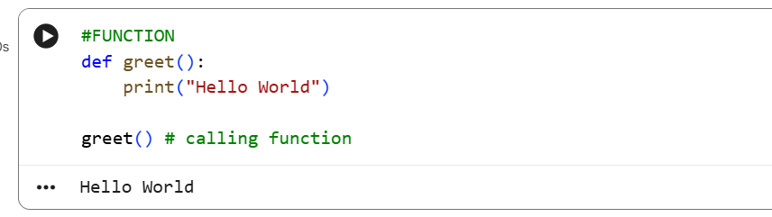
2. PARAMETERS
Values passed to function
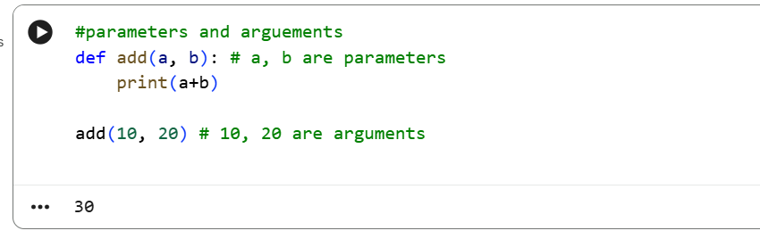

3. RETURN VALUES
Function sends back value using return.
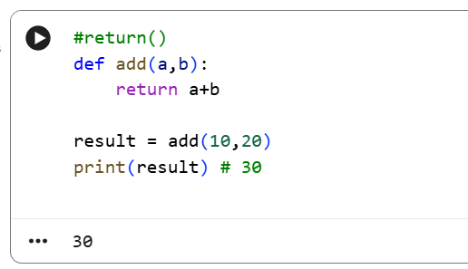
4. LAMBDA
Small anonymous function in one line.
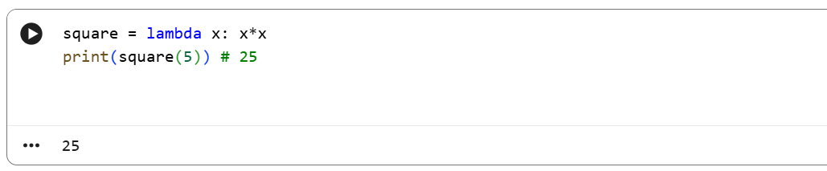
# Normal function vs Lambda
def add(a, b): return a+b
add_lambda = lambda a,b: a+b
5. map()
Applies function to each item in list.
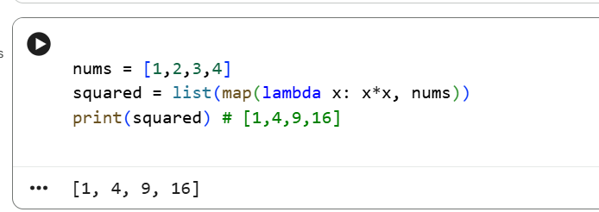
6. filter()
Filters items based on condition.
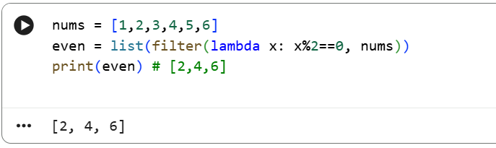

7. LIST COMPREHENSION
Short way to create list.
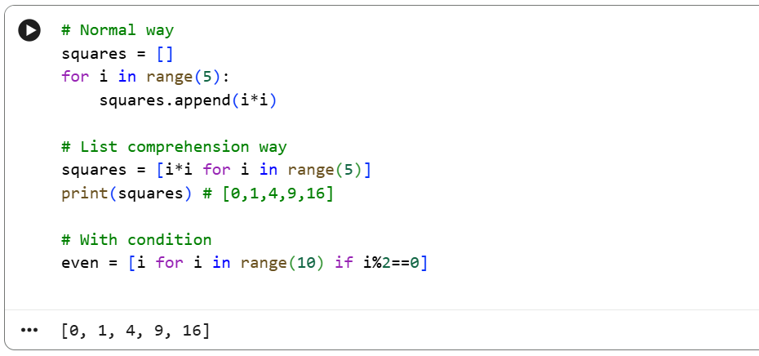
8. DICTIONARY COMPREHENSION
Short way to create dictionary
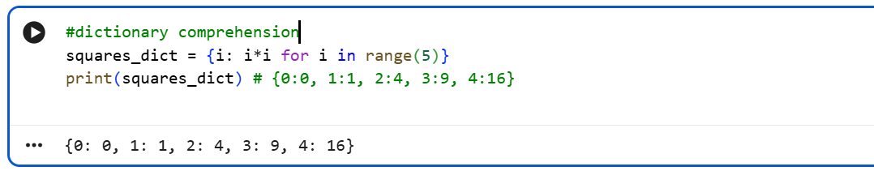

9. EXCEPTION HANDLING
Handles errors without crashing program.
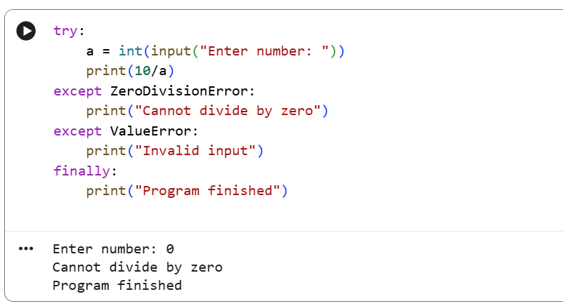
10. MODULES
Module is a Python file with functions. You can import it.
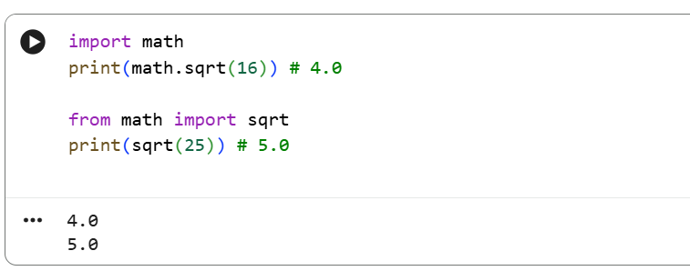

DELIVERABLE :- day03_python_functions.py
# Student Marks Analyzer using Functions

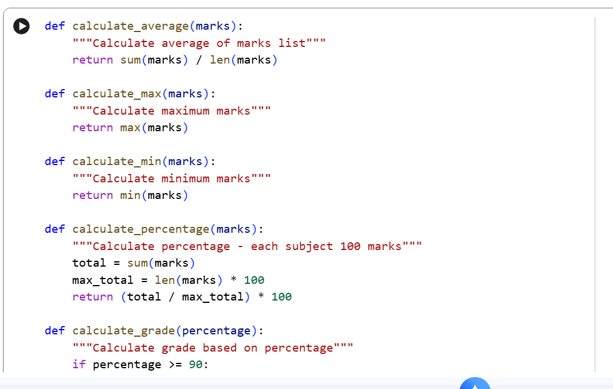
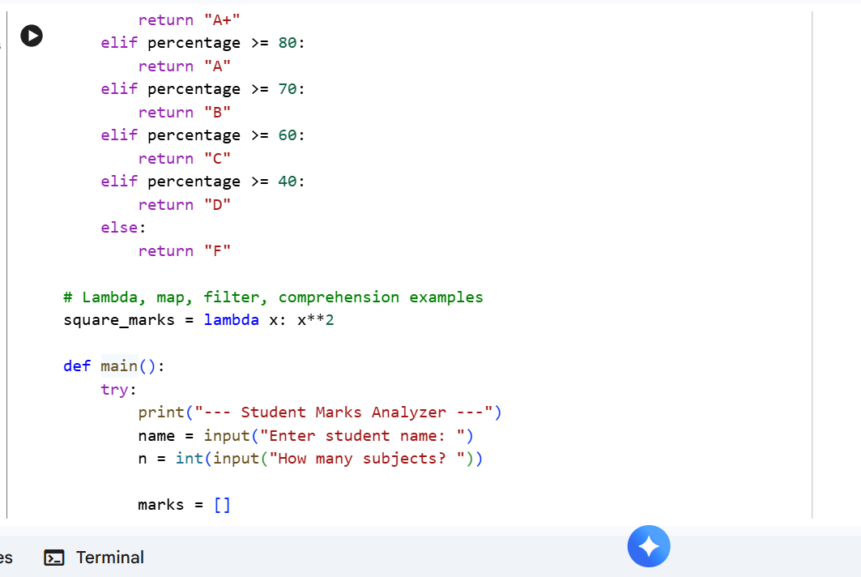
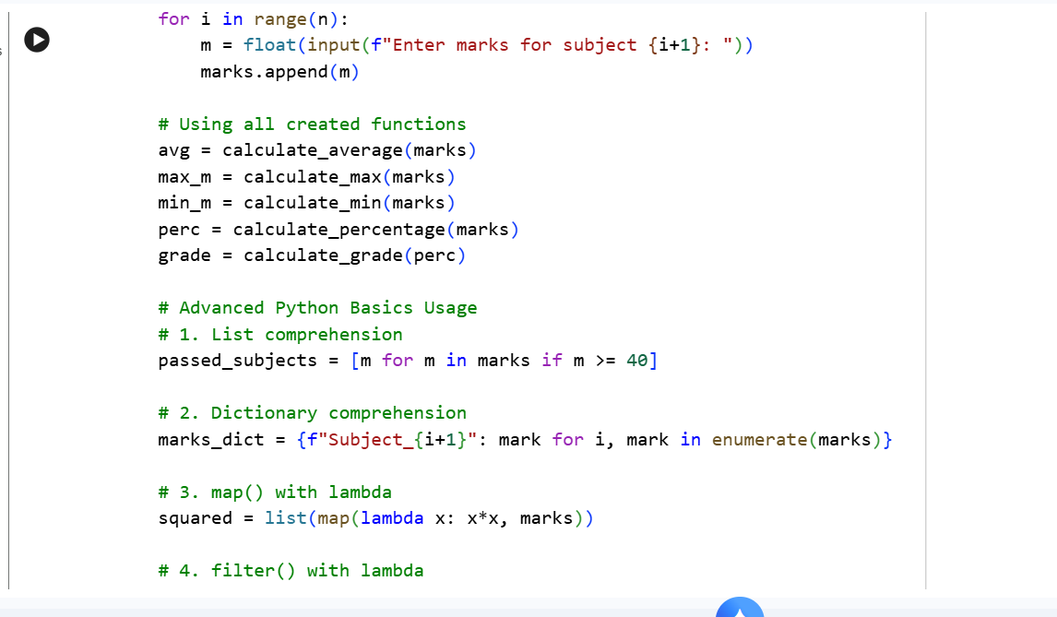
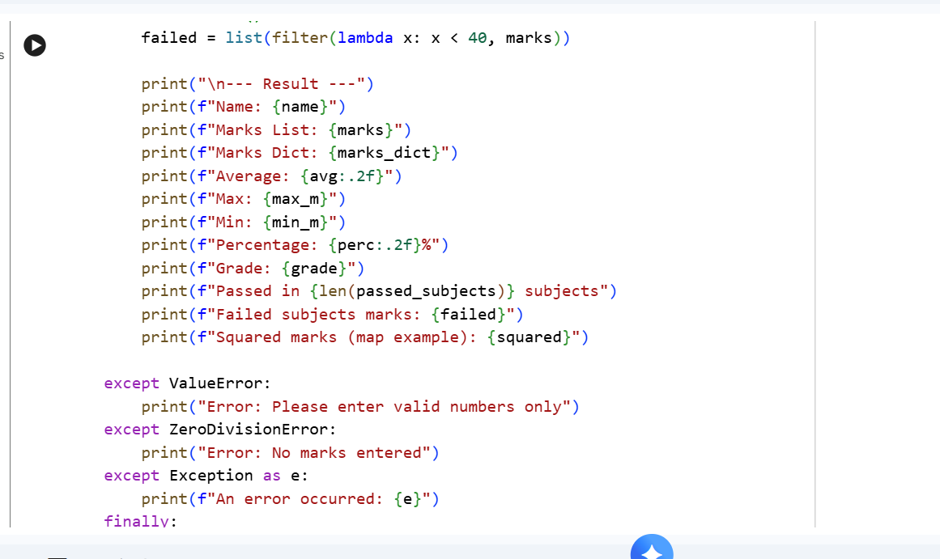
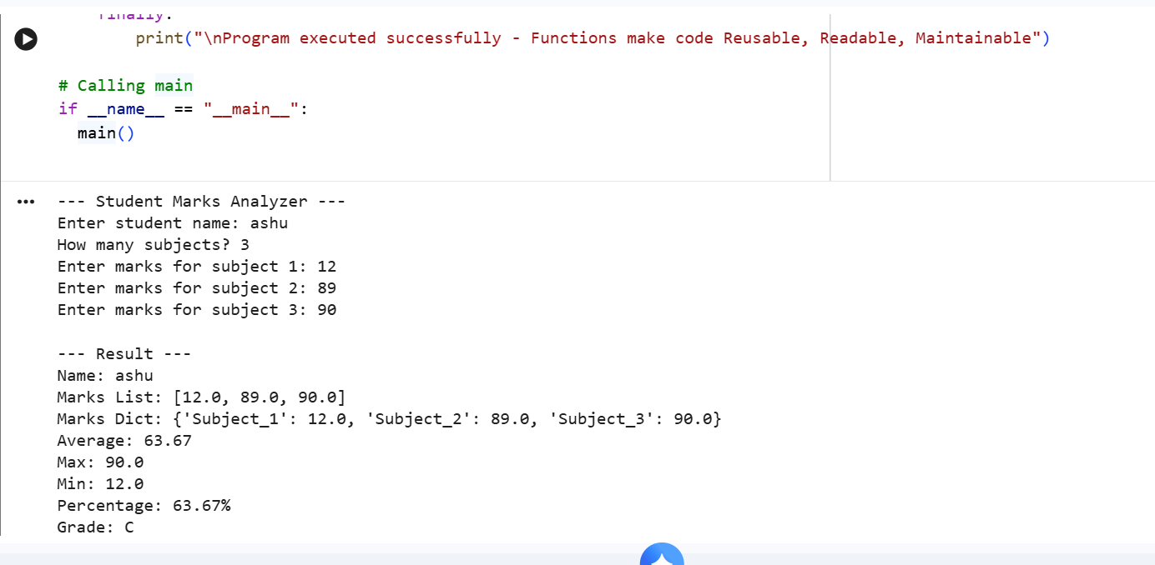
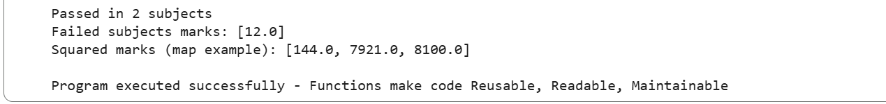
Why Functions?
Large projects cannot be written as one huge script
because:
Reusable - Write once, use many times
Readable - Code is divided into small parts
Maintainable - Easy to fix bugs

