DAY 5 :- Pandas basic
Wednesday,16/09/26
*Pandas is a python library where it is known as python data analysis library and it is used for data analysis ,data cleaning, handling csv/excel files.
1. Series
One-dimensional labeled array, single column.
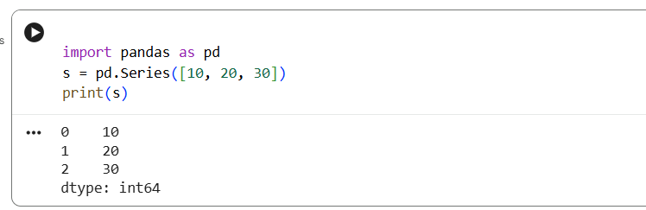

2. DataFrame
Two-dimensional table with rows and columns.
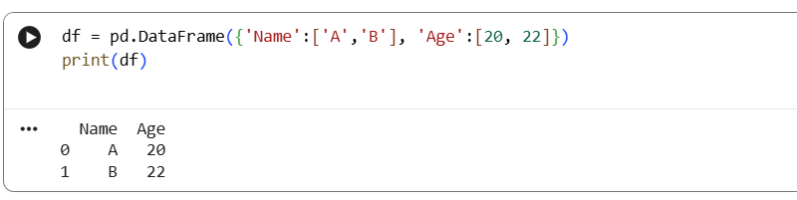
3. read_csv()
Loads CSV file into DataFrame.
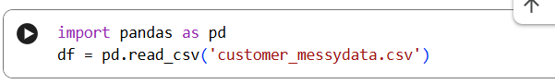

4. head()
Shows first n rows (default 5).
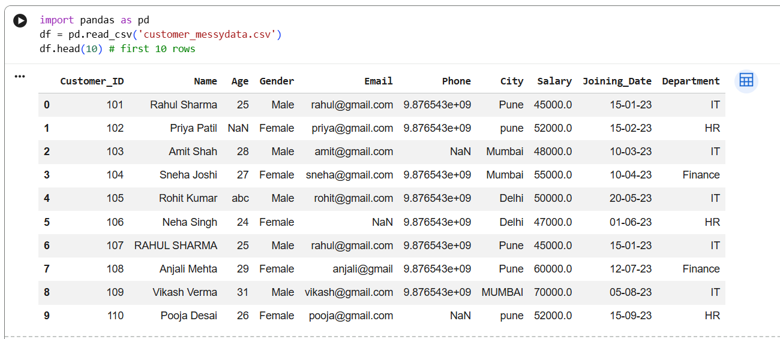

5. tail()
Shows last n rows.
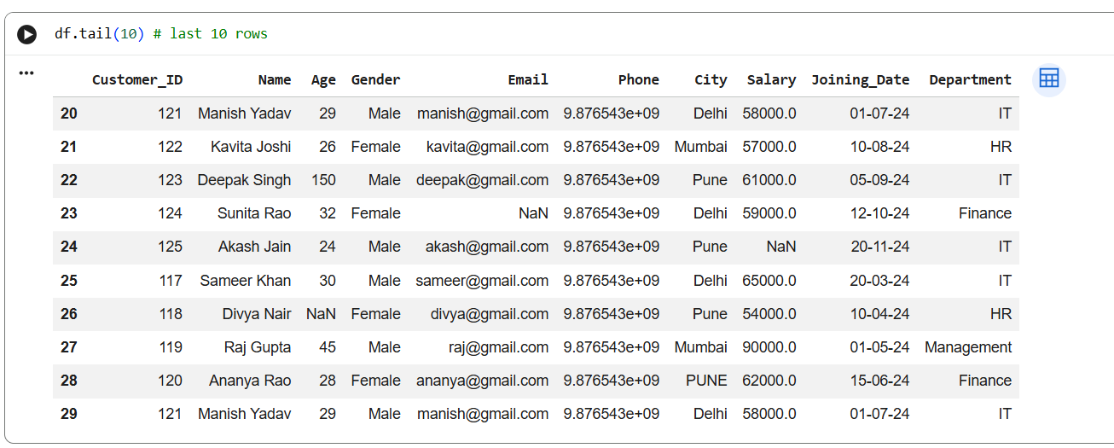
6. info()
Shows summary of DataFrame like rows, cols, data types, non-null counts.
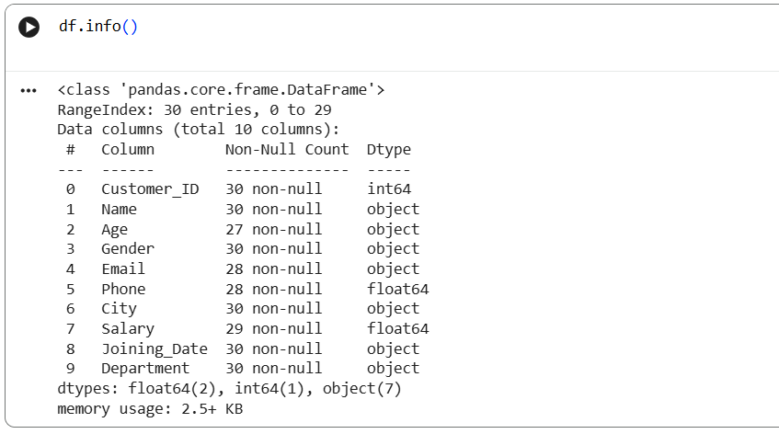

7. describe()
Generates statistics: count, mean, std, min, max, quartiles.
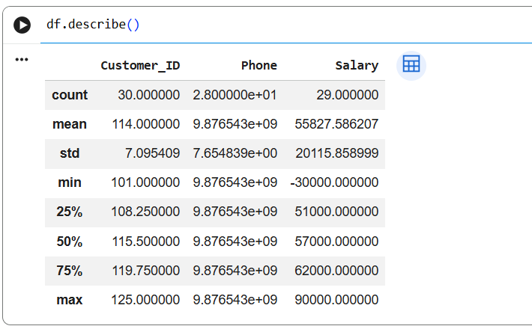
8. shape
Returns (number of rows, number of columns).
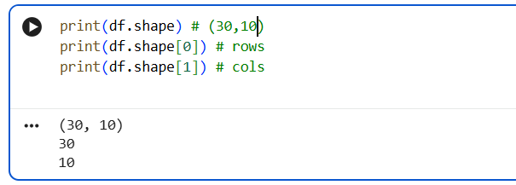

9. columns
Lists all column names.
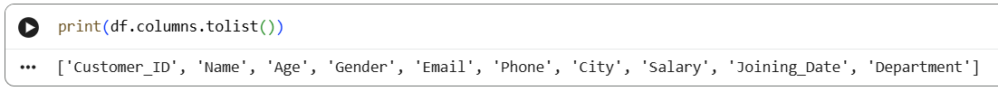
10. dtypes
Shows data type of each column.
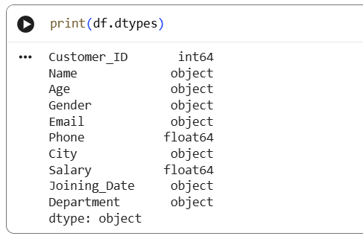

Deliverables: Day05_Pandas.ipynb

- Load dataset
- Display first 10 rows
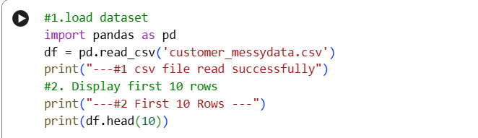
Output:-
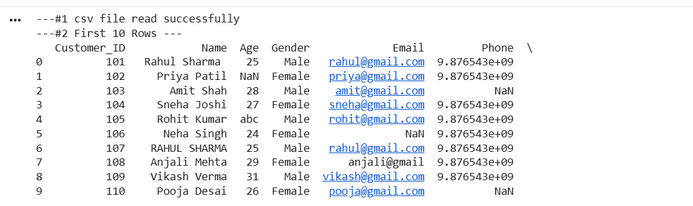

- Display last 10 rows
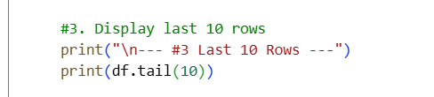

Output:
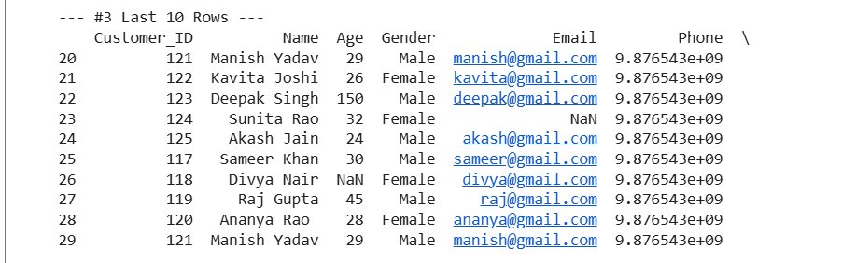
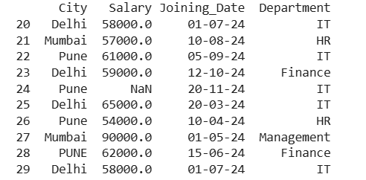

- Find number of rows
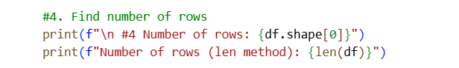
Output:-
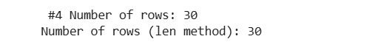
- Find number of columns
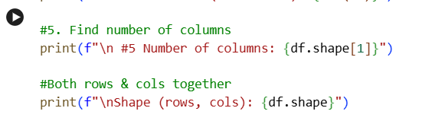
Output :-
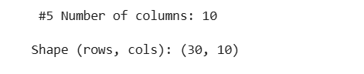
- Check data types
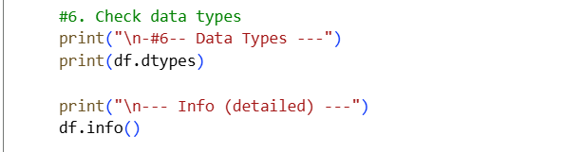
Output:-
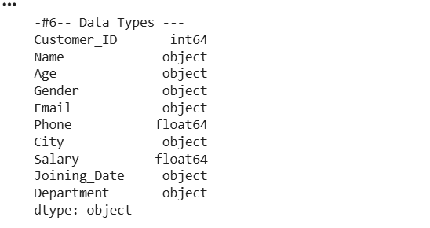
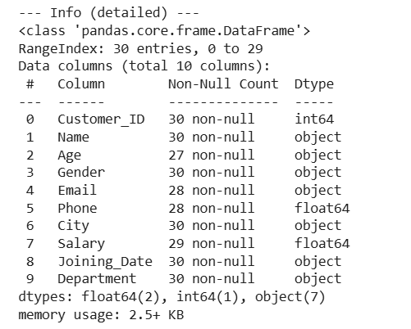
- Find missing values
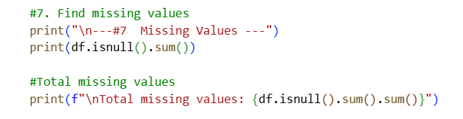
Output:-
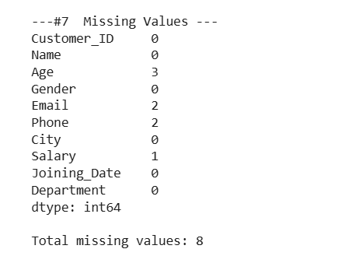
- Generate summary statistics
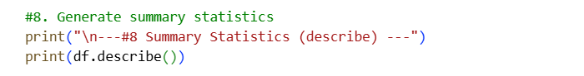
Output:-
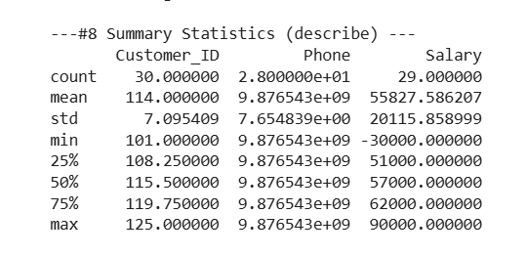
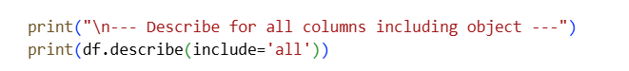
Output:-
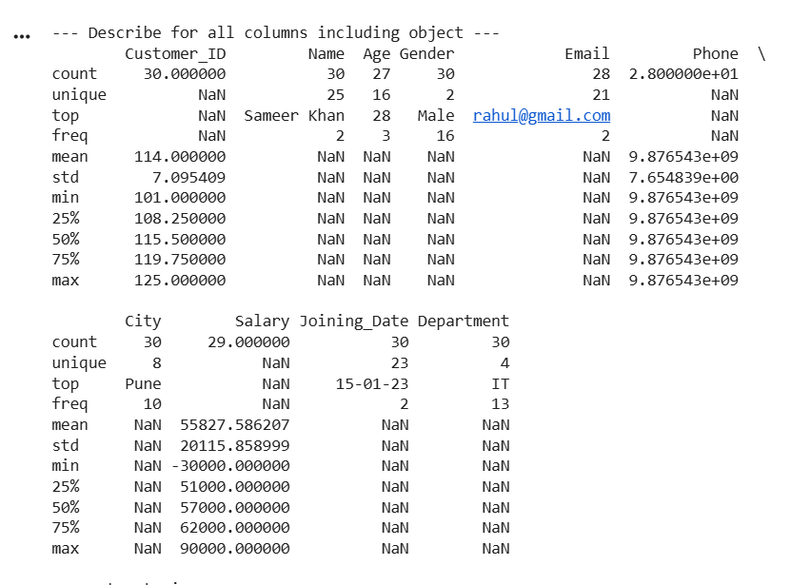

*Why Pandas will be used almost every day in the projects?*
- Pandas is used daily because it provides DataFrame, which is like an Excel sheet in Python.
- It allows fast filtering, grouping, cleaning missing data, merging datasets, and EDA.
- NumPy handles numbers, but Pandas handles real-world table data with rows, columns, names, and missing values.

