Day-6: Data Cleaning
Thursday,10/09/26
Data Cleaning is the process of fixing dirty, wrong, or incomplete data to make it ready for analysis.
# Topics: -
- Missing values:-
to find empty/ blank data in a dataset.
df.isnull().sum()
- Duplicates:-
to find rows that are repeated exactly same.
Df.duplicated().sum()
- Wrong data types:-
to fix columns where data is stored in wrong format like age as text
Df[‘age’].astype(int)
- Incorrect values:-
To find and fix impossible or wrong values like age=200.
Df[‘age’].replace(200,30)
- Inconsistent text:-
To make same text written in different ways into one standard format.
Df[‘City’].str.lower().str.strip()
- Outliers:-
To find abnormal values that are too high or too low compared to others
Uses IQR or mean/std to detect
- Handle missing values:-
To fill or remove the empty data after identifying it.
Df.fillna() or df.dropna()

- Short summary of functions used in data cleaning:

- - *Missing values:* Empty data -> use `isnull()` to find, `fillna()` / `dropna()` to fix
- - *Duplicates:* Same row repeated -> `duplicated()` to count, `drop_duplicates()` to remove
- - *Wrong data types:* Numbers stored as text -> `astype()` or `pd.to_numeric()`
- - *Incorrect values:* Age 200 -> filter it `df[df['Age'] < 100]` or use `replace()`
- - *Inconsistent text:* Mumbai vs mumbai vs MUMBAI -> `str.strip().str.lower().str.title()`
- - *Outliers:* Value far from others -> find with `describe()` and remove/handle

Tasks:-Data cleaning
*Create a Dirty Dataset First
Since real data is messy, let's create one to perform data cleaning.
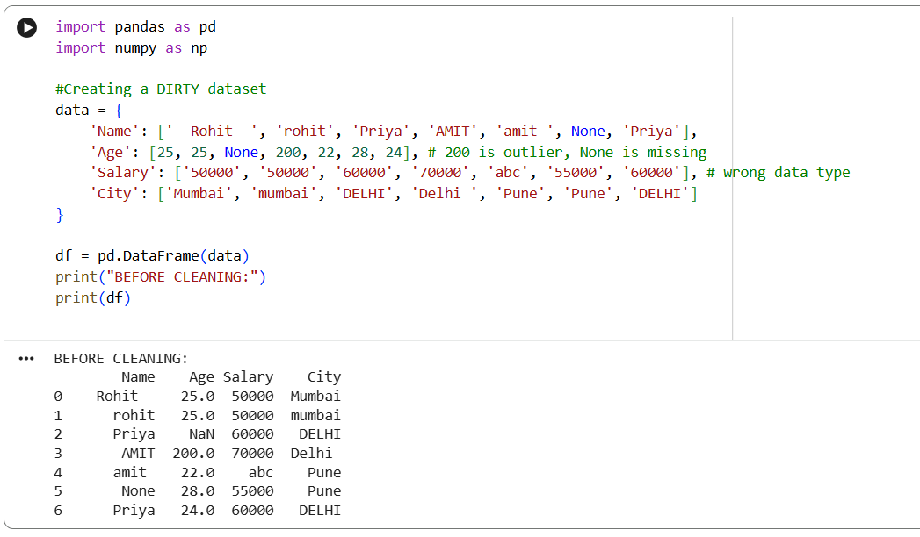
1. Identify missing values
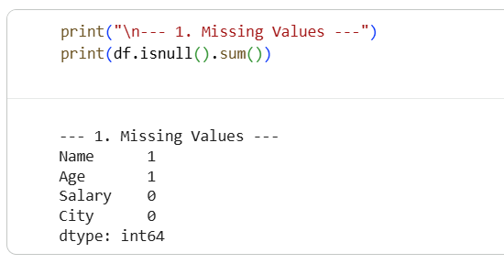
2. Identify duplicates
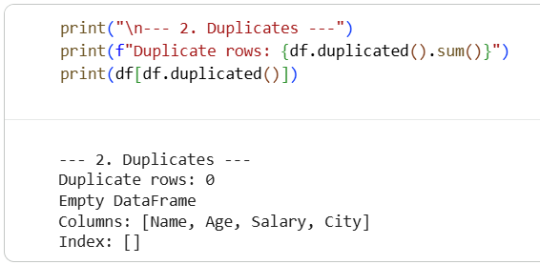

3. Fix data types
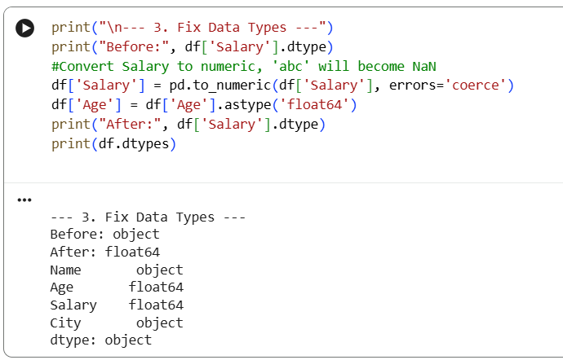
4. Standardize text (Inconsistent text): 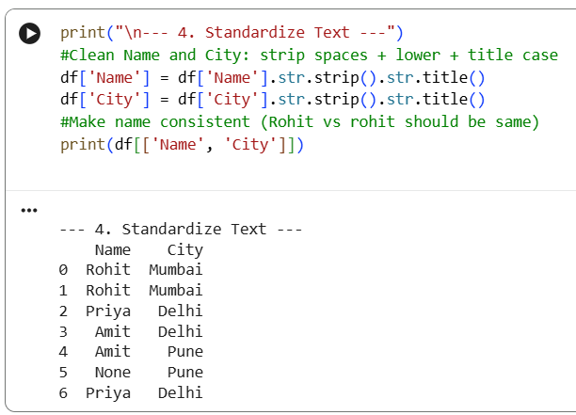
5. Remove/handle duplicates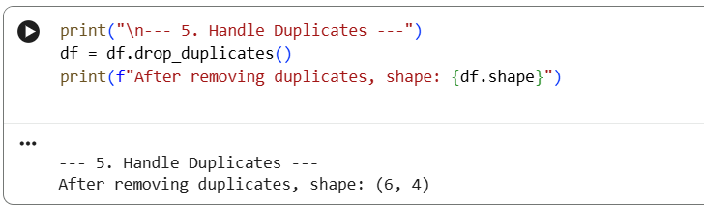

6. Handle missing values
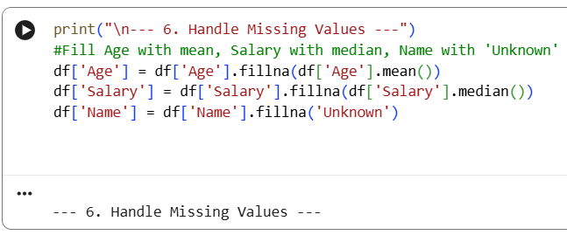

7. Identify & handle abnormal values (Outliers)
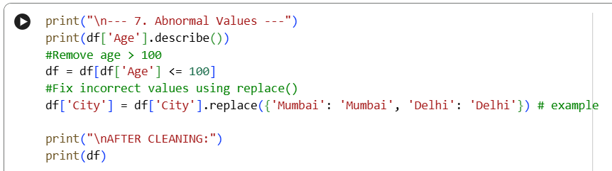

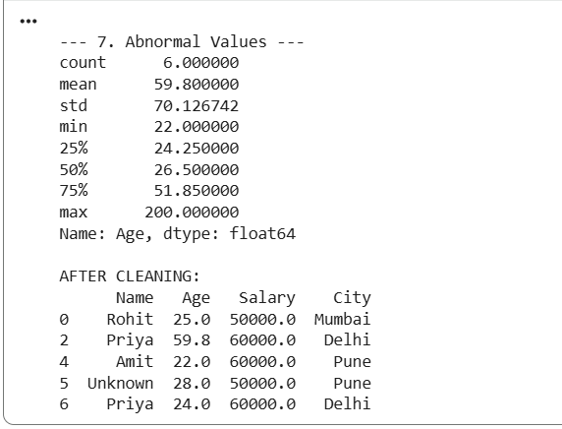

Save cleaned dataset
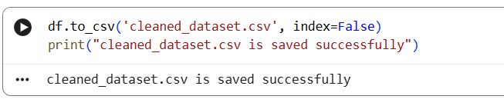

- Why real-world data is never clean?

- Real data is made by humans and machines, not in a lab.
- So, it has typing mistakes, blank values, same data repeated from different sources, and system failures.
- That is why we must clean it, otherwise our model will give wrong results.

Deliverables: -Day06
dirty_dataset.csv (before)
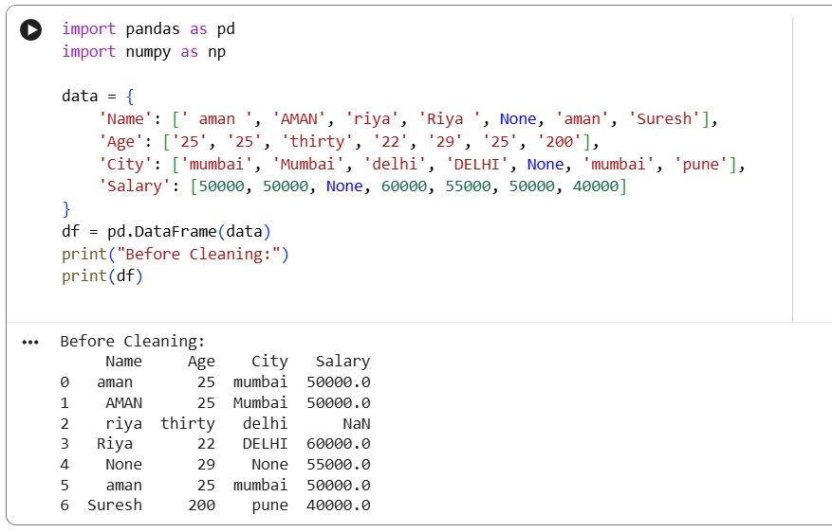
cleaned_dataset.csv (after)
