DAY 8 — Advanced SQL.
Saturday,19/09/26
Advanced SQL is the next level of SQL where we use powerful concepts like JOIN, Subquery, CTE, and Window Functions (RANK, LAG, LEAD).
#advance SQL concepts are as follow: -
- JOIN - Combines rows from 2 tables based on a common column.
- INNER JOIN - Returns only matching rows from both tables.
- LEFT JOIN - Returns all rows from left table + matching from right.
- Subquery - Query inside another query.
- CTE (WITH) - Temporary named result to make query clean.
- Window Functions - Does calculation without losing rows.
- ROW_NUMBER () - Gives unique number 1,2,3...
- RANK() - Gives rank with gaps. Ex: 1,2,2,4
- DENSE_RANK() - Gives rank without gaps. Ex: 1,2,2,3
- LAG() - See previous row value.
- LEAD() - See next row value
*TASK:- perform 20 advance SQL querries
- Deliverables: - day08:-Advanced_Q .sql.
*Modifying the created tables for advanced queries
- Add category column to products
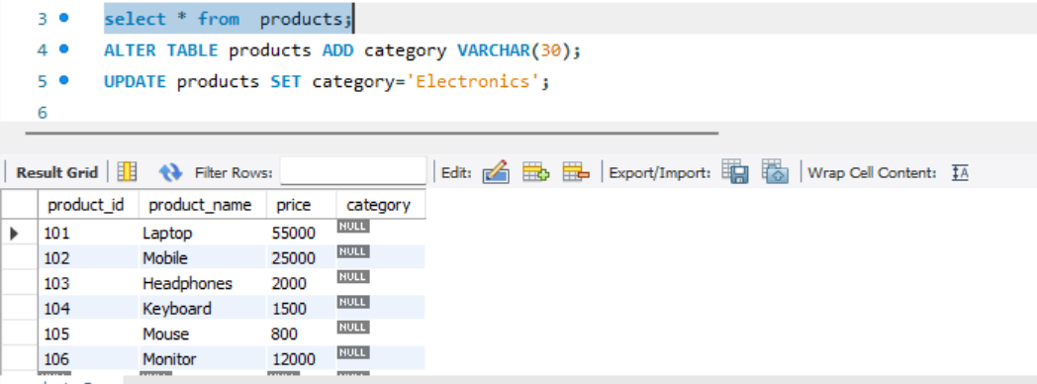

- Add order_date to order
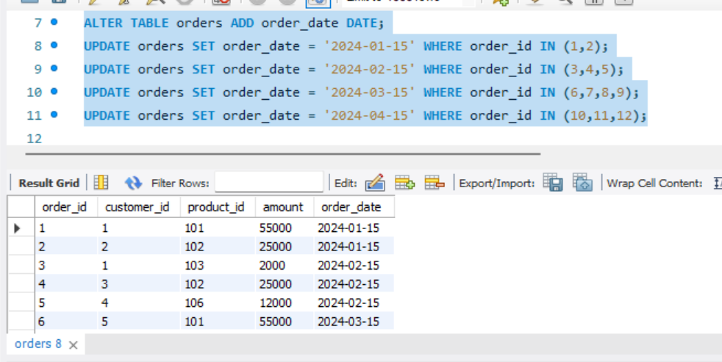
- Create table employee and insert values in it.
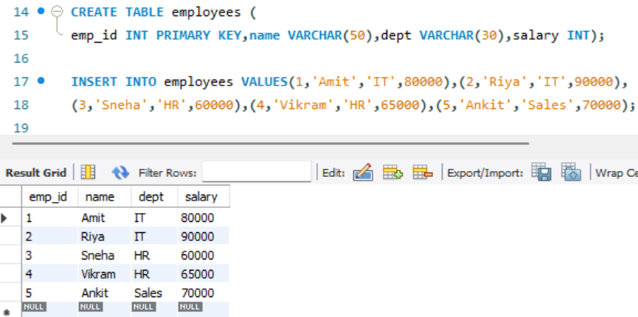

- Write 20 SQL queries:-
- Top 3 customers by total purchase (JOIN + GROUP BY)
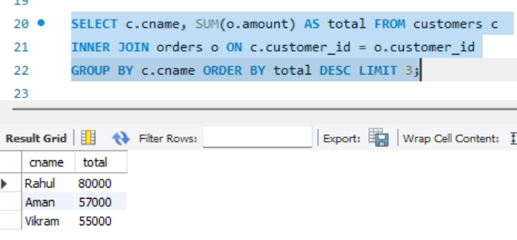
- Top 3 products per category (DENSE_RANK
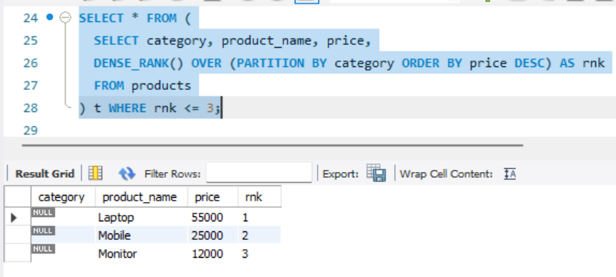

- Customer ranking by total spend (RANK)
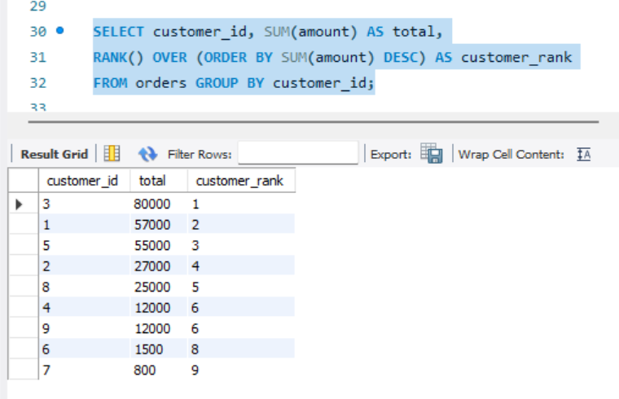

- Monthly revenue (GROUP BY Month)
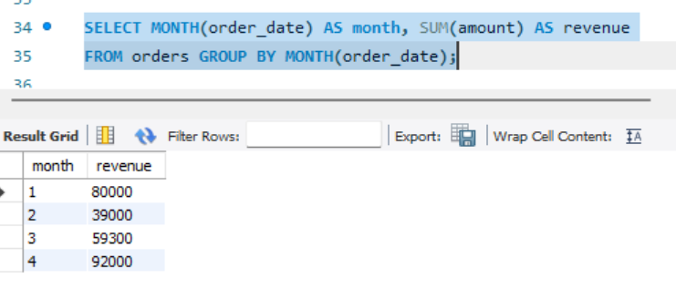
- Previous month revenue (LAG)
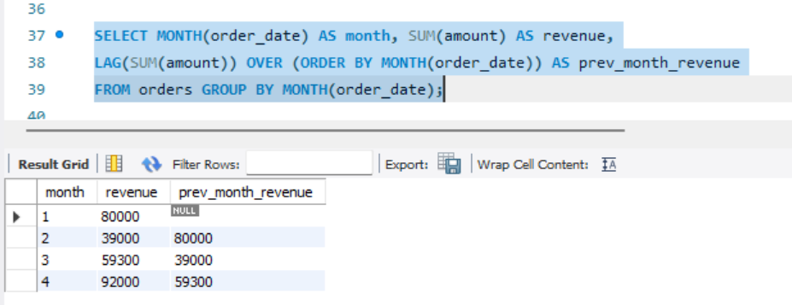

- Month-over-month growth %
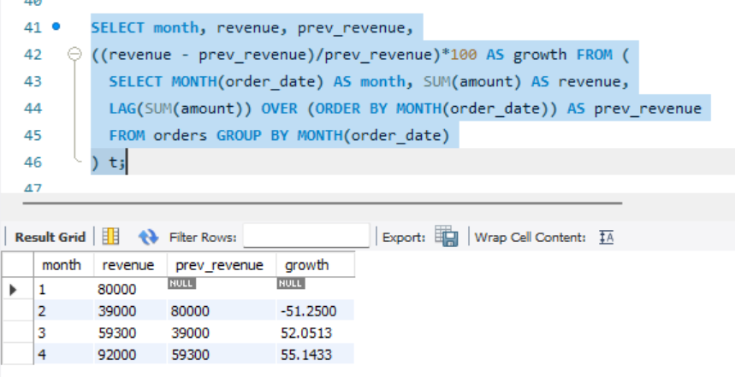

- Employee salary ranking per department
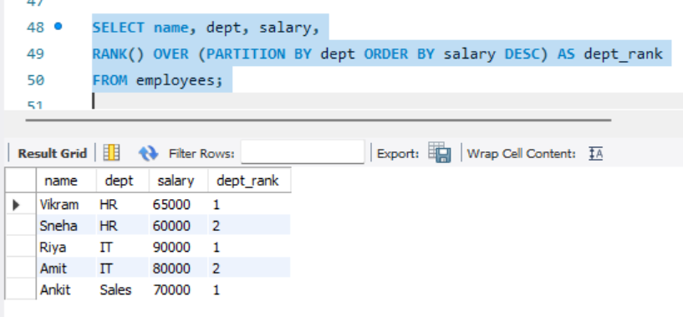
- INNER JOIN - Customers who placed orders
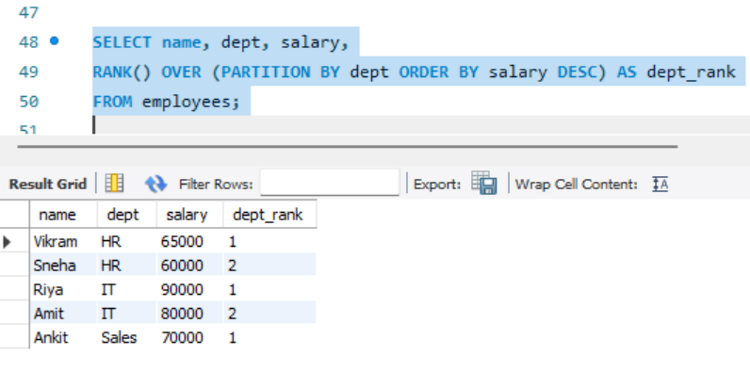
- LEFT JOIN - All customers even if no order
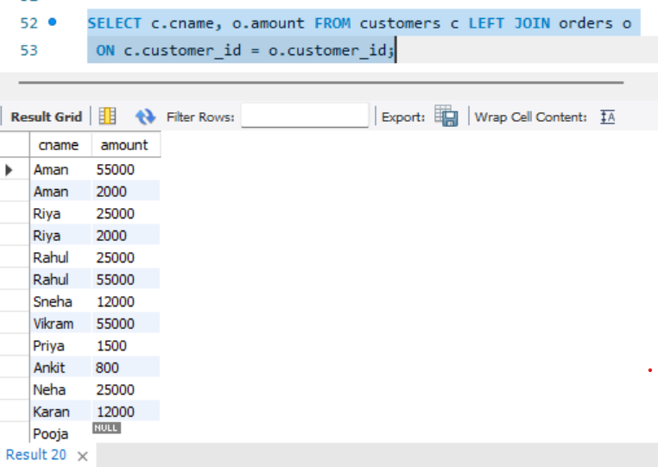

- Subquery - Customers who bought Laptop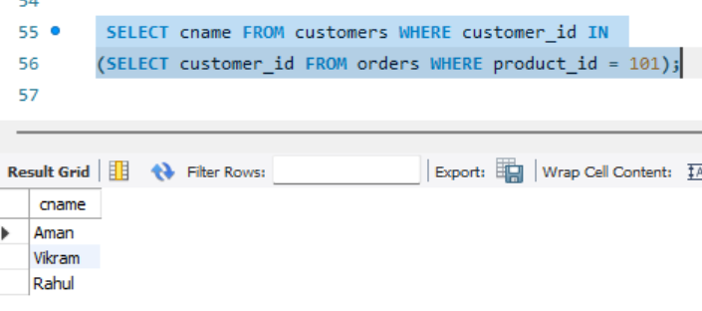
- CTE - Calculate avg order value then filter
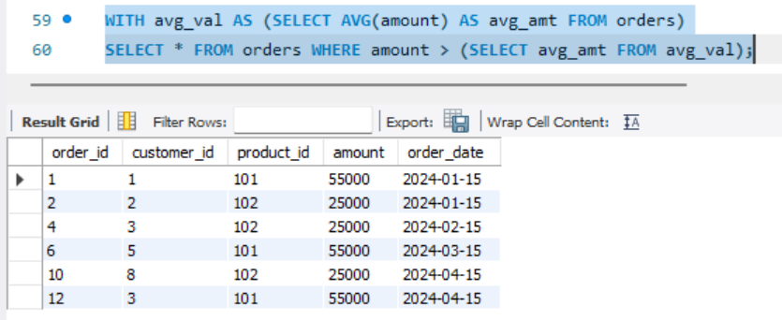

- ROW_NUMBER - Give row number to orders by amount
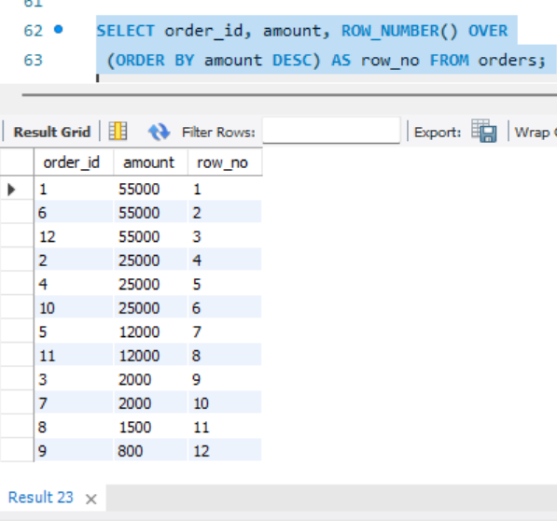
- RANK vs DENSE_RANK comparison
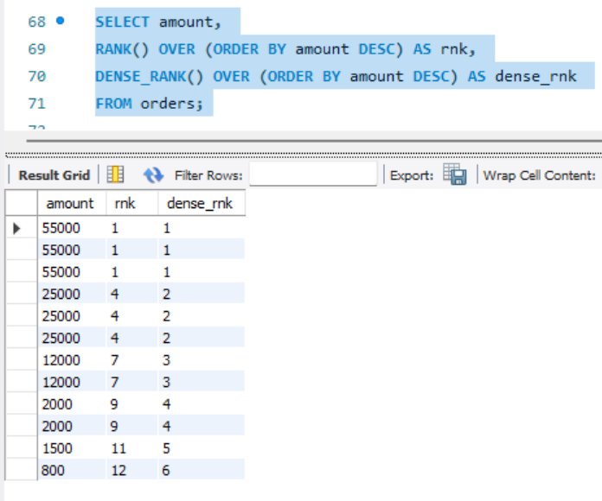

- LAG - Find difference from previous order amount
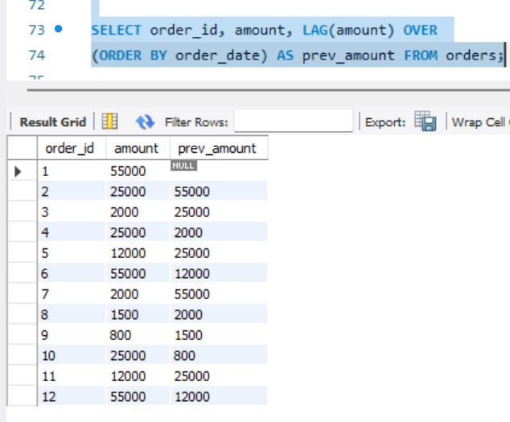

- LEAD - Find next order amount
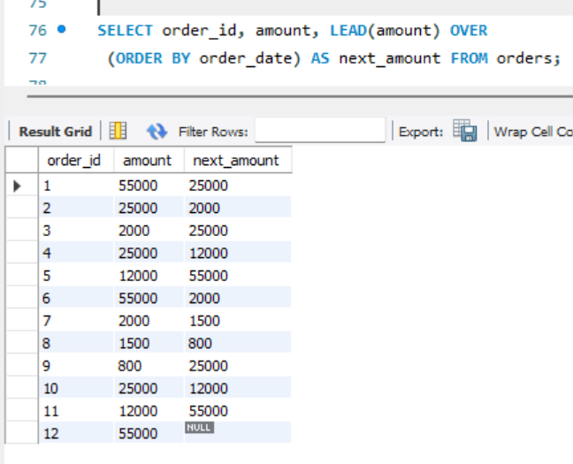
- CTE + JOIN - Top customer per city
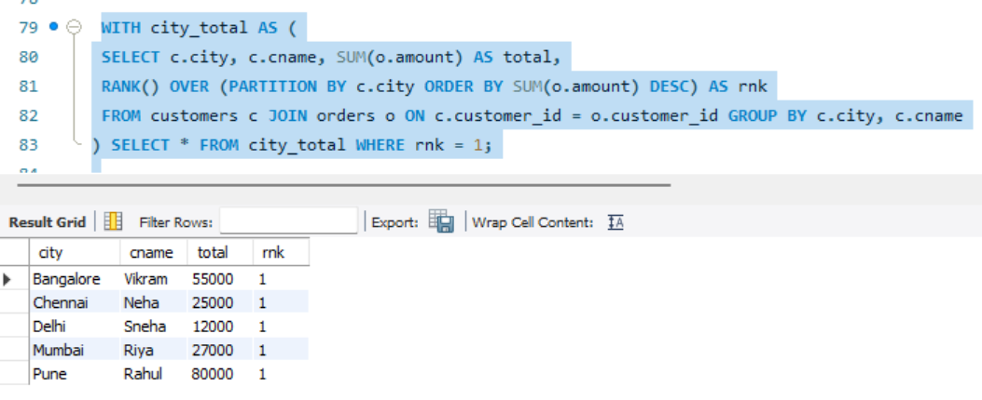

- Subquery - Second highest salary
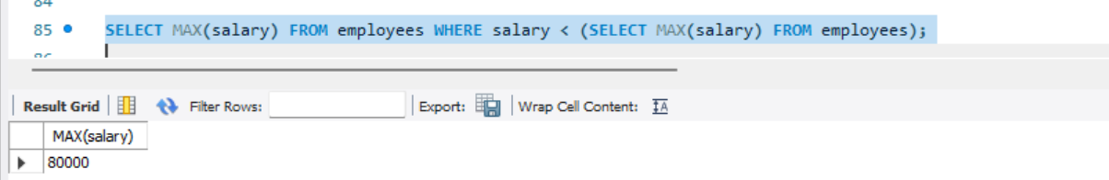

- Window - Running total of revenue
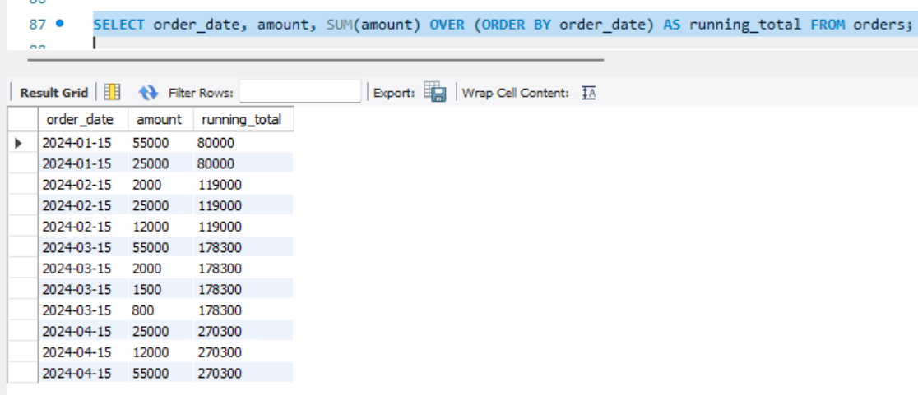

- Window - Average salary per dept without GROUP BY
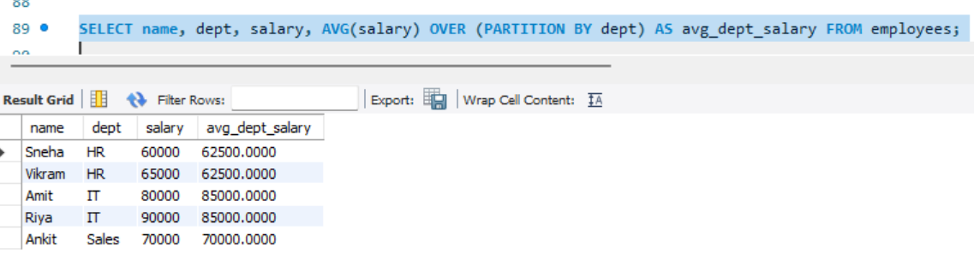
- LEFT JOIN to find customers who never ordered
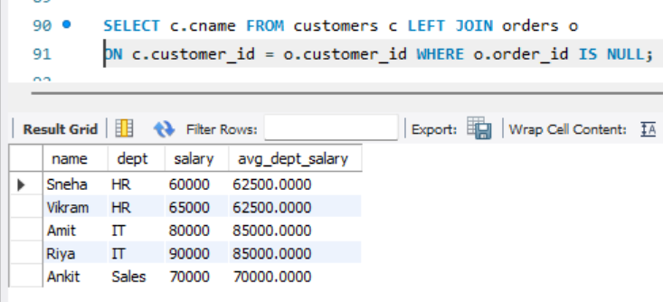
*Why Advanced SQL is essential for professional analytical work?
- Exactly.
- Basic SQL just tells you what data is there.
- Advanced SQL tells you why it's happening and what to do next.
- Without Advanced SQL (JOIN, CTE, Window Functions), you can't do ranking, growth analysis, or Top N reports

