Day-9: Statistics
Monday,21/09/26
Statistic is a numerical value that describes your data.
Statistical topic is as below: -
- Mean: Average of all values - sum / count
- Median: Middle value after sorting data - 50% data below and 50% above
- Mode: Most frequently occurring value in data
- Range: Difference between Max and Min :( Max – Min)
- Variance: Average of squared distance of each value from Mean - shows how much data is spread: summation(x-mean)/(n-1)
- Standard deviation: Square root of Variance - average distance of values from Mean in same unit:sqrt(variance)
- Percentile: Value below which X% of data falls - e.g. 90th percentile = 90% data is below it
- Quartile: Data divided into 4 equal parts - Q1(25%), Q2(50% Median), Q3(75%)
- IQR: Spread of middle 50% data :( Q3 - Q1) .IT is used to find outliers(upper or lower bound):(quartile-(1.5*IQR)
- Covariance: Shows whether two variables move together (+ve together, -ve v opposite):
(summation(x-meanx)*(y-meany)/(n-1)
- Correlation: Standardized Covariance from -1 to +1 - shows strength and direction of relation:(covar/(std_x *std_y))

Deliverables:- statistics.py
Creating one statistic data
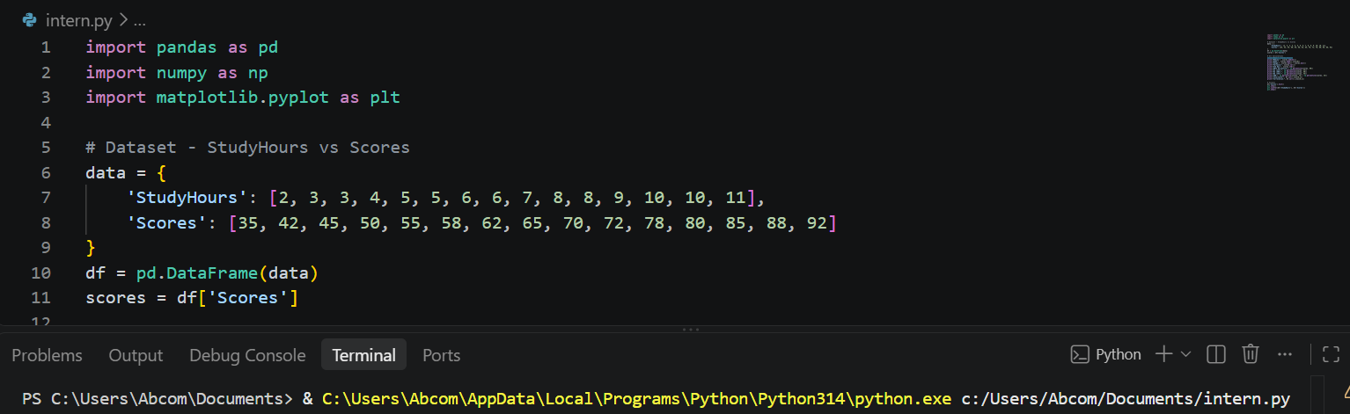

Different task performing on above data:-
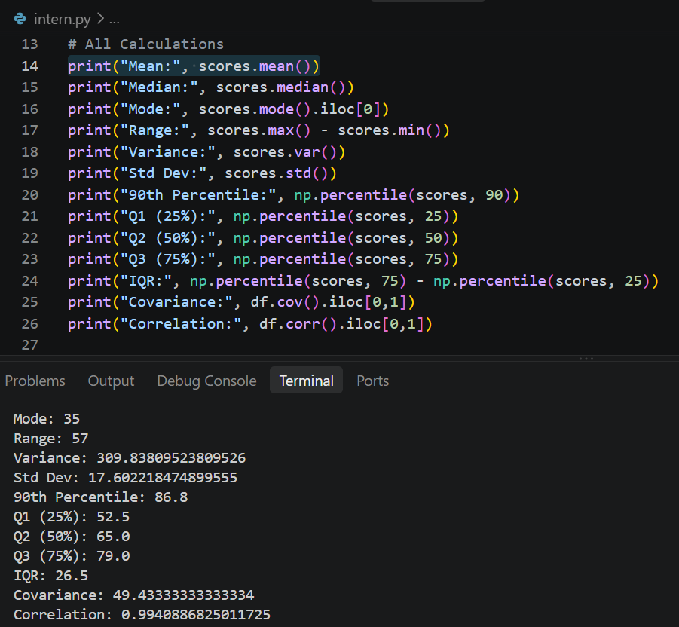

2. Explanation Document - What Each Value Means?
- Dataset used: Scores =[35][42][45][50][55][58][62][65][70][72][78][80][85][88][92]
- Mean = 65.13: Average score.
explanation: Overall performance is 65%.
Why important?
It gives central tendency but gets affected by low scores like 35.
- Median = 65: Middle value when sorted.
explanation: 50% students scored below 65 and 50% above. More reliable than mean when outliers are present. Here mean ~ median so data is balanced.
- Mode = 35: Most frequent value.
explanation :In this dataset all values are unique, so first value is taken. In real data, mode tells you the most common category/score.
- Range = 57 (92-35): Difference between max and min.
explanation: Shows total spread of performance is 57 marks - from very low to very high.
- Variance = 309.84
explanation :Variance is average squared distance from mean. &
- Std Dev = 17.60: Std dev is its square root.
explanation: Scores deviate by ∼17.6 marks on average from mean. High std dev means students performance is very diverse.
- Percentile - 90th = 86.8: 90% students scored below 86.8. explanation: To be in top 10%, you need >86.8. Used for cutoffs.
- Quartile - Q1=52.5, Q2=65, Q3=79 i.e.
Q1 = 25% students below 52.5, Q3 = 75% below 79.
explanation: Middle 50% of students are between 52.5 and 79.
- IQR = 26.5 (Q3-Q1): Spread of middle 50%.
explanation: Used to detect outliers. Any score < Q1-1.5_IQR or > Q3+1.5_IQR is outlier. Here it shows core group variability without extreme values.
- Covariance = 49.43: Positive value means StudyHours and Scores move together. But its number is hard to interpret because it depends on units.
- Correlation = 0.99: Standardized version of covariance, range -1 to +1. Story: 0.99 is very strong positive correlation.
Means as Study Hours increase, Scores almost perfectly increase. This is the most important business insight.

- Some graphs to express the result of our data:-
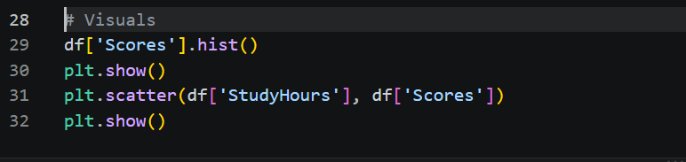
Histogram:-
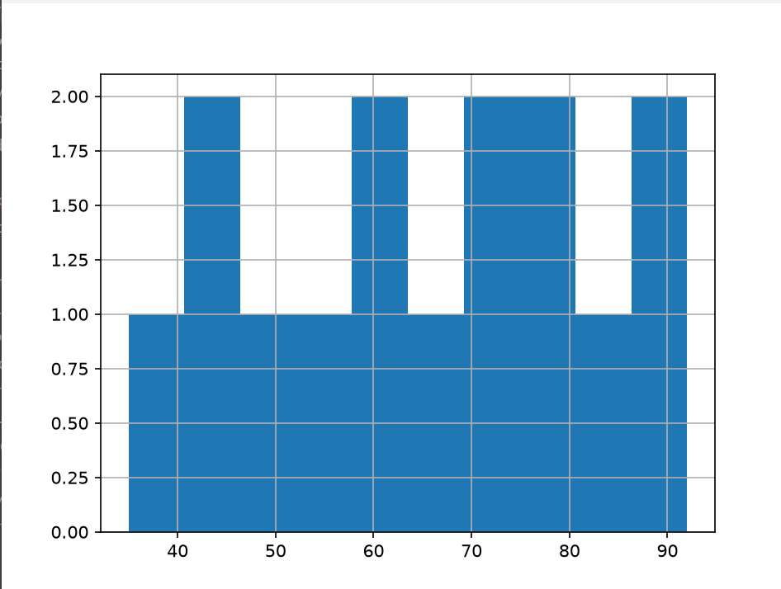
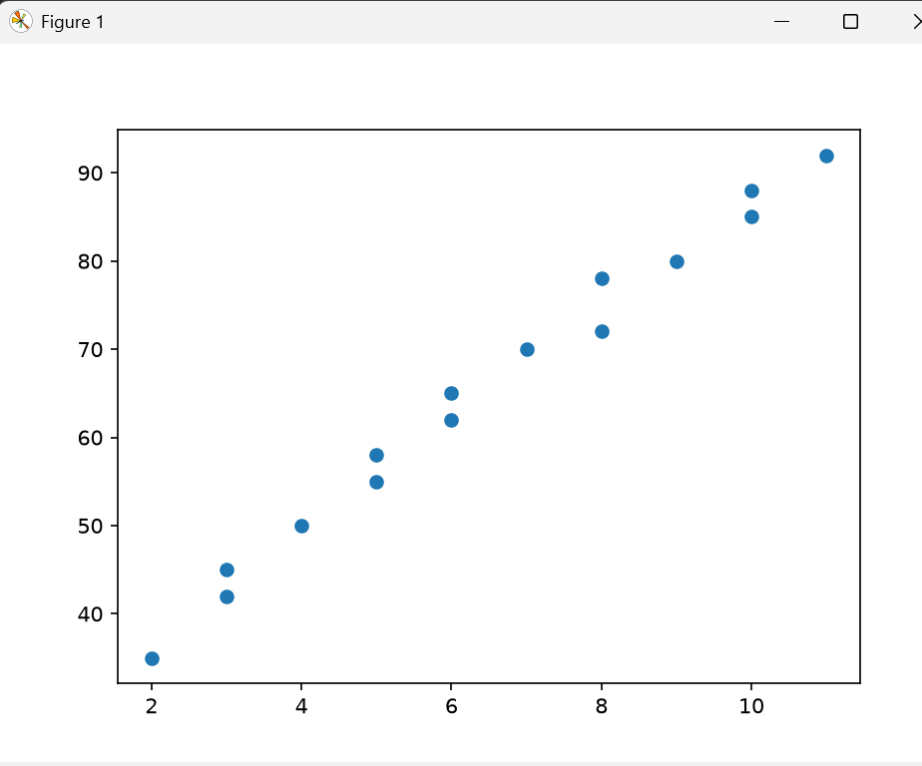
Final result of Data: Students performance is average 65 with high diversity (17.6 std). But performance is highly predictable from study hours (r=0.99) - so intervention should be to increase study hours.

