Day4: -NumPy
Tuesday,15/09/26
*Here we are learning about the one of the python libraries which is NumPy.
NumPy stands for numerical python which mainly deals with arrays.
Concepts of NumPy is as below: -
- Array:
array is collection of homogeneous elements and like list but faster.
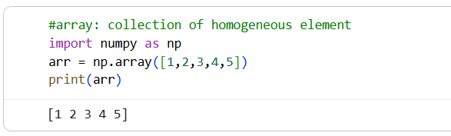
- Dimensions:
1D=single list,2D=table(rows ,columns),3D=cube
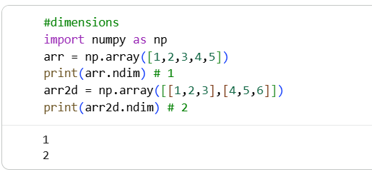
- Shape:
Shows structure of array i.e. rows, columns.
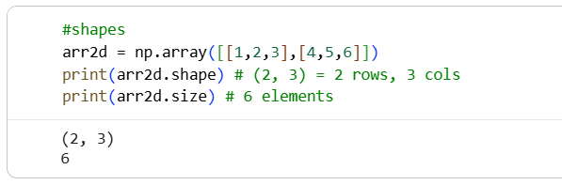

- Indexing:
Accessing the element using their index.
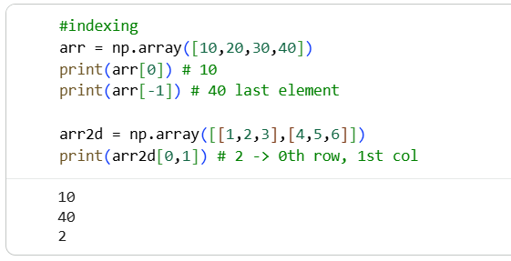
- Slicing:
Extracting the selected element or part of array. (start, step, stop)
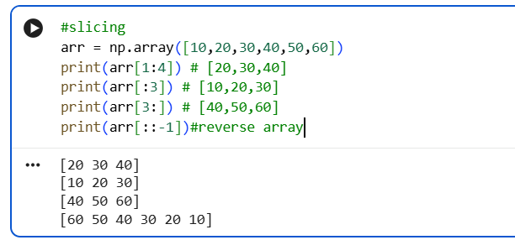
- Reshape:
Changing shape of array without changing data
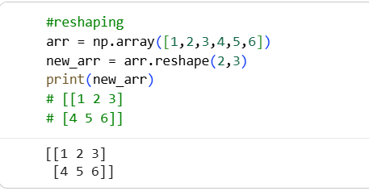

- Arithmetic operations:
Operations on full array at once.
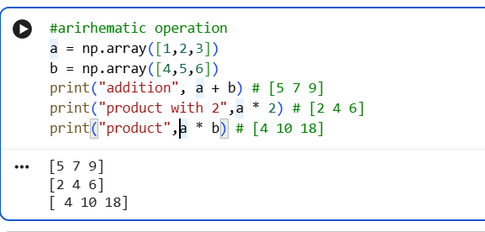
- Aggregations ,mean ,median ,standard deviation:
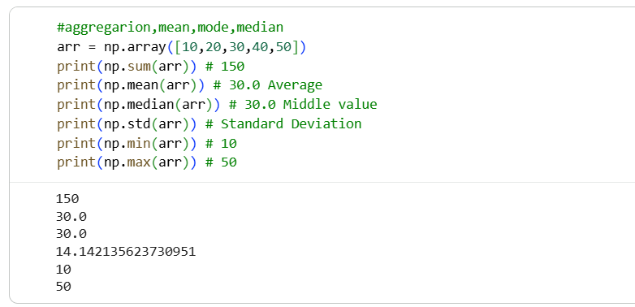

Deliverables :- Day04_Numpy.ipynb

#Create a NumPy array containing sales data and perform
(total sale ,average sale ,maximum sale, minimum sale, standard deviation ,median ,25th percentile, 75th percentile)

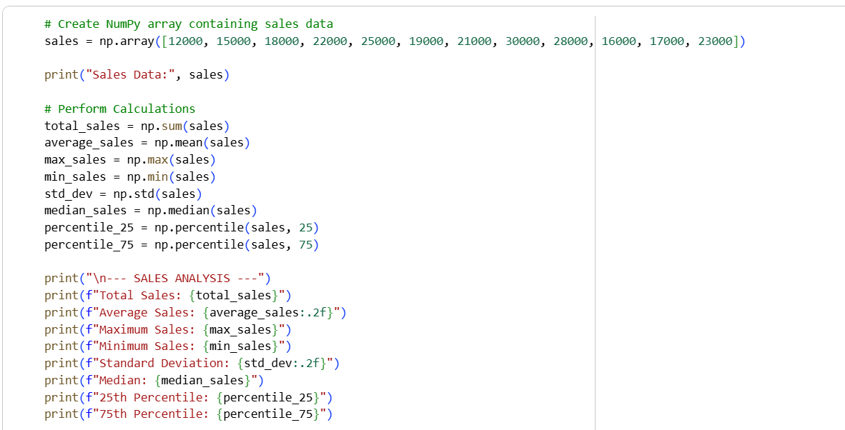

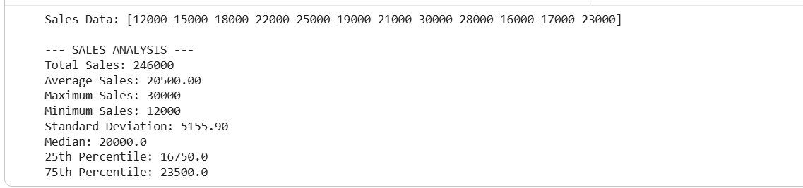
# 1D Array: 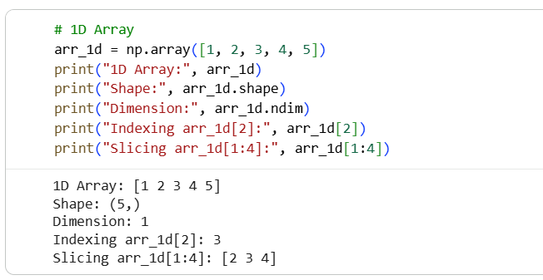
# 2D Arrays:
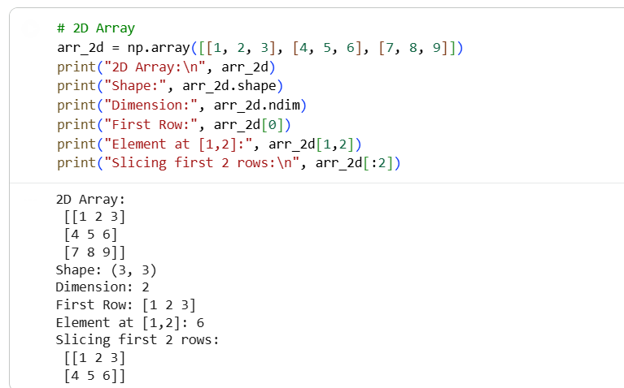

#Matrix multiplication:

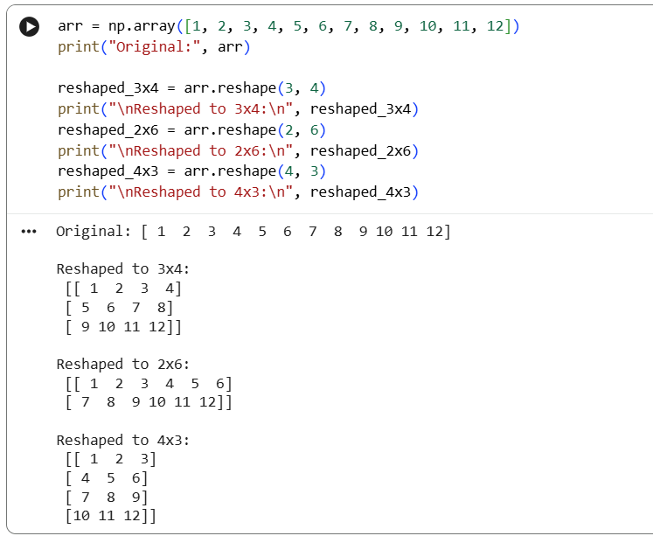
#reshape
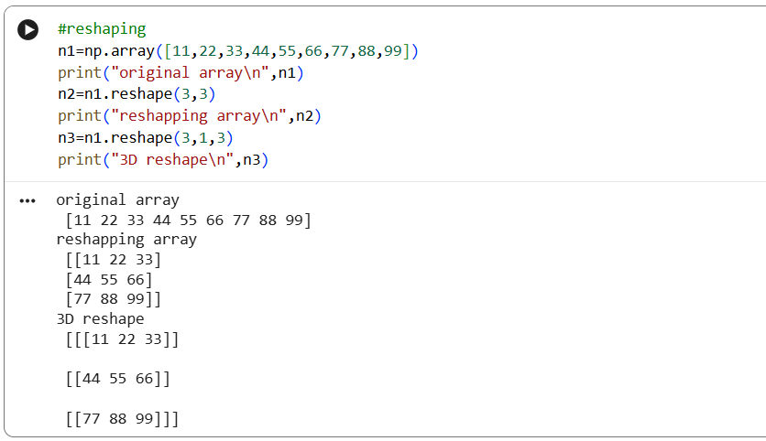

*Why NumPy provide numerical foundation used by many data-science library?
1. NumPy is 50x faster than normal Python lists
2. Foundation for Pandas, Matplotlib, Scikit-Learn
3. Uses less memory
4. Vectorized operations - no need for loops

