Day 7: -SQL Fundamentals
Friday,18/09/26
SQL Topics
Database -:
A container that holds many tables. Ex: Flipkart_DB
Table -:
Data stored in rows and columns. Ex: customers table
Row -:
One single record. Ex: 1 customer
Column - :
One attribute. Ex: city, age
Primary Key - :
Unique ID for each row. Ex: customer_id
Foreign Key -:
Links two tables together. Ex: (orders.customer_id)
SELECT -:
Used to read data.
WHERE -:
To filter rows.
ORDER BY -:
To sort data (in ascending or descending order).
GROUP BY -:
To group same type of data.
HAVING -:
To filter after grouping.
DISTINCT -:
To remove duplicates.
CASE -:
To add if-else logic in SQL.

Tasks-:
- Create a database: ( customers, products, orders)
- Write at least 20 SQL queries.

Deliverables: - day07__SQL File15.

- Create database and tables (customers, products, orders)
- Create database myntramarket
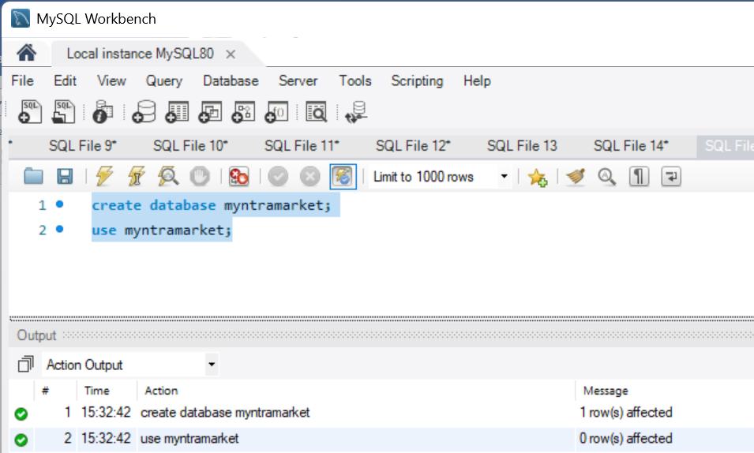
- Create table (customers ,product ,order)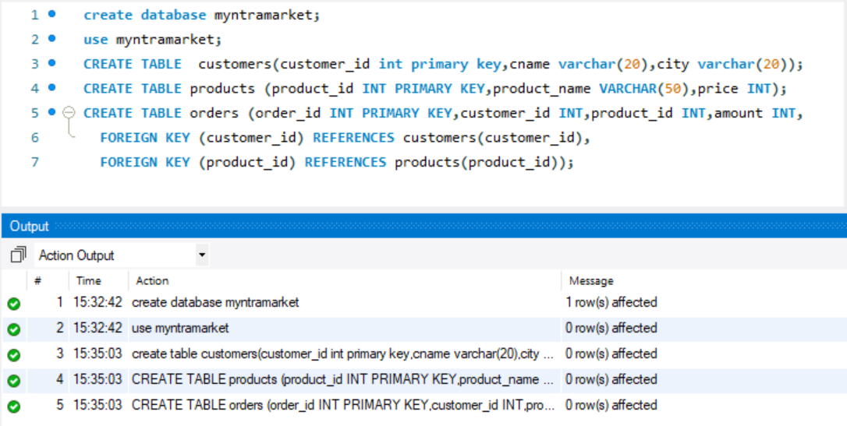

- Insert values into tables
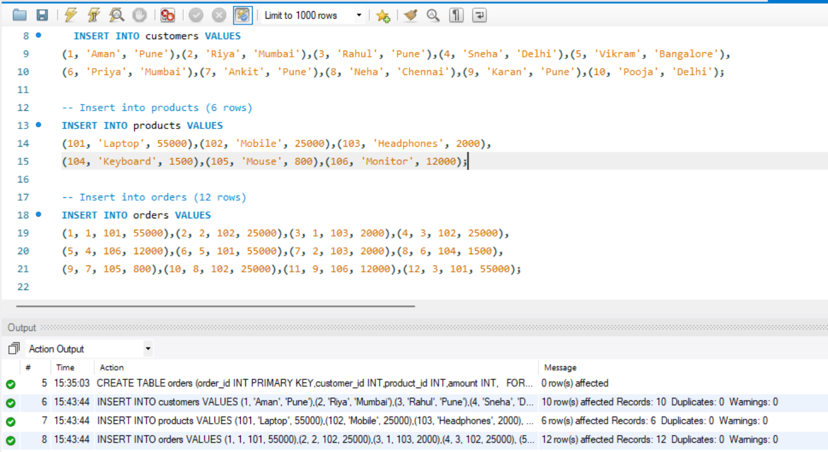

- Write 20 SQL queries:-
- Find all customers from customers table.
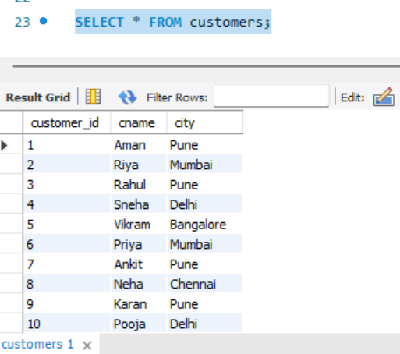

- Find customers from Pune.
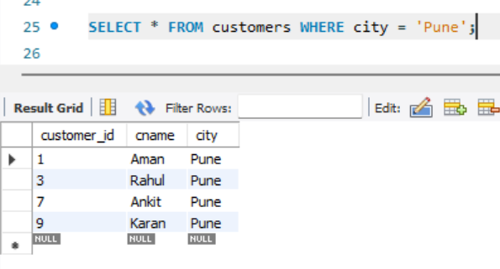

- Find orders above ₹5000.
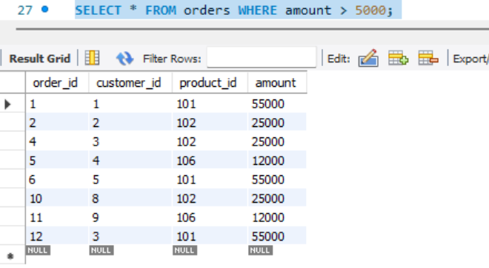
- Find top products (most expensive first)
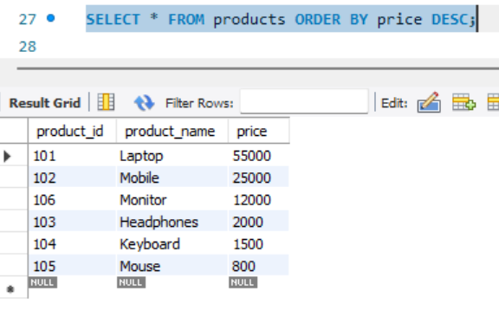

- Calculate average order value
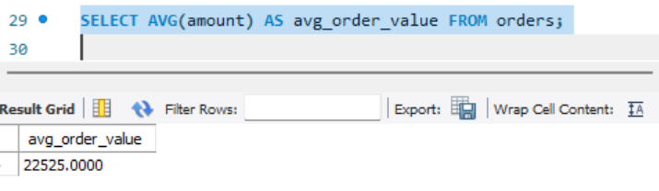

- Find distinct cities
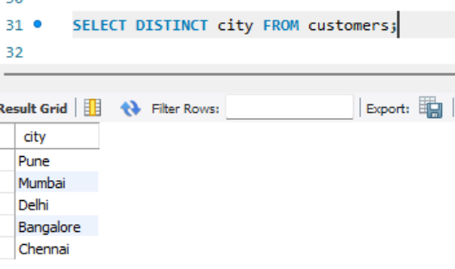

- Count total customers
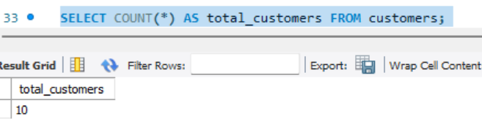

- Calculate total sales
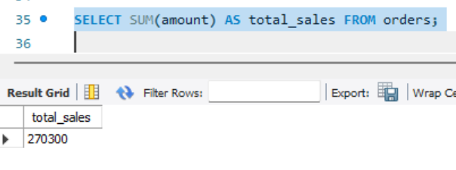

- Find cheapest product
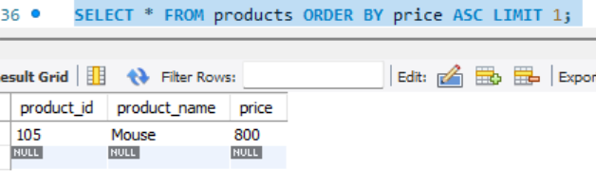

- Group orders by customer
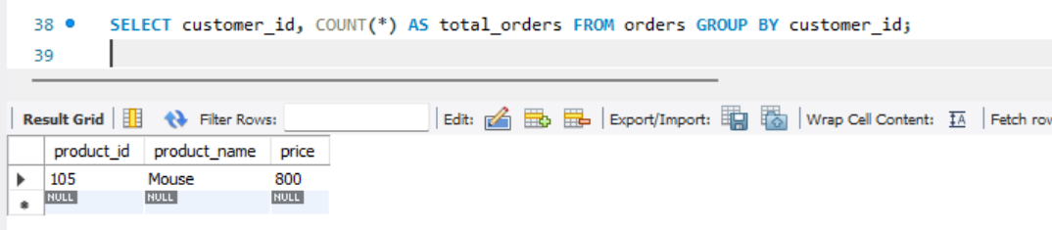

- Find all orders with customer name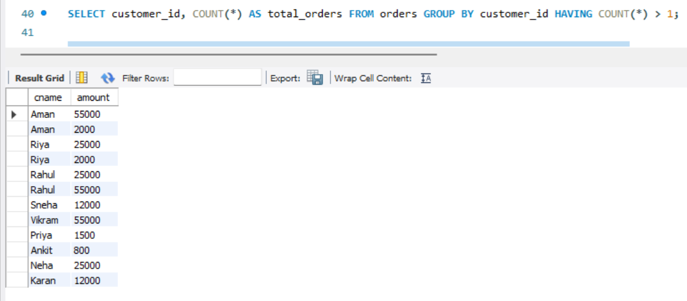
- Find customers who ordered more than 1 times
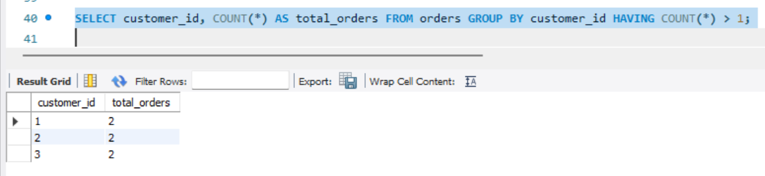

- Find total sales per city
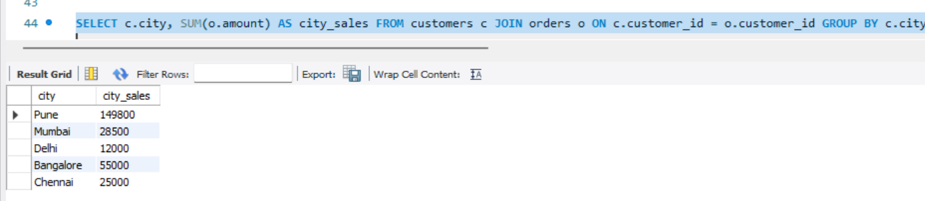

- Find products never ordered
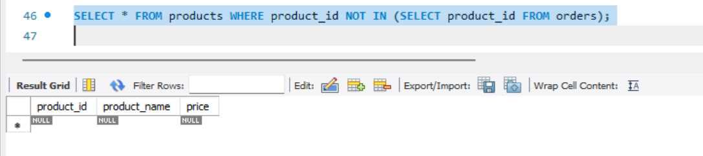

- Find customers from Mumbai and Pune
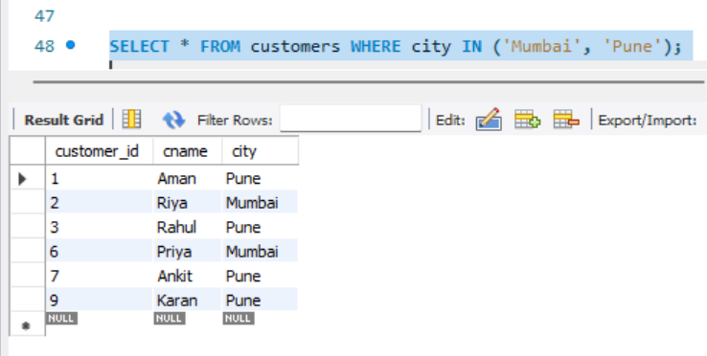
- Find orders between ₹1000 and ₹5000
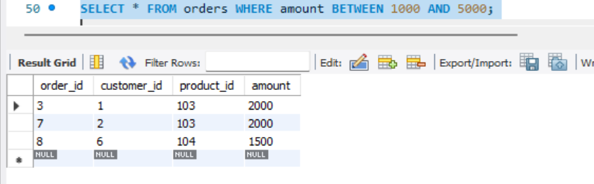

- Sort customers by name A-Z
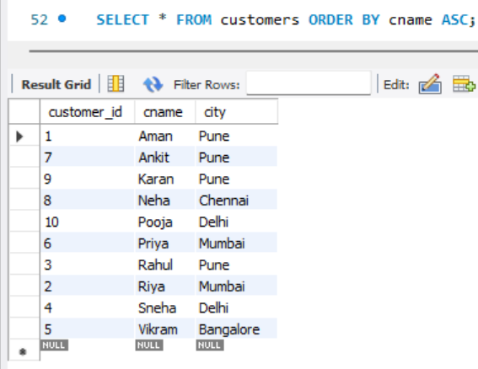

- Find top 3 highest orders
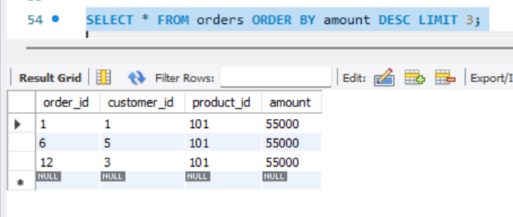
- Use CASE to label orders as High/Low value
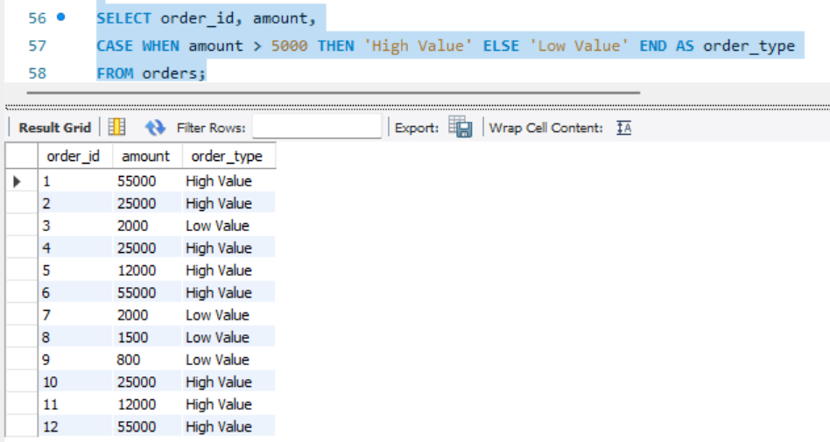

- Find customer with highest total purchase
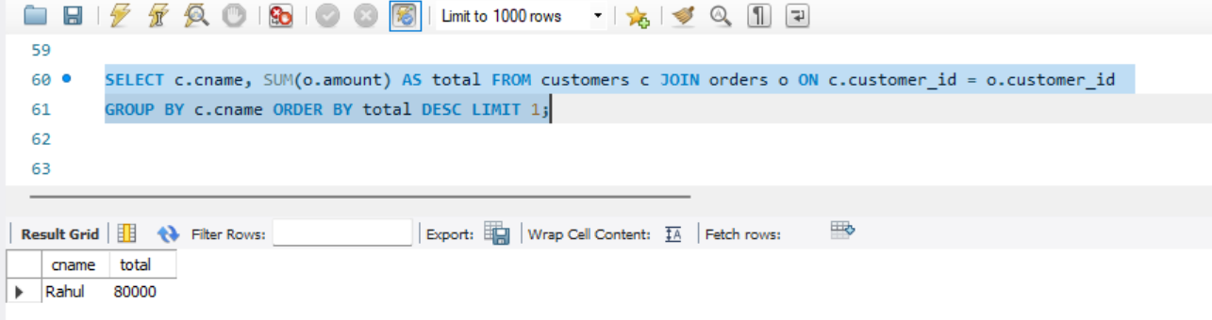

- Why SQL is one of the most important skills for Data Analysts?
- Data Lives in SQL: 90% of company data (Flipkart, Amazon, Swiggy) is stored in SQL databases, not in Excel.
- To Get Data Yourself: Without SQL, you have to ask an engineer for data. With SQL, you can pull data yourself in 2 seconds.
- Fast on Big Data: Excel crashes at 1 lakh rows. SQL can handle 1 crore+ rows easily with SELECT and WHERE.
- Base for Other Tools: Power BI, Tableau, Python (pandas) - all use SQL concepts like GROUP BY, JOIN, HAVING.

