**ASSIGNMENT 1**

Submitted by~Ashu Soni

***Question 1.* In the below elements which of them are values or an expression? eg:- values can be integer or string and expressions will be mathematical operators.**

**\***

**'hello'**

**-87.8**

**-**

**/**

**6**

***Asnwer 1:*** Values= 6,-87.8,'hello'

Expression= *,-,/,+

***Question 2.* What is the difference between string and variable?**

**Answer 2:** String: A string is a data Type of values for example a="ashu soni" here "ashu soni" is string type value and a is the variable. A String is just a collection of charachters. In python Strings are considered as array of bytes

Variable: A variable is a data holder in the main memory (RAM), it is used to store data temporarily for coding purposes inside the main memory for example x=12, here x is the variable which holds and integer value 12. The term variable also means that something that can be changed, therefore a variable can be updated.

***Question 3.* Describe three different data types.**

***Answer 3:*** Three Different Data Types are:

1. Integer: represented as “int” is considers Integer data values. It has a size of 4 bytes .
2. String: represented as “str” it considers collection of character type data enclosed withe quotes (“ ”,’ ’). it has a size of 2^31 characters.
3. Boolean: the variable having a boolean data type has only 2 types of values either True or False. Bool() function in python returns True or False as per the parameters passed into it.

***Question 4.* What is an expression made up of? What do all expressions do?**

***Answer 4:*** an expression is a conduct which is made up of variable,operators and method calls.

Expressions are interpreted to produce some other value as per the operators and operands.An expression is evaluated as per the precedence of operators.

Example of expression: x=32 + 23.21

***Question 5.* This assignment statements, like spam = 10. What is the difference between an expression and a statement?**

***Answer 5:*** The Difference between expression and statement:

Expressions always evaluates some values as it is a instruction that is to be executed to produce some result. It is also considered as subset of a statement.

Statement does something like creating a variable or invocating a function or displaying a value.it is used to form the sequence of the program.

When a variable is assigned to an expression the whole set is called a statement.

***Question 6.* After running the following code, what does the variable bacon contain?**

**bacon = 22**

**bacon + 1**

**Answer6:**After running the code we get bacon=23

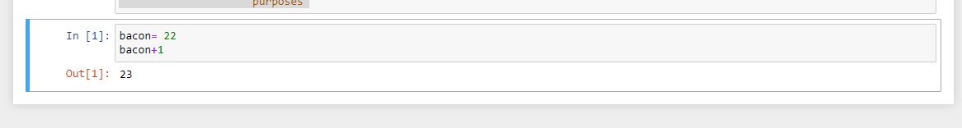

***Question 7.* What should the values of the following two terms be?**

**'spam' + 'spamspam'**

**'spam' * 3**

**Answer7:**After running the above two expressions we get “spamspamspam” in both the cases.

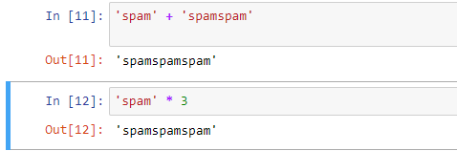

***Question 8.* Why is eggs a valid variable name while 100 is invalid?**

**Answer 8:**eggs satisfies the rules of being a variable which are:

*1.A variable must start with a letter or underscore and not with a number*

*2. A variable can only contain alphanumeric characters and underscores*

As 100 does not satisfy these rules therefore it can never be a variable name.

**Question 9. What three functions can be used to get the integer, floating-point number, or string version of a value?**

**Answer 9:**The int(), float(), str() functions will be used to get integer, floating-point number or string version of a values passed to them.

**Question 10. Why does this expression cause an error? How can you fix it?**

**'I have eaten ' + 99 + ' burritos.'  
Answer 10:** The above expression if executed gives a TypeError due to 99 in between two String as it is a integer type value therefore it is not possible to concatenate two different type of values.

We can fix it by removing the 99 form between.

