1.What are the two values of the Boolean data type? How do you write them?

**Answer:** The two Values are true and false

Eg: bool1 = True, bool2 = False

2. What are the three different types of Boolean operators?

Answer: there are 3 type of Boolean operators in python

1. And operator
2. Or operator
3. Not operator

3. Make a list of each Boolean operator's truth tables (i.e. every possible combination of Boolean values for the operator and what it evaluate ).

**Answer:** Below is the code

1. AND operator 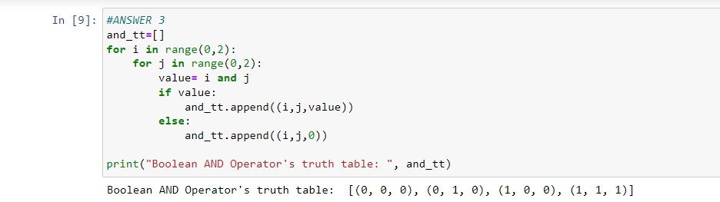
2. OR operator: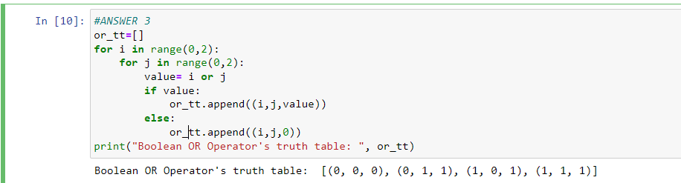
3. NOT operator:

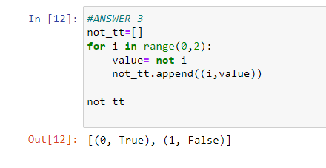

4. What are the values of the following expressions?

(5 > 4) and (3 == 5)

not (5 > 4)

(5 > 4) or (3 == 5)

not ((5 > 4) or (3 == 5))

(True and True) and (True == False)

(not False) or (not True)

**Answer:** Expressions are

* **(5 > 4) and (3 == 5):** 5>4 is True=1, 3==5 is False = 0, so 1 and 0 = 0
* **not (5 > 4):** 5>4 is True, not(True) = False
* **(5 > 4) or (3 == 5):** 5>4 is True = 1, 3==5 is False = 0, so 1 or 0 = 1
* **not ((5 > 4) or (3 == 5)) :** not(1) = 0
* **(True and True) and (True == False):** True = 1, False =0, also 1 and 1 = 1, True == False is False = 0 therefore, 1 and 0 = 0
* **(not False) or (not True):** not(False) = True, not(True) = Flase , True or Flase = True

5. What are the six comparison operators?

**Answer:**

1. > greater than
2. < smaller than
3. >= greater than equal to
4. <= smaller than equal to
5. == equal to
6. != not equal to

6. How do you tell the difference between the equal to and assignment operators?Describe a condition and when you would use one.

**Answer:** Equal to the operator has a double “ = “ operator whereas the assignment operator has a single “ = ” operator. We use the assignment operator when we want to assign some value to a variable or to any instance variable a=5 here the value of a has been assigned as 5. We use equal to operator to check if two values/ variable have similar values or not, Eg: a=5, b=6, a==b this will return False as a is not equal to b they both have been assigned different values.

7. Identify the three blocks in this code:

spam = 0

if spam == 10:

print('eggs')

if spam > 5:

print('bacon')

else:

print('ham')

print('spam')

print('spam')

**Answer:**

spam = 0

if spam == 10: # BLOCK 1

print('eggs')

if spam > 5: #BLOCK 2

print('bacon')

else: # BLOCK 3

print('ham')

print('spam')

print('spam')

8. Write code that prints Hello if 1 is stored in spam, prints Howdy if 2 is stored in spam, and prints Greetings! if anything else is stored in spam.

**ANSWER:**

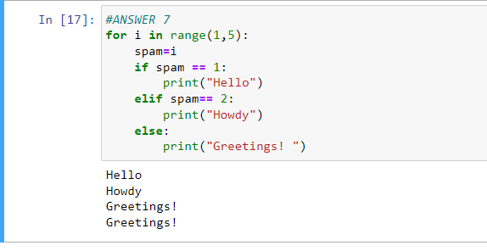

9.If your programme is stuck in an endless loop, what keys you’ll press?

**ANSWER:** To stop and infinite loop we use the key combination of ***CTRL + C*** in order to terminate the loop.

10. How can you tell the difference between break and continue?

**ANSWER:** Break statement is used to terminate or break the flow of the loop and gives he control to the very next statement after the loop statement. i.e. it breaks the loop and the control comes out of the loop.

Continue on the other hand does breaks the loop but the control does not come out of it rather it just skips the next statement and forces the control to jump on to the next iteration of the loop.

11. In a for loop, what is the difference between range(10), range(0, 10), and range(0, 10, 1)?

**ANSWER:**  There is absolutely no difference between between the working of range(10), range(0, 10), and range(0, 10, 1). It is just that range () function can take 3 arrguments a ,b, c where a = starting index (inclusively) default value = 0, b= ending index (exclusively) i.e [a,b) there is no default value for b and c= the direction of the loop and the number of steps/ jumps so default value is +1 or 1 + sign is just for the +ve direction in the number line, range(10) = [0,10) i.e 0 to 9

12. Write a short program that prints the numbers 1 to 10 using a for loop. Then write an equivalent program that prints the numbers 1 to 10 using a while loop.

**ANSWER:**

* FOR LOOP

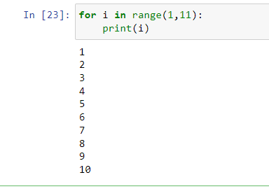

* WHILE LOOP:

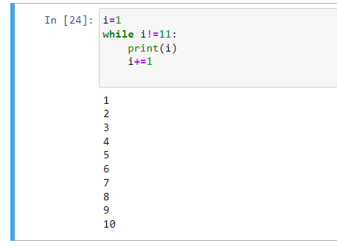

13. If you had a function named bacon() inside a module named spam, how would you call it after importing spam?

**ANSWER:** Here is how I would call it

Import spam as sp

_bacon=Sp.bacon() #_bacon is the object for the bacon function now