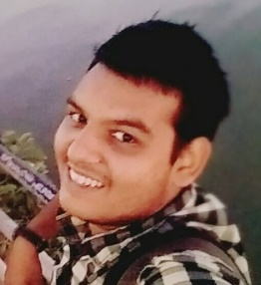**Ashuthosh Heda (PhNo: 7799339394)**

CVR College of Engineering

Information Technology

DATE: 08-09-2015

**About Me:**

I was born on 12th Feb 1996 at Hyderabad. I completed my SSC Education from Cambridge School Tirupati. I completed my Intermediate from NRI academy Tirupati. I got a rank of 13991 in EAMCET and got a seat in CVR College, IT department. I feel I am a very calm person, I am great Student, I am a great Learner, I am a hard worker, I understand things more effectively.

**Languages Known:** Marwari (Mother Tongue), Telugu, Hindi and English.

Coming to my Interests, I like Dancing, I like Playing Computer Games, I like Coding, I like to Explore New Things, I always like to learn new things which seems amazing to me. I like Enjoying Nature.

**Objectives of my life:**

* I want to be a Game Developer.
* I want to be a Youtuber. (Game Commentary)

**What MRND Means To Me:**

I came to know about MRND just before 6 weeks. I came to know about this program from a senior. I felt it truly amazing. I felt like this course will help me get mould more towards researching and development of software’s. After Sunday’s Class I felt it is much more than that. I feel this will be one of the life changing experience. I will try my 100% to get this golden Opportunity.

**About My Family:**

I feel myself very lucky to have 3 siblings and wonderful supporting parent. I feel family as a part of my Body. My family is supportive to me in all the good things I want to do. I always concern my family before taking any big steps in my life. I always want my family to be happy and one of my great objective of my life is to make my family proud of me.