Example Circuit 1:
- Circuit:
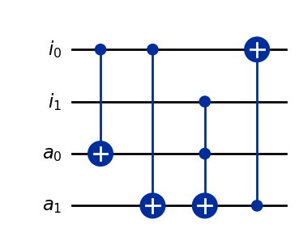
- Bennett’s Uncomp Circuit:
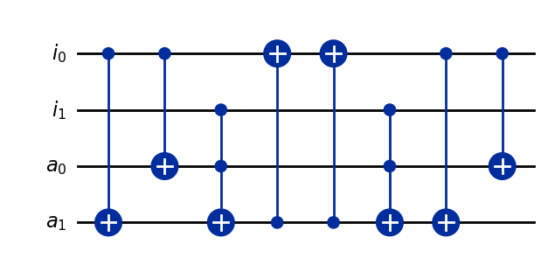
- Exhaustive/Partial Uncomp:
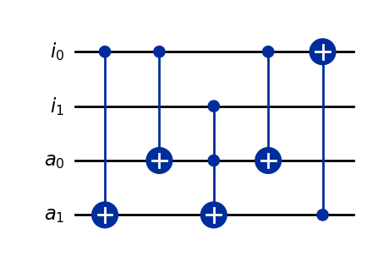
- Exhaustive/Partial Uncomp and then Bennetts:
N/A

Example Circuit 2:
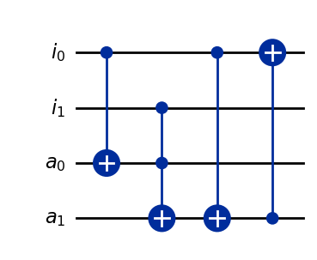
- Circuit:
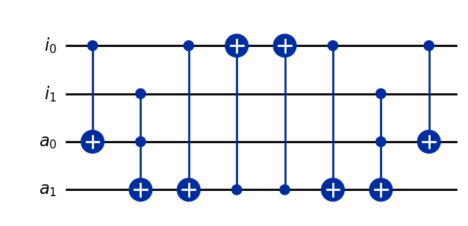
- Bennett’s Uncomp Circuit:
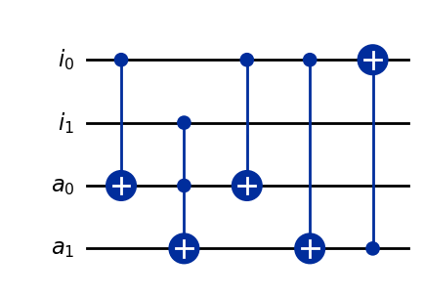
- Exhaustive/Partial Uncomp:
- Exhaustive/Partial Uncomp and then Bennetts:
N/A

Example Circuit 3:
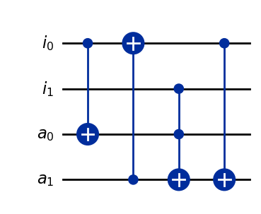
- Circuit:
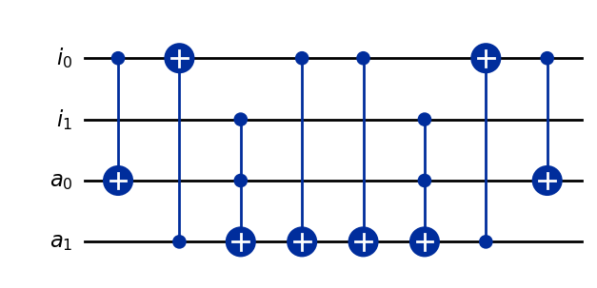
- Bennett’s Uncomp Circuit:
- Exhaustive/Partial Uncomp:
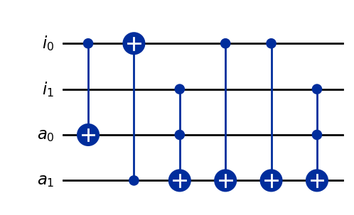
- Exhaustive/Partial Uncomp and then Bennetts:

Notes for Example Circuit 3:
Circuit Graph:
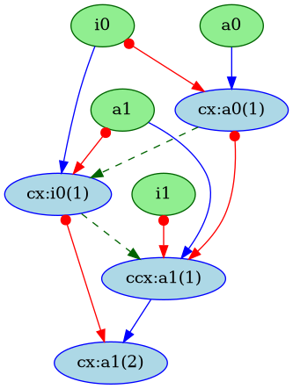
Bennetts Uncomp Circuit Graph:
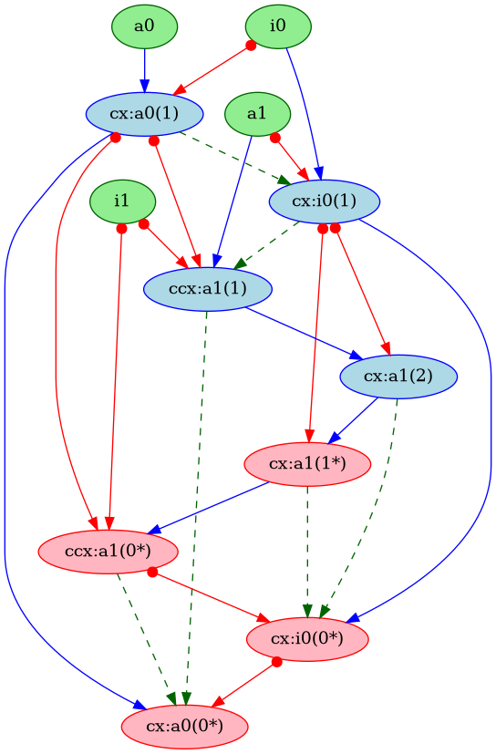
PLDI Full Uncomp:

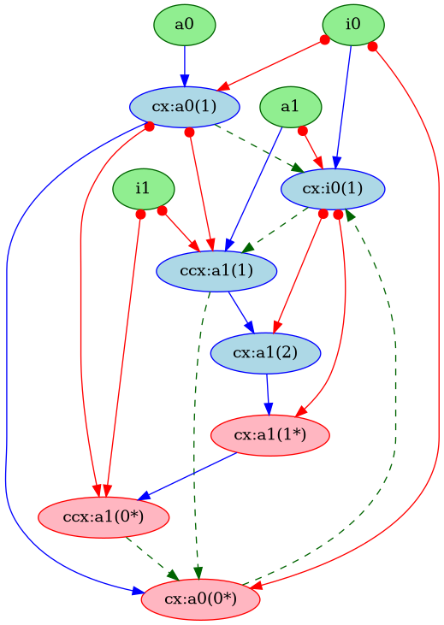
- Note, that the cycle is caused by uncomputing the ancilla ‘a0’
- However, cycles and counter outputs:
Counter({'a0': 0, 'a1': 0})
['cx:a0(0*)', 'cx:i0(1)', 'ccx:a1(1)', 'cx:a1(2)', 'cx:a1(1*)', 'ccx:a1(0*)']
['cx:a0(0*)', 'cx:i0(1)', 'ccx:a1(1)']
['cx:a0(0*)', 'cx:i0(1)', 'cx:a1(2)', 'cx:a1(1*)', 'ccx:a1(0*)']
['cx:a0(0*)', 'cx:i0(1)', 'cx:a1(1*)', 'ccx:a1(0*)']
Counter({'a1': 10, 'a0': 4})
- The counter results show that removing uncomp for a1 will remove all cycles, but it is uncomp for a0 that adds the cycles!!!!

