Research Article

In Silico Screening of Natural Compounds for Identification of GLP-1 Receptor Agonists for Type 2 Diabetes Mellitus
Aniket Aayush , Karthik Prakash , Shivam Verma, Ashish Kumar, Ashutosh Mani*
Department of Biotechnology, Motilal Nehru National Institute of Technology Allahabad, INDIA

*Corresponding author: amani@mnnit.ac.in

Abstract
Type 2 diabetes mellitus (T2DM) is a persistent metabolic syndrome, which is associated with insulin resistance, and insulin insufficient secretion. The use of glucagon-like peptide-1 (GLP-1) receptor agonists is an effective form of treatment as it stimulates secretion of insulin depending on glucose, inhibits glucagon release, postpones stomach emptying and satiates the stomach. But the existing GLP-1 agonists are mostly peptide based and need parenteral route. A computer-aided drug design (CADD)-based structure methodology was used in the current research to discover possible small-molecule GLP-1 receptor agonists in natural product libraries. Virtual screening of 4000 natural compounds obtained in the AnalytiCon Discovery library was performed on the crystal structure of the GLP-1 receptor catalytic domain (PDB ID: 5TTG). Autodock Vina was used to carry out molecular docking and compounds whose binding energy was more than -11.0 kcal/mol were shortlisted. The best ligands were further tested with SwissADME on pharmacokinetic and drug-likeness. Some of the natural compounds showed high binding affinity, good ADMET profiles and stable binding to important GLP-1 receptor residues. These results indicate that the specified compounds can be taken as good leads towards the creation of orally active GLP-1 receptor modulators, which should be further experimentally substantiated.

Keywords: Type 2 diabetes mellitus, GLP-1 receptor, natural compounds, molecular docking, virtual screening, SwissADME
Received on: 11.11.2025
Accepted on: 23.12.2025
Published on 26.12.2025

Introduction
Type 2 diabetes mellitus (T2DM) is a highly common metabolic disorder globally that is found in over 90 percent cases of diabetes. It is a disease of chronic hyperglycemia caused by insulin resistance and progressive pancreatic 8 cell dysfunction. Heart diseases, kidney disease, nerve diseases and eye disease are long-term problems that are caused by T2DM and they represent a significant health challenge in the world [1,2].
GLP-1 or glucagon-like peptide-1 is an incretin hormone that is a key factor in glucose homeostasis. GLP-1 receptor stimulation stimulates insulin secretion glucose-dependently, inhibits glucagon release, retards gastric emptying, and decreases appetite. Even though the clinical efficacy of peptide-derived GLP-1 receptor agonists, including liraglutide and semaglutide, is clinical evidence, their injectable characteristics, high cost, and stability preclude large-scale application [3-6]. Thus, the identification of the orally available non-peptidic GLP-1 receptor agonists is of high interest.
Natural products are considered as an abundant source of structurally different and biologically active molecules [7]. Together with the methods of computer-aided drug design (CADD), natural product screening is a relatively cost efficient approach to drug discovery in the early stages [8,9]. Here we utilized an in silico workflow that was integrated in order to discover potential natural GLP-1 receptor agonists in terms of molecular docking and pharmacokinetic analysis.

Materials and Methods

Protein Structure Preparation
The three-dimensional crystal structure of the GLP-1 receptor catalytic domain (PDB ID: 5TTG) was retrieved from the Protein Data Bank. The structure was selected based on its high resolution and suitability for structure-based screening. Receptor preparation was performed using AutoDock Tools by removing water molecules and heteroatoms, adding polar hydrogens, and assigning Kollman charges. The prepared protein was saved in PDBQT format for docking studies.

Ligand Dataset Preparation
A library of 4000 natural compounds was obtained from the AnalytiCon Discovery database. Ligands were converted from SDF format to three-dimensional structures using OpenBabel, followed by energy minimization. The optimized ligands were then converted into PDBQT format with appropriate torsional flexibility for docking.
Molecular Docking and Virtual Screening
Virtual screening was carried out using AutoDock Vina [10,11]. A grid box encompassing the active binding pocket of the GLP-1 receptor was defined based on CASTp analysis. Docking simulations were performed batch-wise, and ligands were ranked according to their binding affinities. Compounds exhibiting binding energies better than −11.0 kcal/mol were shortlisted for further analysis.

ADMET and Drug-Likeness Analysis
The shortlisted compounds were evaluated using SwissADME to predict pharmacokinetic properties, including gastrointestinal absorption, lipophilicity, solubility, blood–brain barrier permeability, and compliance with Lipinski’s Rule of Five. Compounds with favorable ADMET profiles and no PAINS alerts were considered potential drug candidates.

Interaction Analysis and Visualization
Docked ligand–receptor complexes were visualized using PyMOL and Discovery Studio. Key interactions such as hydrogen bonds, hydrophobic contacts, π–π stacking, and salt bridges were analyzed to understand binding stability and receptor compatibility.

Results and Discussion

Receptor Validation
Structural validation using PROCHECK, ERRAT, VERIFY3D, and WHATCHECK confirmed the reliability of the 5TTG structure. Approximately 85% of residues were located in favored regions of the Ramachandran plot, and ERRAT scores exceeded 90%, indicating good structural quality for docking studies.

Virtual Screening Outcomes
Docking of the 4000 natural compounds against the GLP-1 receptor identified several ligands with strong binding affinities (≤ −11.0 kcal/mol). These compounds demonstrated favorable steric complementarity within the receptor binding pocket, suggesting potential agonistic activity.

Pharmacokinetic Evaluation
SwissADME analysis revealed that many of the shortlisted compounds exhibited high predicted oral absorption, acceptable solubility, and compliance with Lipinski’s rule [12, 13]. The absence of PAINS alerts further supported their suitability as drug-like molecules [14].

Ligand–Receptor Interaction Analysis
Visualization of docking poses revealed stable ligand–receptor interactions involving key residues of the GLP-1 receptor. Hydrogen bonding, hydrophobic interactions, and π–π stacking contributed to binding stability, supporting the predicted affinity of the shortlisted compounds.
Table 1. List of top-ranked natural compounds identified through virtual screening against the GLP-1 receptor along with their docking scores.
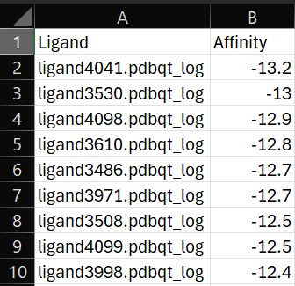
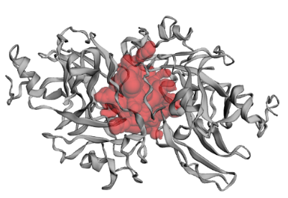
Figure 1. Three-dimensional structure of the GLP-1 receptor (PDB ID: 5TTG) used for docking studies.
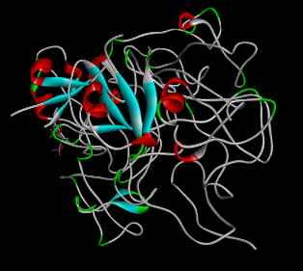
Figure 2. Representative docking pose of a top-ranked natural compound within the active site of the GLP-1 receptor showing key intermolecular interactions.

Conclusion
The current work proves the usefulness of the combined CADD methodology in the identification of the possible natural GLP-1 receptor agonists to treat the type 2 diabetes mellitus. Virtual screening and molecular docking have identified a number of compounds that have good binding affinities and good pharmacokinetic characteristics. Acetoxy guaianolide was a good potential anti-diabetic herbal drug. An acetoxy guaianolide, a natural sesquiterpene lactone (complex organic molecule produced by plants), with an acetoxy group (-OCOCH) group attached to a distinct site is a promising lead compound to be further validated in vitro and in vivo, and may play a role in the future development of orally active GLP-1 receptor modulators.

Acknowledgements
The authors received the facilities and computational resources needed by the Department of Biotechnology, Motilal Nehru National Institute of Technology Allahabad.

References:
- DeFronzo RA, Ferrannini E, Groop L, et al. Type 2 diabetes mellitus. Nat Rev Dis Primers. 2015;1:15019.
- Cho NH, Shaw JE, Karuranga S, et al. IDF Diabetes Atlas: Global estimates of diabetes prevalence. Diabetes Res Clin Pract. 2018;138:271–281.
- Drucker DJ. The biology of incretin hormones. Cell Metab. 2006;3(3):153–165.
- Holst JJ. The physiology of glucagon-like peptide 1. Physiol Rev. 2007;87(4):1409–1439.
- Nauck MA, Meier JJ. Incretin hormones: Their role in health and disease. Diabetes Obes Metab. 2018;20(S1):5–21.
- Knudsen LB, Lau J. The discovery and development of liraglutide and semaglutide. Front Endocrinol. 2019;10:155.
- Harvey AL, Edrada-Ebel R, Quinn RJ. The re-emergence of natural products. Nat Rev Drug Discov. 2015;14(2):111–129.
- Sliwoski G, Kothiwale S, Meiler J, Lowe EW. Computational methods in drug discovery. Pharmacol Rev. 2014;66(1):334–395.
- Lionta E, Spyrou G, Vassilatis DK, Cournia Z. Structure-based virtual screening for drug discovery. Curr Top Med Chem. 2014;14(16):1923–1938.
- Trott O, Olson AJ. AutoDock Vina: Improving docking speed and accuracy. J Comput Chem. 2010;31(2):455–461.
- Morris GM, Huey R, Lindstrom W, et al. AutoDock4 and AutoDockTools4. J Comput Chem. 2009;30(16):2785–2791.
- Daina A, Michielin O, Zoete V. SwissADME: A free web tool for ADME evaluation. Sci Rep. 2017;7:42717.
- Lipinski CA. Lead- and drug-like compounds: The rule-of-five. Drug Discov Today Technol. 2004;1(4):337–341.
- Baell JB, Holloway GA. New substructure filters for PAINS. J Med Chem. 2010;53(7):2719–2740.

