DA02: CinemaScope Analytics
Unveiling the Dynamics of Movie Success
Field | Details
Name | Ashutosh
Batch | DA02
Domain | Entertainment / Movie Industry Analytics
Chosen Company | Netflix
Dataset | Hollywood Insights Inc. movies.csv
Tools Used | PostgreSQL, Excel, Power BI, n8n, GenAI
Date | 30 May 2026

Final project document covering business understanding, schema design, SQL ETL, Excel analysis, Power BI dashboarding, and GenAI automation.

Project Overview and Objectives
The entertainment industry is a major part of the global economy, covering film, music, television, gaming, and digital content. Streaming services and digital platforms have made content consumption more accessible, personalized, and data-driven.
Data scientists help entertainment companies understand audience preferences, predict demand, optimize recommendations, improve engagement, and support revenue growth using analytics, machine learning, and automation.
Week | Focus | Outcome
Week I | Netflix product dissection, schema design, guesstimates, A/B testing, DBMS scenario analysis | Business case study and data architecture foundation
Week II | SQL ETL, data cleaning, Excel EDA and dashboard visuals | Cleaned dataset and analytical insights
Week III | Power BI dashboarding, n8n automation and GenAI explanation | Interactive dashboard and automated insight workflows

Dataset Column | Description
name | Movie title
rating | Certification / rating
genre | Primary movie genre
year | Release year
released | Release date with country text
score | IMDb score
votes | IMDb vote count
director | Director name
writer | Writer name
star | Lead star
country | Production country
budget | Production budget
gross | Gross earnings
company | Production company
runtime | Runtime in minutes

Week I: Business Understanding and DBMS Foundations

Task 1: Business Case Study - Netflix

1. Platform Selection
- Selected platform: Netflix, a global OTT streaming platform for movies, TV shows, documentaries, anime, and original content.
- Popularity: Netflix operates across more than 190 countries and is one of the most recognized streaming brands.
- Impact: Netflix shifted entertainment from fixed TV schedules to on-demand streaming and accelerated OTT adoption.
- Relevance: Personalized recommendations, originals, multi-device streaming, and multilingual access make Netflix highly relevant.

2. Core Features and Functionalities
Feature | Business Contribution
Personalized recommendations | Improves discovery, watch time, and retention through AI/ML suggestions
Vast content library | Serves different genres, languages, regions, and audience segments
Netflix Originals | Creates exclusivity and lowers dependence on licensed content
Multi-device access | Supports TV, mobile, laptop, tablet, and gaming device viewing
Offline downloads | Improves convenience for travel and limited internet access
Continue watching | Creates smooth cross-device viewing continuity
Multi-language support | Expands international reach through subtitles and dubbing
Smart search | Reduces discovery friction by title, genre, actor, and language
Flexible plans | Improves affordability for different customer segments
Adaptive streaming | Reduces buffering by adjusting quality to internet speed

3. Real World Problems
Problem | Netflix Solution
Limited entertainment access | Online streaming makes content available anytime and anywhere
Fixed TV schedules | On-demand model allows viewing on user schedule
Content discovery difficulty | Recommendation engine suggests relevant titles
Language barriers | Subtitles and dubbing support global audiences
High entertainment cost | Subscription model gives predictable access cost
Device dependency | Multi-device support removes TV-only limitation
Internet quality issues | Adaptive streaming improves playback stability

Schema Design
The Netflix-style schema is centered on users, profiles, content, subscriptions, payments, devices, viewing behavior, ratings, recommendations, genres, and content people.
Entity | Key Attributes | Main Relationships
Users | user_id, name, email, country, signup_date, plan_id | One user has profiles, devices, subscriptions
Profiles | profile_id, user_id, profile_name, language_preference | Profiles create watch history, ratings, recommendations
Content | content_id, title, type, release_year, runtime, rating, language | Content connects to genres, cast, watch history
Genres | genre_id, genre_name | Many-to-many with content
People | person_id, name, role_type | Actors, directors, writers linked to content
Subscriptions | subscription_id, user_id, plan_id, status, start_date, end_date | Subscription lifecycle per user
Payments | payment_id, subscription_id, amount, status, payment_date | Billing and payment tracking
Watch History | watch_id, profile_id, content_id, watch_time, completion_percent | Engagement and retention data
Ratings | rating_id, profile_id, content_id, score, review_date | Explicit feedback
Recommendations | recommendation_id, profile_id, content_id, model_score | AI recommendation output
Devices | device_id, user_id, device_type, last_login | Access and security tracking

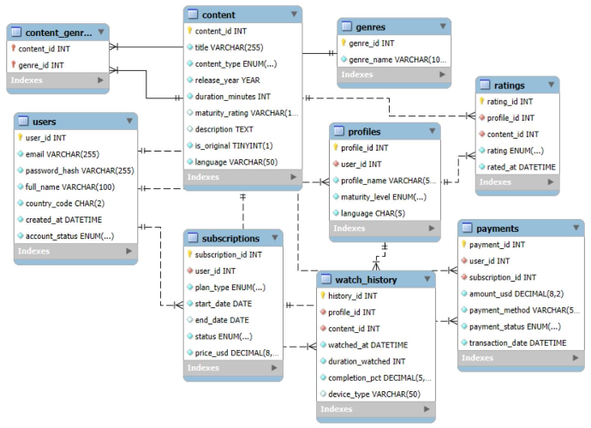
ER Diagram: Netflix Platform Data Model

Revenue and Profit Growth Strategies
Strategy | Expected Lift | Justification | Execution Focus
AI recommendation optimization | 5% | Higher relevance increases watch time and reduces churn | Use watch history, ratings, search, completion data
Ad-supported plan | 4% | Lower-price plan attracts price-sensitive users and adds ad revenue | Controlled ads for selected markets
Password sharing controls | 3% | Converts unpaid viewers into paid users | Device/location rules and paid sharing
Regional content expansion | 5% | Local content improves acquisition in high-growth markets | India, Korea, Latin America originals
Production cost optimization | 3% | Budget discipline improves ROI | Demand prediction before greenlighting
Retention programs | 3% | Lower churn protects recurring revenue | Month-3 offers, annual plans, bundles
Telecom partnerships | 2% | Bundles reduce acquisition cost | Mobile and smart TV partners

Combined expected profit lift: approximately 25%. Timeline: 0-3 months for analytics and retention pilots, 3-6 months for plan/partner rollout, 6-12 months for regional content and production optimization.

Guesstimate Questions
Question | Estimated Answer | Reasoning
Global streaming subscription increase over five years | 35% to 45% | Growth from emerging markets, mobile-first users, bundles, and ad-supported plans
Average weekly digital content consumption in 2025 | 20 to 25 hours | Streaming, music, gaming, short-form video, and social media increase daily screen time
VR/AR entertainment share in next decade | 8% to 12% | Growth in gaming, concerts, sports, and immersive events; hardware cost limits mass adoption
New films and TV shows globally per year by 2030 | 75,000 to 100,000 titles | OTT platforms, regional studios, and independent creators expand production
International box office revenue share in next five years | 65% to 70% | Asia, Europe, and other non-domestic markets contribute majority revenue

Cohort Analysis and A/B Testing
Scenario | Answer
Premium cohort retention calculation | Group users by signup month. Monthly retention = renewed users from cohort in month N / total users in signup cohort x 100.
Drop-off after third month | Use loyalty discounts, exclusive content drops, personalized recommendations, annual plan offers, watchlist reminders, and churn-risk campaigns.
Tutorial A/B test design | Randomly split new users into Version A text tutorial and Version B interactive tutorial. Track D1/D7 retention, tutorial completion, first purchase within 7 days, conversion rate, ARPU, and LTV.
Version B higher conversion but lower retention | Use Version B if LTV improves, then refine tutorial length and pacing. Test a hybrid version to recover retention.

Task 2: DBMS and Data Architecture Scenario Answers

ACID Properties
Scenario | Answer
Payment deducted but movie not in library | Use one transaction for payment, entitlement, and library update. Atomicity commits all or rolls back all; durability preserves success after crash.
Two users reserve last seat | Use row-level locking or serializable isolation. Consistency prevents negative inventory and fairness allows one confirmed reservation.

Indexing
Scenario | Answer
Search by actor, genre, language | Create indexes on actor_id, genre_id, language and full-text indexes for title/description. Use composite indexes for common filters.
Index view_count | Avoid indexing heavily updated view_count because each update must update the index. Use aggregates or materialized summaries.

Partitioning
Scenario | Answer
Billions of streaming logs | Use range partitioning by event_date and list/hash partitioning by region for faster analytics.
Regional data regulations | Use geo-partitioning by country/region to keep regulated data local and reduce query latency.

Sharding
Scenario | Answer
Global live-event authentication | Shard by user_id hash to distribute login load across database nodes.
Subscriptions sharded by region risks | Cross-shard joins, global reports, region changes, billing complexity, and rebalancing become harder.

Normalization and Denormalization
Scenario | Answer
Artists, albums, tracks, genres | Use separate normalized tables plus junction tables to avoid redundancy and update errors.
Daily recommendation engine | Use denormalized feature tables for fast scoring; retain normalized source tables for governance.

Data Lakes vs Data Warehouses
Scenario | Answer
Raw clickstream, preferences, transactions | Raw/semi-structured logs go to data lake; cleaned churn, transaction, and engagement metrics go to warehouse.
Monthly executive reports | Warehouse supports OLAP, consistent KPIs, churn reporting, revenue summaries, and engagement reports.

Data Ingestion and Pipelines
Scenario | Answer
Live viewing data pipeline | App/TV SDK events -> streaming queue -> stream processing -> lake/warehouse -> dashboard refresh.
Weekly box office data | Use scheduled batch ETL because the data arrives weekly and does not require real-time ingestion.

ETL
Scenario | Answer
Unify YouTube, Spotify, internal app | Extract APIs, standardize schemas, deduplicate IDs, map metrics, and load unified artist engagement tables.
ETL failed halfway | Use staging tables, transactions, checkpoints, idempotent loads, unique keys, and rollback/upsert logic.

Additional DBMS Topics
Scenario | Answer
TV metadata versioning | Use Slowly Changing Dimension Type 2 or temporal tables.
Audit copyrighted access | Use immutable access logs, audit tables, user/device identifiers, and compliance retention.
Fast recommendation access | Use caching, materialized views, feature stores, key-value history storage, and hybrid OLTP/OLAP design.
Duplicate artist records | Use fuzzy matching, canonical IDs, similarity scoring, ETL validation, and manual review for uncertain matches.

Week II: SQL ETL, Excel EDA and Advanced Analytics

Hollywood Insights Inc. Dataset
Hollywood Insights Inc. is a movie-industry analytics dataset covering titles, genres, directors, stars, companies, budgets, gross earnings, runtime, votes, and IMDb scores. The objective is to clean, transform, analyze, and visualize movie performance.
Metric | Value
Original rows | 7,668
Cleaned rows | 7,665
Year range | 1980 to 2020
Genres | 19
Countries | 60
Production companies | 2,385
Total gross earnings | $587.11B
Total profitability | $364.30B
Average IMDb score | 6.39
Average budget | $25.5M

Task 3: SQL-Based ETL and Data Cleaning
Each SQL query is followed by its output screenshot. Link to SQL ETL

Section 1: Extracting Data

1. Create movies table with appropriate data types
CREATE TABLE movies (
name VARCHAR(255),
rating VARCHAR(50),
genre VARCHAR(100),
year INT,
released VARCHAR(255),
score FLOAT,
votes FLOAT,
director VARCHAR(255),
writer VARCHAR(255),
star VARCHAR(255),
country VARCHAR(100),
budget FLOAT,
gross FLOAT,
company VARCHAR(255),
runtime FLOAT
);

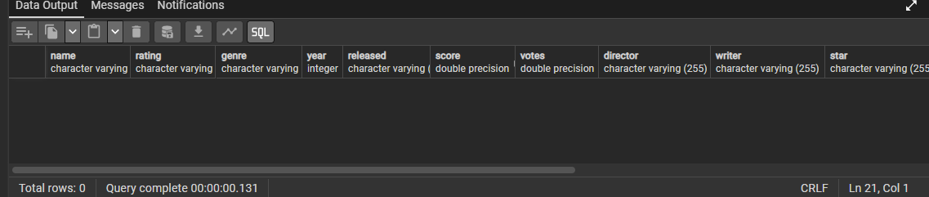
Output screenshot: 1. Create movies table with appropriate data types

2. Import movies.csv into movies table
-- Import completed through PostgreSQL import / COPY workflow.
SELECT *
FROM movies;

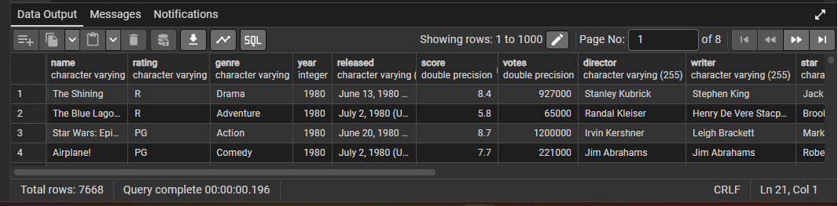
Output screenshot: 2. Import movies.csv into movies table

3. Display first 10 records
SELECT *
FROM movies
LIMIT 10;

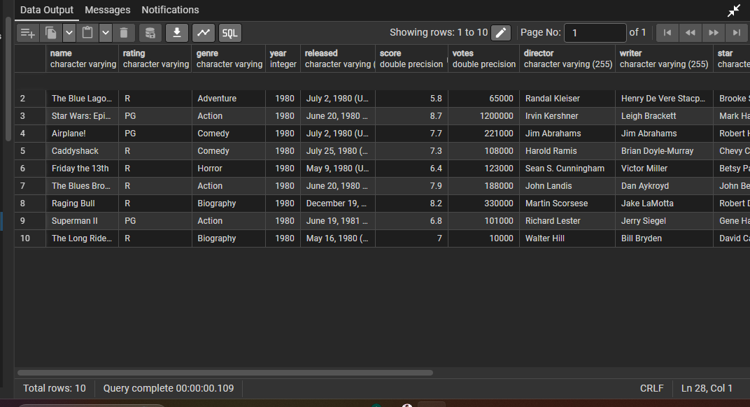
Output screenshot: 3. Display first 10 records

4. List all distinct genres
SELECT DISTINCT genre
FROM movies
ORDER BY genre;

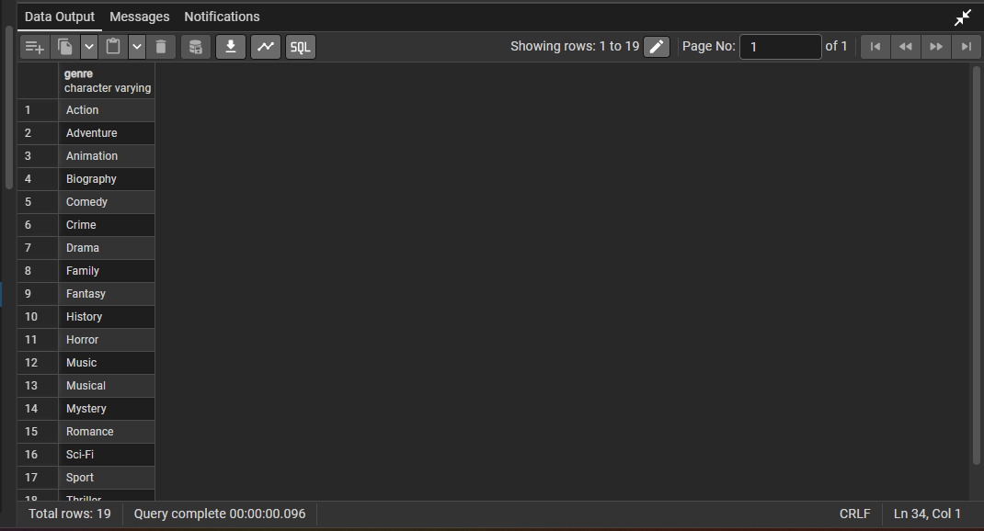
Output screenshot: 4. List all distinct genres

5. Check missing values in critical columns
SELECT
COUNT(*) FILTER (WHERE name IS NULL OR TRIM(name) = '') AS missing_name,
COUNT(*) FILTER (WHERE genre IS NULL OR TRIM(genre) = '') AS missing_genre,
COUNT(*) FILTER (WHERE year IS NULL) AS missing_year,
COUNT(*) FILTER (WHERE score IS NULL) AS missing_score,
COUNT(*) FILTER (WHERE budget IS NULL) AS missing_budget,
COUNT(*) FILTER (WHERE gross IS NULL) AS missing_gross
FROM movies;

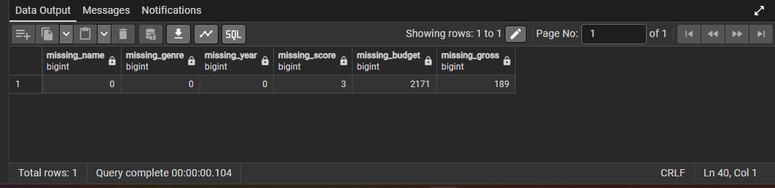
Output screenshot: 5. Check missing values in critical columns

Section 2: Transforming Data

1. Update missing countries with Unknown
UPDATE movies
SET country = 'Unknown'
WHERE country IS NULL OR TRIM(country) = '';

SELECT country
FROM movies
WHERE country = 'Unknown';

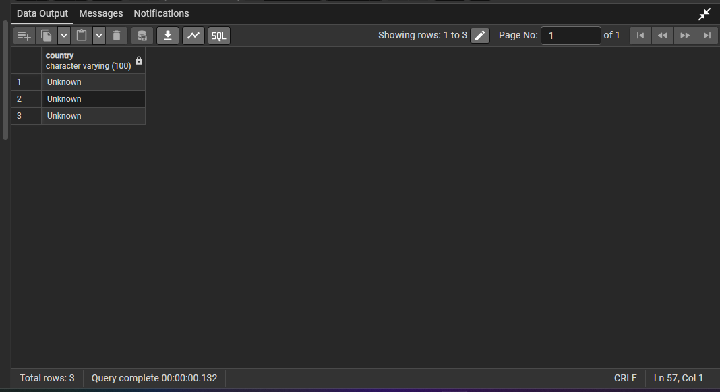
Output screenshot: 1. Update missing countries with Unknown

2. Fill missing gross values with 0
UPDATE movies
SET gross = 0
WHERE gross IS NULL;

SELECT COUNT(*) AS updated_rows
FROM movies
WHERE gross = 0;

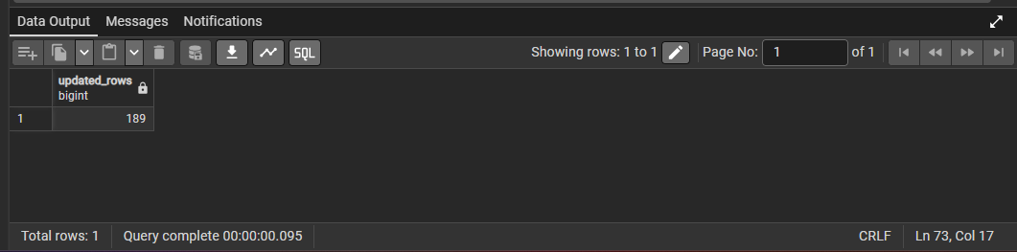
Output screenshot: 2. Fill missing gross values with 0

3. Create profitability column
ALTER TABLE movies
ADD COLUMN profitability FLOAT;

UPDATE movies
SET profitability = gross - budget;

SELECT name, gross, budget, profitability
FROM movies
LIMIT 10;

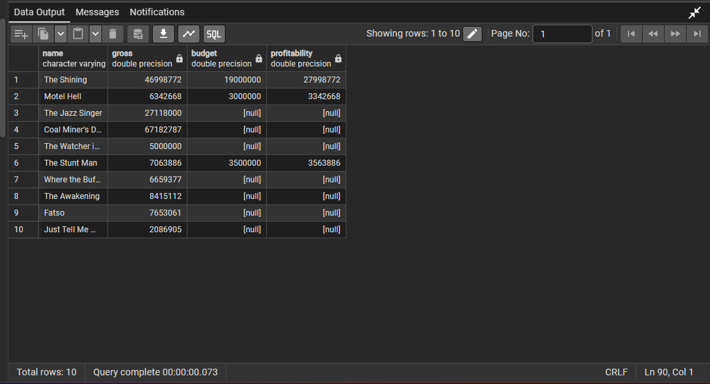
Output screenshot: 3. Create profitability column

4. Create score_category column
ALTER TABLE movies
ADD COLUMN score_category VARCHAR(20);

UPDATE movies
SET score_category =
CASE
WHEN score >= 8 THEN 'High'
WHEN score >= 5 AND score < 8 THEN 'Medium'
WHEN score < 5 THEN 'Low'
ELSE 'Unknown'
END;

SELECT score, score_category,
CASE
WHEN score >= 8 THEN 'Correct High'
WHEN score >= 5 AND score < 8 THEN 'Correct Medium'
WHEN score < 5 THEN 'Correct Low'
END AS verification
FROM movies
LIMIT 15;

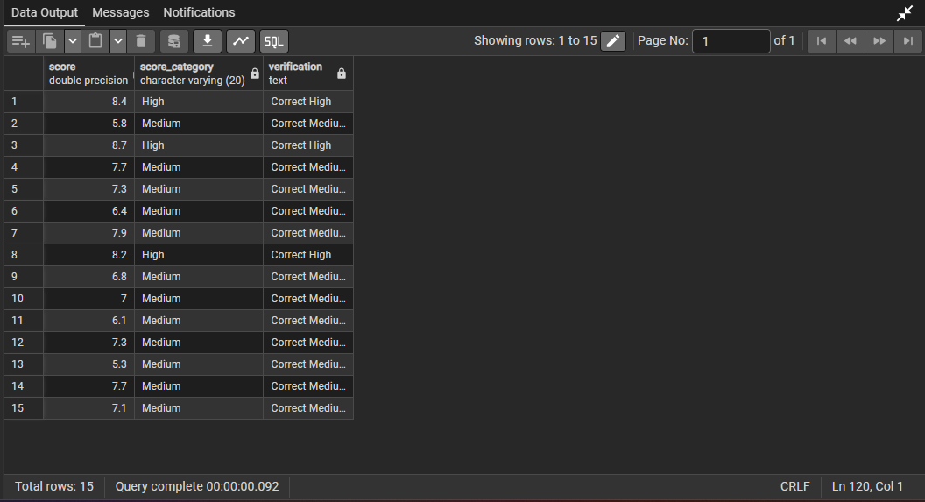
Output screenshot: 4. Create score_category column

5. Extract year from released column
SELECT name, year, released,
SUBSTRING(released FROM '[0-9]{4}')::INT AS extracted_year
FROM movies
WHERE year <> SUBSTRING(released FROM '[0-9]{4}')::INT
LIMIT 15;

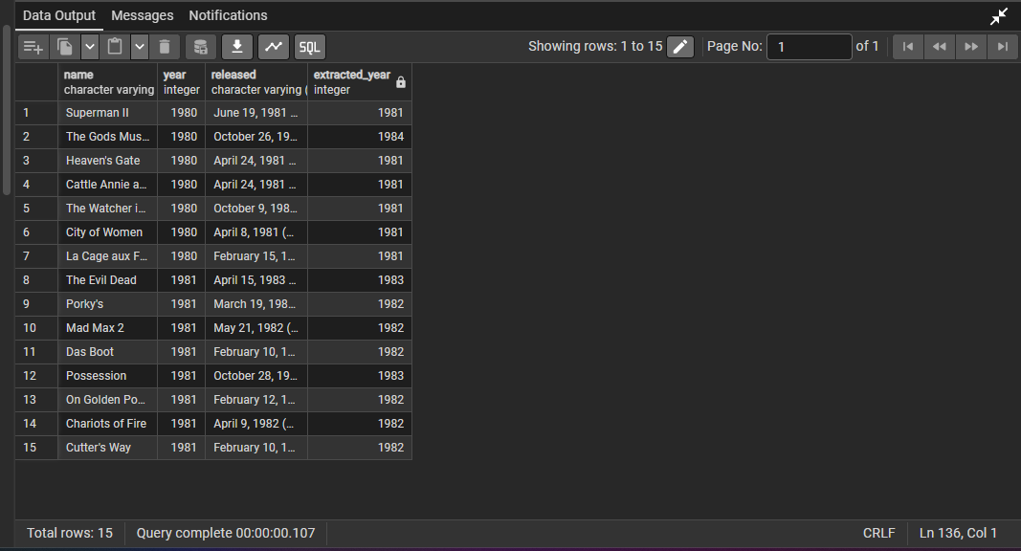
Output screenshot: 5. Extract year from released column

Section 3: Preparing for Load / Export

1. Create cleaned table
DROP TABLE IF EXISTS movies_cleaned;

CREATE TABLE movies_cleaned AS
SELECT *
FROM movies
WHERE name IS NOT NULL
AND TRIM(name) <> ''
AND genre IS NOT NULL
AND TRIM(genre) <> ''
AND year IS NOT NULL
AND score IS NOT NULL;

SELECT *
FROM movies_cleaned
LIMIT 15;

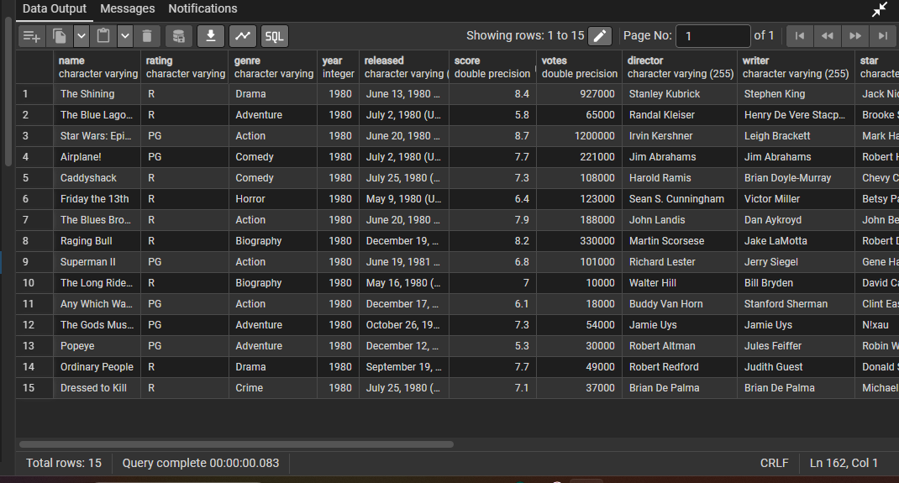
Output screenshot: 1. Create cleaned table

2. Add decade column
ALTER TABLE movies_cleaned
ADD COLUMN decade VARCHAR(20);

UPDATE movies_cleaned
SET decade = CONCAT((year / 10) * 10, 's');

SELECT name, year, decade
FROM movies_cleaned
LIMIT 10;

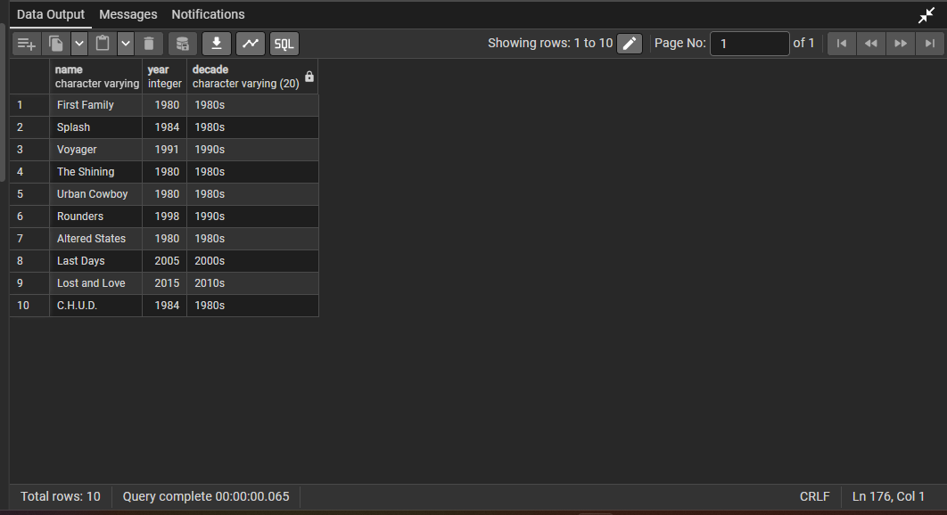
Output screenshot: 2. Add decade column

3. Check duplicates by movie name and year
SELECT name, year, COUNT(*) AS duplicate_count
FROM movies_cleaned
GROUP BY name, year
HAVING COUNT(*) > 1;

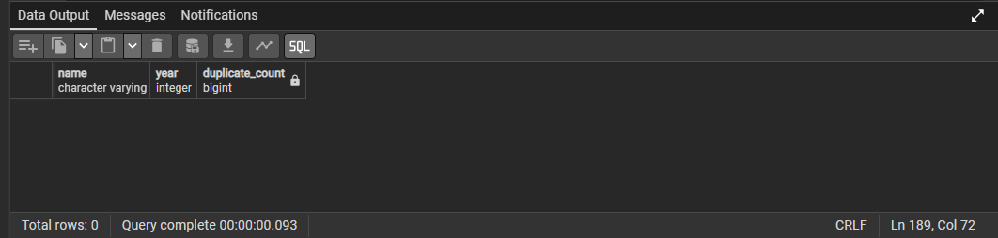
Output screenshot: 3. Check duplicates by movie name and year

4. Sort cleaned data by year and gross
SELECT year, gross
FROM movies_cleaned
ORDER BY year ASC, gross DESC;

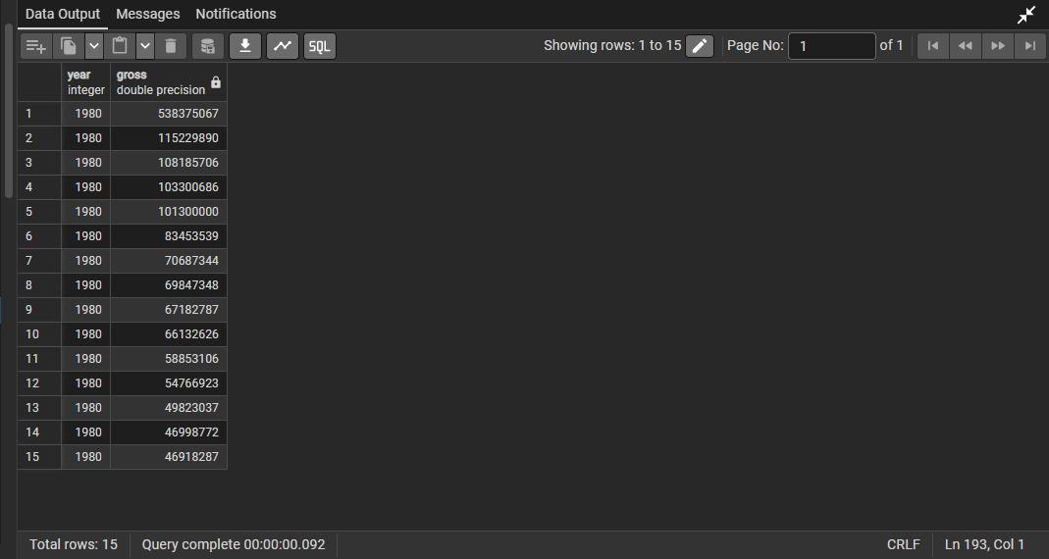
Output screenshot: 4. Sort cleaned data by year and gross

5. Export cleaned data for Excel
SELECT *
FROM movies_cleaned
ORDER BY year ASC, gross DESC;

-- Exported as movies_cleaned_ankitcsv.csv and movies_cleaned_ankit.xlsx

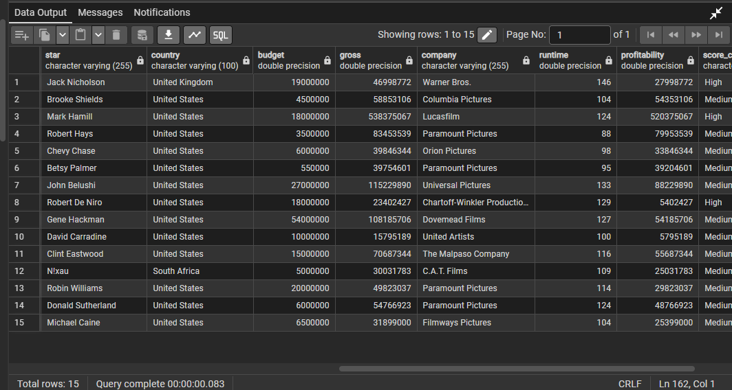
Output screenshot: 5. Export cleaned data for Excel

Task 4: Excel-Based Exploratory Data Analysis
Excel Based EDA

1. Missing Data Handling
- Missing values: score = 3, budget = 2171, gross = 189, name = 0, genre = 0, year = 0.
- Country blanks were standardized as Unknown and missing gross values were filled with 0.
- Budget blanks were kept as blank where needed to avoid false profitability.
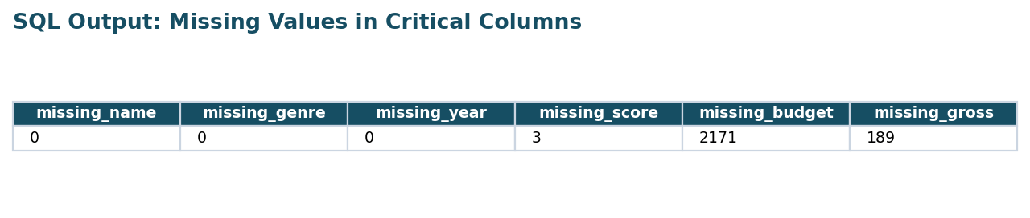
Excel visual: 1. Missing Data Handling

2. Data Sorting and Filtering
- Data was sorted by year and gross earnings.
- IMDb score above 8.0 filter identifies high-rated movies.
- This supports premium content identification.

Excel visual: 2. Data Sorting and Filtering

3. Analysis of Movie Genres
- Comedy has the highest movie count with 2,245 movies.
- Action and Drama are also major categories.
- Niche genres have lower production volume.
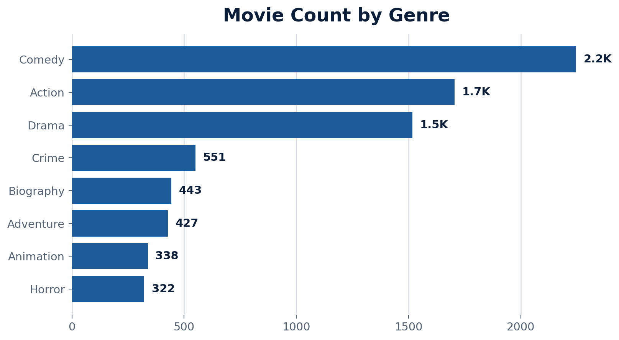
Excel visual: 3. Analysis of Movie Genres

4. Budget and Gross Earnings Comparison
- Budget and gross show positive relation, but high budget does not guarantee high revenue.
- Outliers show franchise and audience impact.
- Mid-budget movies can outperform if genre fit is strong.
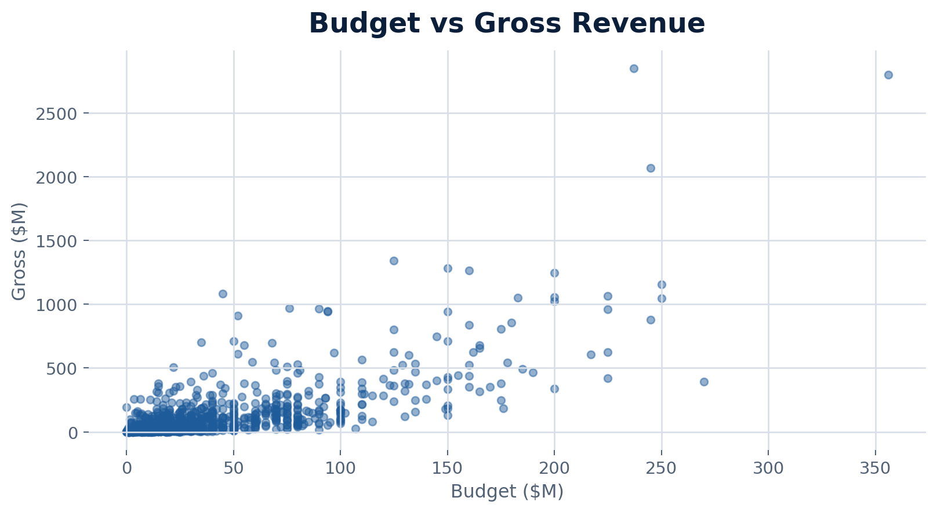
Excel visual: 4. Budget and Gross Earnings Comparison

5. IMDb Score Categorization
- High >= 8, Medium = 5 to 7.9, Low < 5.
- Most movies fall in Medium category.
- High scoring movies support brand and catalog value.
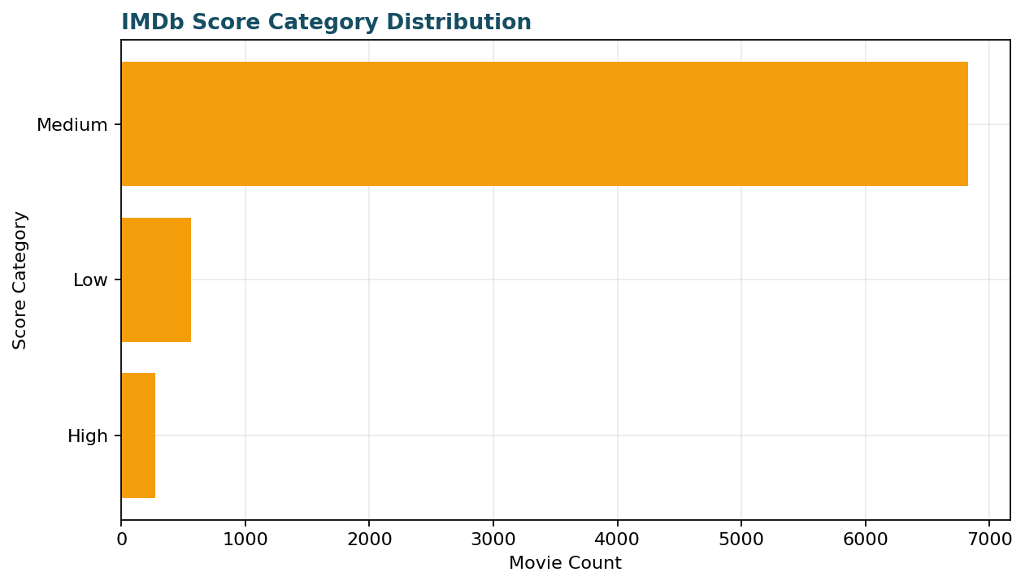
Excel visual: 5. IMDb Score Categorization

6. Country-wise Movie Production
- United States leads production with 5,472 movies.
- United Kingdom, France, Canada, and Germany follow.
- Production is heavily US-centered.

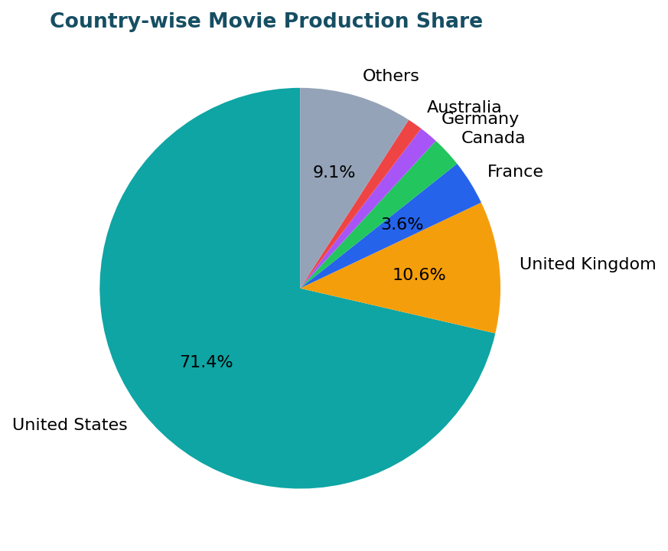
Excel visual: 6. Country-wise Movie Production

7. Director Analysis
- Average gross by director was calculated through grouped aggregation.
- Directors with repeated high-gross releases show stronger commercial consistency.
- This supports studio talent investment decisions.
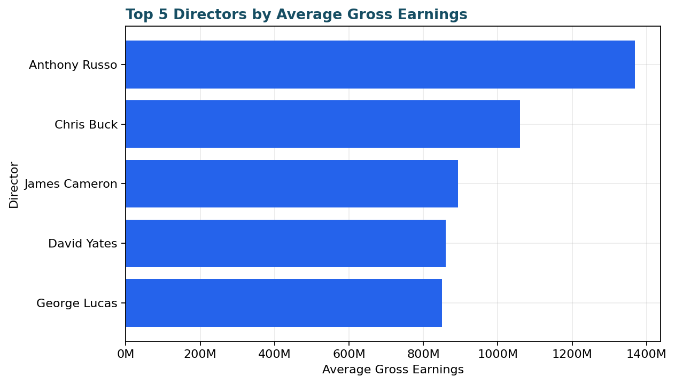
Excel visual: 7. Director Analysis

8. Runtime Analysis
- Average runtime is 107.2 minutes.
- Runtime differs by genre and storytelling format.
- Biography, Action, and Drama generally run longer than lighter genres.
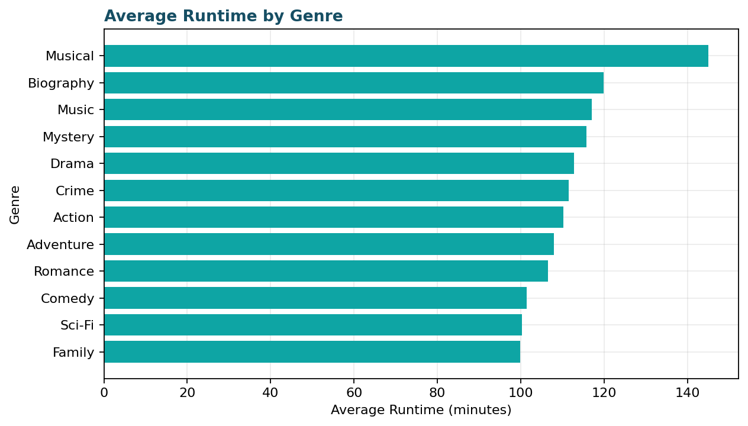
Excel visual: 8. Runtime Analysis

9. Top Grossing Movies by Year
- Each year was grouped and the highest grossing movie was selected.
- This identifies annual box-office leaders.
- The table shows a sample of yearly leaders.
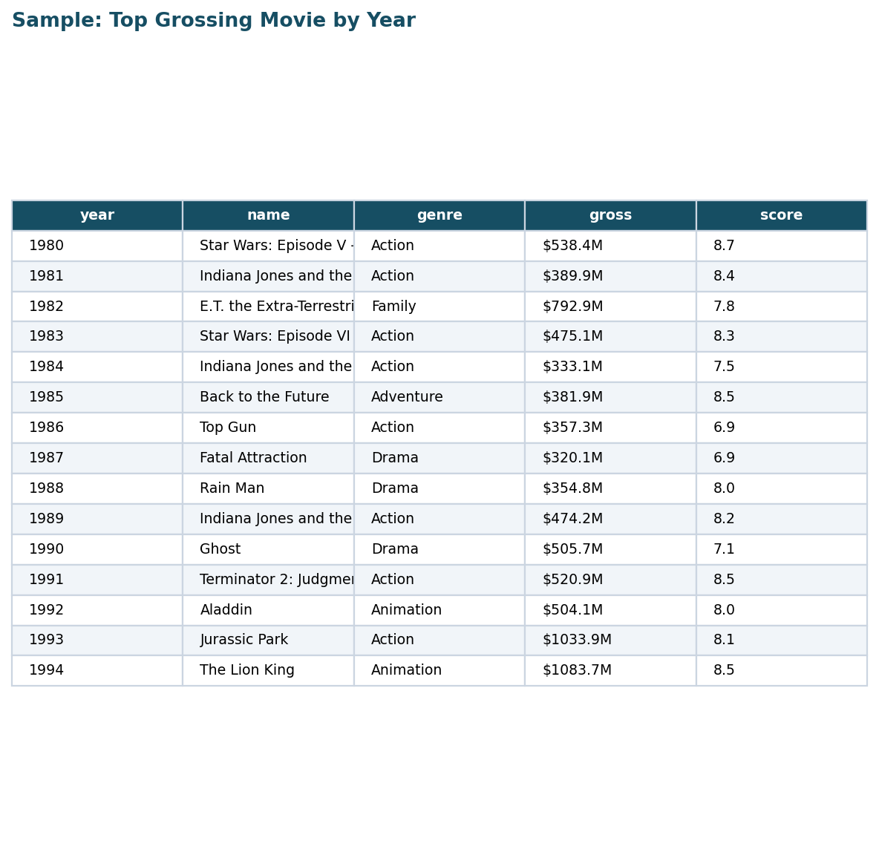
Excel visual: 9. Top Grossing Movies by Year

10. Rating Popularity Over Time
- R and PG-13 ratings dominate many decades.
- Rating trends show audience targeting changes.
- The chart compares major rating categories by decade.
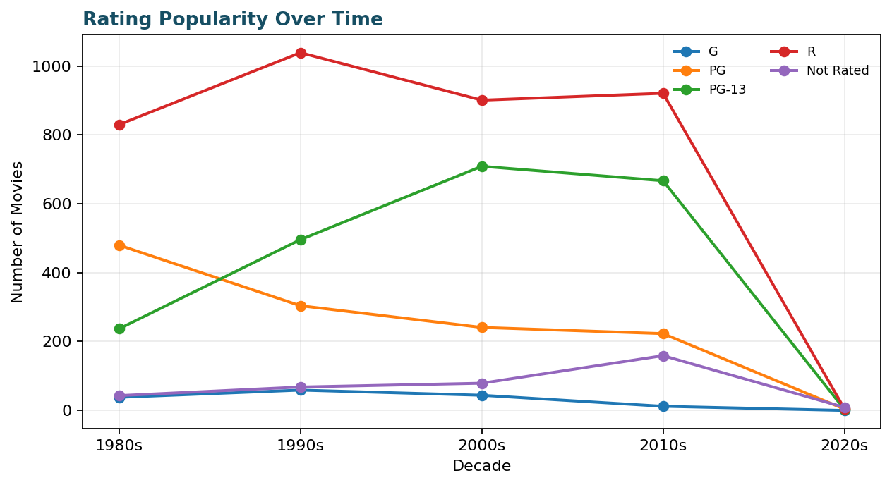
Excel visual: 10. Rating Popularity Over Time

11. Conditional Formatting for High Budget Movies
- High budget movies were highlighted for risk review.
- This quickly identifies expensive titles with break-even pressure.
- The table shows the highest budget examples.
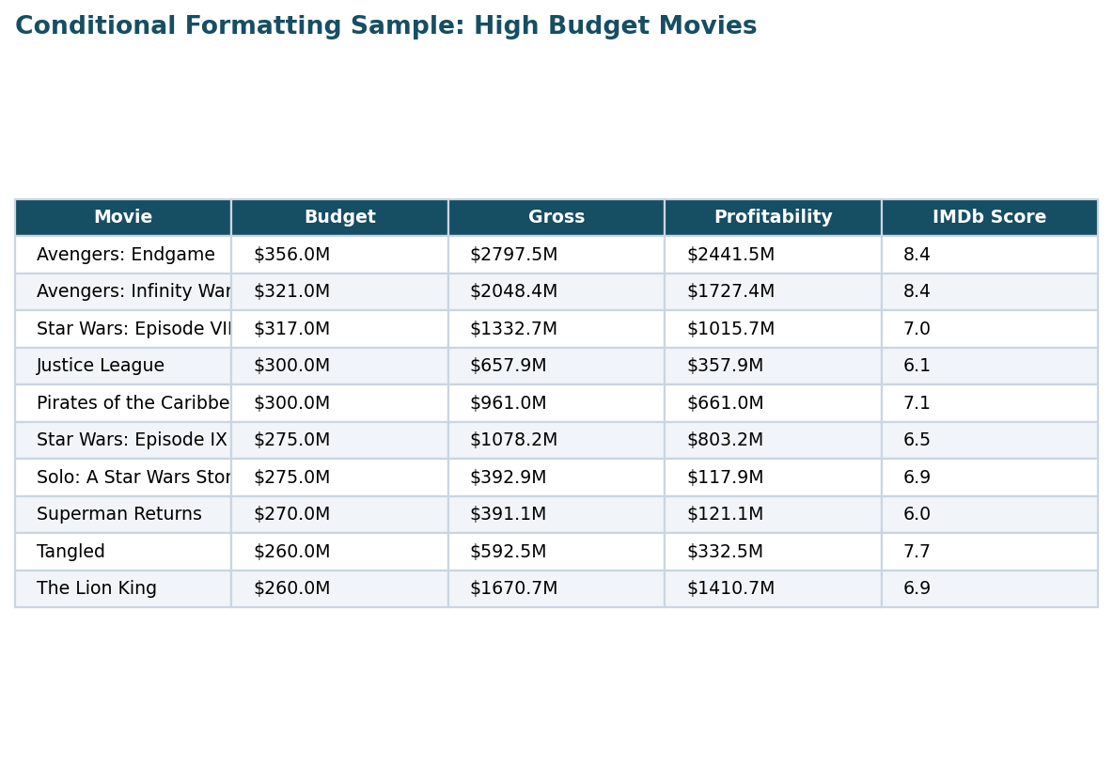
Excel visual: 11. Conditional Formatting for High Budget Movies

12. Star Impact Analysis
- Stars were grouped by average score, average gross, and movie count.
- Strong stars can improve marketing appeal.
- Impact should be read with genre, director, and franchise context.
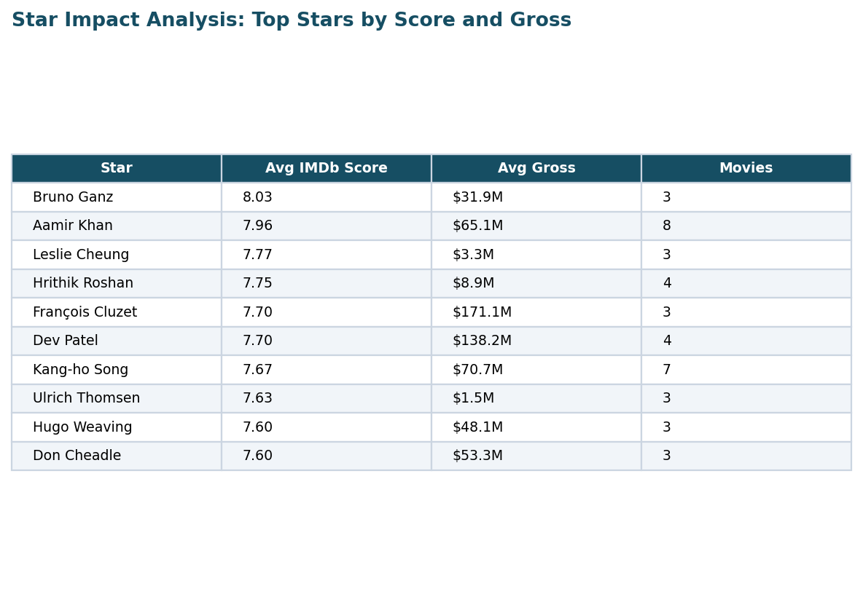
Excel visual: 12. Star Impact Analysis

13. Profitability Calculation
- Profitability = gross - budget.
- Avatar, Avengers: Endgame, Titanic, Star Wars: Episode VII, and Avengers: Infinity War are top profitable movies.
- Profitability is stronger than gross alone because it includes cost.

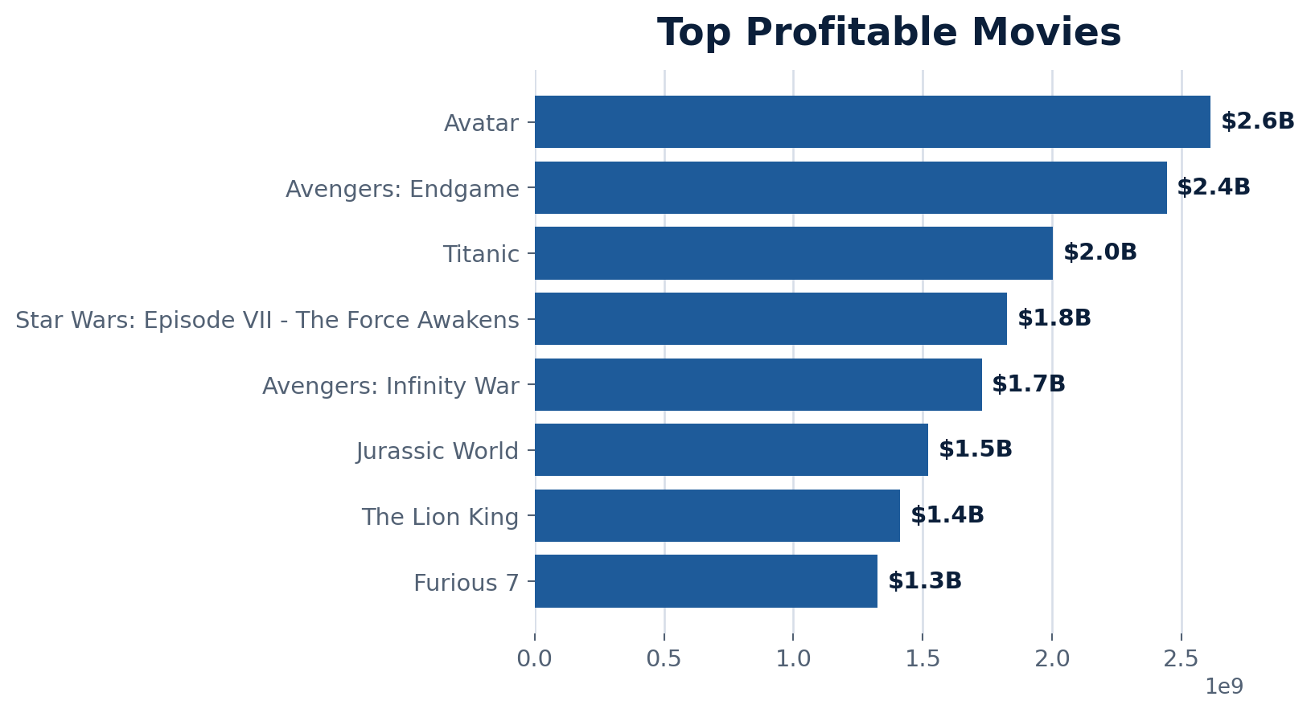
Excel visual: 13. Profitability Calculation

14. Decade-wise Movie Analysis
- Movies were grouped into decades using release year.
- Average gross rises in later decades due to larger markets and franchise economics.
- Average IMDb score is more stable than gross.

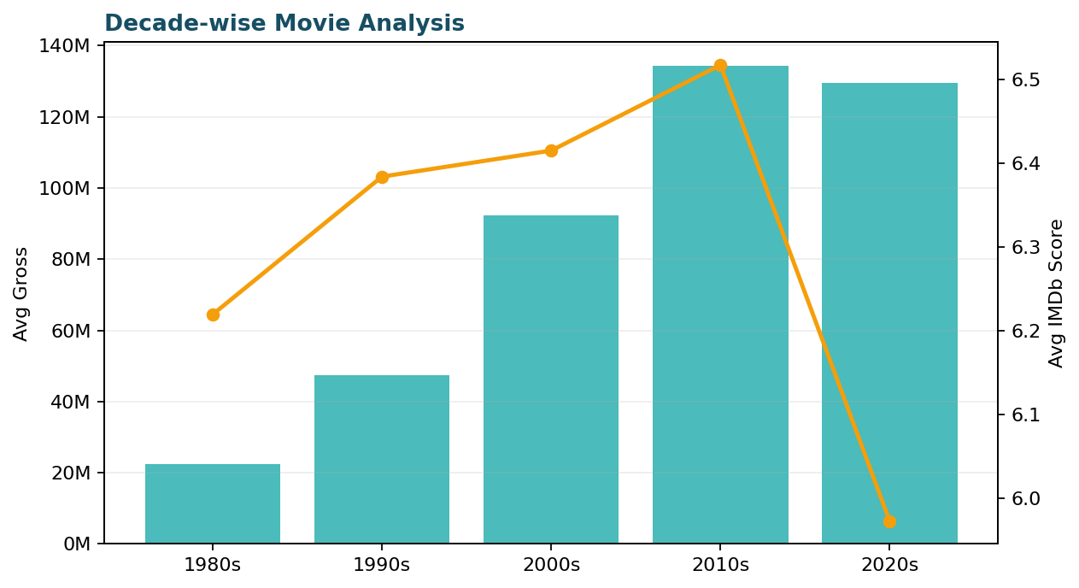
Excel visual: 14. Decade-wise Movie Analysis

15. Pivot Table for Genre Analysis
- A genre pivot was created for average budget, average gross, and movie count.
- Action and Animation show strong commercial potential.
- Pivot analysis supports content portfolio planning.

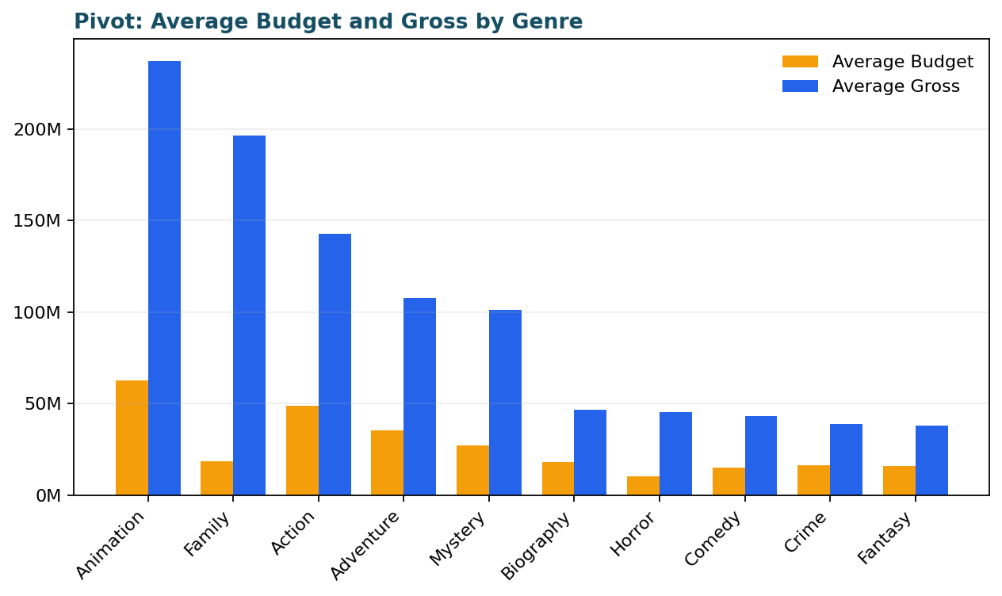
Excel visual: 15. Pivot Table for Genre Analysis

16. Correlation Analysis
- Correlation between runtime and IMDb score is approximately 0.40.
- The relationship is weak-to-moderate.
- Runtime alone does not explain audience rating.

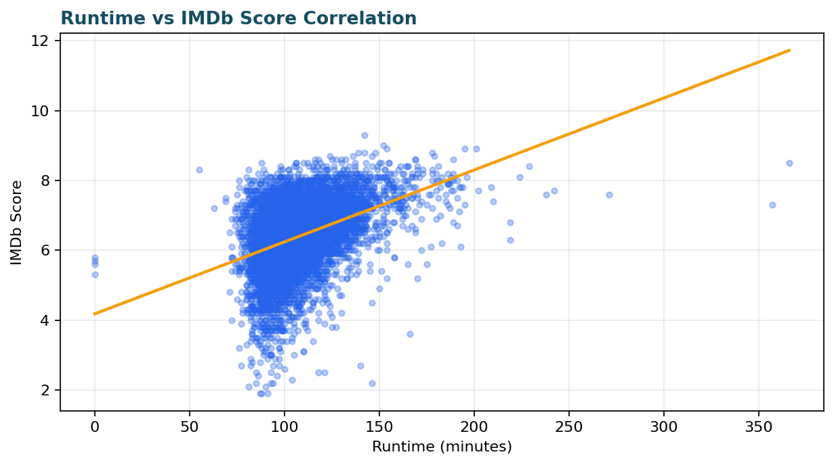
Excel visual: 16. Correlation Analysis

17. Budget Evolution Over Time
- Average budget trends upward over time.
- VFX, premium production, marketing, and franchises increase production costs.
- Budget trend helps forecast capital needs.
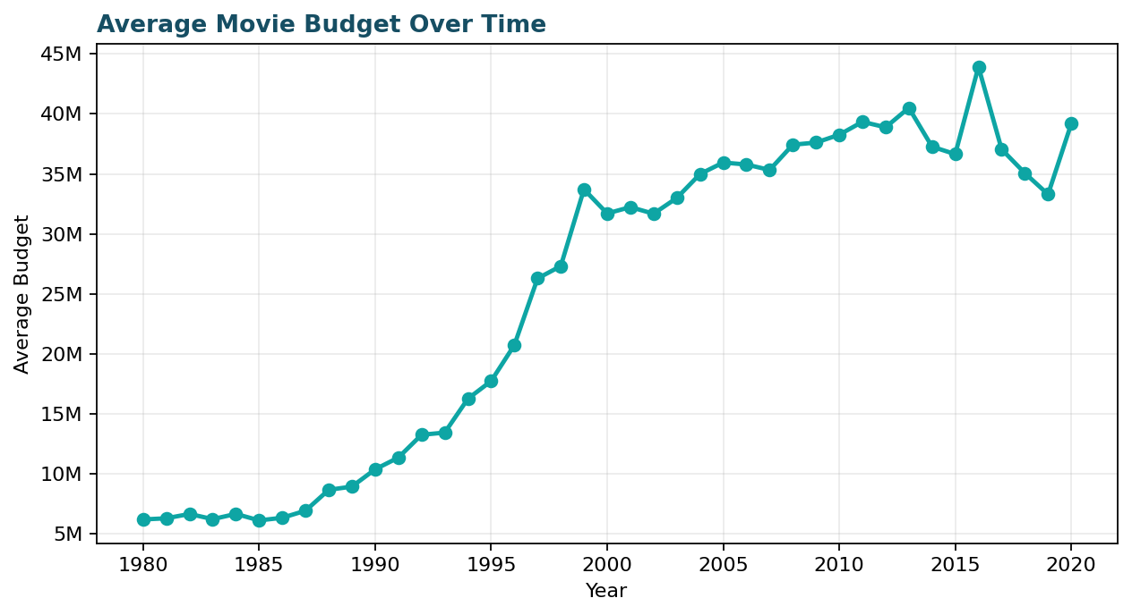
Excel visual: 17. Budget Evolution Over Time

18. Top Companies in Movie Production
- Major studios dominate movie count.
- High-volume studios benefit from distribution strength.
- The chart ranks companies by production volume.
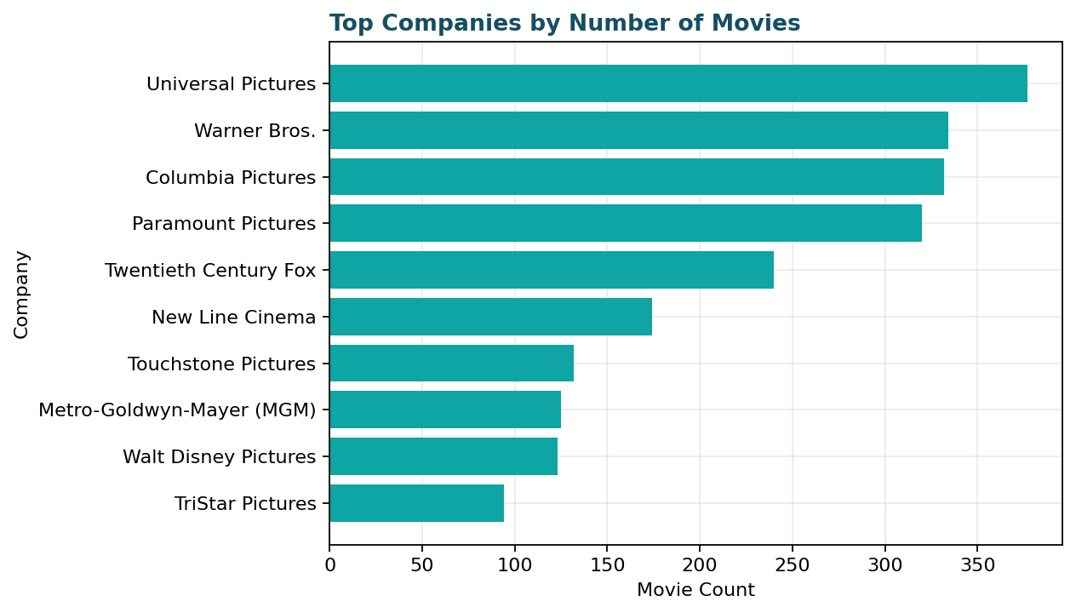
Excel visual: 18. Top Companies in Movie Production

19. Time-Series Analysis of Genre Popularity
- Genre popularity was analyzed by year.
- Comedy, Action, and Drama remain consistently important.
- Trend lines support genre demand planning.
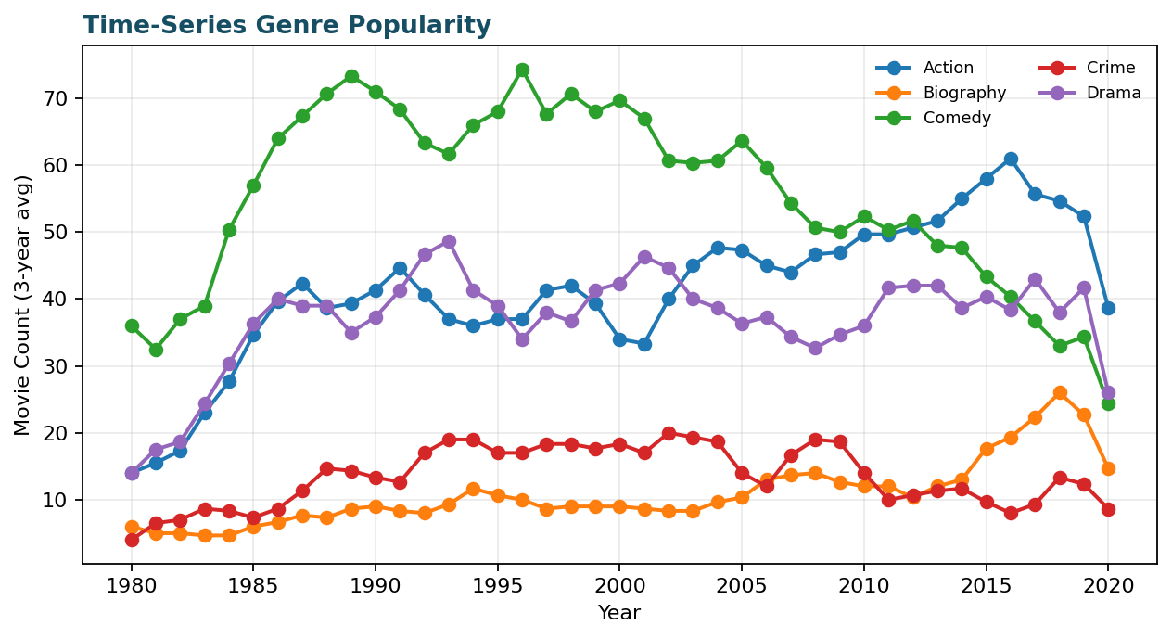
Excel visual: 19. Time-Series Analysis of Genre Popularity

20. Predictive Analysis for Future Gross Earnings
- A historical trend forecast was prepared using yearly gross.
- Forecast should be treated as directional due to market and release-slate changes.
- A stronger model should include genre, budget, score, votes, and franchise status.
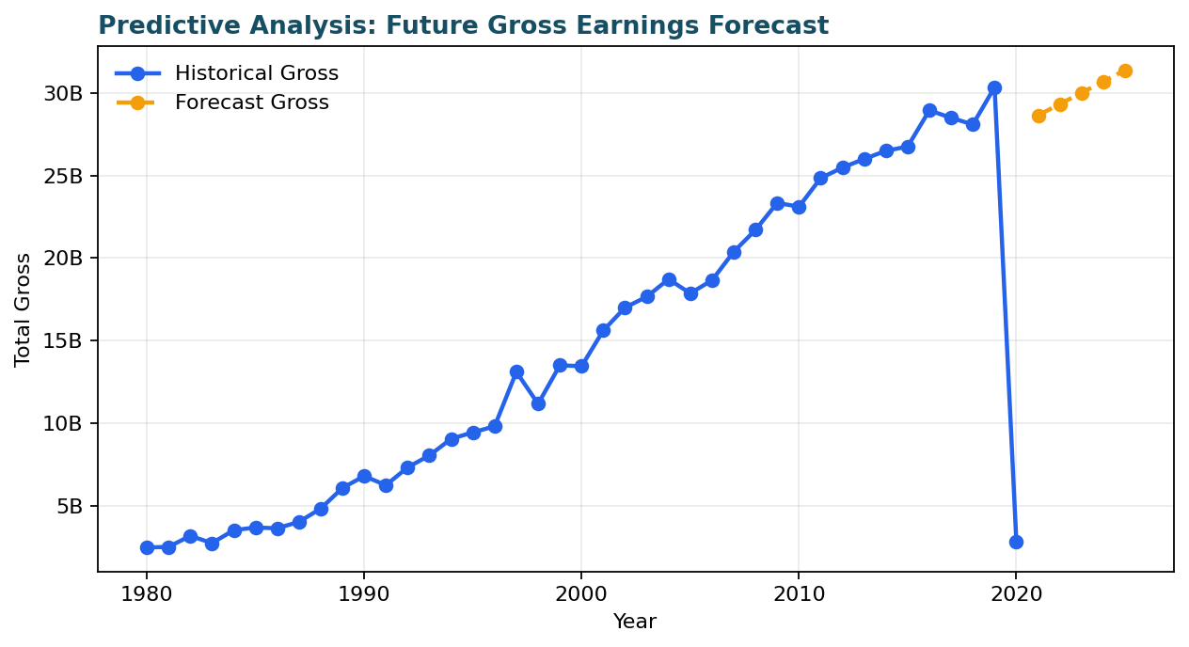
Excel visual: 20. Predictive Analysis for Future Gross Earnings

Excel Key Insight Tables
Genre | Movie Count
Comedy | 2245
Action | 1704
Drama | 1516
Crime | 551
Biography | 443
Adventure | 427
Animation | 338
Horror | 322
Fantasy | 44
Mystery | 20

Country | Movie Count
United States | 5472
United Kingdom | 816
France | 279
Canada | 190
Germany | 117
Australia | 92
Japan | 81
India | 62
Italy | 61
Spain | 47

name | genre | year | budget | gross | profitability | score
Avatar | Action | 2009 | $0.24B | $2.85B | $2.61B | 7.8
Avengers: Endgame | Action | 2019 | $0.36B | $2.80B | $2.44B | 8.4
Titanic | Drama | 1997 | $0.20B | $2.20B | $2.00B | 7.8
Star Wars: Episode VII - The Force Awakens | Action | 2015 | $0.24B | $2.07B | $1.82B | 7.8
Avengers: Infinity War | Action | 2018 | $0.32B | $2.05B | $1.73B | 8.4
Jurassic World | Action | 2015 | $0.15B | $1.67B | $1.52B | 7.0
The Lion King | Animation | 2019 | $0.26B | $1.67B | $1.41B | 6.9
Furious 7 | Action | 2015 | $0.19B | $1.52B | $1.33B | 7.1
Frozen II | Animation | 2019 | $0.15B | $1.45B | $1.30B | 6.8
The Avengers | Action | 2012 | $0.22B | $1.52B | $1.30B | 8.0

Genre | Average Budget | Average Gross | Movie Count
Animation | $62.6M | $237.1M | 338
Family | $18.6M | $196.2M | 11
Action | $48.6M | $142.9M | 1704
Adventure | $35.2M | $107.5M | 427
Mystery | $27.1M | $101.2M | 20
Biography | $18.0M | $46.8M | 443
Horror | $10.5M | $45.2M | 322
Comedy | $15.2M | $43.3M | 2245
Crime | $16.4M | $38.8M | 551
Fantasy | $16.1M | $37.8M | 44

Year | Forecast Gross
2021 | $28.64B
2022 | $29.32B
2023 | $30.00B
2024 | $30.68B
2025 | $31.37B

Insights and Observations
- The cleaned dataset contains 7,665 valid movie records from 1980 to 2020.
- Total gross revenue is about $587.11B; total profitability is about $364.30B.
- Action is the strongest profit genre, while Comedy has the highest movie volume.
- The United States dominates movie production count, followed by the United Kingdom and France.
- High budgets increase upside but ROI depends on genre fit, rating, franchise strength, and marketing effectiveness.

Recommended Business Actions
- Prioritize Action, Animation, and proven franchise films for high-budget investment.
- Use IMDb score, votes, genre, star, and director history as early signals for planning.
- Control production risk through genre-level budget benchmarks.
- Expand regional production in high-growth non-US markets.
- Automate weekly performance summaries for decision-makers.

Reflection
Area | Reflection
Challenges Faced | Handling missing budget/gross values, aligning release-year fields, and turning SQL outputs into clean analysis.
Learning Outcomes | End-to-end practice in SQL ETL, Excel analysis, dashboard storytelling, data architecture, and GenAI automation.
Business Learning | Movie success depends on creative quality and financial discipline; automation speeds up decisions.

Week III: Power BI, Automation and GenAI

Task 5: Power BI Dashboarding
The Power BI dashboard integrates movie performance metrics, genre popularity, director/star impact, financial analysis, and interactive filters.
Dashboard Element | Included Output
Movie performance overview | Total movies, total profit, average IMDb score, profitability percentage, total gross, average budget
Genre popularity tracker | Number of movies by genre, ROI by genre, profitability by genre
Director and star analysis panel | Top stars by IMDb score, top directors by average gross, top directors by profit
Financial analysis | Total profit over time, budget vs gross analysis, top profitable movies
Interactive features | Genre, country, rating, director, and year slicers
Design | Professional compact dashboard with clear labels and analytical views

Power BI Dashboard Link

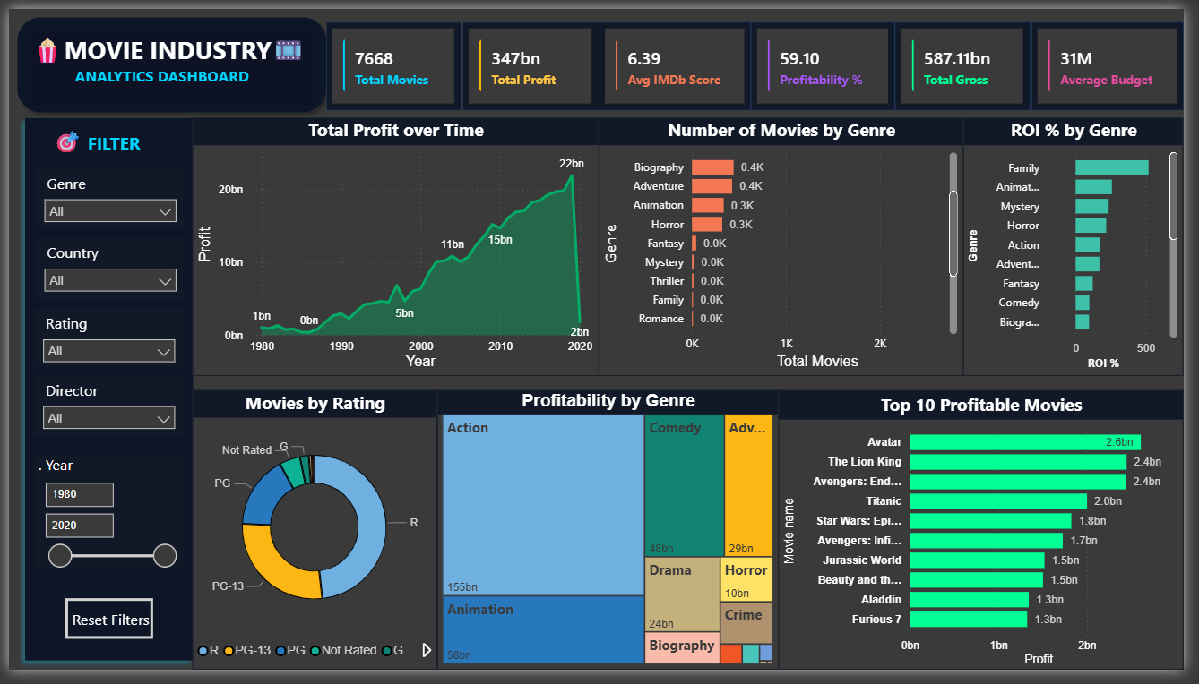
Power BI Dashboard: Movie Industry Analytics

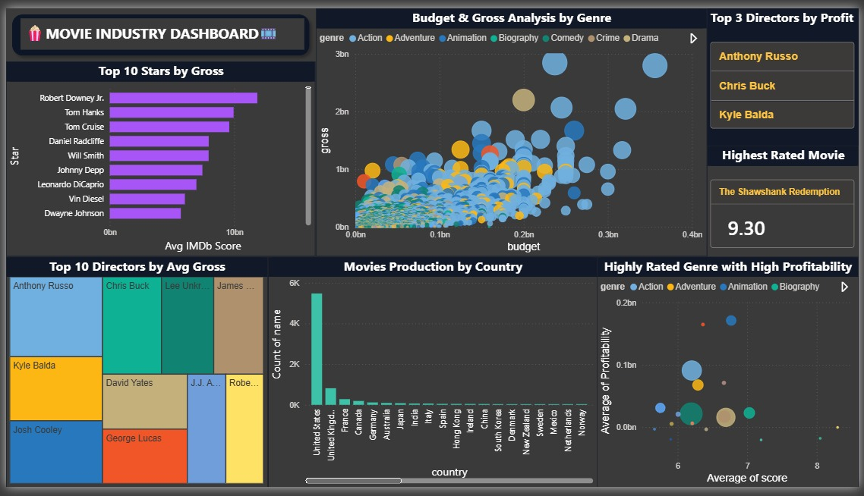

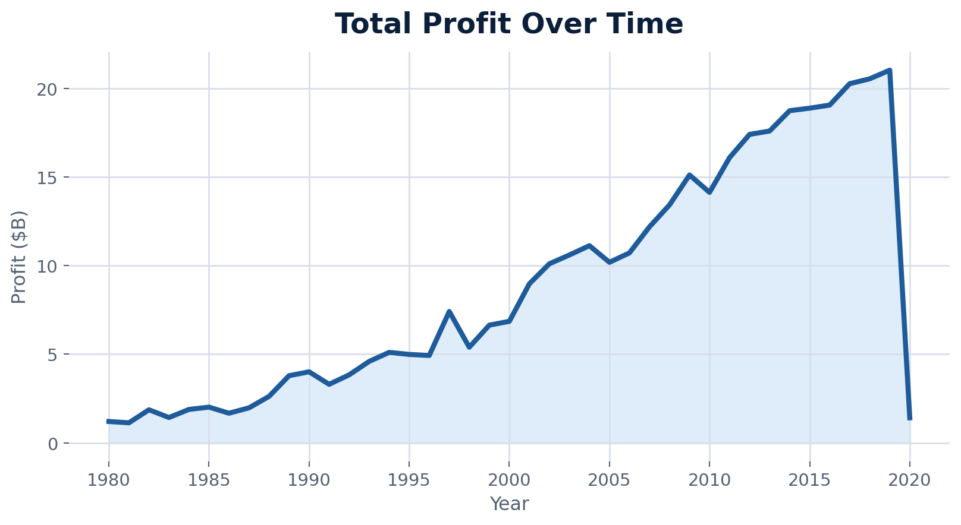
Supporting visual: Total Profit Over Time
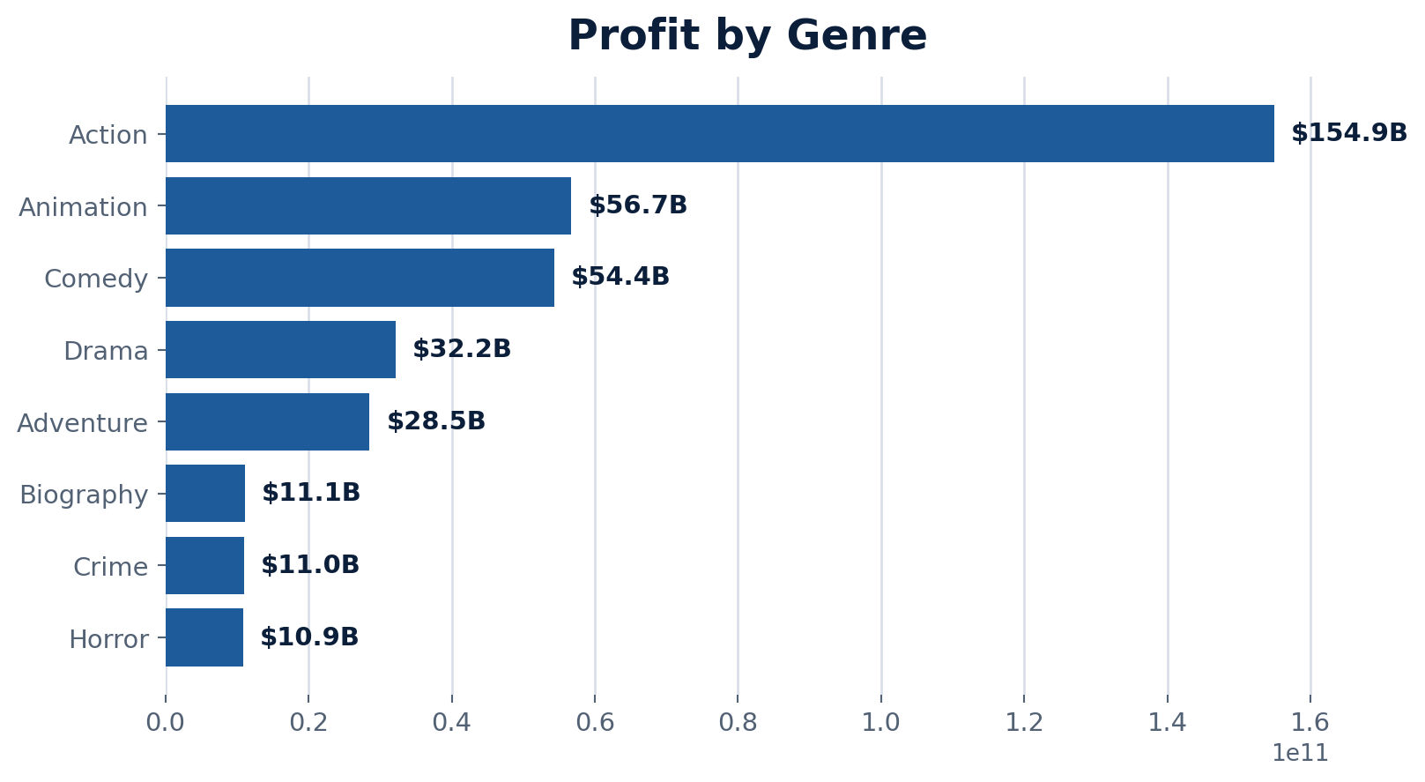
Supporting visual: Profitability by Genre

Task 6: GenAI + n8n Automation
Business teams and content managers do not want to open dashboards daily. They need automated insights and explanations generated from data.

Problem I: Automated Movie Performance Insight Generator
Workflow Node | Purpose
Schedule Trigger | Runs workflow daily or weekly
Google Sheets | Reads weekly and historical KPI data
Edit Fields | Formats KPI values into a structured prompt
OpenAI Chat Model | Generates business insights and release environment analysis
Send Email | Sends AI-generated report via email

Detected Node Name | Detected n8n Type
Schedule Trigger | scheduleTrigger
Google Sheets | googleSheets
Edit Fields | set
OpenAI Chat Model | openAiChatModel
Gmail | gmail

GenAI Component | Details
Input | Weekly average gross, profitability, ratings, release count, and same for previous 18-month benchmark KPIs
Prompt | Compare weekly performance against the previous 18-month benchmark and determine whether the week was a favorable movie release environment
Output | Executive summary with performance insights, release environment assessment, and business recommendations

Sample AI output: The analyzed week delivered stronger box office performance than the previous 18-month benchmark, with higher average gross revenue and healthy profitability levels. Although audience ratings were slightly below historical highs, the increased number of releases likely supported overall revenue growth.
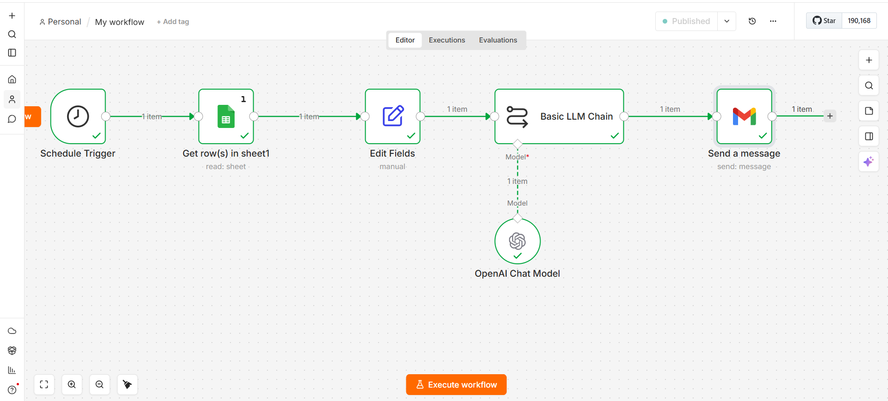
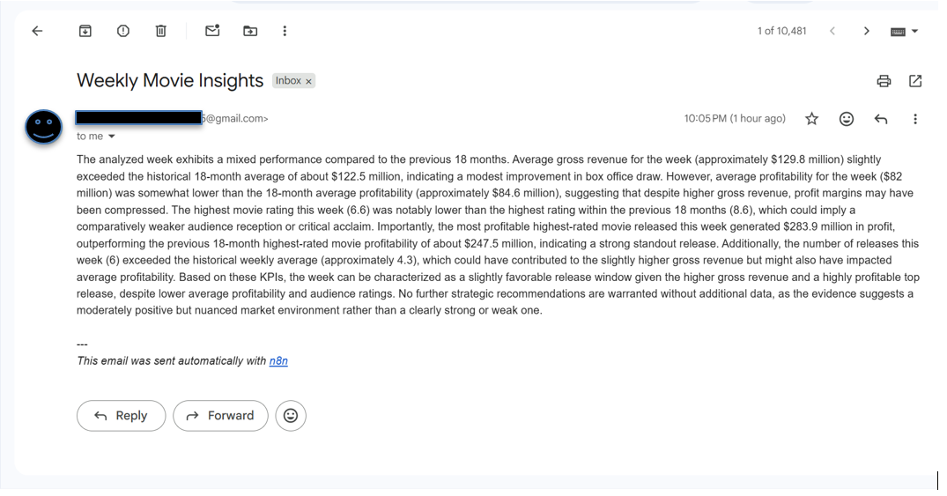

Problem II: AI Movie Recommendation and Explanation Automation
Workflow Node | Purpose
Webhook | Receives user question
Simple LLM Chain | Fetches budget, gross, genre, IMDb score, votes, runtime
Google Gemini Chat Model | Structures movie record and question for GenAI
Respond to Webhook | Returns generated explanation as text

Detected Node Name | Detected n8n Type
Code | code
HTTP Request | httpRequest
Respond to Webhook | respondToWebhook
Webhook | webhook

GenAI Component | Details
Input | User question plus selected movie metrics from SQL database
Prompt | Explain performance, compare with similar movies, and provide data-backed reasoning
Output | Readable explanation of success/failure factors and recommended action

Sample AI response: The selected movie underperformed because its production budget was high compared with its gross earnings and its IMDb score indicates weaker audience reception. Similar movies in the same genre achieved better ROI with lower budgets, so the issue appears to be cost optimization and audience fit.

n8n + GenAI GitHub Repository Requirements
Required Item | Status / Note
n8n workflow JSON exports | Automated_Movie_Performance_Insight_Generator.json; AI_Movie_Recommendation___Explanation_Automation1.json
README.md | Include problem statement, workflow steps, GenAI input-prompt-output, screenshots, and sample outputs
Screenshots | Add n8n workflow screenshots and sample email/webhook output screenshots
Security | Do not upload hard-coded API keys. Rotate exposed keys and use n8n credentials or environment variables before GitHub upload.

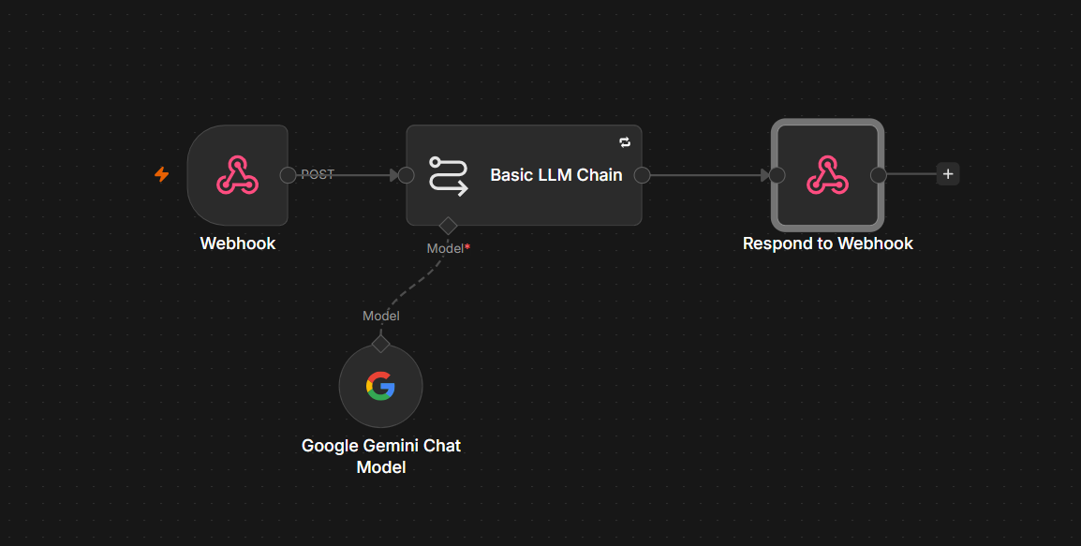
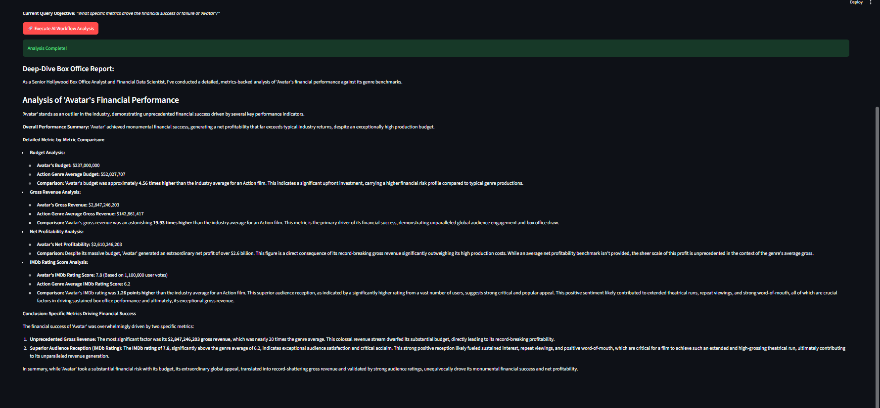

Conclusion
- The project completes the full analytics lifecycle from business understanding to SQL ETL, Excel analysis, Power BI dashboarding, and GenAI automation.
- Netflix case study shows how personalization, content strategy, and data architecture improve retention and profitability.
- Movie analysis shows that genre, budget, rating, director/star impact, and profitability must be analyzed together to understand success.
- Power BI converts analysis into decision-ready dashboards, while n8n and GenAI automate insight delivery.

