

CMPE-277 Smartphone Application Development

Fall- 2016

**Assignment -2**

**Implicit Intents**

**Submitted To**

Professor Chandrasekhar Vuppalapati

**Submitted By**

Ashutosh Sharma (010729186)

**Submission Date**

September 20th, 2016

**Web Links and Phone call App**

1. Main Activity which consist of 2 edit text and 3 button. This is to show the functionality of implicit intents.

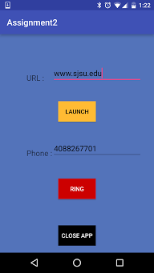

2. When user enter the URL to be opened and launch it, we see a list of relevant application are list in app chooser.

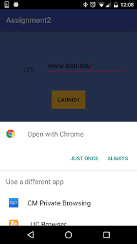

3. Same in case of call, it will prompt all the apps in app chooser which can perform calling action.

