1. Goals Overview

1. Get 20k to 50k books in database with important qualities
2. Collection of books read by user
- Able to search books from database
- Rate the book
- Select what user liked about book
- Select what user disliked about book
3. Generate User preference parameters
4. Recommend most relevant books based on search (based on user description and previously read books).
5. Filter and sort for search results.
6. Login
7. Dashboard with precalculated recommendations.
8. Basic profile setting with preferences options and logout

Design Overview
Basic flow of experience can contain-
- Login / continue without.
- Chose books user have read before and give its experience, or chose not to.
- Dashboard- with profile setting, searching books, recommendations.
- Searching books- with keywords, description of what user wants, also sort and filter results.
- View recommendations- know basic qualities, description, add to wish list etc.

Login page:
Login page will be main landing page, page will contain basic login by mobile or email with password as well as description of website and what problem it exactly solves.
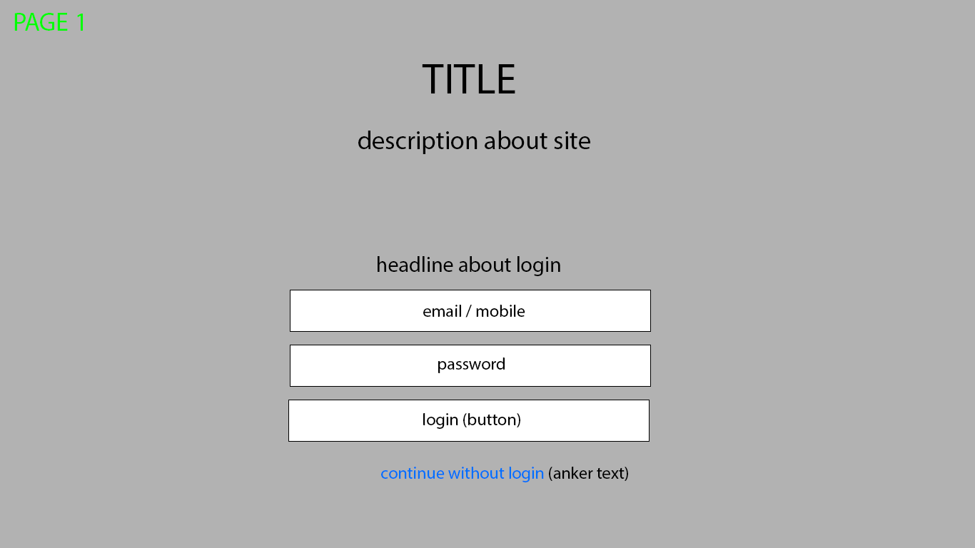

Collection of books:
Login page leads to a page which collects book read by user and its experience. User will be able to search books from the database and add it.
At first website will ask user to search and select a book, after selecting book it will direct to a sub page which will collect user experience from the specific book. User can continue without adding books if he haven’t read any previously.
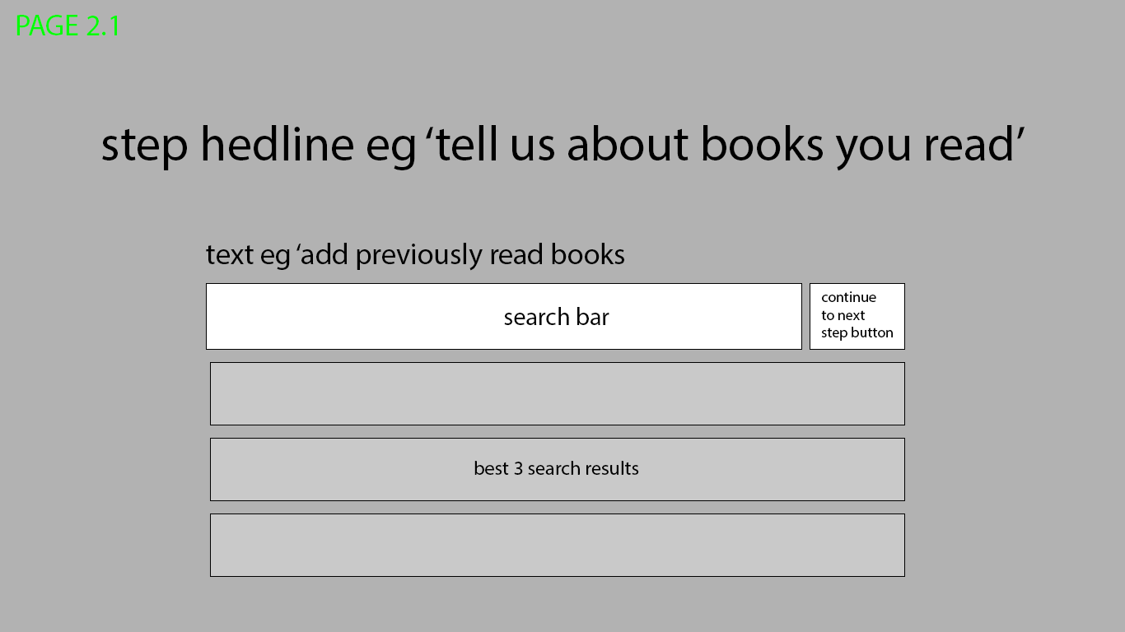
After selecting the book, it will open a dialogue / sub page with fields to get review from the user about the book.
Fields may contain, 1] rating out of 5 stars, 2] predefined keywords on what user liked about the book, user may select one, more or none out of keywords, 3] keywords on what user disliked about book.
All the fields are completely optional. After confirming details, it will redirect back to search page and user can either continue to add more books or continue further.
