BANK LOAN / CREDIT RISK ANALYSIS
Understanding Default Patterns and the Factors that Drive Credit Risk
Data Analytics Project Report
Prepared by: Ashutosh Kumar Singh
B.Tech CSE (Data Science) | Delhi, India
Tools: Python (Pandas, NumPy, Matplotlib, Seaborn, Scikit-learn), Jupyter
Dataset: Kaggle - Credit Risk Dataset (32,580 loans)

Table of Contents
1. Executive Summary
2. Introduction & Objectives
3. Dataset Description
4. Data Quality & Cleaning
5. Portfolio Overview
6. Default Patterns by Category
7. Default Patterns by Numeric Factors
8. Correlation & Combined Effects
9. Risk Scorecard
10. Predictive Modelling
11. Recommendations
12. Limitations & Future Work
13. Conclusion

1. Executive Summary
This project analyses a public credit-risk dataset of 32,580 personal loans to understand which borrower and loan characteristics are associated with default. After cleaning, 32,411 loans were analysed. Of these, 21.9% (7,089 loans) defaulted, and defaulted loans represent about 24.8% of the total amount lent.
Key findings:
- Loan-to-income ratio is the sharpest warning sign. Default jumps from 22% to 69% once a loan exceeds 30% of the borrower's income.
- Loan grade and interest rate behave as expected. Default rises from 10% (grade A) to 59% (grade D) and 98% (grade G); rates above 14% are linked to 50-68% default.
- Income and housing matter. The lowest income quintile defaults at 43% versus 9% for the highest; renters default at 31.6% versus 7.5% for home-owners.
- Loan purpose matters. Debt consolidation (28.7%), medical (26.8%) and home improvement (26.2%) loans are riskiest; venture (14.9%) and education (17.3%) are the safest.
- Prior default on file doubles the risk (37.9% vs 18.4%). Age and credit-history length add almost no signal.
- A simple 6-flag scorecard separates borrowers cleanly: 4.4% default with zero flags, 99.1% with all six.
- Predictive models reach AUC of 0.93 (Random Forest) and 0.92 (Gradient Boosting), versus 0.87 for Logistic Regression.

2. Introduction & Objectives
Lending is a risk business. Every loan approved carries the possibility that the borrower will not repay, and the cost of that default is borne by the lender. Credit risk analysis helps a bank decide who to lend to, how much, and at what price. Analysts in banks, NBFCs and fintech companies routinely study historical loan performance to find the patterns that separate good borrowers from bad ones.
This project applies the data analyst workflow - data quality checks, cleaning, exploratory analysis, segmentation, simple scorecard design and predictive modelling - to a finance-domain dataset.

2.1 Business questions
- What share of loans default and how much money is exposed?
- Which borrower and loan attributes are most strongly related to default?
- Do risk factors compound when they appear together?
- How accurately can default be predicted using these attributes?
- What practical lending recommendations follow from the evidence?

2.2 Scope
The analysis is descriptive and diagnostic: it shows where defaults concentrate and which variables are associated with them. Associations are not proof of cause; for example, low income and default move together, but this analysis does not prove that low income causes default.

3. Dataset Description
The data is the "Credit Risk Dataset" published on Kaggle, a table of personal loans with borrower demographics, loan terms and the final loan outcome. Each row is one loan. The file used here is stored in the project folder under data/credit_risk_dataset.csv.
Column | Type | Description
person_age | Numeric | Borrower age in years
person_income | Numeric | Annual income
person_home_ownership | Categorical | RENT, MORTGAGE, OWN, OTHER
person_emp_length | Numeric | Employment length in years
loan_intent | Categorical | Purpose: education, medical, venture, personal, home improvement, debt consolidation
loan_grade | Categorical | Lender-assigned grade A (best) to G (worst)
loan_amnt | Numeric | Loan amount
loan_int_rate | Numeric | Interest rate (%)
loan_status | Binary target | 1 = default, 0 = repaid
loan_percent_income | Numeric | Loan amount divided by income
cb_person_default_on_file | Categorical | Prior default on credit bureau record (Y/N)
cb_person_cred_hist_length | Numeric | Credit history length in years

3.1 Important note on the data
This dataset is a cleaned public sample that is widely understood to be simulated rather than taken from a specific bank's books. Patterns here are therefore useful for demonstrating analytical method, but should not be presented as real-world lending statistics for any institution. Also, loan_grade and loan_int_rate are decisions made by the lender itself, so they partly reflect risk that the lender had already identified.

4. Data Quality & Cleaning

4.1 Issues found
Issue | Count | Action taken
Missing person_emp_length | 895 | Filled with median; flag column emp_length_missing added
Missing loan_int_rate | 3,116 | Filled with median of the same loan grade (rate depends on grade); flag int_rate_missing added
Duplicate rows | 165 | Removed
Impossible ages (123, 144) | 4 | Rows removed
Employment length of 123 years | 2 | Set to missing, then median-filled

After cleaning, 32,411 rows remained. The cleaned file is saved as data/credit_risk_cleaned.csv.

4.2 Why these choices
Interest rate is strongly tied to loan grade, so a grade-level median is a more faithful fill than a single overall median. Missing-value flags were kept as features because the fact that a value was missing can itself carry information. Income outliers (up to about 2 million) were retained in the data because they are plausible and the analysis uses quintiles and medians that are robust to them.
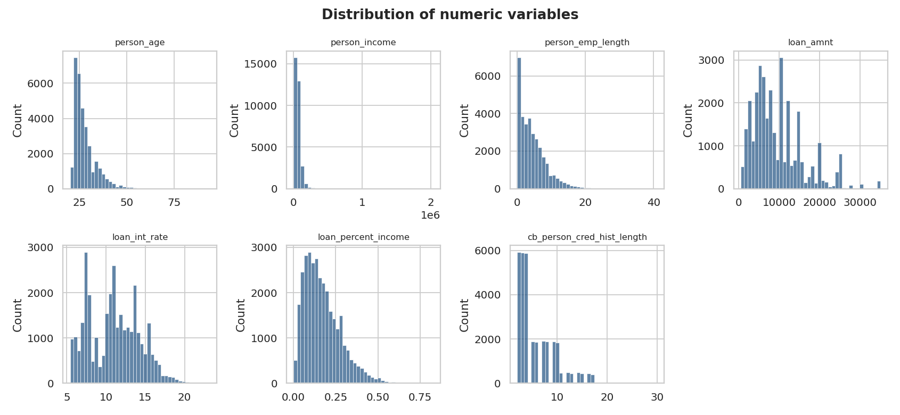
Figure 1: Distribution of numeric variables after cleaning

5. Portfolio Overview
Out of 32,411 loans, 7,089 defaulted - a default rate of 21.9%. The classes are imbalanced (roughly 4 repaid loans for every 1 default), which matters later when judging models: a model that predicts "repaid" for everyone would be about 78% accurate yet useless.
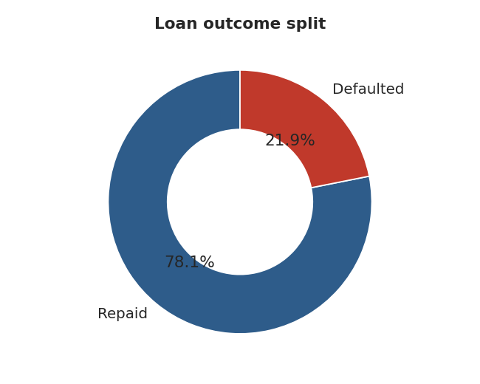
Figure 2: Loan outcome split
The total value of loans in the dataset is about 311 million, of which about 77 million (24.8%) was lent to borrowers who later defaulted. Defaulters tend to take slightly larger loans, so the share of money at risk is higher than the share of loans.

5.1 Defaulters versus repaying borrowers (medians)
Measure | Repaid | Defaulted
Annual income | 60,000 | 41,682
Loan as % of income | 13% | 24%
Interest rate | 10.65% | 13.48%

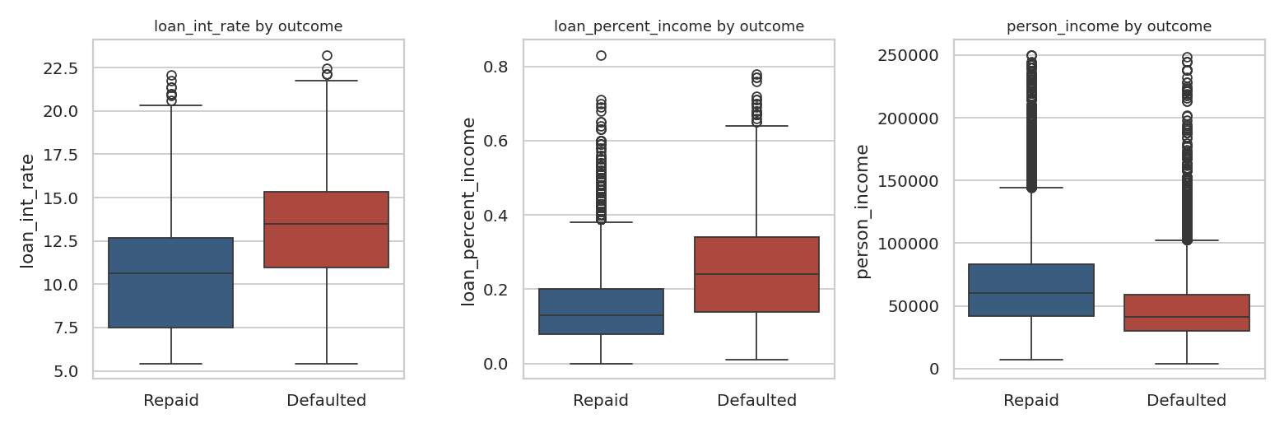
Figure 3: Interest rate, loan-to-income and income by outcome
The typical defaulter earns about 30% less, borrows nearly twice as much relative to income, and pays about 2.8 percentage points more in interest.

6. Default Patterns by Category

6.1 Loan grade
Grade | Loans | Default rate
A | 10,703 | 10.0%
B | 10,384 | 16.3%
C | 6,436 | 20.8%
D | 3,620 | 59.1%
E | 963 | 64.5%
F | 241 | 70.5%
G | 64 | 98.4%
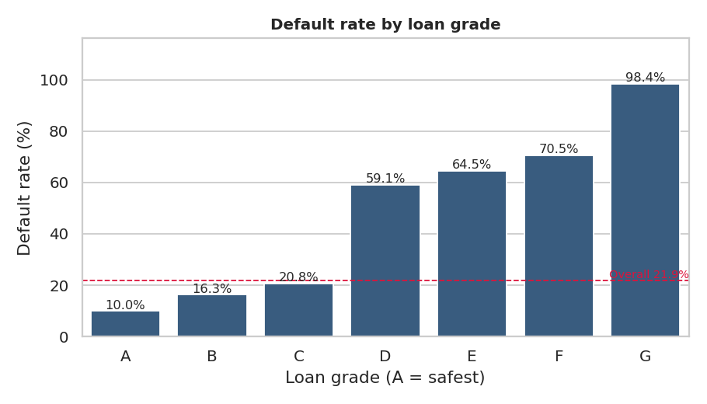
Figure 4: Default rate by loan grade
Grades A to C sit between 10% and 21%, then default more than doubles at grade D (59%). Grades D to G hold only about 15% of loans but a disproportionate share of defaults. Grade G is almost a guaranteed default, although with only 64 loans this should be read cautiously.

6.2 Home ownership
Home ownership | Loans | Default rate
MORTGAGE | 13,367 | 12.6%
OTHER | 106 | 31.1%
OWN | 2,563 | 7.5%
RENT | 16,375 | 31.6%
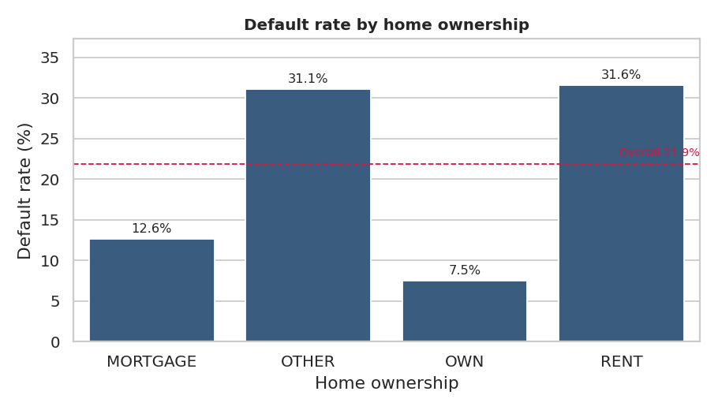
Figure 5: Default rate by home ownership
Renters are four times more likely to default than owners. Mortgage holders sit in between. A plausible reading is that housing status acts as a proxy for financial stability and assets, though the dataset cannot confirm the mechanism.

6.3 Loan purpose
Loan purpose | Loans | Default rate
DEBTCONSOLIDATION | 5,189 | 28.7%
EDUCATION | 6,409 | 17.3%
HOMEIMPROVEMENT | 3,594 | 26.2%
MEDICAL | 6,042 | 26.8%
PERSONAL | 5,497 | 19.9%
VENTURE | 5,680 | 14.9%
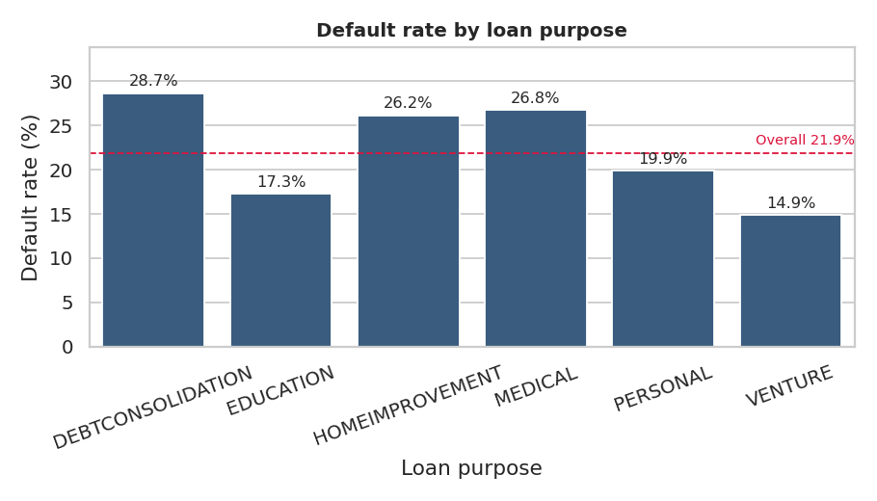
Figure 6: Default rate by loan purpose
Loans taken to consolidate debt, or for medical and home-improvement needs, default more often than loans for education or ventures. Debt consolidation and medical loans are often taken under financial pressure, which is consistent with their higher risk.

6.4 Prior default on file
Prior default | Loans | Default rate
N | 26,681 | 18.4%
Y | 5,730 | 37.9%
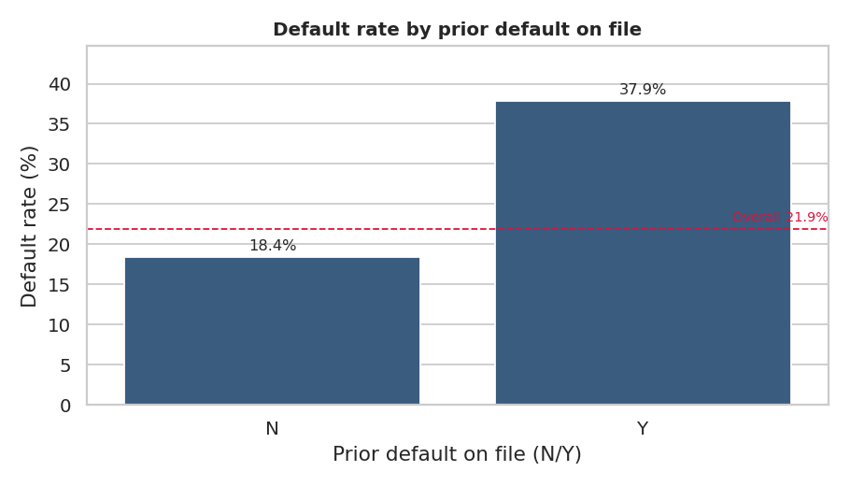
Figure 7: Default rate by prior default record
A borrower with a previous default is about twice as likely to default again. This is a cheap, reliable flag for underwriting teams.

7. Default Patterns by Numeric Factors

7.1 Loan-to-income ratio
Loan as % of income | Loans | Default rate
0-10% | 10,427 | 11.8%
10-20% | 11,999 | 15.1%
20-30% | 6,166 | 22.0%
30-40% | 2,700 | 68.9%
40%+ | 1,119 | 74.2%
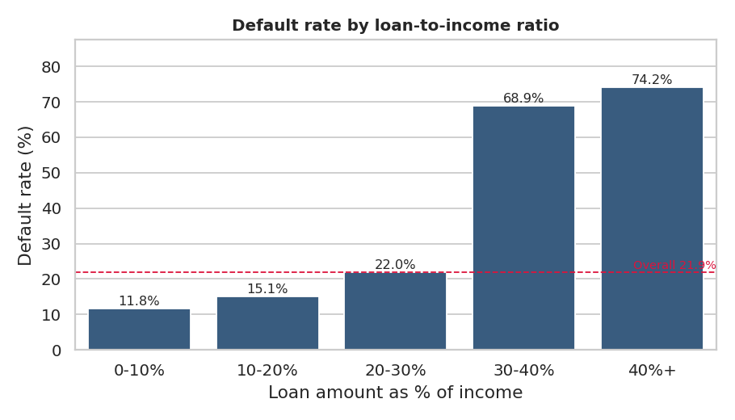
Figure 8: Default rate by loan-to-income ratio
This is the clearest threshold in the data. Up to 30% of income, default rises gradually from 12% to 22%. Beyond 30% it leaps to 69% and 74%. It is an affordability measure: a borrower asked to repay more than three-tenths of a year's income struggles to do so.

7.2 Income
Income quintile | Loans | Default rate
Q1 (lowest) | 6,591 | 43.3%
Q2 | 6,508 | 23.5%
Q3 | 6,367 | 18.3%
Q4 | 6,484 | 14.6%
Q5 (highest) | 6,461 | 9.2%
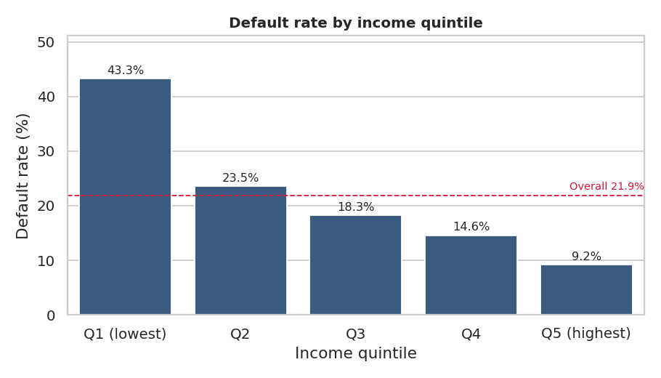
Figure 9: Default rate by income quintile
Risk falls steadily as income rises, from 43% in the lowest fifth to 9% in the highest.

7.3 Interest rate
Interest rate | Loans | Default rate
<8% | 8,896 | 9.4%
8-11% | 7,967 | 15.5%
11-14% | 9,564 | 19.7%
14-17% | 5,111 | 49.8%
17%+ | 873 | 68.3%
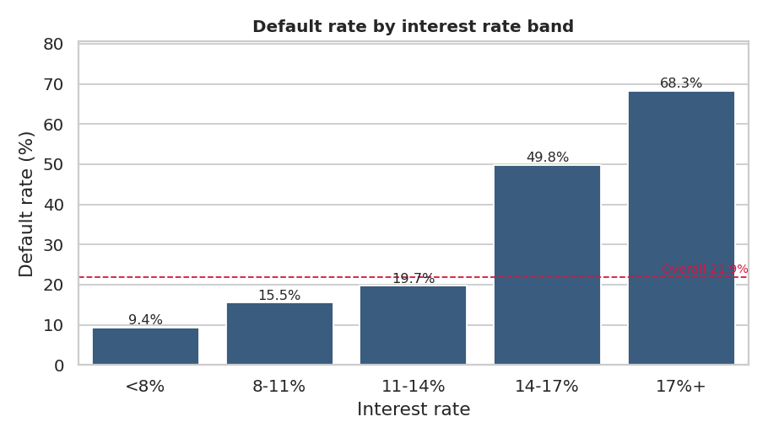
Figure 10: Default rate by interest-rate band
Higher rates go with higher default. This follows partly from pricing: the lender already charges more to borrowers it judges risky. Raising rates does not cause default here; it reflects risk already seen.

7.4 Age and employment length
Age band | Loans | Default rate
20-24 | 12,222 | 23.3%
25-29 | 11,142 | 21.4%
30-34 | 4,973 | 20.0%
35-44 | 3,320 | 20.5%
45+ | 754 | 22.7%
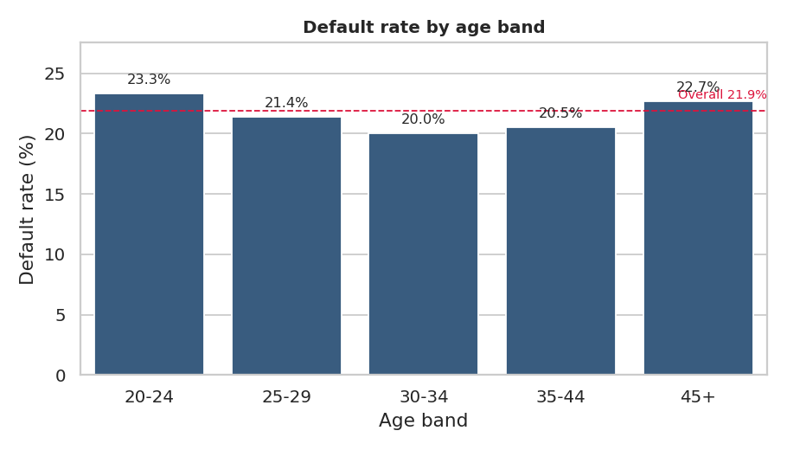
Figure 11: Default rate by age band
Age is nearly flat (20% to 23%), so it is a weak risk factor in this data. Employment length shows a mild downward trend: borrowers with 0-1 years of employment default at 27.9%, versus 16.2% for those with more than 10 years.

8. Correlation & Combined Effects
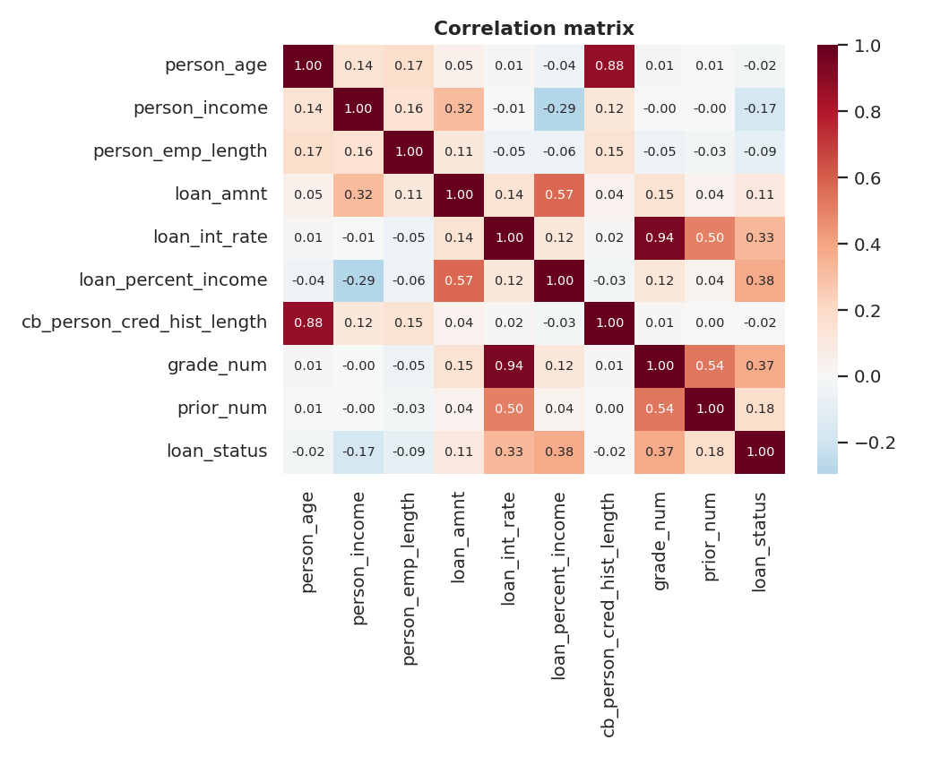
Figure 12: Correlation matrix (grade and prior default encoded numerically)
Correlation with default (Pearson):
Variable | Correlation with default
loan_percent_income | 0.380
grade_num | 0.373
loan_int_rate | 0.334
prior_num | 0.179
loan_amnt | 0.106
cb_person_cred_hist_length | -0.016
person_age | -0.022
person_emp_length | -0.086
person_income | -0.169

Loan-to-income (0.38), loan grade (0.37) and interest rate (0.33) lead, followed by prior default (0.18) and income (-0.17). Grade and interest rate are themselves highly correlated, so they overlap in what they tell us.

8.1 Where risks combine
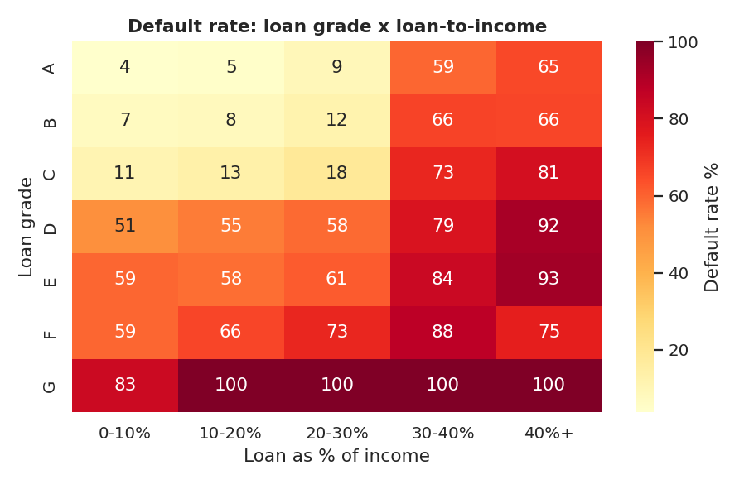
Figure 13: Default rate by loan grade and loan-to-income band
The heatmap shows the compounding effect: a grade A borrower with a small loan has a low default rate, while a weaker grade combined with a high loan-to-income ratio pushes default close to certainty.
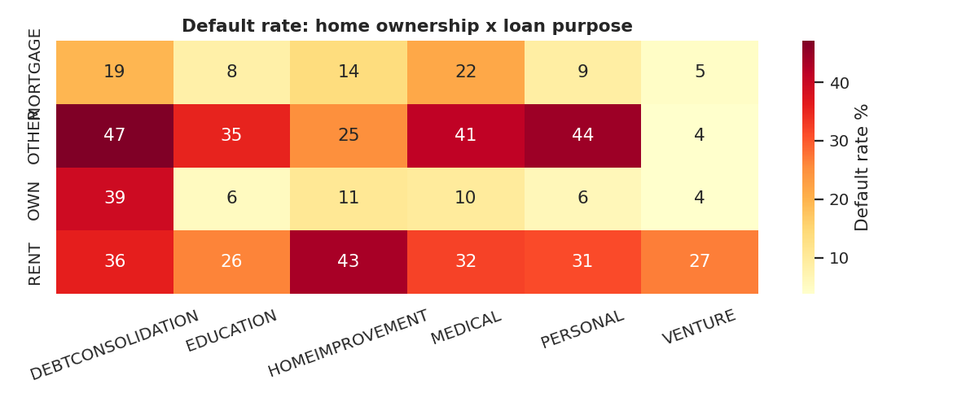
Figure 14: Default rate by home ownership and loan purpose
Renters borrowing for debt consolidation, medical or home-improvement purposes are the most exposed segment; home-owners are consistently safe across all purposes.

9. Risk Scorecard
To turn the findings into something a credit officer could use, a simple additive scorecard was built. One point is added for each of six risk flags:
- Loan grade D to G
- Loan amount at least 30% of income
- Renter or "other" housing
- Prior default on file
- Interest rate of 14% or more
- Income in the bottom quartile
Flags | Loans | Default rate
0 | 9,629 | 4.4%
1 | 10,131 | 7.4%
2 | 6,322 | 28.9%
3 | 3,615 | 57.6%
4 | 1,872 | 66.9%
5 | 725 | 87.6%
6 | 117 | 99.1%
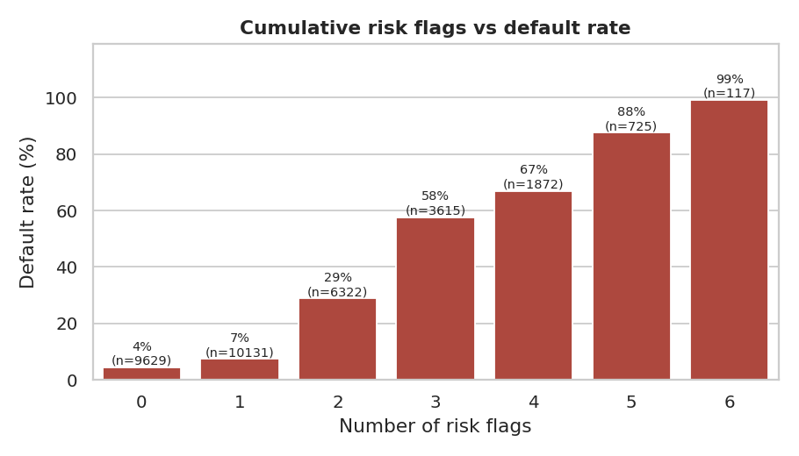
Figure 15: Default rate by number of risk flags
Risk climbs quickly: borrowers with 0 or 1 flag default at 4-7%, while those with 3 flags default at 58% and those with 5 or more flags at nearly 90% or above. The two lowest tiers contain about 61% of all loans, meaning most of the portfolio is low risk and risk is concentrated in a minority with several flags.
Limitation: the flags use thresholds chosen from the exploratory analysis on the same data, so the scorecard is descriptive. A production scorecard would be validated on separate data.

10. Predictive Modelling

10.1 Approach
Default was framed as a binary classification problem. Categorical variables were one-hot encoded, numeric variables were standardised for Logistic Regression, and the data was split 80/20 into training and test sets with stratification so both sets keep the same default rate. Three models were compared: Logistic Regression (a transparent baseline), Random Forest and Gradient Boosting.

10.2 Results on the test set
Model | AUC | Accuracy | Precision | Recall | F1
Logistic Regression | 0.869 | 0.814 | 0.553 | 0.778 | 0.647
Random Forest | 0.929 | 0.924 | 0.888 | 0.748 | 0.812
Gradient Boosting | 0.922 | 0.925 | 0.934 | 0.707 | 0.804

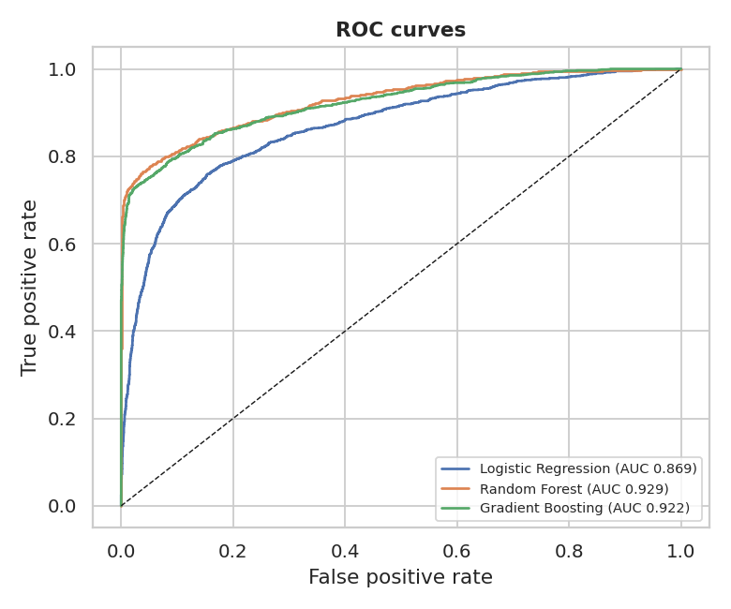
Figure 16: ROC curves for the three models
Random Forest has the best AUC (0.929) and F1, Gradient Boosting has the highest precision (0.934), and Logistic Regression is clearly weaker (AUC 0.869) because it cannot capture the sharp thresholds seen in the data, such as the 30% loan-to-income jump.

10.3 Understanding the errors
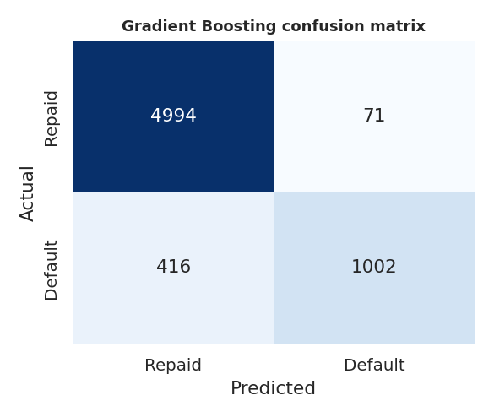
Figure 17: Gradient Boosting confusion matrix
Of 1418 actual defaults in the test set, Gradient Boosting caught 1002 and missed 416 (recall about 71%). It wrongly flagged only 71 of 5065 good loans. In lending, missing a default usually costs more than rejecting a good borrower, so a lender may lower the decision threshold to raise recall, accepting more false alarms. Logistic Regression with class weighting is an example of this trade-off: recall of 0.78 but precision of only 0.55.

10.4 Feature importance
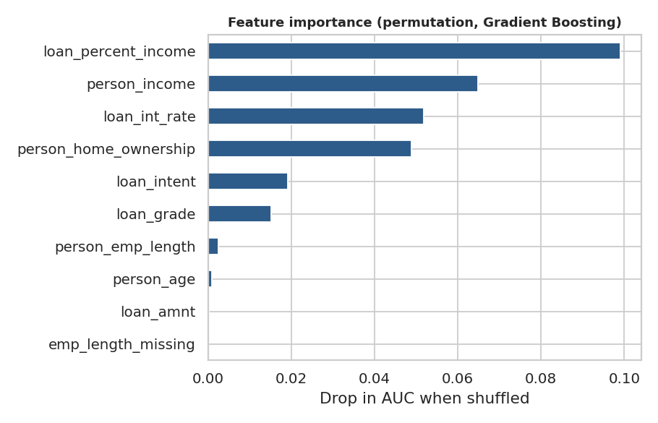
Figure 18: Permutation importance (Gradient Boosting)
Permutation importance measures how much the AUC drops when a feature is shuffled. Loan-to-income ratio, income, interest rate and home ownership matter most; age, employment length and loan amount alone contribute almost nothing. Loan grade scores lower than its category analysis suggests because its information overlaps with interest rate.

11. Recommendations
- Use loan-to-income as a hard guardrail. Loans above about 30% of income show default rates near 70%. Cap the ratio or require extra security above it.
- Tighten underwriting for grades D and below. These grades have 59-98% default rates; they warrant stronger collateral, lower limits or decline.
- Treat prior default as a mandatory review trigger. It doubles risk and is simple to check.
- Segment by purpose and housing. Renters seeking debt-consolidation or medical loans are the highest-risk segment and deserve closer income verification.
- Adopt a multi-flag scorecard for triage. Auto-approve 0-1 flag applications, send 2-3 flags to manual review, and decline or restructure 4+ flags.
- Tune model thresholds to business cost. Choose the cut-off by weighing the cost of a missed default against the cost of a rejected good borrower, rather than defaulting to 0.5.

12. Limitations & Future Work
- The dataset is a public, simulated-style sample; findings demonstrate method rather than describing any real bank.
- Grade and interest rate are set by the lender, so using them as predictors partly reuses the lender's own risk view. A model that must assess brand-new applicants before pricing should be tested without them.
- The analysis shows association, not causation.
- Loan amounts have no currency or date information, so time trends and loss-given-default could not be studied.
- Future work: hyperparameter tuning, SHAP explanations, probability calibration, threshold optimisation with a cost matrix, and a Power BI or Tableau dashboard on the cleaned file.

13. Conclusion
Default in this portfolio is not random. It concentrates among borrowers who borrow a large share of their income, hold weaker grades, pay higher rates, earn less, rent their homes and have a prior default. When these flags stack up, default becomes close to certain; when none are present it is rare (4.4%). Machine learning models confirm the same story and predict default well (AUC about 0.93), but the simple scorecard achieves much of the separation with rules that a credit officer can read and explain.
The project demonstrates an end-to-end analyst workflow on finance data: data cleaning, exploratory analysis, segmentation, scorecard design, modelling and business recommendations.

Appendix: Project files
File | Purpose
data/credit_risk_dataset.csv | Original Kaggle data
data/credit_risk_cleaned.csv | Cleaned data
data/credit_risk_featured.csv | Cleaned data with bands and risk flags
notebooks/Credit_Risk_Analysis.ipynb | Full executed analysis notebook
analysis.py | Script that regenerates all charts and results
charts/ | All 18 charts used in this report
README.md | Project summary

