PROJECT REPORT
Supermarket Sales Dashboard
Analysis of Sales, Profit and Quantity using Power BI
Prepared by
Ashutosh Kumar Singh
B.Tech (CSE – Data Science), Delhi, India
Tools: Power BI Desktop · DAX · Excel/CSV
October 2026

Contents
1. Introduction
2. Tools and Data
3. Dashboard Overview
4. KPI Analysis
5. Time Analysis: Months and Quarters
6. Geographic Analysis: Regions and States
7. Customer Segment Analysis
8. Ship Mode Analysis
9. Product-Level Analysis
10. Key Findings
11. Business Recommendations
12. Dashboard Evaluation and Improvements
13. Limitations and Assumptions
14. Conclusion
Appendix A: Corrections to the README
Appendix B: Values Read from the Dashboard

1. Introduction

1.1 Background
Retail businesses generate large volumes of transactions every day, but raw rows of sales data do not help a manager decide what to stock, where to focus or when to run promotions. A dashboard turns that data into a small set of visuals that can be read in seconds. This project presents a Power BI dashboard, titled Supermarket Sales Dashboard, that summarises sales, profit and quantity sold for a supermarket operating across the United States.
This report analyses the dashboard in detail. It explains how the dashboard is built, interprets every visual, derives additional metrics from the numbers it shows, and converts the findings into practical business recommendations and design improvements.

1.2 Objectives
- Track overall Sales, Profit and Quantity sold.
- Analyse sales trends by month and quarter, with a Year slicer available for deeper cuts.
- Compare performance across states and regions.
- Understand the sales split by customer segment (Consumer, Corporate, Home Office).
- Review ship mode usage and the sub-categories that drive revenue.
- Identify products that make or lose money at product level.
- Let users filter dynamically by Quarter, Year, State and Month.

1.3 Scope of this report
The analysis is based on the dashboard screenshot and the project README. The underlying data file was not part of the files supplied, so every number in this report is either printed on the dashboard or derived arithmetically from numbers printed on it. Values that had to be estimated by measuring a chart (for example the ship-mode bars) are clearly marked as approximate. Section 13 lists the resulting limitations.

2. Tools and Data

2.1 Tools used
Tool | Role in the project
Power BI Desktop | Data modelling, DAX measures, visual design, slicers and interactivity
DAX | Measures such as Total Sales, Total Profit and Total Quantity
Excel / CSV | Source data loaded into Power BI

2.2 Data fields visible in the dashboard
Although the raw file is not included, the visuals reveal which fields the data model contains:
Field | Evidence in dashboard | Used for
Product ID / Product Name | Detail table (e.g. FUR-BO-10000112) | Product-level sales, quantity and profit
Sub-Category | Button slicer (Binders, Envelopes, Bookcases, Chairs …) | Filtering by product family
Segment | Donut chart | Consumer, Corporate, Home Office split
Ship Mode | Area chart | Standard, Second, First class and one more mode
State / Region | Map and treemap | Geographic analysis; four regions (Central, East, South, West)
Order date (Month, Quarter, Year) | Bar chart, pie chart, slicers | Seasonality and period filtering
Sales, Quantity, Profit | KPI cards and table | Core measures

2.3 Data observations
- Product IDs follow a pattern of category code, sub-category code and number. In the visible rows, FUR-BO appears to mean Furniture – Bookcases. This is an inference from the IDs and the product names, not a field shown separately.
- The table total (22,97,200.86) uses Indian digit grouping, while the cards use the 2.30M style. Both refer to the same figure, 2,297,200.86; the mixed formats suggest the table inherits the system locale.
- Currency is not displayed anywhere on the dashboard. Because the map and states are in the US, amounts are presumably in US dollars, but the report quotes plain numbers.

3. Dashboard Overview
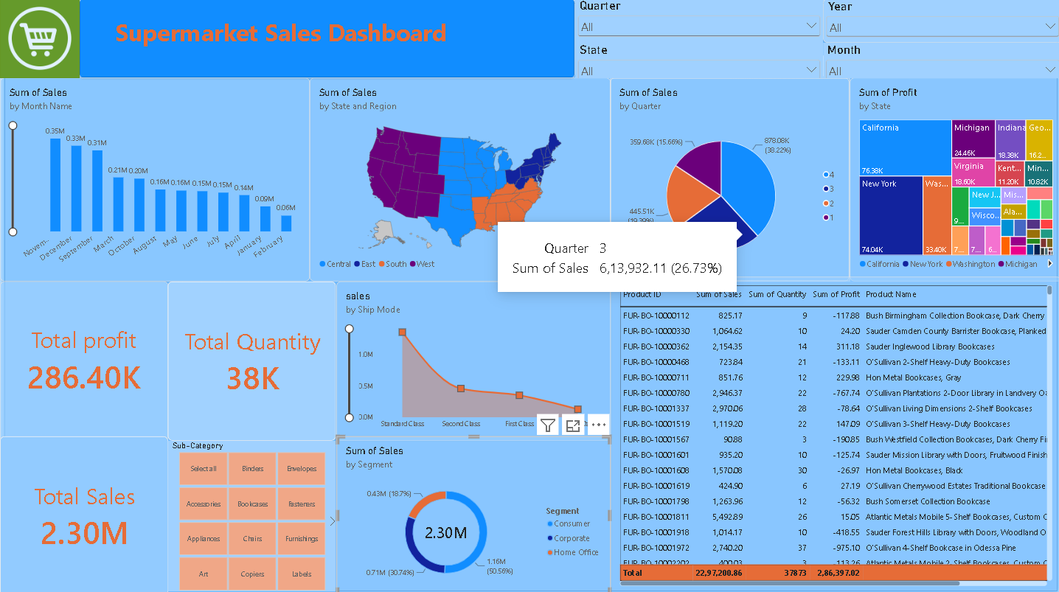
Figure 1: The Supermarket Sales Dashboard
The dashboard uses a single-page layout on a light-blue canvas with orange text for key numbers. The title banner and cart logo sit top-left, four dropdown slicers (Quarter, Year, State, Month) sit top-right, and the visuals are arranged in three bands: trend and geography at the top, KPIs and mix charts in the middle, and a product table on the right.
Visual | Type | What it shows
Sum of Sales by Month Name | Column chart | Monthly sales, sorted from highest (November) to lowest (February)
Sum of Sales by State and Region | Filled map | US states coloured by region: Central, East, South, West
Sum of Sales by Quarter | Pie chart | Share of sales by quarter, with value and percentage labels
Sum of Profit by State | Treemap | Profit contribution by state; California and New York dominate
Total Profit / Quantity / Sales | KPI cards | 286.40K / 38K / 2.30M
Sales by Ship Mode | Area/line chart | Sales for each shipping class
Sum of Sales by Segment | Donut chart | Consumer, Corporate and Home Office share
Sub-Category | Button slicer | One-click filter by product sub-category
Product table | Table | Product ID, sales, quantity, profit and name with a totals row

3.1 Interactivity
Every visual is cross-filtered. Selecting a quarter, state, month or sub-category recalculates the cards, charts and table together. This is what turns the page from a static summary into an exploration tool: a manager can select Bookcases and Q4 and see how those products behave in the busiest quarter. All slicers are set to All in the screenshot, so this report covers the full dataset.

4. KPI Analysis
The three headline cards give the overall scale of the business. The table total confirms them at full precision, and a few ratios can be derived from them.
Metric | Value | Source
Total Sales | 2,297,200.86 (shown as 2.30M) | KPI card; table total
Total Profit | 286,397.02 (shown as 286.40K) | KPI card; table total
Total Quantity | 37,873 (shown as 38K) | KPI card; table total
Profit margin | 12.47% | Derived: profit ÷ sales
Average sales per unit | 60.66 | Derived: sales ÷ quantity
Average profit per unit | 7.56 | Derived: profit ÷ quantity

A margin of about 12.5% means that for every 100 units of sales the business keeps roughly 12.5 as profit. That is a workable but not generous margin: a few percentage points lost to discounts, freight or a poor product mix can erase a large share of profit. This is why the loss-making products in Section 9 matter far more than their size suggests.
The dashboard has no margin card, so this key ratio has to be calculated by the reader. Adding it is the first improvement suggested in Section 12.

5. Time Analysis: Months and Quarters

5.1 Monthly sales
The dashboard sorts months by sales value rather than calendar order. The chart below re-plots the same values in calendar order, which makes the seasonal shape easier to see.
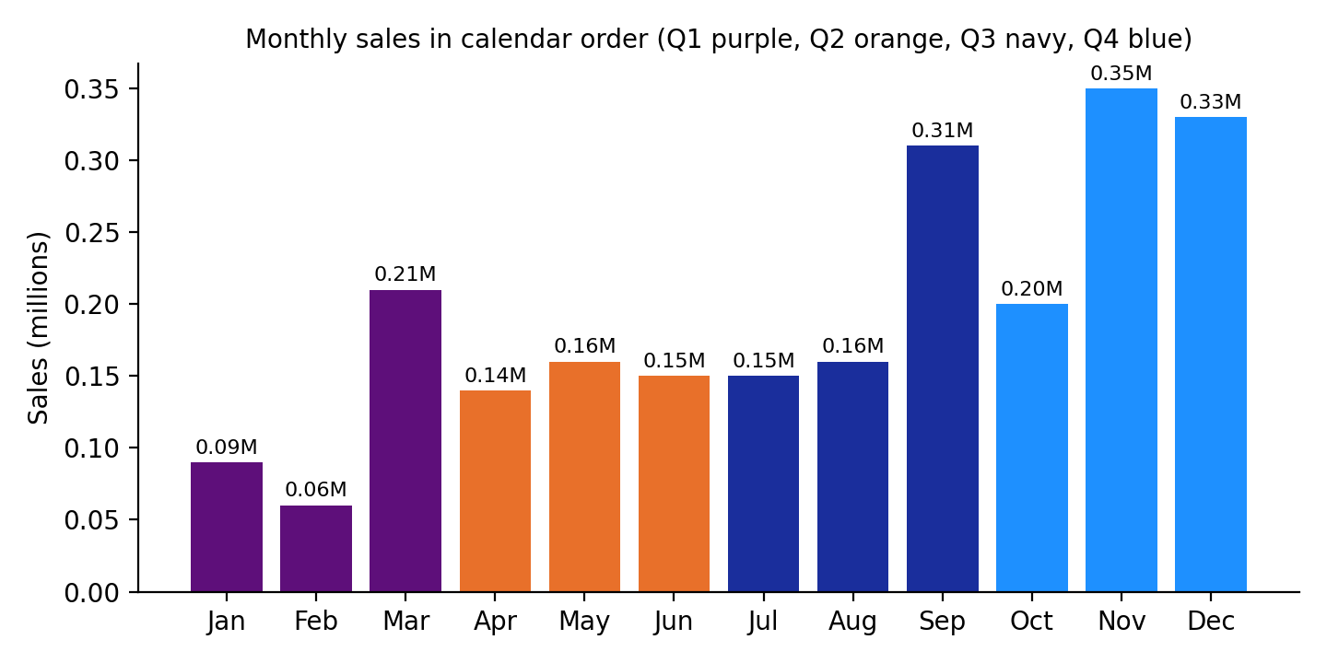
Figure 2: Monthly sales in calendar order (values as labelled on the dashboard)
Month | Sales (M) | Share of 2.30M
January | 0.09 | 3.9%
February | 0.06 | 2.6%
March | 0.21 | 9.1%
April | 0.14 | 6.1%
May | 0.16 | 7.0%
June | 0.15 | 6.5%
July | 0.15 | 6.5%
August | 0.16 | 7.0%
September | 0.31 | 13.5%
October | 0.20 | 8.7%
November | 0.35 | 15.2%
December | 0.33 | 14.3%

Month labels on the dashboard are rounded to two decimals, so shares are approximate (the labels add to 2.31M against the exact 2.30M).

5.2 Quarterly sales
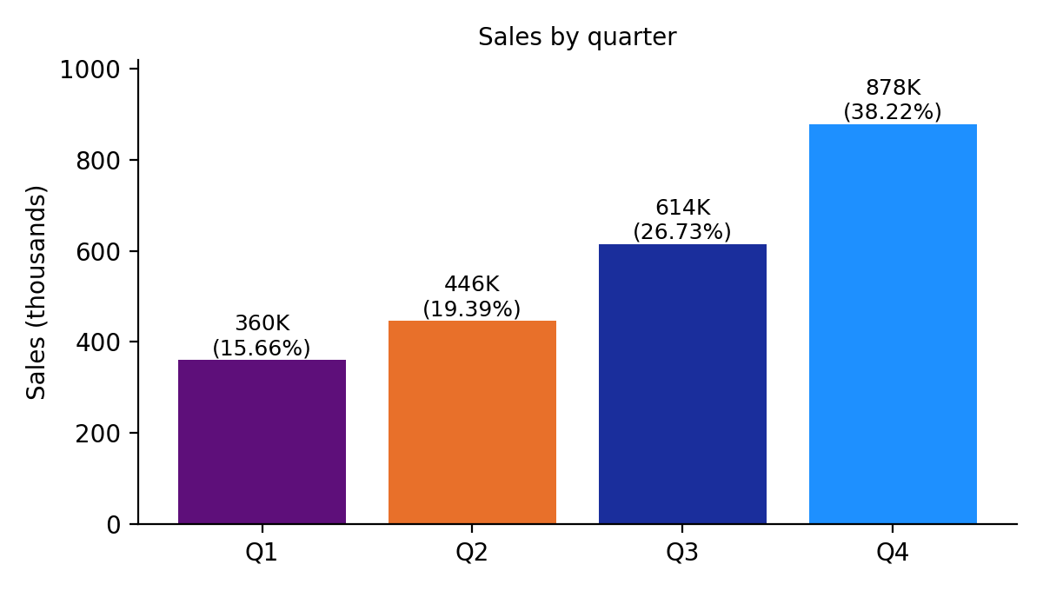
Figure 3: Sales by quarter
Quarter | Months | Sales | Share
Q1 | Jan–Mar | 359.68K | 15.66%
Q2 | Apr–Jun | 445.51K | 19.39%
Q3 | Jul–Sep | 613,932.11 | 26.73%
Q4 | Oct–Dec | 878.08K | 38.22%

5.3 Observations
- Q4 is the strongest quarter by a wide margin with 38.22% of sales. Q3 comes second at 26.73%, which the dashboard shows in its tooltip. The monthly bars agree: October, November and December add up to about 0.88M.
- The second half of the year carries about 65% of sales (Q3 + Q4 = 64.95%), while the first half carries about 35%.
- November is the peak month at 0.35M, followed by December (0.33M) and September (0.31M). These three months alone produce roughly 43% of annual sales.
- February is the weakest month at 0.06M, about one-sixth of November. January and February together contribute only about 6.5%.
- September is a notable jump: it nearly doubles August (0.31M against 0.16M) and then October falls back to 0.20M. This looks like a back-to-school or seasonal-start effect, but the data shown cannot confirm the cause.
- March (0.21M) is the best first-half month, ahead of April to July, suggesting a spring or financial-year-end bump.
Because the Year slicer is set to All, these months combine every year in the dataset. The dashboard therefore shows seasonality well but cannot show whether sales are growing from one year to the next.

6. Geographic Analysis: Regions and States

6.1 Regional map
The filled map colours every state by region: West (purple), Central (light blue), East (dark blue) and South (orange). The map shows the sales-by-region structure, but the regional totals are not labelled, so the dashboard cannot say which region leads. Adding data labels or a small regional bar chart would answer that at a glance.

6.2 Profit by state
The treemap shows profit rather than sales, so it answers a different question from the map. The labelled tiles are:
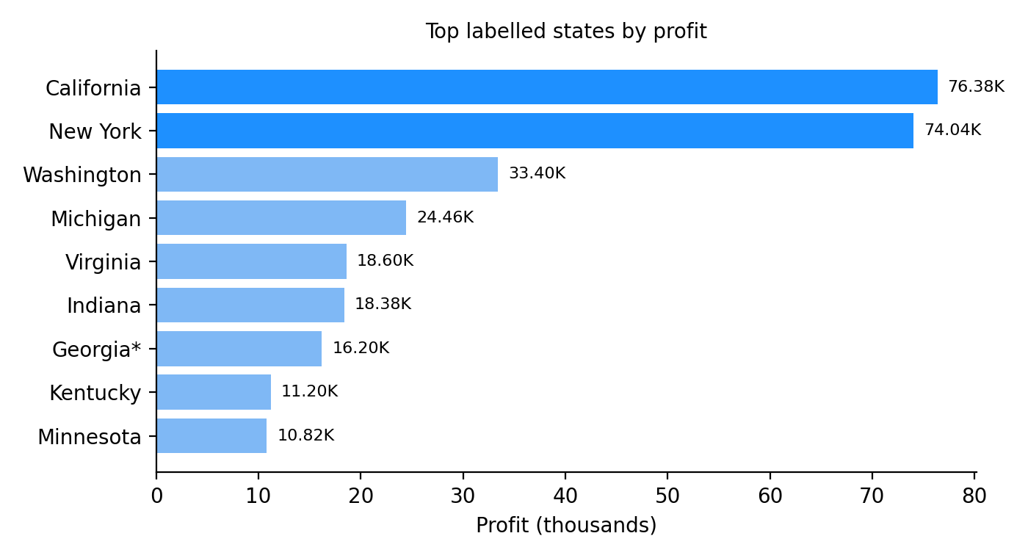
Figure 4: Top labelled states by profit (Georgia's label is truncated on the dashboard; 16.2K is the visible part)
State | Profit | Share of total profit
California | 76.38K | 26.7%
New York | 74.04K | 25.9%
Washington | 33.40K | 11.7%
Michigan | 24.46K | 8.5%
Virginia | 18.60K | 6.5%
Indiana | 18.38K | 6.4%
Georgia (approx.) | 16.2K | 5.7%
Kentucky | 11.20K | 3.9%
Minnesota | 10.82K | 3.8%

6.3 Observations
- California and New York are the profit engines. Together they generate about 150K of the 286K total, which is 52.5% of all profit from two states.
- Concentration is high. The top four states (California, New York, Washington, Michigan) deliver about 72.7% of profit.
- A treemap cannot show losses. The nine labelled states already add up to roughly 283.5K, which is about 99% of the 286.4K total, even though many smaller tiles remain unlabelled. The only way this adds up is if some states have negative profit that the treemap cannot display. This is an inference from the arithmetic, and it means the dashboard may be hiding its worst-performing states.
- The map uses sales while the treemap uses profit, so the two should not be compared directly without a note on the dashboard.

7. Customer Segment Analysis
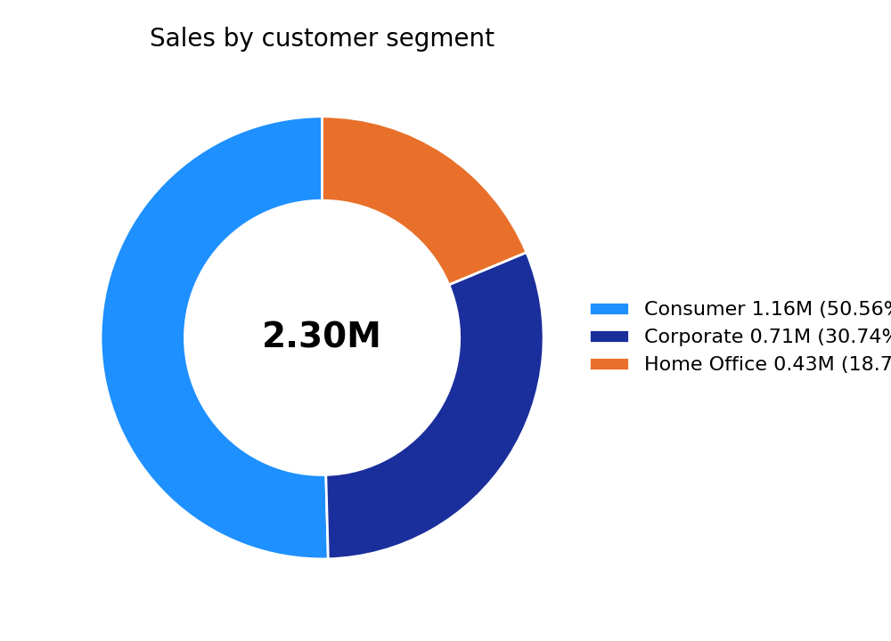
Figure 5: Sales by customer segment
Segment | Sales | Share
Consumer | 1.16M | 50.56%
Corporate | 0.71M | 30.74%
Home Office | 0.43M | 18.70%

- Consumer customers generate half of all sales (50.56%), making them the core of the business.
- Corporate is a solid second at 30.74%. Bulk and repeat purchasing is typical of business buyers, so this segment is a good target for contract pricing or loyalty offers.
- Home Office is the smallest at 18.70% and the segment with the most room to grow, especially with furniture and office supplies appearing in the sub-category list.
The dashboard shows only sales for each segment. Profit by segment would reveal whether the largest segment is also the most profitable, which sales alone cannot tell.

8. Ship Mode Analysis
The ship-mode visual shows four points. The last category label is cut off in the screenshot, so it is shown here as "4th class"; the three visible names are Standard Class, Second Class and First Class. The values below were estimated by measuring the chart against its 0.0M, 0.5M and 1.0M axis marks, so they are approximate (roughly ±0.03M).
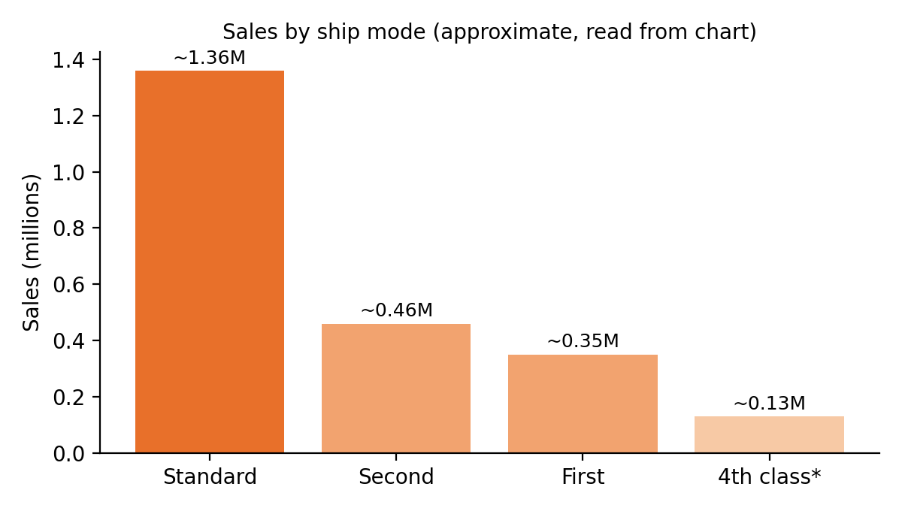
Figure 6: Sales by ship mode (approximate; *label cut off on the dashboard)
Ship mode | Approx. sales | Approx. share
Standard Class | 1.36M | 59%
Second Class | 0.46M | 20%
First Class | 0.35M | 15%
4th class (label cut off) | 0.13M | 6%

- Standard Class dominates, carrying close to 60% of sales. Customers overwhelmingly choose the cheapest, slowest option.
- Faster modes together account for roughly 40% of sales, which is a meaningful share and suggests a segment of customers who will pay for speed.
- The estimates add up to 2.30M, which supports the measurements.
An area chart implies a continuous trend between categories. Ship modes are separate categories with no natural order, so a sorted bar chart would be the more accurate choice (see Section 12).

9. Product-Level Analysis
The table on the right of the dashboard lists products with their sales, quantity and profit. The rows visible in the screenshot are all bookcases (Product IDs starting FUR-BO), sorted by Product ID. They are a scrolled slice of the full product list, not a top-N ranking, but they are the only product-level evidence available and they are revealing.
Product ID | Product name (shortened) | Sales | Qty | Profit
FUR-BO-10000112 | Bush Birmingham Collection Bookcase, Dark Cherry | 825.17 | 9 | -117.88
FUR-BO-10000330 | Sauder Camden County Barrister Bookcase | 1,064.62 | 10 | 24.20
FUR-BO-10000362 | Sauder Inglewood Library Bookcases | 2,154.35 | 14 | 311.18
FUR-BO-10000468 | O'Sullivan 2-Shelf Heavy-Duty Bookcases | 723.84 | 21 | -133.11
FUR-BO-10000711 | Hon Metal Bookcases, Gray | 851.76 | 12 | 229.98
FUR-BO-10000780 | O'Sullivan Plantations 2-Door Library | 2,946.37 | 22 | -767.74
FUR-BO-10001337 | O'Sullivan Living Dimensions 2-Shelf | 2,970.06 | 28 | -78.64
FUR-BO-10001519 | O'Sullivan 3-Shelf Heavy-Duty Bookcases | 1,119.20 | 22 | 147.09
FUR-BO-10001567 | Bush Westfield Collection Bookcases | 90.88 | 3 | -190.85
FUR-BO-10001601 | Sauder Mission Library with Doors | 935.20 | 10 | -125.74
FUR-BO-10001608 | Hon Metal Bookcases, Black | 1,570.08 | 10 | -26.97
FUR-BO-10001619 | O'Sullivan Cherrywood Estates Bookcase | 424.90 | 6 | 27.19
FUR-BO-10001798 | Bush Somerset Collection Bookcase | 1,263.96 | 12 | -56.32
FUR-BO-10001811 | Atlantic Metals Mobile 5-Shelf Bookcases | 5,492.89 | 26 | 15.05
FUR-BO-10001918 | Sauder Forest Hills Library with Doors | 1,014.17 | 10 | -418.55
FUR-BO-10001972 | O'Sullivan 4-Shelf Bookcase in Odessa Pine | 2,740.20 | 37 | -975.10
FUR-BO-10002202 | Atlantic Metals Mobile 2-Shelf Bookcases | 400.03 | 3 | -113.26

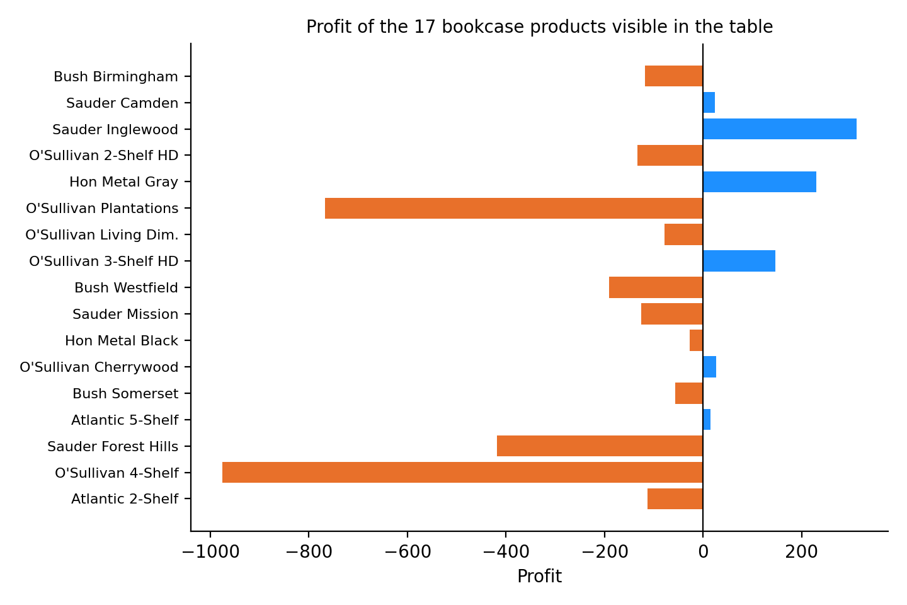
Figure 7: Profit of the 17 visible bookcase products (orange = loss, blue = profit)

9.1 Findings from the visible rows
Measure | Value
Products visible | 17
Combined sales | 26,587.68
Combined quantity | 255
Combined profit | -2,249.47 (margin -8.46%)
Loss-making products | 11 of 17 (65%)
Total loss on those 11 | -3,004.16 on sales of 15,479.96
Profitable products | 6, with combined profit of 754.69

- Most visible bookcases lose money. 11 of the 17 products are loss-making, and together the 17 products produce a net loss even though the business as a whole earns 286K.
- The biggest losses sit on large sales. The O'Sullivan 4-Shelf Bookcase in Odessa Pine sold 37 units for 2,740.20 and lost 975.10. The O'Sullivan Plantations 2-Door Library sold 2,946.37 and lost 767.74. The Sauder Forest Hills Library lost 418.55 on sales of just over 1,000.
- High sales do not mean high profit. Atlantic Metals Mobile 5-Shelf Bookcases has the largest sales in the table (5,492.89) but earns only 15.05, a margin of about 0.3%.
- The profitable items show what good looks like. Sauder Inglewood Library Bookcases earned 311.18 on 2,154.35 (about 14% margin), and Hon Metal Bookcases, Gray earned 229.98 on 851.76 (about 27%).
The dashboard does not contain a Discount or Cost field, so the cause of the losses cannot be proved from it. Heavy discounting, high freight on bulky furniture and unfavourable purchase cost are the usual candidates and should be checked in the source data.

10. Key Findings
- Scale and margin: sales of 2.30M, profit of 286.40K and 37,873 units give a profit margin of 12.47%, with an average sale of about 60.66 per unit.
- Strong seasonality: Q4 delivers 38.22% of sales and Q3 26.73%; together the second half is about 65% of the year. February (0.06M) is one-sixth of November (0.35M).
- Geographic concentration: California and New York produce 52.5% of profit; the top four states produce about 72.7%.
- Hidden losses: the treemap cannot display negative values, and the arithmetic suggests some states are loss-making.
- Customer mix: Consumers bring 50.56% of sales, Corporate 30.74% and Home Office 18.70%.
- Shipping preference: Standard Class accounts for roughly 59% of sales.
- Product profitability problem: among the 17 visible bookcases, 11 lose money and the group has a margin of -8.46%.
- The README has two errors (see Appendix A): it names Q3 as the highest quarter when Q4 is highest, and it describes the treemap as sales by state when it shows profit by state.

11. Business Recommendations
Area | Recommendation | Reason
Inventory and staffing | Build stock and staffing plans around Q4 and September; keep leaner levels in January and February. | Q4 = 38.22% of sales; February is the lowest month.
Promotions | Run targeted campaigns in January–February and April–July to lift the low months, rather than discounting the peak. | Peak months already sell well; low months have the most headroom.
Pricing and discounts | Audit every loss-making product, starting with the bookcases that lose the most; review discount depth, supplier cost and freight. | 11 of 17 visible bookcases lose money, some on high sales.
Product mix | Promote products with healthy margins (for example Sauder Inglewood, Hon Metal Gray) ahead of high-volume, low-margin lines. | Sales volume alone is a poor guide to profit.
Regional strategy | Protect California and New York, and study Washington and Michigan as the next tier; investigate the weakest states for losses. | Top two states earn 52.5% of profit.
Segments | Offer bundle or contract pricing to Corporate and starter packs to Home Office. | Corporate and Home Office are 49% of sales combined and less developed than Consumer.
Shipping | Check shipping cost against price for Standard Class; consider a modest premium for faster modes. | About 59% of sales ship Standard, 41% pay for faster options.

12. Dashboard Evaluation and Improvements

12.1 Strengths
- A clear one-page layout that covers time, geography, segment, shipping and product views.
- The slicers and sub-category buttons give fast, intuitive filtering.
- KPI cards use large, readable numbers.
- Useful hover tooltips (for example the Quarter 3 value and share on the pie chart).
- Consistent use of orange for key numbers.

12.2 Suggested improvements
Issue observed | Suggested improvement
Months are sorted by sales, not by calendar | Sort by month number so seasonality reads left to right, or add a line for the trend.
Ship-mode data shown as an area chart; chart title is lower-case "sales" | Use a sorted bar chart and a consistent title such as "Sum of Sales by Ship Mode".
Treemap hides negative profit | Use a bar chart sorted by profit so loss-making states appear as negative bars, or add a conditional colour.
No profit margin KPI | Add a Profit Margin % card and an average-sales-per-unit card.
Map shows regions but no regional totals | Add data labels or a small region bar chart.
Detail table sorted by Product ID | Sort by profit ascending by default so the worst products appear first; add conditional red/green font for profit.
Orange text on a blue background has modest contrast | Use a darker text colour or a neutral background for small labels.
Mixed number formats (2.30M vs 22,97,200.86) | Set one locale and one display format across the report.
No year-on-year view | Add a Year trend line or a year-over-year change card.
No discount field | Add Discount to the data model and show it beside profit in the product table.

12.3 Example DAX measures
The table and column names below are placeholders; replace them with the names in the actual data model.
Profit Margin % = DIVIDE ( SUM ( Sales[Profit] ), SUM ( Sales[Sales] ) )
Avg Sales per Unit = DIVIDE ( SUM ( Sales[Sales] ), SUM ( Sales[Quantity] ) )
Loss-Making Products = COUNTROWS ( FILTER ( VALUES ( Sales[Product ID] ), CALCULATE ( SUM ( Sales[Profit] ) ) < 0 ) )

13. Limitations and Assumptions
- The raw dataset was not supplied. All figures come from the dashboard image and README, so analysis is limited to what the visuals display.
- Several chart labels are rounded (for example 0.35M), and the monthly labels add to 2.31M against the exact 2.30M total.
- The ship-mode values are estimated from the chart axis, and the fourth category's name is cut off.
- The Georgia tile label is truncated (16.2…); 16.2K is treated as its visible value.
- The product table is a scrolled slice of bookcases, not the full product list. Conclusions about profitability apply to those rows only.
- The Year slicer is set to All, so time periods combine multiple years if the data spans them. Growth cannot be assessed.
- The causes of seasonality and losses (promotions, discounts, freight, cost) are hypotheses; the dashboard has no field to confirm them.
- Currency is not shown and is assumed to be US dollars given the US geography.

14. Conclusion
The Supermarket Sales Dashboard gives a compact and well-organised view of a business with 2.30M in sales, 286.40K in profit and 37,873 units sold. The analysis shows a business with a pronounced second-half peak led by Q4, a heavy reliance on California and New York for profit, a Consumer-led customer base, and a strong preference for Standard shipping.
The most important discovery is not on the cards but in the product table: a number of high-selling bookcases lose money, and the treemap's design can hide loss-making states. Fixing these blind spots, by adding a margin KPI, a sorted profit view and discount data, would turn the dashboard from a description of what sold into a tool that shows where profit is being made and lost.
As a portfolio project, it demonstrates data modelling, DAX, visual design and interactive filtering in Power BI, and this report shows the ability to read a dashboard critically and turn it into actionable business advice.

Appendix A: Corrections to the README
README statement | What the dashboard shows | Suggested fix
"Q3 contributed the highest share of sales (26.73%) among all quarters." | Q4 has the highest share (38.22%, 878.08K). Q3 is second at 26.73%. | Say that Q4 is highest at 38.22% and Q3 second at 26.73%.
"Sum of Sales by State – tree map of top-selling states" | The treemap title is Sum of Profit by State. | Rename it to profit by state in the README.
"California and New York are the top-performing states by sales." | The treemap shows California and New York leading in profit. State sales are not labelled. | Say "by profit" or add state sales labels.
Repository file `Supermarket_Sales_Dashboard.pbix` | The zip contains only README.md and the screenshot. | Add the .pbix and the source data file to the repository.

Appendix B: Values Read from the Dashboard
Item | Value | Precision
Total Sales | 2.30M (table total 2,297,200.86) | Exact (table)
Total Profit | 286.40K (table total 2,86,397.02) | Exact (table)
Total Quantity | 38K (table total 37,873) | Exact (table)
Quarter 1 / 2 / 3 / 4 | 359.68K / 445.51K / 613,932.11 / 878.08K | Labelled
Segment | Consumer 1.16M, Corporate 0.71M, Home Office 0.43M | Labelled (rounded)
Monthly sales | Nov 0.35M, Dec 0.33M, Sep 0.31M, Mar 0.21M, Oct 0.20M, Aug 0.16M, May 0.16M, Jun 0.15M, Jul 0.15M, Apr 0.14M, Jan 0.09M, Feb 0.06M | Labelled (rounded)
Profit by state | CA 76.38K, NY 74.04K, WA 33.40K, MI 24.46K, VA 18.60K, IN 18.38K, GA 16.2K, KY 11.20K, MN 10.82K | Labelled
Ship mode | ~1.36M, ~0.46M, ~0.35M, ~0.13M | Estimated from chart
Product table | 17 bookcase rows (Section 9) | Exact (as printed)

