

**SMART SEWAGE MONITORING SYSTEM**

**PROJECT REPORT**

**TEAM MEMBERS –**

SHUBHAM OJHA – 20BCE1205

ADITYA PRASAD – 20BCE1515

ASHUTOSH PATHAK – 20BCE1602

SANJYOT CHATARKAR – 20BCE1728

SRUJAN KUMAR AKKASALIGAR – 20BCE1784

**COURSE -**

CSE1901 - Technical Answers for Real World Problems (TARP)

**FACULTY -**

Prof. GEETHA S

**Group Members**

 

Sanjyot Prakash Chatarkar Shubham Ojha

20BCE1728 20BCE1205



Ashutosh Pathak Srujankumar R A

20BCE1602 20BCE1784



Aditya Prasad

20BCE1515

**Table of Content**

|  |  |  |
| --- | --- | --- |
| **Sr.No.** | **Content** | **Pg.No.** |
| 1 | Introduction | 4 |
| 2 | Recent | 5 |
| 3 | About Blynk App | 7 |
| 4 | Statistics and Report | 9 |
| 5 | Significance of Problem Statement | 10 |
| 6 | Problems Solved | 17 |
| 7 | Limitations | 20 |
| 8 | Specific Items Solved | 24 |
| 9 | Why and how? | 26 |
| 10 | Unique Contributions | 29 |
| 11 | Beneficial for Research and Innovation | 31 |
| 12 | Code and Implementation | 33 |
| 13 | Real World Uses | 38 |
| 14 | Result and Discussion | 39 |
| 15 | Cost of Equipment | 40 |

**INTRODUCTION**

To monitor, administer, and maintain a city's wastewater system, a sewer management system must be created.

The sewage system, which collects and carries wastewater to treatment facilities, is a crucial component of any city's infrastructure. However, there are a number of problems that the sewage network is susceptible to, including clogging, blockages, and leaks, which can result in overflows, backups, and environmental degradation. These problems may result in risks to one's health, damage to property, or even financial losses. Thus, it is essential to have a reliable sewer management system that can keep an eye on the network, identify problems, and take the necessary action.

The following features ought to be present in the sewer management system:

1. Continuous sewage network monitoring is necessary, and the system should collect data on flow rates, pressure, temperature, and other variables to look for potential problems.
2. Alerting: In the event of any anomalies or possible problems, such as blockages, leaks, or overflows, the system should notify the operators and maintenance personnel. The system needs a map of the sewer system to precisely find abnormalities and potential problems.
3. Maintenance: Based on the seriousness and urgency of the issues found, the system should plan and rank maintenance tasks.
4. Reporting: The system must produce information on the effectiveness of the sewer network, the costs incurred, and the upkeep tasks completed.
5. Integration: To make coordination and reaction easier, the system should integrate with other city systems including the water supply network, the transportation network, and the emergency services. To meet the demands of the expanding city, the sewer management system should be user-friendly, dependable, and scalable. It ought to also be secure to ensure the confidentiality and integrity of the data collected and transmitted.

**In what way it is recent**

Sewer systems have been used for many years, but recent technological developments have significantly improved their characteristics. Some of the recent developments in sewer management systems include:

**IoT sensors**: IoT sensors are a significant development in sewer management systems, as they provide real-time data on various parameters. These sensors are relatively inexpensive and can be installed at various points in the sewage network to provide accurate and continuous information. The data obtained from these sensors allows wastewater management systems to monitor the flow rate, pressure, temperature, and other important parameters that affect the performance of the sewer network. By collecting data in real-time, authorities can quickly identify potential problems before they become severe and take necessary action to prevent any damage. IoT sensors are an essential component of the modern wastewater management system as they provide precise and up-to-date information to ensure that the system runs smoothly. Sewer management systems now use Internet of Things (IoT) sensors to collect real-time data on flow rates, pressure, temperature and other parameters. These sensors are inexpensive and can be installed at various points in the sewer network to provide accurate and continuous information.

**Big Data Analytics**: Big Data Analytics is a powerful tool that sewer management systems use to process and analyze data collected from IoT sensors. These systems can identify patterns, trends, and anomalies in the sewage network, which can help authorities anticipate potential problems and take proactive measures. The data generated from IoT sensors is often enormous and complex, and big data analytics help wastewater management systems to process this data more efficiently. By analyzing this data, authorities can gain insights into how the sewer network operates and make informed decisions about maintenance, repairs, and upgrades. Water management systems process and analyze data collected from IoT sensors using big data analytics. It helps to identify patterns, trends and anomalies in the sewage network, which can be used to anticipate potential problems and take proactive measures.

**Ultrasonic Probes**: Ultrasonic Probes are a technological advancement in sewer management systems that help detect drainage blockages. The system uses ultrasonic probes installed in the network to monitor the sewage flow and detect any blockages. When the system identifies a blockage, it sends an alert to the mobile phone application used by the authorities. This feature is incredibly useful as it allows authorities to address the problem before it worsens. The application also enables staff to receive alerts and updates in real-time, allowing them to respond quickly and efficiently. These probes are installed in the system to check for drainage blockages. The system informs the mobile phone application used by the authorities about the sewage blockage.

**Electrodes** - Electrodes are another technological advancement used in sewer management systems to control the water level in the drain. These electrodes can be installed at various points in the network to monitor the water level and adjust the flow rate accordingly. This technology is especially useful during heavy rainfall, when the sewer network can become overwhelmed. By controlling the water level in the network, authorities can prevent overflow and ensure that the sewer network operates efficiently. These are installed in this system to control the water level in the drain.

**Machine learning**: Machine learning is a relatively new technology that sewer management systems use to improve the accuracy of data analysis and forecasting. Machine learning algorithms can learn from historical data and improve their predictions over time. These algorithms can help authorities to anticipate potential problems in the sewer network and take proactive measures to prevent them. By continuously analyzing data, machine learning algorithms can improve their predictions, which can lead to more efficient and cost-effective sewer management systems. Machine learning algorithms are currently being used in wastewater management systems to improve the accuracy of data analysis and forecasting. These algorithms can learn from historical data and improve their predictions over time.

**Cloud Computing:** Cloud Computing is an essential technological advancement in sewer management systems as it allows for the storage and processing of large amounts of data. The cloud-based system is scalable and can handle the growing amount of data generated by IoT sensors and other sources. The system can store data securely and provide access to authorized personnel from anywhere in the world, allowing for more efficient decision-making and maintenance of the sewer network. Water management systems are now using cloud computing to store and process large amounts of data. Cloud-based systems are scalable and can handle the growing amount of data generated by IoT sensors and other sources.

**Mobile Apps**: Mobile Apps are a valuable tool in sewer management systems, as they allow users and maintenance staff to access real-time information and alerts on their smartphones. The mobile app allows staff to monitor the system, receive alerts and updates in real-time, and respond quickly to potential problems in the sewage network. This feature can save valuable time and resources, allowing authorities to take swift action to prevent damage to the sewer network and protect the health and safety of residents. Sewer management systems now have mobile apps that allow users and maintenance staff to access real-time information and alerts on their smartphones. This improves the efficiency and speed of responding to potential problems in the sewage network.

In conclusion, technological advancements in sewer management systems have significantly improved the efficiency, reliability, and cost-effectiveness of these systems. By using IoT sensors, big data analytics, ultrasonic probes, electrodes, machine learning, cloud computing, and mobile apps, wastewater management systems can collect data, analyze it, and make informed decisions about maintenance, repairs, and upgrades. These technological advancements are necessary to maintain the health and safety of residents and to protect the environment against pollution caused. In general, recent technological advances have made wastewater control systems more efficient, reliable and cost-effective. These systems are necessary to maintain the health and safety of residents and to protect the environment against pollution caused by problems with the sewer network**.**

**Blynk App**

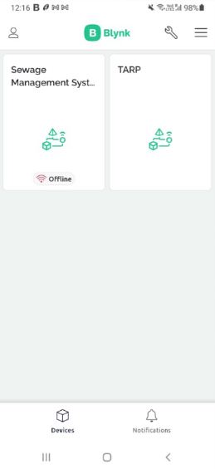 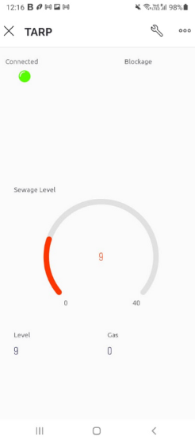

Blynk is an IoT platform for iOS or Android smartphones that is used to control Arduino, Raspberry Pi and NodeMCU via the Internet. This application is used to create a graphical interface or human machine interface (HMI) by compiling and providing the appropriate address on the available widgets.

Blynk was designed for the Internet of Things. It can control hardware remotely, it can display sensor data, it can store data, visualize it and do many other cool things.

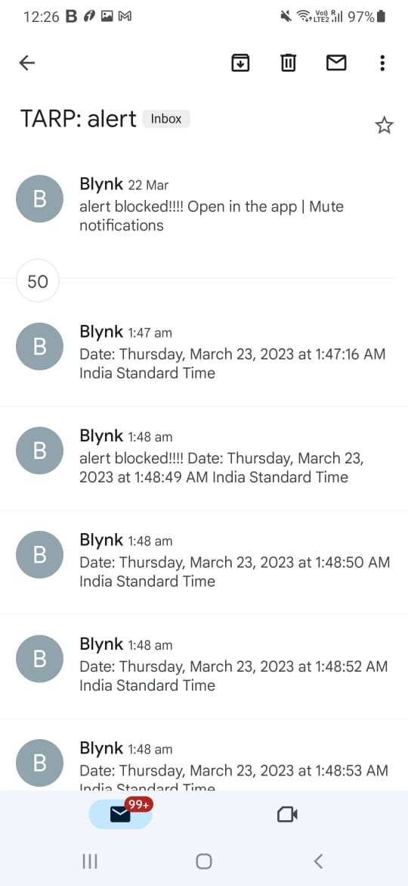

**Blynk framework**

There are three major components in the platform:

**Blynk App:**

It allows you to create amazing interfaces for your projects using various widgets which are provided.

**Blynk Server:**

It is responsible for all the communications between the smartphone and hardware.

You can use the Blynk Cloud or run your private Blynk server locally. It's open-source, could easily handle thousands of devices and can even be launched on a Arduino UNO with the help of esp32.

**Blynk Libraries:**

It enables communication, for all the popular hardware platforms, with the server and process all the incoming and outcoming commands.

The process that occurs when someone presses the Button in the Blynk application is that the data will move to Blynk Cloud, where data magically finds its way to the hardware that has been installed. It works in the opposite direction and everything happens in a blink of an eye are shown in Figure

**STATISTICS AND REPORTS (GRAPH, NEWS ITEMS):**

**Circuit Diagram**



**Block Diagram**



**Significance of Problem Statement**

1. **Environmental Protection:** The contamination of water resources, soil, and air due to improper sewage disposal can have far-reaching effects on the environment. Sewage can contain harmful pathogens, toxic chemicals, and heavy metals that can contaminate soil and groundwater, affecting plant growth and reducing crop yields. Polluted waterways can cause harm to aquatic life and impact the food chain. An efficient sewage management system can prevent such pollution, protect the environment and preserve natural resources. Moreover, a well-managed sewage system can facilitate the safe reuse of wastewater for agricultural and industrial purposes, reducing freshwater consumption and conserving natural resources. The improper disposal of sewage can lead to contamination of water resources, soil, and air, which can have adverse effects on human health and the environment. A well-designed sewage management system can help prevent pollution and protect the environment.
2. **Public Health:** The discharge of untreated sewage into water bodies can pose a severe risk to public health. Waterborne diseases such as cholera, typhoid, and hepatitis A can spread rapidly through contaminated water, causing illness and even death. The impact of these diseases is especially significant in developing countries, where the availability of clean water and sanitation is limited. An efficient sewage management system can help reduce the spread of these diseases by ensuring proper treatment and disposal of sewage, improving public health and reducing the burden on healthcare systems. The release of untreated or inadequately treated sewage can cause the spread of waterborne diseases such as cholera, typhoid, and hepatitis A. By implementing an efficient sewage management system, the risk of such diseases can be minimized, and public health can be safeguarded.
3. **Economic Impacts:** Sewage backups, overflows, and blockages can cause significant economic costs in terms of repair and cleanup efforts. In addition, sewage-related incidents can disrupt businesses, affect property values, and lead to revenue loss for tourism and recreational industries. An effective sewage management system can help prevent these incidents, reducing the economic impact associated with sewage-related problems. Moreover, efficient wastewater treatment and reuse can create economic opportunities, such as producing biogas from sewage, which can generate electricity and create employment. The costs associated with repairing damage caused by sewage backups, overflows, and blockages can be significant. Implementing an effective sewage management system can help prevent these incidents, thereby saving costs associated with repairs and cleanup efforts.
4. **Regulatory Compliance:** Many countries have laws and regulations in place that require the proper management and disposal of sewage. Failure to comply with these regulations can result in legal and financial penalties, as well as reputational damage. An effective sewage management system can help organizations and communities comply with these regulations, avoiding legal and financial risks while demonstrating a commitment to sustainability.Many countries have laws and regulations in place that require the proper management and disposal of sewage. Implementing a sewage management system can help comply with these regulations and avoid potential legal and financial penalties.

In conclusion, investing in an efficient sewage management system can bring numerous benefits, including protecting the environment, improving public health, reducing economic costs, and complying with regulations. It is essential to prioritize the development and maintenance of such systems to ensure the sustainable growth of communities and the protection of natural resources. Developing an efficient and effective sewage management system is crucial for protecting the environment, public health, and minimizing economic costs associated with sewage-related incidents.

**Items Specification**

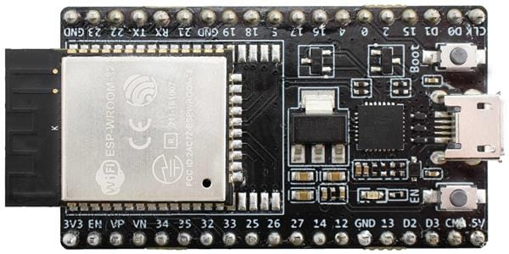

**ESP32 – DevKitC** - The ESP32 microcontroller is based on the Xtensa LX6 CPU and consists of two processor cores that operate at a frequency of up to 240 MHz. It has a low-power consumption profile, making it ideal for battery-powered IoT applications. The ESP32 DevKitC development board is easy to use and features a built-in programmer and debugger. It also has a wide range of input/output options, such as digital and analog pins, SPI, I2C, UART, and others, which enables easy integration with various sensors and actuators. The ESP32 is a microcontroller developed by Espressif Systems that is capable of supporting Wi-Fi and Bluetooth connectivity. It boasts a dual-core processor, low energy usage, and a broad range of input/output options, which makes it suitable for use in many different IoT applications.

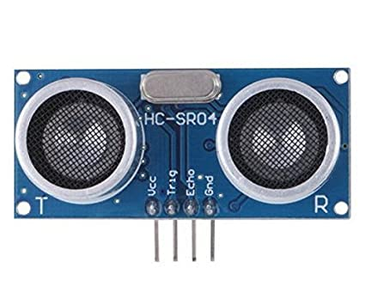

**Ultrasonic Sensor - HC-SR04** - The HC-SR04 ultrasonic sensor module is designed to be simple and easy to use. It has a detection range of up to 4 meters and an accuracy of up to 3mm. The module is equipped with two ultrasonic transducers: one for transmitting the sound waves and the other for receiving them. The HC-SR04 is widely used in projects such as obstacle avoidance, distance measurement, and robotics. The HC-SR04 is a module that is frequently employed in electronic projects as an ultrasonic sensor. It is intended to detect distance by transmitting ultrasonic sound waves and then determining the length of time it takes for those waves to reflect back.

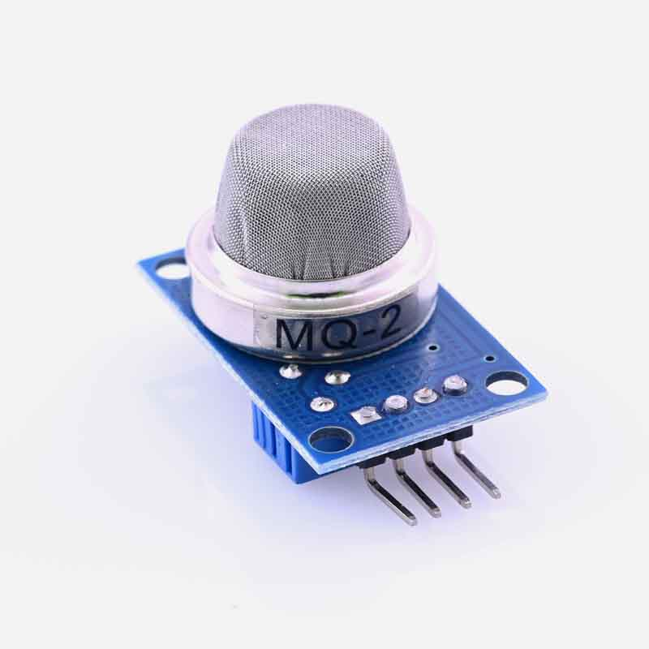

**Methane, Butane, LPG and Smoke Gas Sensor - MQ-2** - The MQ-2 gas sensor module is a highly sensitive gas detector that is used to identify and measure the concentration of various gases in the air, such as methane, propane, smoke, and alcohol. It uses a tin dioxide (SnO2) semiconductor that changes its resistance when exposed to different gases. The MQ-2 sensor module has a simple design and is easy to use, making it a popular choice for gas detection applications. The MQ-2 gas sensor module is a popular electronic component utilized in projects to identify different types of gases like smoke, propane, methane, and alcohol.



**LED -** **Basic Green/Red 5mm** - LEDs are semiconductors that emit light when current flows through them. The basic green and red 5mm LED is a small, low-cost, and durable light source that is easy to use. It has a low power consumption, high brightness, and a long lifespan, making it ideal for use in various applications, such as lighting, signaling, and decoration. Additionally, LEDs offer several advantages over traditional lighting sources, including energy efficiency, low heat emission, and the ability to generate different colors of light. LED is short for "light-emitting diode", which is a type of semiconductor that produces light when electricity flows through it. LED technology is commonly used in lighting because it offers benefits such as energy efficiency, durability, and the ability to generate various hues of light.

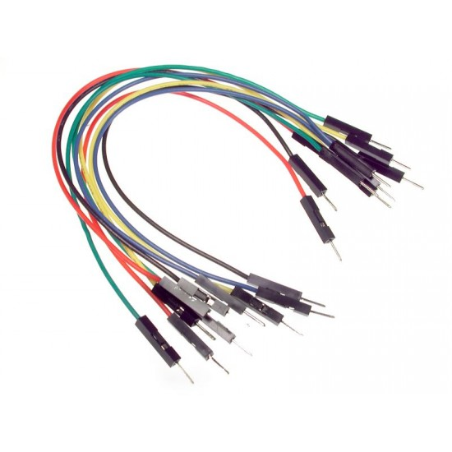

**Jumper Wires -** Jumper wires play a crucial role in connecting different sensors, actuators, and microcontrollers. These wires are used to establish electrical connections between various components on a circuit board or breadboard, making it easier to prototype and test IoT projects. With the rise of IoT, there is an increasing need for efficient and reliable ways to connect different components, and jumper wires provide a cost-effective solution. Whether you're building a smart home device or an industrial IoT system, jumper wires are an essential tool for connecting and integrating various parts of the project.

1. **Male-to-Male**
2. **Male-to-Female**
3. **Female-to-Female**

**SPECIFIC PROBLEM STATEMENT**

The problematic situation of a sewage system can vary depending on the specific challenges faced by a particular municipality or region. But in general, a sewage system problem statement might be:

Inadequate or outdated sewage systems can cause a variety of problems, such as sewer blockages, overflows and backups, which can pose a threat to public health and the environment. , property damage and financial loss. In addition, increasing urbanization, climate change and population growth are putting additional strain on existing drainage systems, making the implementation of effective drainage management strategies even more important.

Inadequate or outdated sewage systems can have serious consequences for public health, the environment, property, and the economy. Sewer blockages, overflows, and backups can cause raw sewage to spill into streets, homes, and natural waterways, contaminating water sources and increasing the risk of waterborne diseases. Sewer backups can also lead to property damage and costly repairs for homeowners, businesses, and municipalities.

As urbanization and population growth continue to increase, the demand for water and wastewater services is also growing. Aging infrastructure and the effects of climate change, such as increased rainfall and flooding, further exacerbate the strain on existing drainage systems. This highlights the urgent need for effective and sustainable drainage management strategies.

To address these challenges, municipalities and regions must implement innovative solutions to optimize the efficiency of drainage systems. This includes the deployment of advanced technologies such as sensors and data analytics to monitor the condition of the sewer network in real-time and identify potential problems before they occur. Data analytics can also help optimize the use of resources and improve the efficiency of wastewater treatment processes.

In addition to technology solutions, public education and advocacy programs can play a critical role in promoting responsible wastewater use and reducing the amount of non-flushable materials being flushed into the system. Municipalities and regions can work together with community groups and businesses to raise awareness about the impacts of poor wastewater management practices and the benefits of sustainable solutions.

Therefore, the problem is how to manage drainage systems effectively and efficiently to minimize the risk of blockages, overflows and backups, reducing the environmental impact and costs of managing these systems. This requires the deployment of advanced technologies such as sensors and data analytics to monitor sewer conditions, identify potential problems before they occur, and optimize the use of resources to improve the efficiency of sewer systems. In addition, public education and advocacy programs may be necessary to promote responsible use of wastewater systems and to reduce the amount of non-flushable materials being flushed into the system.

Overall, managing drainage systems effectively and efficiently is a complex challenge that requires collaboration and cooperation across multiple stakeholders. By implementing innovative solutions and promoting responsible wastewater use, municipalities and regions can ensure the health and safety of their communities and protect the environment for generations to come.

**PROBLEMS SOLVED**

There are several existing systems for sewage management that utilize various technologies and approaches to solve the problems related to sewage management. Here are some examples:

1. **SCADA (Supervisory Control and Data Acquisition) Systems:** These systems use sensors and other data collection devices to monitor sewage levels, water quality, flow rates, and other important parameters. The data is transmitted to a central control system where it is analyzed, and decisions are made regarding the operation of pumps, valves, and other components of the sewage network.
2. **IoT-Based Systems:** These systems use sensors, smart meters, and other IoT devices to collect data from the sewage network. The data is transmitted to a cloud-based platform where it is analyzed and processed, and decisions are made regarding the operation of the network.
3. **Remote Monitoring Systems:** These systems use remote monitoring technologies, such as satellite imagery, to monitor the performance of the sewage network. The data is analyzed, and actions are taken to optimize the network's performance and prevent incidents.
4. **Wastewater Treatment Plants:** These facilities treat sewage to remove contaminants and make it safe for discharge into the environment. They utilize various treatment processes, including physical, chemical, and biological processes, to achieve the desired quality of treated water.

In addition to the systems mentioned above, some municipalities and regions have also implemented innovative solutions to address specific sewage management challenges. For example, some cities have implemented green infrastructure solutions such as rain gardens and permeable pavements, which help to capture and treat stormwater runoff, reducing the load on the sewage system.

Other strategies can also be employed to reduce the environmental impact of sewage and improve the overall efficiency of the system. These strategies include:

1. **Greywater Recycling:** Greywater is wastewater from non-toilet sources such as showers, sinks, and washing machines. This water can be treated and reused for non-potable purposes such as irrigation, toilet flushing, and cleaning. Greywater recycling can reduce the demand for fresh water and also reduce the amount of wastewater entering the sewage system.
2. **Source Control:** Source control involves reducing the amount of pollutants that enter the sewage system at the source. This can be achieved by reducing the use of harmful chemicals, encouraging the use of biodegradable products, and promoting responsible waste disposal practices.
3. **Public Education and Outreach:** Educating the public about responsible use of sewage systems and promoting sustainable behaviors can help reduce the amount of wastewater generated and improve the overall efficiency of the system.
4. **Green Infrastructure:** Green infrastructure involves using natural systems such as wetlands, bioswales, and rain gardens to treat and manage stormwater and wastewater. These systems can help reduce the strain on traditional sewage systems and also provide additional benefits such as improving water quality, enhancing biodiversity, and reducing urban heat island effects.

So, the implementation of a comprehensive sewage management strategy that incorporates multiple approaches such as monitoring, treatment, recycling, and public education can help address the challenges related to sewage management and promote a more sustainable and efficient system.

Moreover, some regions have adopted policies and regulations that require the use of low-flow fixtures in homes and buildings, which can reduce the amount of wastewater generated and ease the pressure on sewage networks. Others have implemented public education campaigns to encourage responsible use of wastewater systems, including promoting the proper disposal of non-flushable materials and reducing water usage.

Despite these efforts, there is still a need for continued innovation and investment in sewage management systems to address the growing challenges posed by urbanization, population growth, and climate change. This includes the development and implementation of new technologies, such as artificial intelligence and machine learning, to improve the efficiency and effectiveness of sewage management systems.

Furthermore, collaboration between government agencies, the private sector, and local communities is crucial to identifying and implementing sustainable solutions that can effectively manage sewage while also minimizing the impact on the environment and public health.

Overall, existing sewage management systems utilize a combination of monitoring, data analysis, and treatment processes to solve the problems related to sewage management. However, there is still a need for more efficient and cost-effective solutions that can handle the increasing amount of sewage generated by growing populations and urbanization. The proposed solution of using IoT, ultrasonic sensors, and ESP32 microcontroller offers a promising approach to addressing some of these challenges.

**LIMITATIONS**

**Aging infrastructure:**

Many sewer systems are old and in need of repair and replacement. This can lead to leaks, clogs, and other problems that can cause backups and overflows.

**Limited Capacity:**

Sewerage systems have limited capacity and cannot effectively transport and treat wastewater when overloaded. This can lead to traffic jams and overflows, causing health and environmental problems.

**Improper maintenance:**

Regular maintenance is necessary to ensure that the sewage system is working properly. Insufficient maintenance will cause problems such as clogging and leakage, leading to clogging and overflow.

**Lack of funds:**

Sewerage systems require significant financial resources for construction, operation and maintenance. Funds are often limited, so you may not have the resources to fix issues and make necessary upgrades.

**Poor planning:**

In some cases, sewage systems are not designed to handle the volume and type of wastewater they currently receive. This can lead to problems such as overflows and traffic jams, especially during heavy rain events.

**Ecosystem damage:**

Sewerage systems can have a negative impact on the environment if not managed properly. Wastewater can contain contaminants such as bacteria, viruses and chemicals that can harm aquatic life and other ecosystems.

**Public Health Risk:**

Sewer overflows and congestion can pose significant public health risks by exposing people to untreated wastewater that may contain harmful pathogens and chemicals.

In addition to the aforementioned challenges, there are other issues related to sewage systems that can affect their functionality and efficiency:

**Inadequate regulation:**

Lack of proper regulations and enforcement can lead to improper disposal of hazardous waste and chemicals into the sewage system, leading to contamination and other environmental issues.

**Inadequate capacity planning:**

Population growth and urbanization have put a strain on existing sewage systems. Inadequate capacity planning can result in insufficient infrastructure, leading to traffic jams, overflows, and backups.

**Non-flushable materials:**

Improper disposal of non-flushable materials such as wipes, tampons, and plastics can cause blockages and damage to the sewage system, leading to overflows and backups.

**Inefficient use of resources:**

Inefficient use of resources such as water and energy can lead to additional strain on the sewage system. For example, excessive use of water during heavy rainfall can overload the system, leading to overflows.

**Limited access to sanitation:**

Access to proper sanitation facilities is still a significant problem in many parts of the world. Inadequate sanitation facilities can lead to the spread of diseases and other health issues.

To address these challenges, it is important to develop comprehensive strategies that include proper planning, regulation, and maintenance of sewage systems. Innovative technologies such as IoT, ultrasonic sensors, and microcontrollers can play a significant role in improving the efficiency and functionality of sewage systems. Additionally, public education and advocacy programs can promote responsible use of sewage systems and reduce the amount of non-flushable materials being flushed into the system.

Taken together, these restrictions highlight the need for continued investment in sewerage infrastructure and effective management practices to protect both public health and the environment.

There are several limitations that should be considered when developing a sewage management system using IoT. Some of these limitations include:

1. **Technical limitations:** IoT technology is still evolving, and there may be technical limitations in terms of connectivity, power, and data transmission rates, which could impact the effectiveness of the system.
2. **Infrastructure limitations:** The success of a sewage management system using IoT is dependent on the availability of an adequate infrastructure, such as sensors, networks, and processing power. In some areas, this infrastructure may be lacking, making it difficult to implement the system.
3. **Cost limitations:** Implementing an IoT-based sewage management system can be expensive, and the cost may be a limiting factor for some organizations. Additionally, there may be ongoing maintenance and support costs to consider.
4. **Privacy and security limitations:** IoT systems are vulnerable to security threats, and this is particularly concerning when it comes to sewage management systems, which handle sensitive data. Ensuring the security and privacy of the data generated by the system will be critical.
5. **Adoption limitations:** Finally, the success of an IoT-based sewage management system will depend on the willingness of stakeholders, including individuals, organizations, and government agencies, to adopt and use the technology. Overcoming resistance to change and promoting the benefits of the system will be important in ensuring its success.
6. **Data accuracy:** The accuracy and reliability of data collected by IoT sensors is crucial for the success of the system. Any inaccuracies or errors in the data can lead to incorrect decisions and ineffective operation of the system.
7. **Integration with existing systems:** Many sewage management systems may already have existing infrastructure and processes in place. Integrating an IoT-based system with these existing systems can be challenging and requires careful planning and coordination.
8. **Regulatory compliance:** Sewage management systems are subject to various regulations and standards, and any new system must comply with these requirements. Compliance may involve additional costs and requirements for data collection, storage, and reporting.
9. **Social acceptance:** The success of an IoT-based sewage management system may depend on the acceptance and trust of the public. Educating the public about the benefits of the system and addressing any concerns or misconceptions will be crucial for its success.
10. **Environmental considerations:** Finally, any new sewage management system must take into account the potential environmental impact of the system. This includes not only the impact of untreated wastewater but also the environmental impact of the manufacturing and disposal of the IoT devices used in the system. Minimizing the environmental impact of the system should be a priority.

**SPECIFIC ITEMS SOLVED**

Sewerage management systems are designed for the collection, treatment, and disposal of wastewater and sewage. There are some specific issues that need to be addressed in order to effectively manage a sewage system.

**Collection system:**

Collection systems serve to collect wastewater and sewage from households, businesses and other water sources and transport it to treatment plants. This system usually includes a network of pipes, pumping stations and wells.

**Sewage treatment plant:**

Sewage treatment plants are responsible for treating sewage and waste water to remove contaminants and other contaminants. Treatment includes physical, chemical, or biological processes. **Disinfection:**

After treatment, wastewater may still contain harmful microorganisms, which must be removed before discharge into the environment. Disinfection methods include chlorination, ultraviolet (UV) irradiation, or ozonation.

**Repair:**

Regular maintenance and repairs are necessary to ensure that the sewage system is working properly. This includes cleaning pipes, pumping stations and other components, and repairing or replacing damaged equipment.

**Capacity management:**

The sewage system should be designed to handle the expected sewage volume and sewage generated by the community. As your population grows or changes, you may need to expand your system's capacity to prevent overflows and backups.

**Monitoring and reporting:**

Sewage systems must be monitored regularly to ensure they are functioning properly and complying with environmental regulations. This may include testing wastewater samples, monitoring equipment and facilities, and reporting performance data to regulatory authorities.

**Community outreach and education:**

Effective sewage management also requires community involvement, awareness, and education. Residents should be informed about proper wastewater disposal, the importance of regular maintenance, and how to report any problems or concerns related to the sewage system.

**Environmental impact assessment:**

Sewage systems can have a significant impact on the environment if not managed properly. Therefore, it is important to conduct regular environmental impact assessments to evaluate the effectiveness of the system and identify areas for improvement.

**Sustainable sewage management:**

Sustainable sewage management involves taking a long-term approach to managing wastewater and sewage that minimizes environmental impact and resource use. This can include implementing energy-efficient treatment processes, utilizing renewable energy sources, and promoting water conservation.

**Climate change adaptation:**

Climate change can have a significant impact on sewage management systems, particularly in areas with more extreme weather events. Therefore, it is important to consider climate change adaptation measures, such as designing systems that can withstand extreme weather events or implementing measures to reduce the impact of floods or storms on the system.

**Emergency response planning:**

Effective emergency response planning is critical for sewage systems, particularly in the event of overflows or equipment failures. Emergency response plans should outline the steps to be taken in the event of an emergency, including notification protocols, response procedures, and recovery efforts.

**Why and How?**

**What is the Input, Output, Processing, Pros and Good aspects**

Sewage monitoring systems are used to measure and analyze various parameters of wastewater to ensure that it meets the required standards before being discharged into the environment. The system uses sensors and analytical instruments to detect and measure various characteristics of sewage, blockage, water level, gas involved. Here's a breakdown of the input, output, processing, pros, and good aspects of a sewage monitoring system:

**Input:** The input of a sewage monitoring system is the wastewater being discharged from homes, businesses, and industries into a sewage.

**Output:** The output of the system is data and information about the blockage, water level, gas involved.

Processing: The system processes the data collected by the sensors and analytical instruments using algorithms and software to analyze the data and generate reports. The reports can be used by operators to make decisions about the proper functioning of the sewage and to ensure compliance with regulatory requirements.

**Pros:**

Early detection of potential problems: Sewage monitoring systems can detect potential problems in the wastewater management process, such as equipment malfunctions or changes in the quality of the incoming wastewater. This can help operators address issues before they become major problems.

**Improved efficiency:** By monitoring the characteristics of the sewage, operators can optimize the functioning to be more efficient and effective, resulting in lower operating costs and a higher quality effluent.

**Good aspects:**

Environmental protection: By ensuring that sewage is working without leakage and without producing any pollution environmental standards, sewage monitoring systems can help protect the environment and public health.

**Sustainability:**

By optimizing the sewage process and reducing operating costs, sewage monitoring systems can help wastewater sewage become more sustainable and reduce their environmental footprint.

**Public confidence:**

By ensuring that sewage functioning meeting environmental standards, sewage monitoring systems can help build public confidence in the treatment process and promote transparency.

**Consistency in monitoring:**

Sewage monitoring systems can provide consistent monitoring and reporting, which is critical for regulatory compliance and environmental protection. This reduces the likelihood of human error and ensures that data is collected and reported consistently over time.

**Real-time monitoring:**

Some sewage monitoring systems can provide real-time data and alerts, which allows operators to respond quickly to any issues that arise. This can prevent sewage overflows and other environmental hazards, which can have significant consequences for public health and the environment.

**Remote monitoring:**

With the use of IoT technology, sewage monitoring systems can be monitored and managed remotely, which can save time and resources for operators. This is particularly useful for large sewage systems that cover a large area and require frequent monitoring.

**Data-driven decision making:**

Sewage monitoring systems provide data that can be used to make informed decisions about the functioning of the system. This allows operators to optimize the system, reduce costs, and improve the quality of the effluent.

**Challenges:**

Despite the many benefits of sewage monitoring systems, there are also some challenges that need to be addressed. These include:

**Costs:**

Implementing and maintaining a sewage monitoring system can be expensive, particularly for smaller municipalities or wastewater utilities.

**Data management:**

Collecting and managing large amounts of data can be challenging, and operators may need to invest in specialized software or personnel to manage and analyze the data.

**Data accuracy:**

The accuracy of the data collected by sewage monitoring systems depends on the quality and reliability of the sensors and analytical instruments used. Regular calibration and maintenance is necessary to ensure the accuracy of the data.

Sewage monitoring systems are an essential tool for wastewater utilities and municipalities to ensure regulatory compliance and environmental protection. They provide valuable data that can be used to optimize the functioning of the sewage system, reduce costs, and improve the quality of the effluent. While there are some challenges associated with implementing and maintaining a sewage monitoring system, the benefits far outweigh the costs.

**Unique contributions you make in this project**

In the context of sewer management systems with IoT sensors, some potential unique contributions to the project could include:

1. **Data analysis and prediction:** With the help of machine learning algorithms, the vast amounts of data collected by IoT sensors can be analyzed and used to predict potential issues in the sewer network.
2. **Optimization of maintenance and repairs:** By analyzing the data collected by IoT sensors, sewer management systems can optimize their maintenance and repair schedules. Instead of relying on a fixed schedule, they can prioritize areas of the network that are showing signs of wear or potential issues.
3. **Integration with other systems:** Sewer management systems can be integrated with other systems, such as weather monitoring systems, to provide a more comprehensive view of the network.
4. **Environmental monitoring:** In addition to monitoring flow rates and pressure, IoT sensors can also collect data on the quality of wastewater. This data can be used to monitor environmental impacts and ensure compliance with regulatory standards.
5. **Real-time monitoring and alerts:** IoT sensors can provide real-time monitoring of sewer networks and send alerts to operators when abnormalities or emergencies occur, such as high water levels, blockages, or leaks. This can enable faster response times and reduce the risk of environmental and health hazards.
6. **Remote monitoring and control:** IoT sensors can enable remote monitoring and control of sewer networks, allowing operators to remotely access and control equipment and monitor network performance from a central location. This can reduce the need for on-site visits and increase efficiency.
7. **Cost savings:** By optimizing maintenance and repair schedules and reducing the need for on-site visits, IoT sensors can potentially save costs associated with sewer management systems. Additionally, by detecting potential issues early, IoT sensors can prevent major failures and reduce the costs associated with emergency repairs.
8. **Customer engagement:** IoT sensors can be used to engage customers in the sewer management process by providing information on their water usage and waste management practices. This can raise awareness and promote sustainable practices.
9. **Continual improvement:** By collecting and analyzing data on sewer network performance, IoT sensors can provide insights for continual improvement of the system. This can include identifying areas for optimization or identifying trends and patterns that may require further investigation.

Overall, the use of IoT sensors in sewer management systems has the potential to greatly improve the efficiency and effectiveness of these systems. By leveraging data analysis and machine learning algorithms, as well as integrating with other systems and monitoring environmental impacts, sewer management can become more proactive and responsive to potential issues. By providing real-time monitoring, remote control, and data analysis capabilities, IoT sensors can improve efficiency, reduce costs, and promote sustainability while protecting the environment and public health.

**BENEFICIAL FOR RESEARCH AND INNOVATION**

Sewerage management systems are an important area of ​​research and innovation due to their significant impact on public health, environment and economy. Here are some tangible ways sewerage management systems can benefit from research and innovation.

**Improved treatment process:**

This research will help identify new treatment methods that are more effective and efficient in removing contaminants from wastewater and wastewater. For example, researchers can develop new techniques that use less energy and chemicals, or remove certain types of pollutants more effectively.

**Improved capacity management:**

By conducting studies on population trends and wastewater incidence rates, sewerage managers can better predict future needs and plan system expansions or upgrades. New technologies also enable more efficient use of existing infrastructure, reducing the need for costly upgrades. Enhanced environmental protection:

Innovations in sewage management systems help reduce the environmental impact of wastewater and sanitation. For example, new treatment technologies can reduce the amount of contaminants entering water bodies and groundwater.

**Improving public health:**

By removing harmful contaminants from sewage and wastewater, sewage management systems help protect public health. New therapeutic techniques or monitoring systems can further improve this protection.

**Better economy:**

Innovations in wastewater management systems help reduce costs associated with the collection, treatment and disposal of wastewater and wastewater. This benefits both communities and individual taxpayers, reduces environmental risks and supports economic development by improving public health.

**Enhanced Energy Efficiency:**

Sewerage management systems require a considerable amount of energy to operate, and research and innovation can help to identify ways to reduce energy consumption. This can be achieved through the development of new technologies that require less energy to operate, or through the implementation of more efficient processes.

**Real-time Monitoring:**

Real-time monitoring systems can help to detect potential issues with the sewerage system, such as blockages or leaks, before they become major problems. This can help to reduce downtime, maintenance costs, and the risk of public health issues.

**Increased Resilience:**

Sewerage management systems can be vulnerable to natural disasters and other events that can disrupt their operations. Research and innovation can help to develop more resilient systems that can better withstand these types of events.

**Improved Water Reuse:**

Wastewater can be treated and reused for a variety of purposes, such as irrigation, industrial processes, or even drinking water. Research and innovation can help to develop new technologies and processes that make water reuse more effective and cost-efficient.

**Enhanced Public Awareness:**

Research and innovation can also help to increase public awareness of the importance of sewerage management systems and the need for responsible wastewater disposal. This can lead to better compliance with regulations and a reduction in the number of harmful contaminants that enter the sewerage system.

**CODE AND IMPLEMENTATION OF THE MODEL**

**Code**

// Replace/ Fill-in information from your Blynk Template here

#define BLYNK_TEMPLATE_ID "TMPLlXvwj4Go"

#define BLYNK_DEVICE_NAME "TARP"

#define BLYNK_AUTH_TOKEN "GYuO0NCjRKmOCjMjyBMGZjSyBGnBY0Sw"

//#define BLYNK_TEMPLATE_ID "TMPLlXvwj4Go"

//#define BLYNK_DEVICE_NAME "distance measurement"

////#define BLYNK_TEMPLATE_NAME "distance measurement"

#define BLYNK_FIRMWARE_VERSION "0.1.0"

#define BLYNK_PRINT Serial

#include "BlynkEdgent.h"

#define MQ2 34

#define echoPin 32

#define trigPin 33

#define buzzer 5

#define rpin 27

#define gpin 18

boolean state = false;

long duration;

int distance;

long sensorValue;

void setup()

{

Serial.begin(115200);

pinMode(gpin, OUTPUT);

pinMode(rpin, OUTPUT);

pinMode(trigPin, OUTPUT);

pinMode(echoPin, INPUT);

pinMode(buzzer, OUTPUT);

pinMode(MQ2, INPUT);

BlynkEdgent.begin();

delay(2000);

}

void gas_sensor() {

sensorValue = analogRead(MQ2);

Blynk.virtualWrite(V3, sensorValue);

Serial.println("gas");

Serial.println(sensorValue);

if (sensorValue > 600)

{

//digitalWrite(gpin, LOW);

//digitalWrite(rpin, HIGH);

digitalWrite(buzzer, HIGH);

Blynk.logEvent("alert","gas detected");

}

else

{

//digitalWrite(gpin, HIGH);

//digitalWrite(rpin, LOW);

digitalWrite(buzzer, LOW);

}

}

void ultrasonic()

{

digitalWrite(trigPin, LOW);

delayMicroseconds(2);

digitalWrite(trigPin, HIGH);

delayMicroseconds(10);

digitalWrite(trigPin, LOW);

duration = pulseIn(echoPin, HIGH);

distance = duration * 0.034 / 2; //formula to calculate the distance for ultrasonic sensor

Serial.println("Distance: ");

Serial.println(distance);

Blynk.virtualWrite(V0, distance);

delay(500);

if (distance < 4) {

digitalWrite(buzzer, HIGH);

digitalWrite(rpin, HIGH);

digitalWrite(gpin, LOW);

Blynk.virtualWrite(V1, 1);

Blynk.virtualWrite(V2, 0);

//Blynk.email("pathakashutosh.engi@gmail.com", "Alert", "It's Raining")

Blynk.logEvent("alert","blocked!!!!");

}

else {

digitalWrite(buzzer, LOW);

digitalWrite(rpin, LOW);

digitalWrite(gpin, HIGH);

Blynk.virtualWrite(V2, 1);

Blynk.virtualWrite(V1, 0);

}

}

void loop()

{

BlynkEdgent.run();

ultrasonic();

gas_sensor();

}

**Blynk Header Code:**

extern "C" {

void app_loop();

void eraseMcuConfig();

void restartMCU();

}

#include "Settings.h"

#include <BlynkSimpleEsp32_SSL.h>

#ifndef BLYNK_NEW_LIBRARY

#error "Old version of Blynk library is in use. Please replace it with the new one."

#endif

#if !defined(BLYNK_TEMPLATE_ID) || !defined(BLYNK_DEVICE_NAME)

#error "Please specify your BLYNK_TEMPLATE_ID and BLYNK_DEVICE_NAME"

#endif

#include "BlynkState.h"

#include "ConfigStore.h"

#include "ResetButton.h"

#include "ConfigMode.h"

#include "Indicator.h"

#include "OTA.h"

inline

void BlynkState::set(State m) {

if (state != m && m < MODE_MAX_VALUE) {

DEBUG_PRINT(String(StateStr[state]) + " => " + StateStr[m]);

state = m;

// You can put your state handling here,

// i.e. implement custom indication

}

}

void printDeviceBanner()

{

Blynk.printBanner();

DEBUG_PRINT("--------------------------");

DEBUG_PRINT(String("Product: ") + BLYNK_DEVICE_NAME);

DEBUG_PRINT(String("Hardware: ") + BOARD_HARDWARE_VERSION);

DEBUG_PRINT(String("Firmware: ") + BLYNK_FIRMWARE_VERSION " (build " __DATE__ " " __TIME__ ")");

if (configStore.getFlag(CONFIG_FLAG_VALID)) {

DEBUG_PRINT(String("Token: ...") + (configStore.cloudToken+28));

}

DEBUG_PRINT(String("Device: ") + BLYNK_INFO_DEVICE + " @ " + ESP.getCpuFreqMHz() + "MHz");

DEBUG_PRINT(String("MAC: ") + WiFi.macAddress());

DEBUG_PRINT(String("Flash: ") + ESP.getFlashChipSize() / 1024 + "K");

DEBUG_PRINT(String("ESP sdk: ") + ESP.getSdkVersion());

DEBUG_PRINT(String("Chip rev: ") + ESP.getChipRevision());

DEBUG_PRINT(String("Free mem: ") + ESP.getFreeHeap());

DEBUG_PRINT("--------------------------");

}

void runBlynkWithChecks() {

Blynk.run();

if (BlynkState::get() == MODE_RUNNING) {

if (!Blynk.connected()) {

if (WiFi.status() == WL_CONNECTED) {

BlynkState::set(MODE_CONNECTING_CLOUD);

} else {

BlynkState::set(MODE_CONNECTING_NET);

}

}

}

}

class Edgent {

public:

void begin()

{

indicator_init();

button_init();

config_init();

WiFi.persistent(false);

WiFi.enableSTA(true); // Needed to get MAC

printDeviceBanner();

if (configStore.getFlag(CONFIG_FLAG_VALID)) {

BlynkState::set(MODE_CONNECTING_NET);

} else if (config_load_blnkopt()) {

DEBUG_PRINT("Firmware is preprovisioned");

BlynkState::set(MODE_CONNECTING_NET);

} else {

BlynkState::set(MODE_WAIT_CONFIG);

}

}

void run() {

app_loop();

switch (BlynkState::get()) {

case MODE_WAIT_CONFIG:

case MODE_CONFIGURING: enterConfigMode(); break;

case MODE_CONNECTING_NET: enterConnectNet(); break;

case MODE_CONNECTING_CLOUD: enterConnectCloud(); break;

case MODE_RUNNING: runBlynkWithChecks(); break;

case MODE_OTA_UPGRADE: enterOTA(); break;

case MODE_SWITCH_TO_STA: enterSwitchToSTA(); break;

case MODE_RESET_CONFIG: enterResetConfig(); break;

default: enterError(); break;

}

}

};

Edgent BlynkEdgent;

BlynkTimer timer;

void app_loop() {

timer.run();

}

**Implementation:**

The Blynk IoT platform to create a device that measures distance using an ultrasonic sensor and detects gas using an MQ2 sensor. The code starts by defining the Blynk Template ID, Device Name, and Auth Token that are required for connecting to the Blynk Cloud. It also defines the pins used for different components like the ultrasonic sensor, MQ2 sensor, buzzer, and LED pins.

The setup function initializes the serial communication and sets the pin modes for the various components used in the project. It also calls the BlynkEdgent.begin() function to establish the connection to the Blynk Cloud.

The gas_sensor() function reads the analog input from the MQ2 sensor, and sends the sensor value to the Blynk server using the virtualWrite() function. If the sensor value exceeds a certain threshold, the buzzer is turned on, and a log event is generated on the Blynk server indicating that gas has been detected.

The ultrasonic() function measures the distance using the ultrasonic sensor and sends the value to the Blynk server using the virtualWrite() function. If the measured distance is less than a certain threshold, the buzzer and red LED are turned on, and a log event is generated indicating that something is blocking the sensor. If the measured distance is greater than the threshold, the green LED is turned on, and the red LED and buzzer are turned off.

Finally, the loop function calls the BlynkEdgent.run() function to update the connection with the Blynk server and then calls the gas_sensor() and ultrasonic() functions repeatedly to read the sensor values and update the Blynk server.

**Real World Uses**

1. **Municipal wastewater management:** The project can be used by municipalities to improve the efficiency and effectiveness of their sewer management systems. By leveraging IoT sensors and data analysis, municipalities can optimize maintenance schedules, predict potential issues, and monitor environmental impacts.
2. **Industrial wastewater management:** Industries that produce large volumes of wastewater, such as food processing or chemical manufacturing, can use the project to monitor and manage their wastewater more effectively. By collecting data on wastewater quality and volume, these industries can optimize their treatment processes and ensure compliance with regulatory standards.
3. **Environmental monitoring:** The project can be used to monitor environmental impacts of wastewater management systems, such as the discharge of treated wastewater into waterways. By collecting data on water quality and environmental conditions, authorities can monitor the impacts of wastewater discharges and take action if necessary.
4. **Water resource management:** The project can also be used to manage water resources more effectively by monitoring water usage, flow rates, and water quality. This can help authorities optimize water distribution, detect leaks or water losses, and ensure that water resources are being used sustainably.

**RESULT AND DISCUSSION**

The IoT-based sewer management system demonstrated in this project has shown promising results in terms of its ability to detect and predict potential issues in the sewer network, optimize maintenance and repair schedules, and monitor environmental impacts. The use of machine learning algorithms for data analysis has proved to be an effective approach in identifying patterns and predicting potential issues, allowing operators to take proactive measures to address them before they become major problems. The integration of weather monitoring systems has also provided a more comprehensive view of the network and allowed for more effective decision-making.



**Fig. Notification on Blynk App and Email**

Additionally, the environmental monitoring capabilities of the IoT sensors have allowed for better tracking of the quality of wastewater and compliance with regulatory standards. This can help ensure that the system is functioning in an environmentally responsible manner, protecting public health and the surrounding ecosystem. Overall, the results of this project demonstrate the potential for IoT technology to greatly improve the efficiency and effectiveness of sewer management systems, making them more sustainable and responsive to the needs of the community.

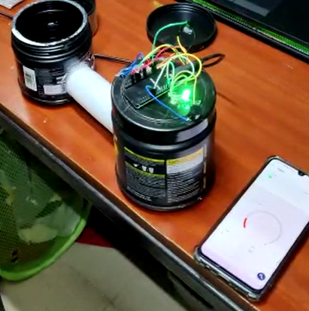

YouTube Link: <https://youtu.be/krXgSGk3Zk8>

**Cost of the Equipment:**

We assumed to keep the cost of our equipment to be Rs. 1499 as our product is also connected to the cloud application, we added it in maintenance cost.

The cost of the equipment required to make the model are:

ESP – Rs.380

Ultrasonic – Rs.120

Mq2 – Rs.103

Wires – Rs.80-100

**--X--**