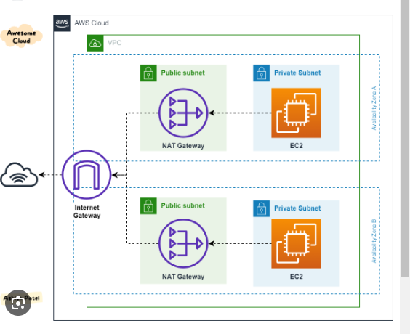
This infra is in private subnet accessable from bastion host in same vpc .There is NAT gateway added to provide internet for the nodes added in cluster.
S3 is created for the backend for storing state file.

