- Slight design tweak

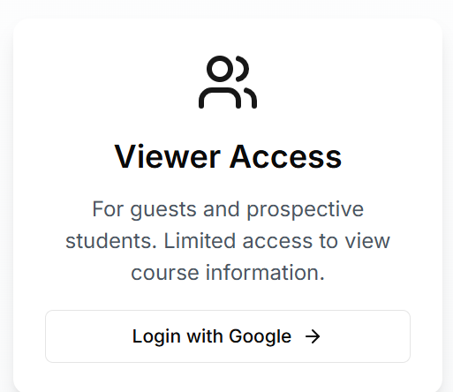
Instead of “Login with Google” write “View as Guest”

- Viewers should not be able to see Course feedbacks as well as not be able to give course feedbacks
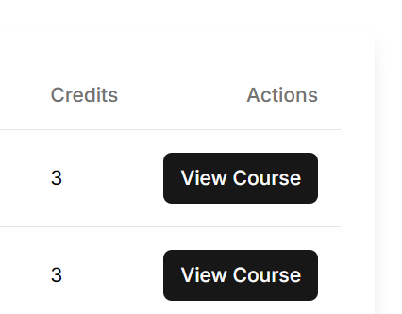
However in the actions keep both the buttons, view course and give feedback
However when the guest user clicks this button pop up a window which reads as follows
“To ensure student privacy and data integrity we regret to inform you that this page cannot be shown to guests. Kindly refer to the image below to observe how this page is displayed to the students:”
{image placeholder}

(I will provide you with the images during finishing touches)

- Remove professor filter
As our data is not unform in regards to prof name kindly remove the professor filter option
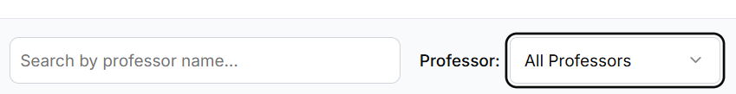

- The downvote tracking issue has not been solved
(After you reload the tracking is lost)
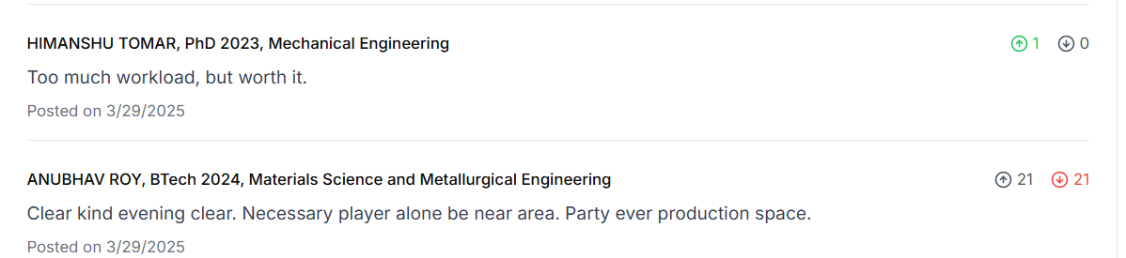

After reloading

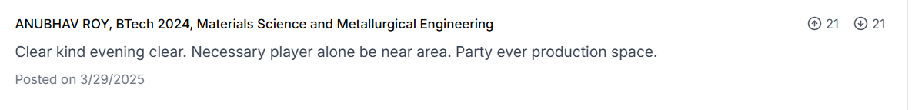
Due to the lost tracking no voting is possible on that comment any further

Same situation for the RESOURCES ( dislike tracking lost after reloading)

- Keep grade obtained in post feedback a compulsory field , iwas able to submit feedback without selecting a grade
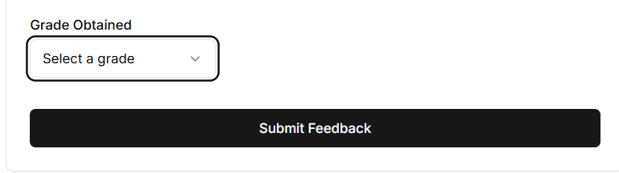
- When you add a resource, if the url is invalid the system does not register it and the resource is not added , however no error screen is shown indicating that the url is incorrect , the user might not understand it
- if the url is incorrect show a pop up – “Kindly provide a valid url and try again”
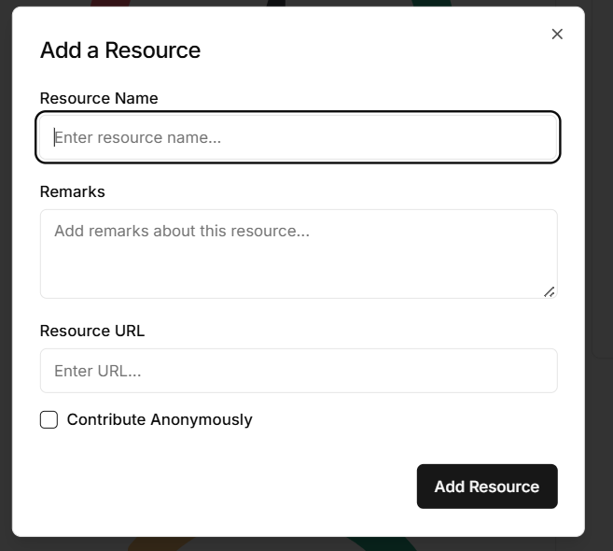

- Slight display tweak -
In edit profile name the field as “Display Name” instead of “Full Name”
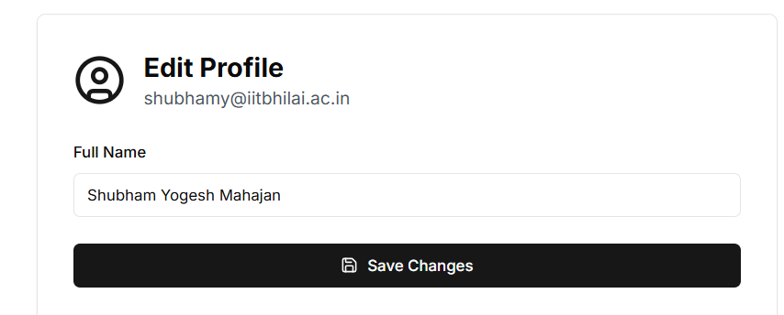

- Design tweak -
Merge the Contact page and About page
(Basically delete the contact page and use the contact page developer cards hyperlinks (email/ git/ linkedin) on the about page instead)
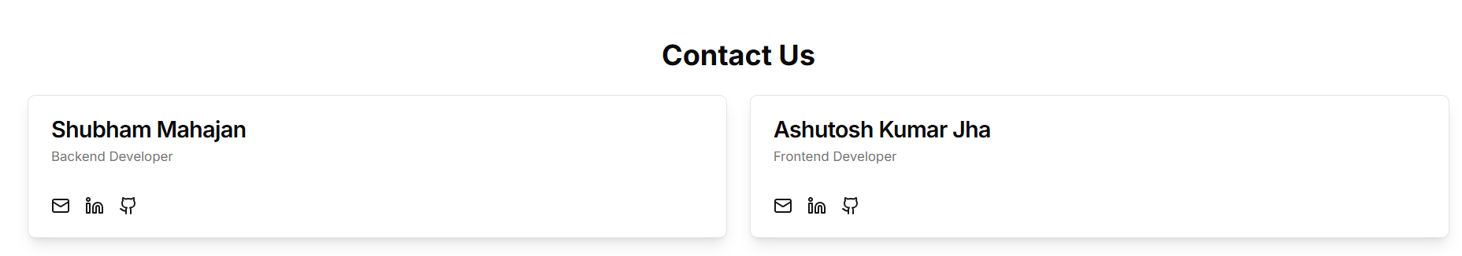

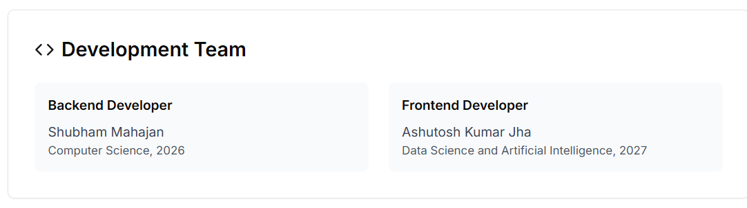
Add the hyperlinks to this and also add an image placeholder where our photos will go

And add tech stack used
“Backend developer
Tech Stack used = Django REST Framework + PostgreSQL “

And for you it will be next js I assume

- Finishing touches ( Display changes)
- Change the name of Website to “IIT Bhilai Student Forum” everywhere


- Edit the text on Home page
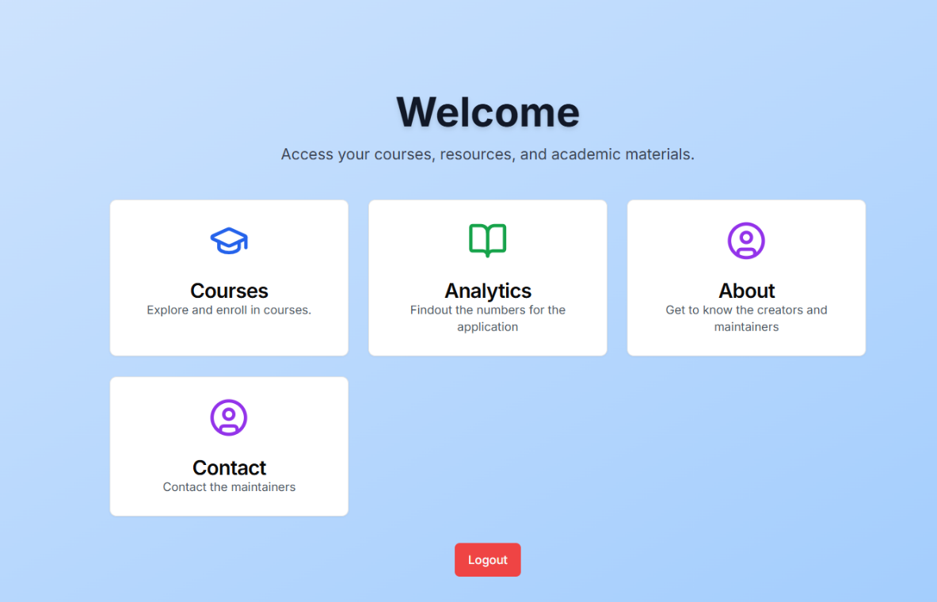

Delete the line below “Welcome” and write –“Real student voices, real course insights — all in one place.”
The contact card will be removed now that contact page is supposed to be deleted

In the text of “Courses card” write – “Explore courses registered on the platform”
“Analytics card” write – “View website statistics”
“About” card – “Get to know our purpose and meet the development team”

- Edit text of about page
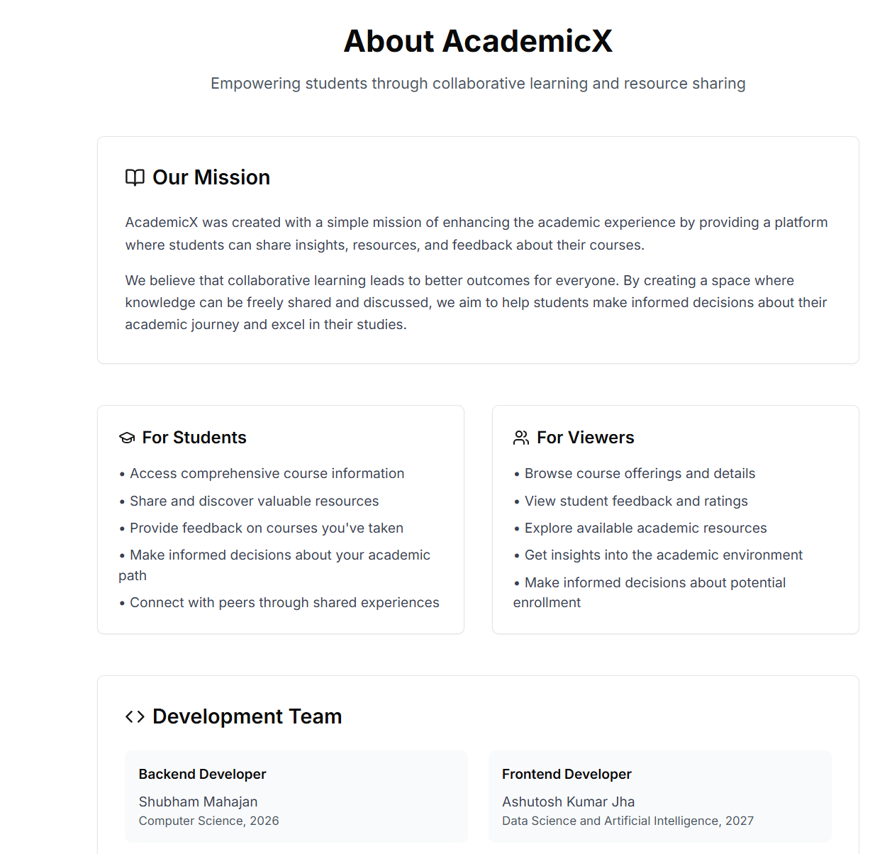
Below the website name write -
“Helping students make smarter course choices through shared feedback and resources.” As our tagline

The our mission is written beautifully
Edit the text of For viewers now that our viewer access has changed.

