Assignment 3

Generating data set:
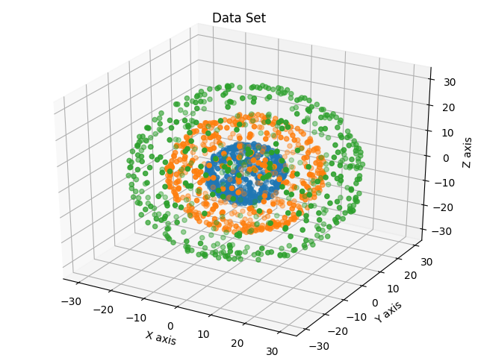
Shell function helps us generate the datasets. A 3d plot of the data set looks like the following diagram:

Clustering 3 feature space using various techniques:
Kmeans, and Gaussian Mixture Model yield more or less similar fashion of clusters, which are less natural than the ones generated by DBSCAN or SpectralClustering.
Following are the plots of clusters generated by various techniques:
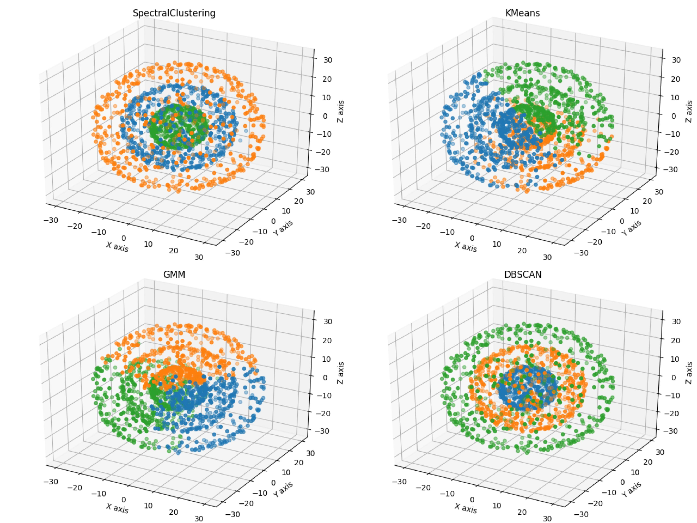

Converting 3 feature space to 2 or 1 feature space:
Using Kernel and PCA functions, we can convert from higher dimension feature space to lower dimension feature space. This technique is called Feature Extraction.
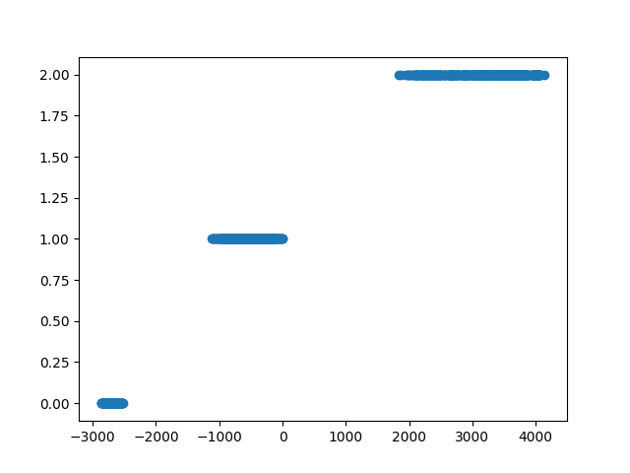
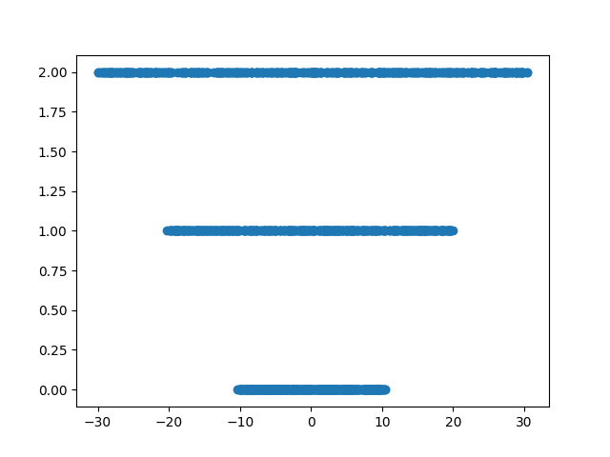
1D features look like the following:
Kernel(X,Y) = (XY^{T} + 1)² yields a good direction to draw seperators, because it transforms the entire region into a region which is more dependent on the radial distance of the point. Whereas just PCA on X fail to give a direction where we could cluster the points as desired.
Kernel PCA
PCA
Naturally, the clusters of the features of Kernel PCA are way better than the ones of just PCA. However, failing to use appropriate kernel might lead to clumsy results. The results are enclosed in the folder, I would refrain from adding those here.

Breast Cancer Dataset:
Comparing accuracies:
RF : 0.9714
LR : 0.9678
LDA: 0.9607
KNN: 0.9642
DT : 0.9428
NB : 0.9571
SVM: 0.9535

