use salesdb
db.sales.insertMany([
{ "_id" : 1, "item" : "Americanos", "price" : 5, "size": "Short", "quantity" : 22, "date" : ISODate("2022-01-15T08:00:00Z") },
{ "_id" : 2, "item" : "Cappuccino", "price" : 6, "size": "Short","quantity" : 12, "date" : ISODate("2022-01-16T09:00:00Z") },
{ "_id" : 3, "item" : "Lattes", "price" : 15, "size": "Grande","quantity" : 25, "date" : ISODate("2022-01-16T09:05:00Z") },
{ "_id" : 4, "item" : "Mochas", "price" : 25,"size": "Tall", "quantity" : 11, "date" : ISODate("2022-02-17T08:00:00Z") },
{ "_id" : 5, "item" : "Americanos", "price" : 10, "size": "Grande","quantity" : 12, "date" : ISODate("2022-02-18T21:06:00Z") },
{ "_id" : 6, "item" : "Cappuccino", "price" : 7, "size": "Tall","quantity" : 20, "date" : ISODate("2022-02-20T10:07:00Z") },
{ "_id" : 7, "item" : "Lattes", "price" : 25,"size": "Tall", "quantity" : 30, "date" : ISODate("2022-02-21T10:08:00Z") },
{ "_id" : 8, "item" : "Americanos", "price" : 10, "size": "Grande","quantity" : 21, "date" : ISODate("2022-02-22T14:09:00Z") },
{ "_id" : 9, "item" : "Cappuccino", "price" : 10, "size": "Grande","quantity" : 17, "date" : ISODate("2022-02-23T14:09:00Z") },
{ "_id" : 10, "item" : "Americanos", "price" : 8, "size": "Tall","quantity" : 15, "date" : ISODate("2022-02-25T14:09:00Z")}
]);

db.sales.aggregate([
{
$group: {
_id: "$item",
totalQty: { $sum: "$quantity" }
}
}
]);

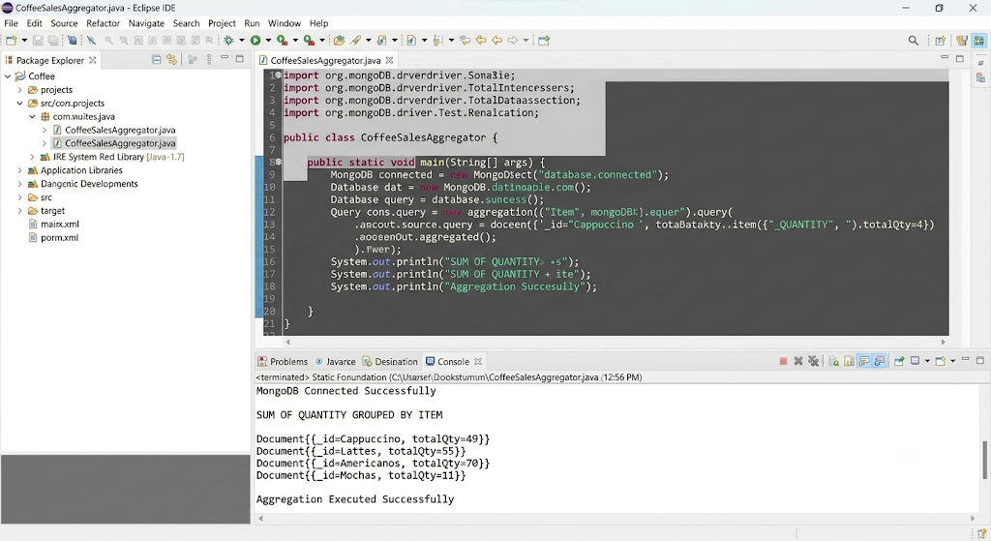

db.sales.aggregate([
{
$group: {
_id: "$item",
totalQty: { $sum: "$quantity" }
}
},
{
$match: {
totalQty: { $gt: 50 }
}
},
{
$sort: {
totalQty: -1
}
}
]);

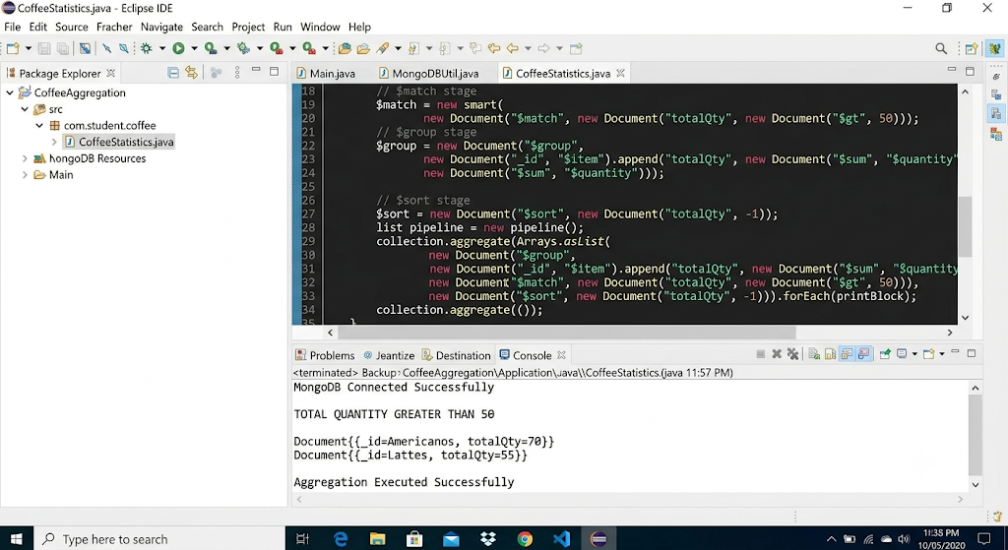

db.sales.aggregate([
{
$group: {
_id: "$item",
maxQty: { $max: "$quantity" }
}
}
]);



