MONGO DB
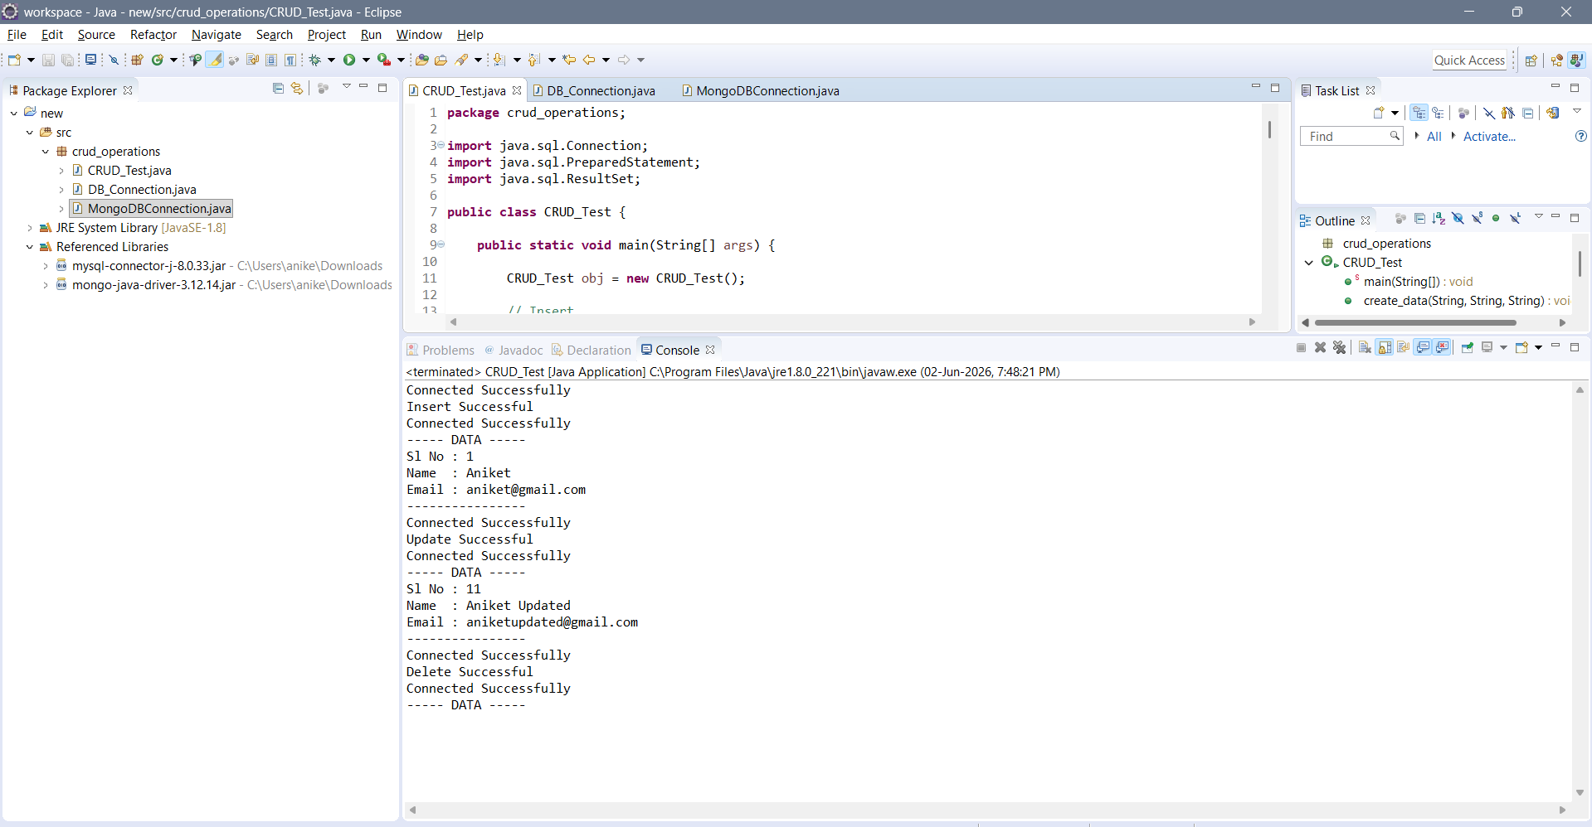
Insert Successful
↓
Read Data
↓
Update Successful
↓
Read Updated Data
↓
Delete Successful
↓
Read Empty Table

import com.mongodb.client.MongoClient;
import com.mongodb.client.MongoClients;
import com.mongodb.client.MongoDatabase;

public class MongoDBConnection {
public static void main(String[] args) {
String connectionString = "mongodb://localhost:27017";

try (MongoClient mongoClient = MongoClients.create(connectionString)) {
MongoDatabase database = mongoClient.getDatabase("testdb");
System.out.println("Connected successfully to MongoDB!");
}
}
}
