1ST June Practice
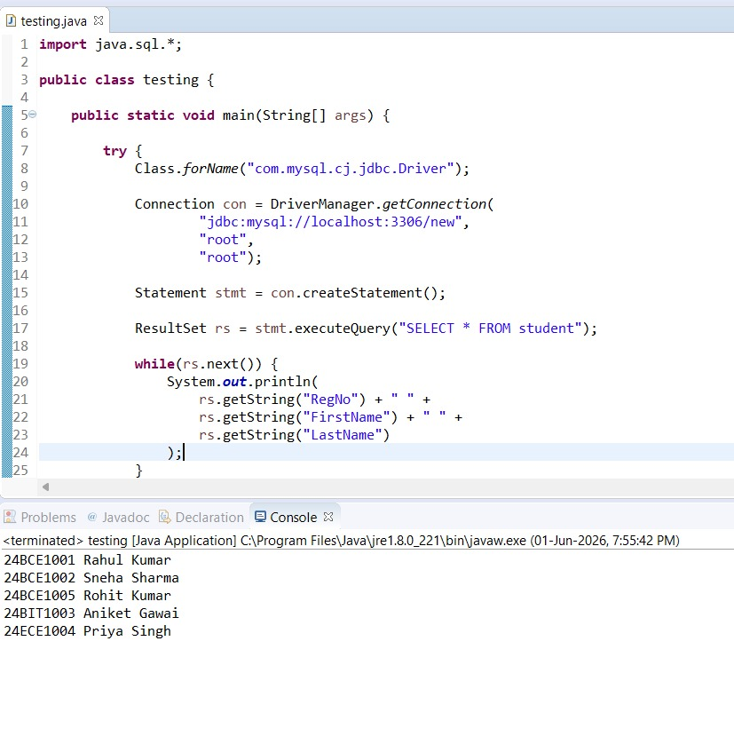

import java.sql.*;

public class testing {

public static void main(String[] args) {

try {
Class.forName("com.mysql.cj.jdbc.Driver");

Connection con = DriverManager.getConnection(
"jdbc:mysql://localhost:3306/new",
"root",
"root");

Statement stmt = con.createStatement();

ResultSet rs = stmt.executeQuery("SELECT * FROM student");

while(rs.next()) {

System.out.println(
rs.getString("RegNo") + " " +
rs.getString("FirstName") + " " +
rs.getString("LastName")
);
}

} catch(Exception e) {
System.out.println(e);
}
}
}

