**Steps to Download and Install TortoiseGit**

1. Search **download tortoiseGit** in the browser and open the first link.

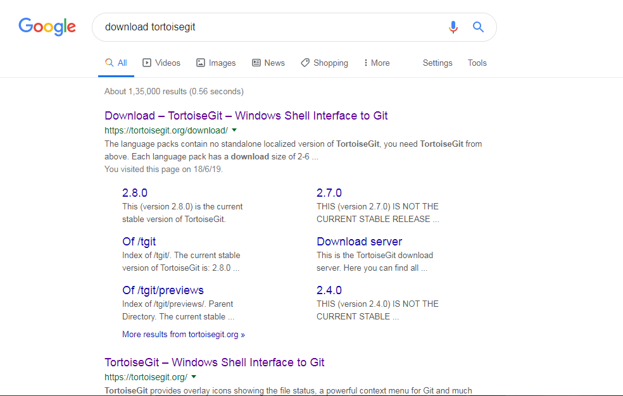

1. **Download** the file as per the operating system.

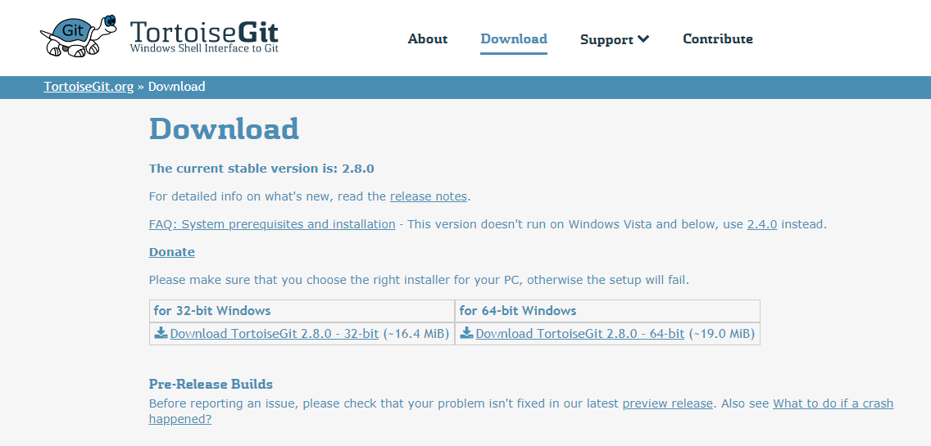

1. Now double click on the file that downloaded and click on the **run** button

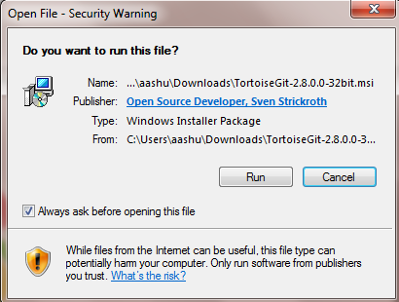

1. Click on the **Next** button.

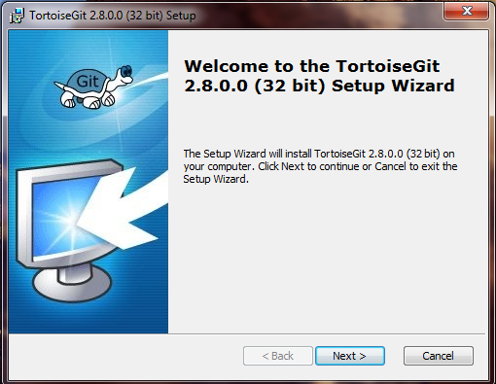

1. Click on the **Next** button.

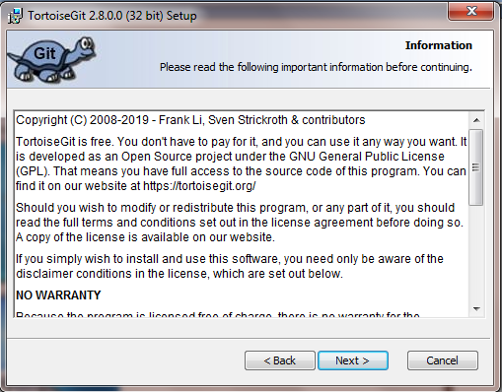

1. Click on the **Next** button.

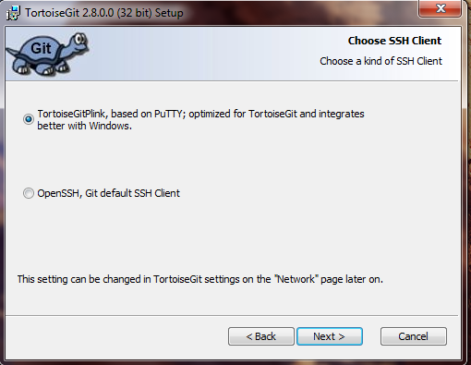

1. Click on the **Next** button.

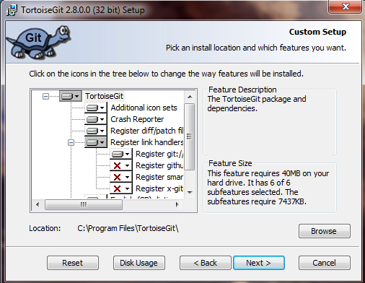

1. Click on the **Install** button.

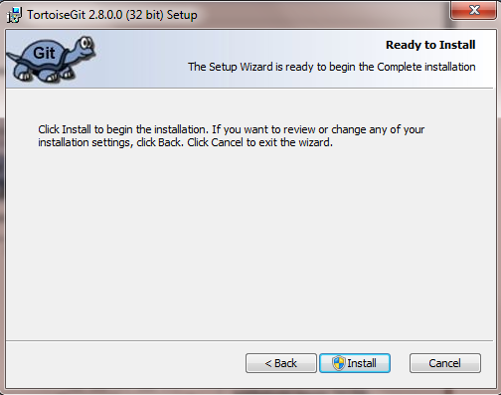

1. Click on the **Finish** button.

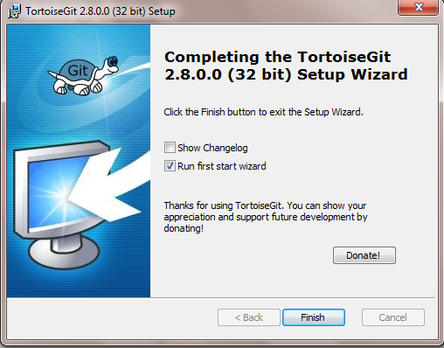

1. Click on the **Next** button.

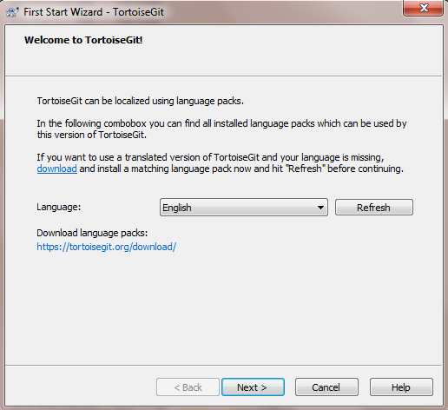

1. Click on the **Next** button.

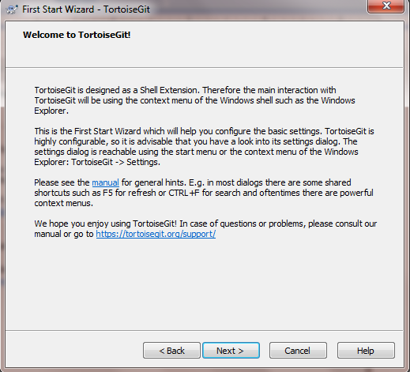

1. Click on the **Next** button

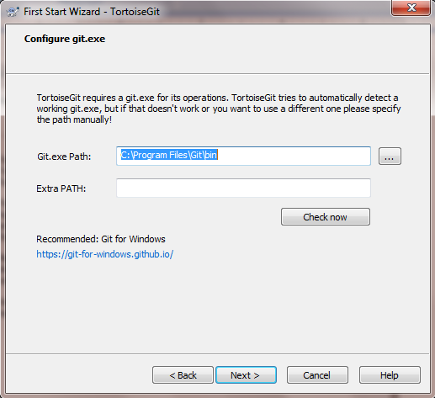

1. Click on the **Next** button. Please provide the name and email address as

you provide in the github account.

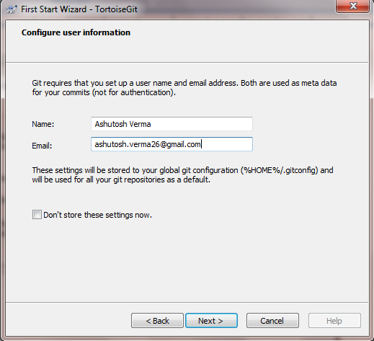

1. Click on the **Finish** button.

