Report
Of
WEB DEVELOPER INTERNSHIP

Submitted
To
School of Computer Science and Engineering
IILM University, Greater Noida, U.P.

In partial fulfilment of the requirement of degree of
B.Tech



By
Roll Number of Student: 25SCS1003003963
Name of Student: ASHUTOSH SINGH
Section: 2CSE31

2026-27

CANDIDATE DECLARATION
I, Ashutosh Singh, hereby declare that this internship report titled Web Developer Internship has been prepared by me in partial fulfilment of the requirements for the degree of Bachelor of Technology. The report presents the work, learning activities, and project case studies completed during my one-month Web Developer Internship at Codec Technologies Pvt. Ltd.
I further declare that the material included in this report is written for academic submission. Wherever concepts, frameworks, and technologies are discussed, they are acknowledged in the reference section. This report has not been submitted to any other institution for the award of a degree or diploma. I understand that I am responsible for the accuracy and originality of this submission.

Signature: ____________________
Student Name: Ashutosh Singh
Roll No.: 25SCS1003003963

ACKNOWLEDGEMENT
I would like to express my sincere gratitude to Codec Technologies Pvt. Ltd. for providing the opportunity to undertake a one-month Web Developer Internship. The internship offered a structured learning environment in which I strengthened my understanding of front-end development, responsive design, JavaScript programming, web services, deployment practices, and project planning.
I am thankful to the program team and mentors for the learning material, project guidance, and practical direction provided throughout the internship. Their support helped me connect classroom concepts with the workflow followed in modern web development, including component-based design, API integration, source control, testing, and deployment preparation.
I also extend my gratitude to the School of Computer Science and Engineering, IILM University, for encouraging practical learning alongside academic study. Finally, I thank my parents and well-wishers for their encouragement and support during this internship period.

Signature: ____________________
Ashutosh Singh
Roll No.: 25SCS1003003963

INTERNSHIP COMPLETION CERTIFICATE
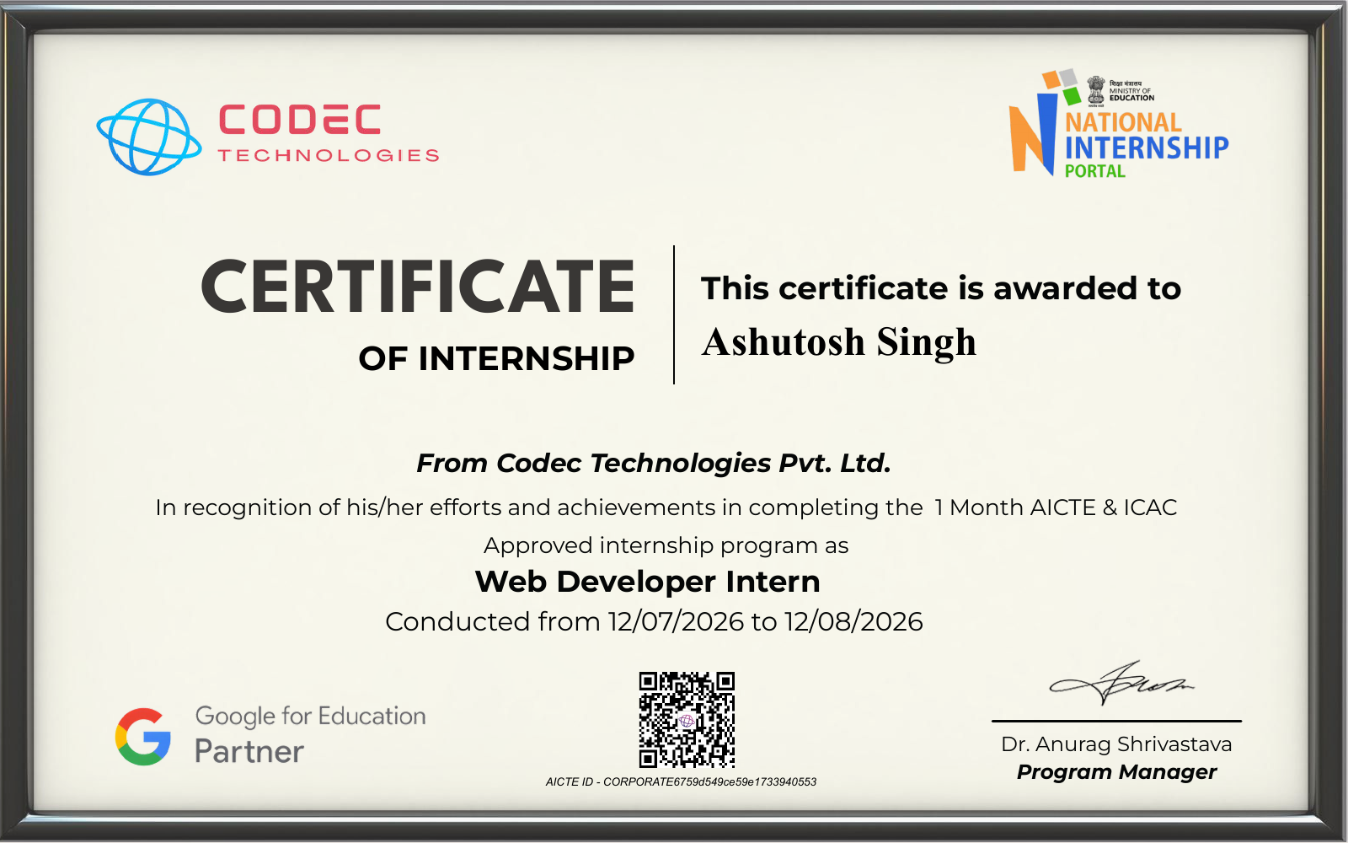
Certificate issued by Codec Technologies Pvt. Ltd.

TABLE OF CONTENTS
Section | Description
1 | Internship Overview and Learning Journey
2 | Organization Profile and Web Development Scope
3 | Project Case Study 1 - SaaS Subscription Management Platform
4 | Project Case Study 2 - Enterprise CRM System
5 | Skills Gained, Reflection, and Conclusion
6 | References
Annexure | Certificate and Supporting Evidence

Report Scope
This report documents a one-month internship focused on web development foundations and practical project planning. It covers the course progression, the organization context, and two selected project case studies: a SaaS Subscription Management Platform and an Enterprise CRM System.

1. INTERNSHIP OVERVIEW AND LEARNING JOURNEY
1.1 Internship Profile
Item | Details
Organization | Codec Technologies Pvt. Ltd.
Internship Role | Web Developer Intern
Duration | 12 July 2026 to 12 August 2026
Programme Length | One month
Academic Programme | B.Tech
Section | 2CSE31

1.2 Learning Progression
The internship was structured as a progressive web-development syllabus. In the first week, I reviewed the building blocks of the web: semantic HTML, forms, tables, CSS selectors, the box model, typography, JavaScript variables, conditions, loops, functions, and browser events. These concepts were applied through a simple registration form exercise, with emphasis on readable markup and user-friendly validation.
During the second week, the learning moved from static pages to responsive and data-driven applications. I worked through media queries, Flexbox, CSS Grid, Bootstrap layouts, React components and state, Node.js and Express server setup, request-response handling, MongoDB concepts, and CRUD operations. This sequence clarified how the front end, application server, and database work together in a complete web solution.
The third week focused on APIs, deployment, and development discipline. Fetching data from APIs, designing a simple API interface, Git-based version control, testing, debugging, and deployment options such as Netlify and Heroku were central topics. The final week was used to consolidate these skills through selected project case studies and documentation.
1.3 Organization Profile and Scope
Codec Technologies Pvt. Ltd. conducted the internship programme with an applied learning focus. The scope of work was to translate foundational web-development skills into organized project thinking: define a user problem, identify application modules, select a practical technology stack, plan data flows, and describe how a solution could be tested and deployed.

2. PROJECT CASE STUDY 1
SaaS Subscription Management Platform
The first selected project is a subscription-management platform intended to help a software business define service plans, onboard subscribers, track account usage, and present billing information in a consistent dashboard. The project addresses the difficulty of managing plan changes, renewal visibility, and account access when subscription information is spread across separate tools.
Technology Stack
Layer | Selected Technology | Purpose
Client | Next.js | Responsive pages, server-rendered routes, and dashboard views
Application | Node.js | Business rules, authentication hooks, and API endpoints
Database | PostgreSQL | Plans, customers, subscriptions, invoices, and usage records
Payments | Stripe API | Payment workflow design and webhook-oriented billing events

Functional Modules
Module | Implementation Focus
Plan catalogue | Create plans with price, billing cycle, feature limits, and active status.
Subscriber account | Show current plan, renewal date, usage summary, and upgrade options.
Billing workflow | Model invoices, payment status, renewal events, and retry states.
Analytics dashboard | Aggregate active subscriptions, plan distribution, churn signals, and usage trends.
Admin control | Restrict plan and billing operations through role-based access rules.

Development Approach
The proposed implementation begins with a relational data model in which customers, products, plans, subscriptions, invoices, and usage entries are linked by stable identifiers. Next.js pages consume protected API endpoints while the Node.js layer validates requests and enforces role rules. Stripe integration is treated as an external payment event source: the application records the event, validates its type, and updates local subscription status without storing card information. Component-level testing would cover plan display, form validation, and state changes, while API tests would focus on authorization and billing-event handling.
Expected Outcome
The resulting design provides a clear, auditable view of the subscription lifecycle. Administrators can manage plans and account roles, while subscribers can understand their active plan, invoices, and usage. The case study demonstrates how a front-end dashboard can be connected to secure server-side workflows and a structured relational database.

3. PROJECT CASE STUDY 2
Enterprise CRM System
The second selected project is an enterprise customer relationship management system designed to organize leads, customer records, deal stages, and sales activities in one application. The problem addressed is the loss of sales context that occurs when follow-ups, contacts, and pipeline updates are maintained in disconnected spreadsheets or personal notes.
Technology Stack
Layer | Selected Technology | Purpose
Client | React.js | Reusable interface components for pipeline, contacts, and dashboards
Application | Node.js and REST APIs | Validated CRUD services and workflow endpoints
Database | MongoDB | Flexible lead, customer, note, activity, and deal documents
Security | Role-based access control | Permissions for sales representatives, managers, and administrators

Functional Modules
Module | Implementation Focus
Lead management | Capture a lead, assign an owner, record source, and maintain follow-up status.
Sales pipeline | Move deals through qualified, proposal, negotiation, won, or lost stages.
Activity log | Store calls, emails, tasks, notes, and scheduled interactions against a record.
Performance dashboard | Summarize open deals, stage distribution, completed activities, and team workload.
Access management | Limit sensitive actions and records according to the role of the user.

Development Approach
The system is designed around React components that present a lead list, a detail view, a pipeline board, and summary cards. REST endpoints expose predictable resources such as leads, contacts, deals, and activities. MongoDB suits the activity history because notes and interaction details can vary in length and structure. Validation occurs on both the client and server so that incomplete or invalid stage changes are rejected. Git branches, issue-oriented commits, and test cases for lead creation, status updates, and authorization support a disciplined development process.
Expected Outcome
This case study shows how an operational tool can make sales information easier to locate, update, and review. The planned dashboard gives managers a current view of the pipeline, while activity history preserves the context needed for meaningful customer follow-up. It also reinforces the importance of API design, state management, and user-role controls in business applications.

4. SKILLS GAINED AND CONCLUSION
4.1 Technical Skills Developed
Area | Skills Applied During the Internship
Front-end development | HTML forms, CSS layout, responsive design, Bootstrap, React components, and state.
Programming | JavaScript fundamentals, event handling, input validation, and asynchronous API calls.
Back-end development | Node.js, Express routing, REST concepts, request-response flow, and CRUD operations.
Data management | MongoDB basics, PostgreSQL-oriented relational modeling, and structured application records.
Engineering practice | Git version control, debugging, testing, deployment planning, and clean code principles.

4.2 Reflection
The internship strengthened my understanding that web development is more than writing individual pages. A useful application requires clear user flows, reliable data handling, responsive interfaces, secure access boundaries, and a plan for maintaining the code over time. The two project case studies helped me practice breaking broad business requirements into features, data entities, technology choices, and testable workflows.
The SaaS platform highlighted the value of a structured subscription lifecycle and careful integration with third-party services. The CRM project highlighted the value of preserving customer context and designing interfaces around frequent user actions. Together, the projects improved my confidence in selecting appropriate front-end and back-end tools for a stated problem.
4.3 Conclusion
The Web Developer Internship at Codec Technologies Pvt. Ltd. provided an effective bridge between academic study and practical software-development thinking. By completing the planned learning modules and documenting two application case studies, I developed a stronger foundation in web technologies, responsive user interface design, APIs, data handling, project structure, and professional development practices.
REFERENCES
MDN Web Docs. HTML, CSS, and JavaScript reference material. https://developer.mozilla.org/
React Documentation. Building user interfaces with components. https://react.dev/
Node.js Documentation. JavaScript runtime and API guides. https://nodejs.org/
MongoDB Documentation. Database and CRUD concepts. https://www.mongodb.com/docs/
Stripe Documentation. Payments and subscription workflow concepts. https://docs.stripe.com/

ANNEXURE A - INTERNSHIP CERTIFICATE
Certificate issued by Codec Technologies Pvt. Ltd.

