**PC users only –– Cognizant email signature guidelines**

1. In this document, highlight and copy one of the following two signatures.

Option 1: animated (recommended) This option will not work if you have an older version of MS Outlook (before Office 365).

**FirstName LastName**(pronouns)

Title

Part of the Organization

**M**  +00 000 00000000

**O**  +00 000 00000000

[copy up to this line so that you have a few lines after the logo]

Option 2: static (Use this option if your version of MS Outlook is older than Office 365)

**FirstName LastName**(pronouns)

Title

Part of the Organization

**M**  +00 000 00000000

**O**  +00 000 00000000

[copy up to this line so that you have a few lines after the logo]

1. Open your email signature in Microsoft Outlook using File > Options > Mail and click on Signatures (or by opening a new message and going to Signatures)

Highlight your existing signature and delete it

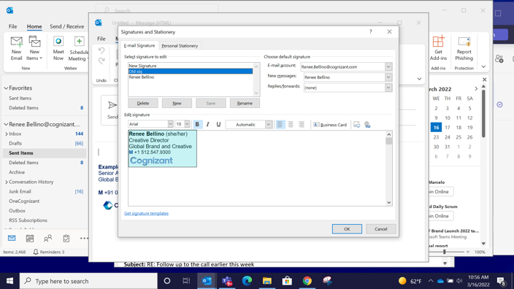

1. Right click and paste in the new signature you copied, **updating with your own information without changing the formatting**. You may not see the logo you’ve pasted in, but that’s ok – you’ll test after you’re finished.

Be sure that where it says: New messages, you’ve selected your new signature. Then click “OK” to exit

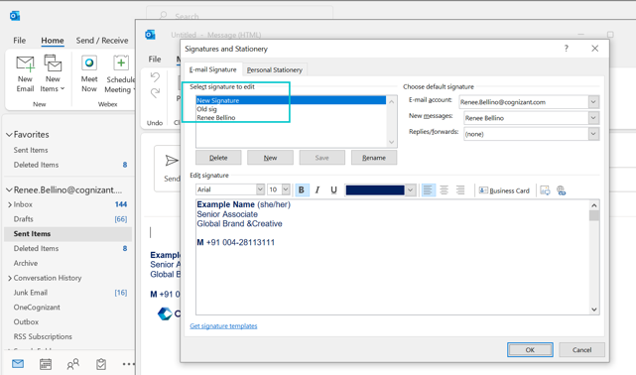

Once you have saved, open a new email message to confirm that your signature worked.