Project Title: Exploratory Data Analysis (EDA) on Titanic Dataset
Submitted by: Sourav Banerjee (Data Analyst)
Tools Used: Python, Pandas, Matplotlib, Seaborn, Jupyter Notebook
Data Source: Titanic - Machine Learning from Disaster | Kaggle

- Dataset Overview
- The dataset contains passenger information such as Age, Sex, Passenger Class (Pclass), Fare, Embarked, and Survival status.
- Total records: 891 (approx.)
- About 38% of passengers survived.
- Missing data was mainly in Age and Cabin columns.

2. Univariate Analysis
- Age Distribution: Most passengers were between 20–40 years, indicating a young adult majority. 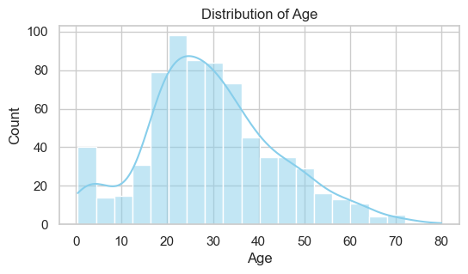
- Fare Distribution: Fares are right-skewed, with a few very high-paying passengers.
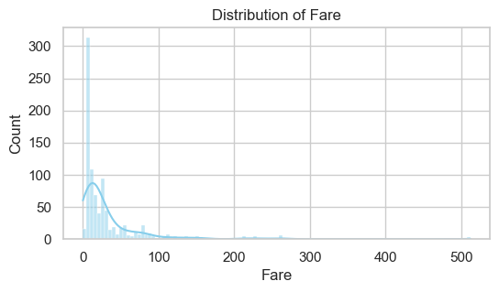

- Pclass: Majority of passengers traveled in 3rd class, followed by 1st and 2nd.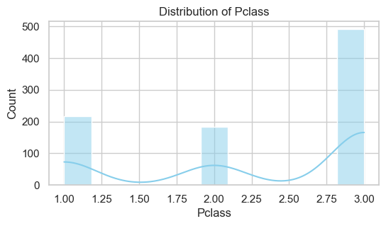
Observation: The passenger profile suggests that the majority were low-fare, 3rd-class males in their 20s–30s.

3. Bivariate Analysis:
- Survival vs. Gender:
Females had a much higher survival rate than males (around 74% vs 19%).
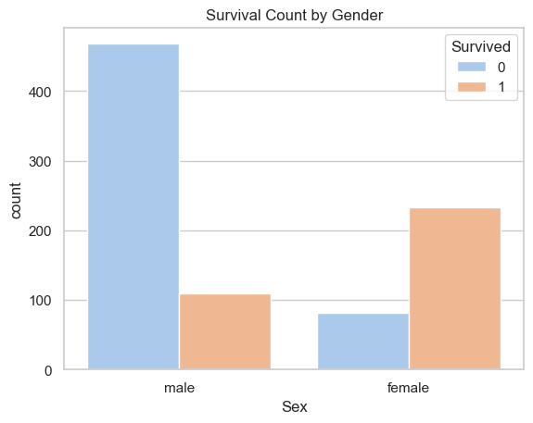
Insight: Gender played a major role in survival — supporting the “women and children first” policy.
- Survival vs. Pclass:
1st-class passengers had the highest survival rate (~63%), while 3rd-class had the lowest (~24%)
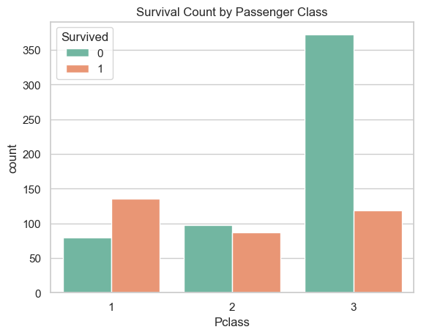
Insight: Socio-economic status strongly influenced survival chances.

- Survival vs. Age:
Younger passengers (especially children) had higher survival rates compared to older passengers.
Insight: Children were prioritized during rescue operations.
- Survival vs. Fare:
Passengers who paid higher fares were more likely to survive.
Insight: Fare correlates positively with survival, indirectly reflecting class advantage.

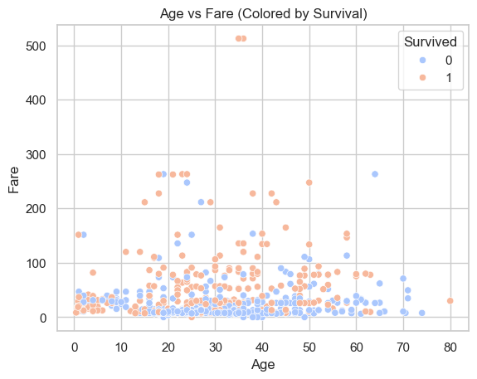

4. Correlation Analysis
- Strong negative correlation between Pclass and Fare (−0.55).
- Survived shows positive correlation with Fare and negative with Pclass.
- Weak or no correlation between Age and Survival.
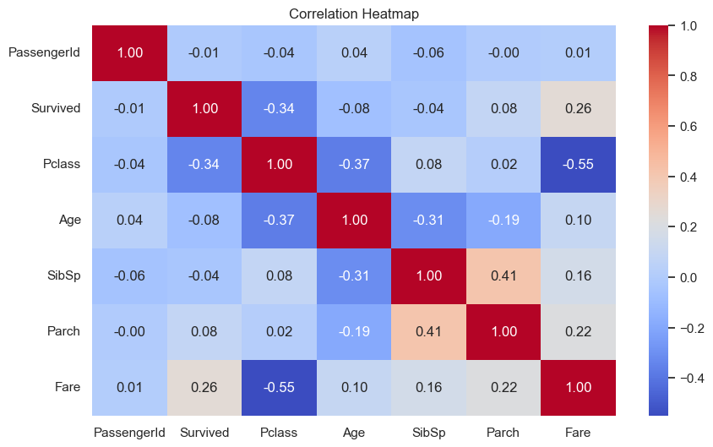
Insight: Wealthier passengers in higher classes had better chances of survival.

5. Pairplot Observations
- Distinct clusters visible for 1st-class survivors.
- Overlap among 3rd-class non-survivors, indicating higher density of loss in that group.
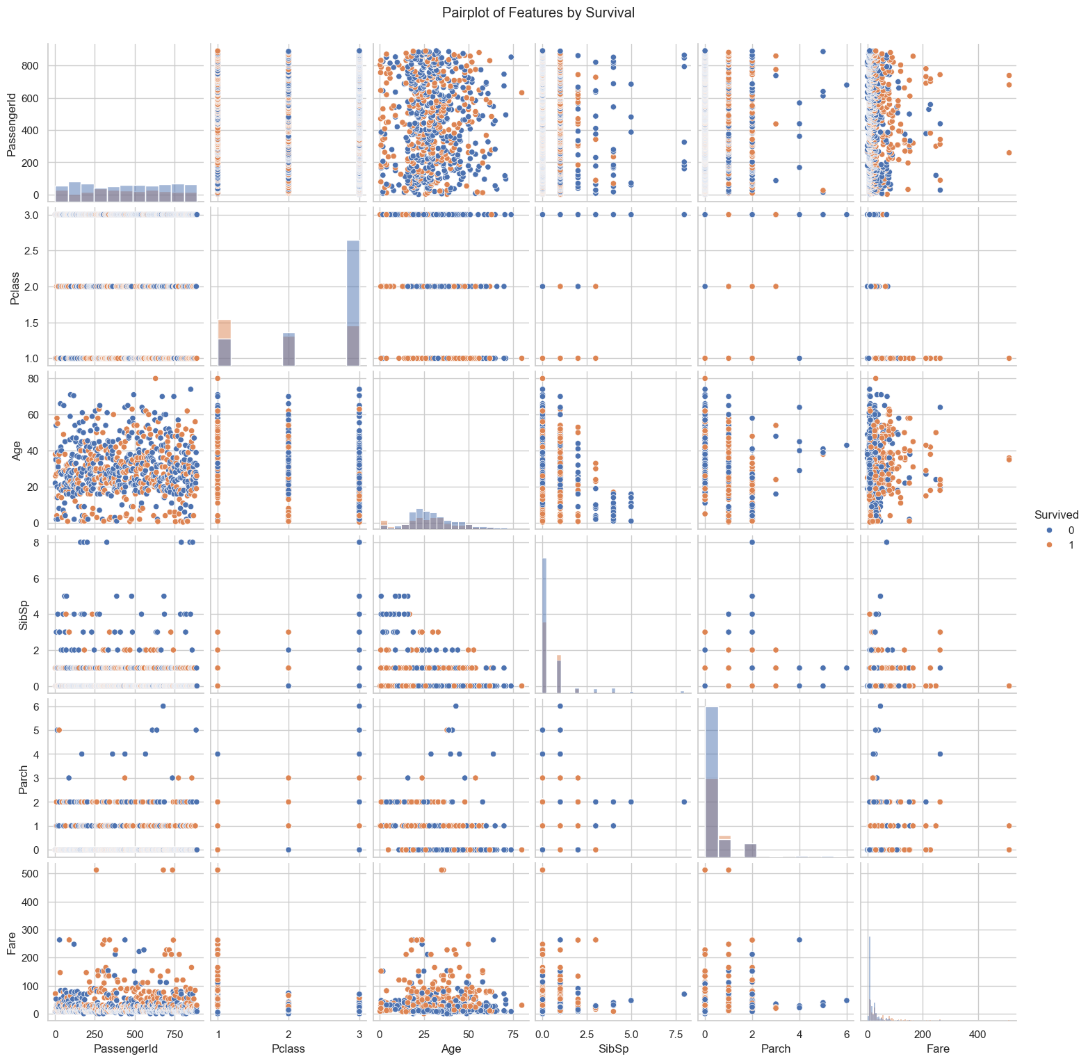

6. Summary of Key Insights
- Overall survival rate: ~38%.
- Gender: Females survived at a significantly higher rate than males.
- Class: 1st-class passengers were most likely to survive; 3rd-class least.
- Age: Children had better survival chances than adults.
- Fare: Higher fares → higher survival probability.
- Embarkation: Passengers from Cherbourg had slightly better survival rates. 7.

8. Conclusion
- The EDA reveals that socio-economic status, gender, and age were the strongest determinants of survival aboard the Titanic. Wealthier, first-class passengers—especially women and children—had the highest chances of survival, reflecting clear patterns of social inequality and emergency prioritization during the disaster.

