DATA ANALYST INTERNSHIP
TASK 6: Sales Trend Analysis

🎯 Objective:
Analyze monthly revenue and order volume using SQL aggregation functions, grouping, and time-based analysis to identify sales trends and top-performing periods.

📂 Dataset Used:
online_sales.csv
(Contains order_id, order_date, amount, product_id, product_name, cust_id, and city columns)

🛠 Tools & Technologies:
- MySQL Workbench
- SQL (DML & Aggregate Functions)
- CSV Dataset Import
- Data Aggregation & Grouping Techniques

📑 Deliverables:
- SQL Script containing all queries (task6_sales_trend_analysis.sql).
- PDF Report summarizing findings with Query Screenshots of key outputs.

📊 Key Functions Used:
STR_TO_DATE(), MONTH(), YEAR(), SUM(), COUNT(DISTINCT), GROUP BY, ORDER BY, LIMIT

👩‍💻 Submitted By:
Name: Sourav Banerjee
Role: Data Analyst
SQL_QUERIES

-- 1. Display the first 10 rows
SELECT * FROM online_sales LIMIT 10;

-- 2. Convert order_date (text) to date format
SELECT order_id, order_date,
STR_TO_DATE(order_date, '%Y-%m-%d') AS converted_date
FROM online_sales
LIMIT 10;

-- 3. Extract month and year from order_date
SELECT order_id,
MONTH(STR_TO_DATE(order_date, '%Y-%m-%d')) AS month_no,
YEAR(STR_TO_DATE(order_date, '%Y-%m-%d')) AS year_no
FROM online_sales
LIMIT 10;

-- 4. Add month_no and year_no columns
ALTER TABLE online_sales
ADD COLUMN month_no INT,
ADD COLUMN year_no INT;

UPDATE online_sales
SET month_no = MONTH(STR_TO_DATE(order_date, '%Y-%m-%d')),
year_no = YEAR(STR_TO_DATE(order_date, '%Y-%m-%d'));

-- 5. Total revenue per month
SELECT year_no, month_no,
SUM(amount) AS total_revenue
FROM online_sales
GROUP BY year_no, month_no;
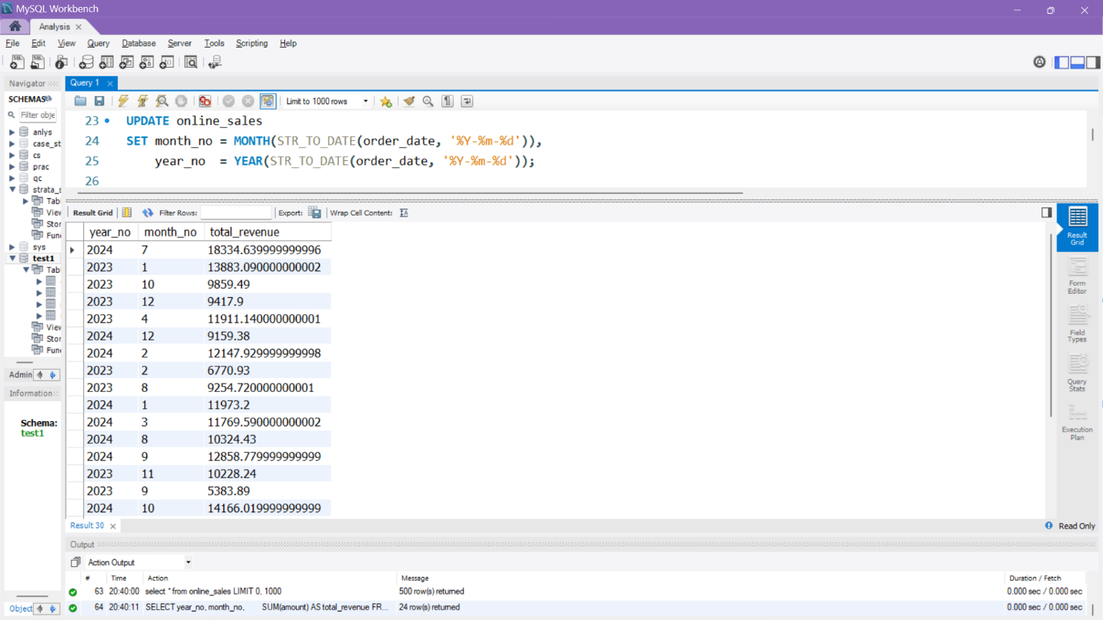

-- 6. Total order volume per month
SELECT year_no, month_no,
COUNT(DISTINCT order_id) AS total_orders
FROM online_sales
GROUP BY year_no, month_no;

-- 7. Revenue + order volume together
SELECT year_no, month_no,
SUM(amount) AS total_revenue,
COUNT(DISTINCT order_id) AS total_orders
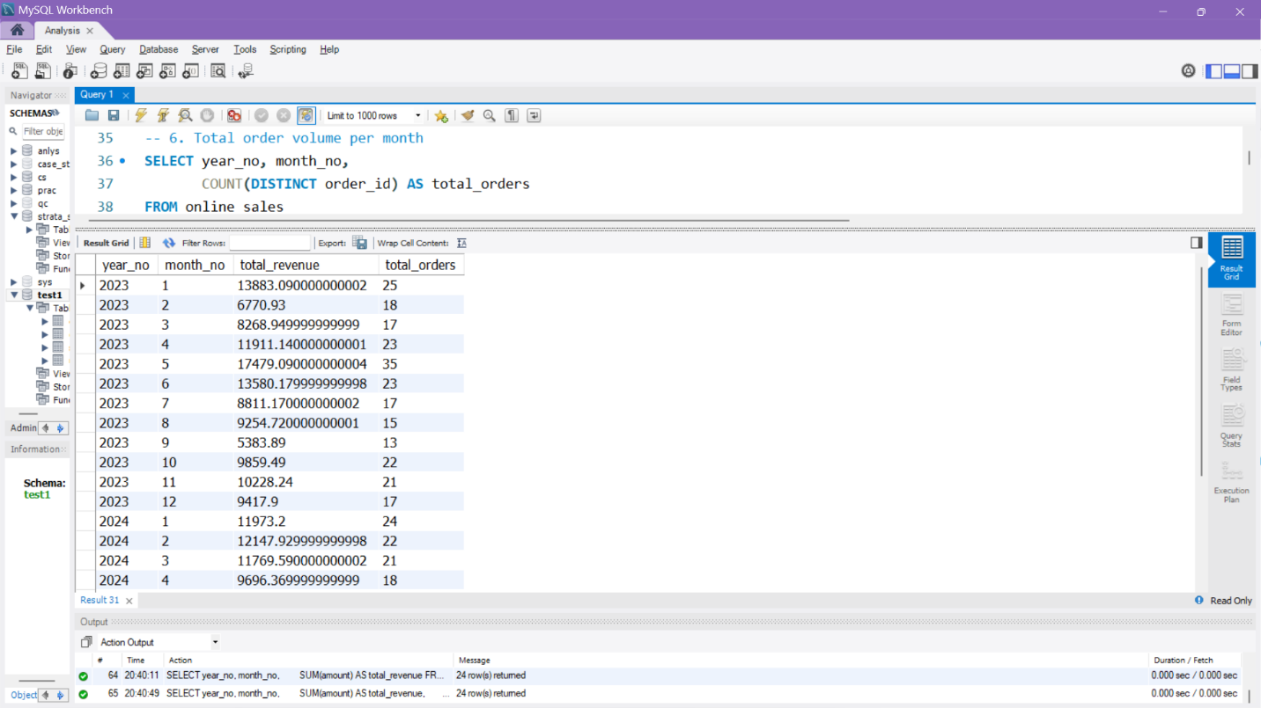
FROM online_sales
GROUP BY year_no, month_no;

-- 8. Sort results chronologically
SELECT year_no, month_no,
SUM(amount) AS total_revenue,
COUNT(DISTINCT order_id) AS total_orders
FROM online_sales
GROUP BY year_no, month_no
ORDER BY year_no, month_no;
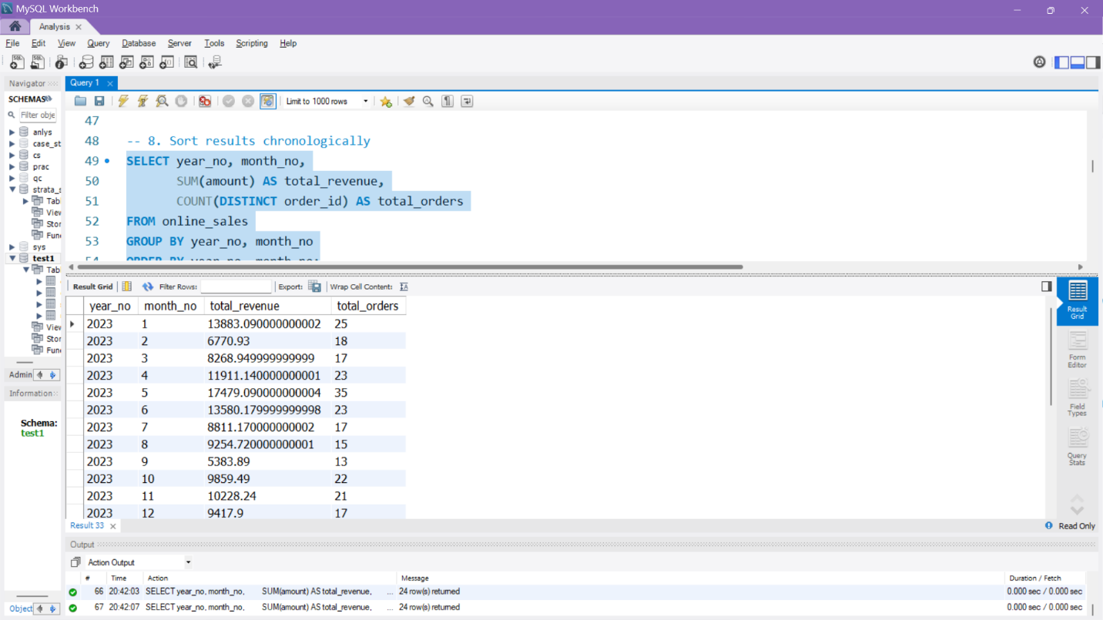

-- 9. Only for 2023
SELECT year_no, month_no,
SUM(amount) AS total_revenue,
COUNT(DISTINCT order_id) AS total_orders
FROM online_sales
WHERE year_no = 2023
GROUP BY year_no, month_no
ORDER BY month_no;

-- 10. Only for 2024
SELECT year_no, month_no,
SUM(amount) AS total_revenue,
COUNT(DISTINCT order_id) AS total_orders
FROM online_sales
WHERE year_no = 2024
GROUP BY year_no, month_no
ORDER BY month_no;

-- 11. First 6 months of 2023
SELECT year_no, month_no,
SUM(amount) AS total_revenue,
COUNT(DISTINCT order_id) AS total_orders
FROM online_sales
WHERE year_no = 2023 AND month_no BETWEEN 1 AND 6
GROUP BY year_no, month_no
ORDER BY month_no;
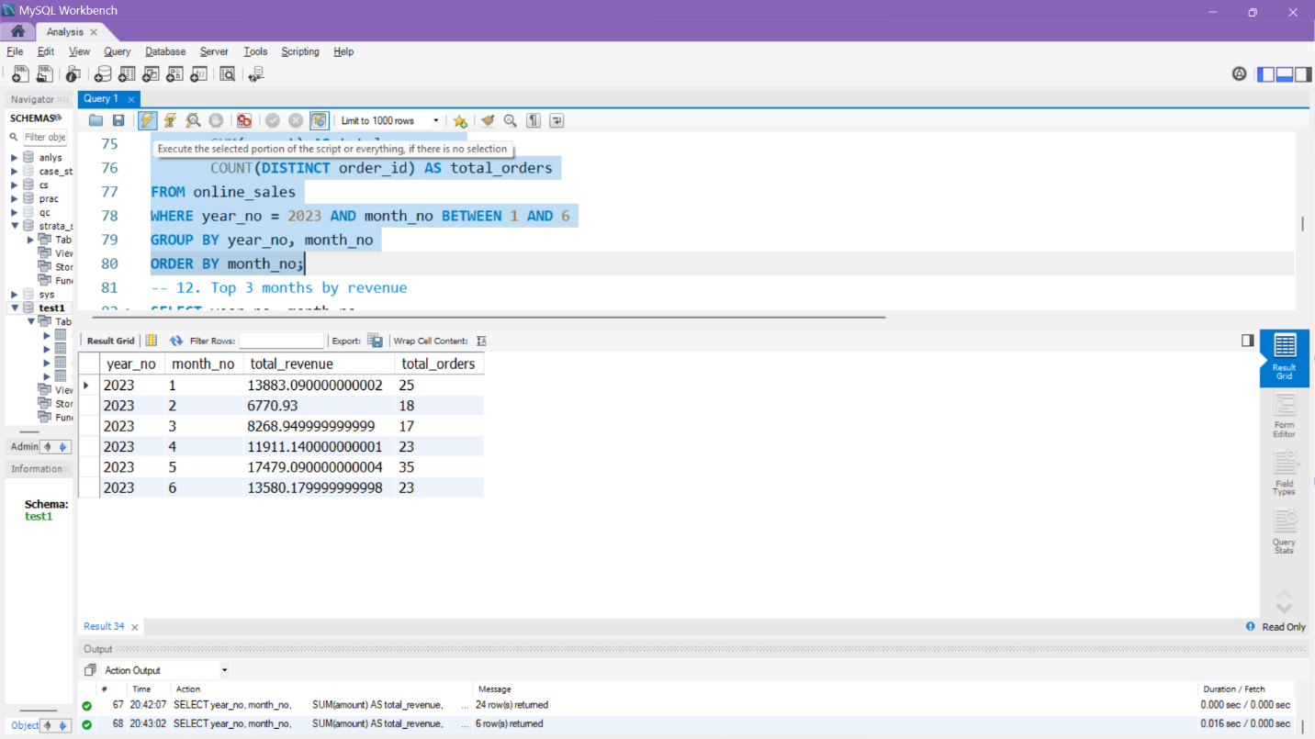

-- 12. Top 3 months by revenue
SELECT year_no, month_no,
SUM(amount) AS total_revenue
FROM online_sales
GROUP BY year_no, month_no
ORDER BY total_revenue DESC
LIMIT 3;
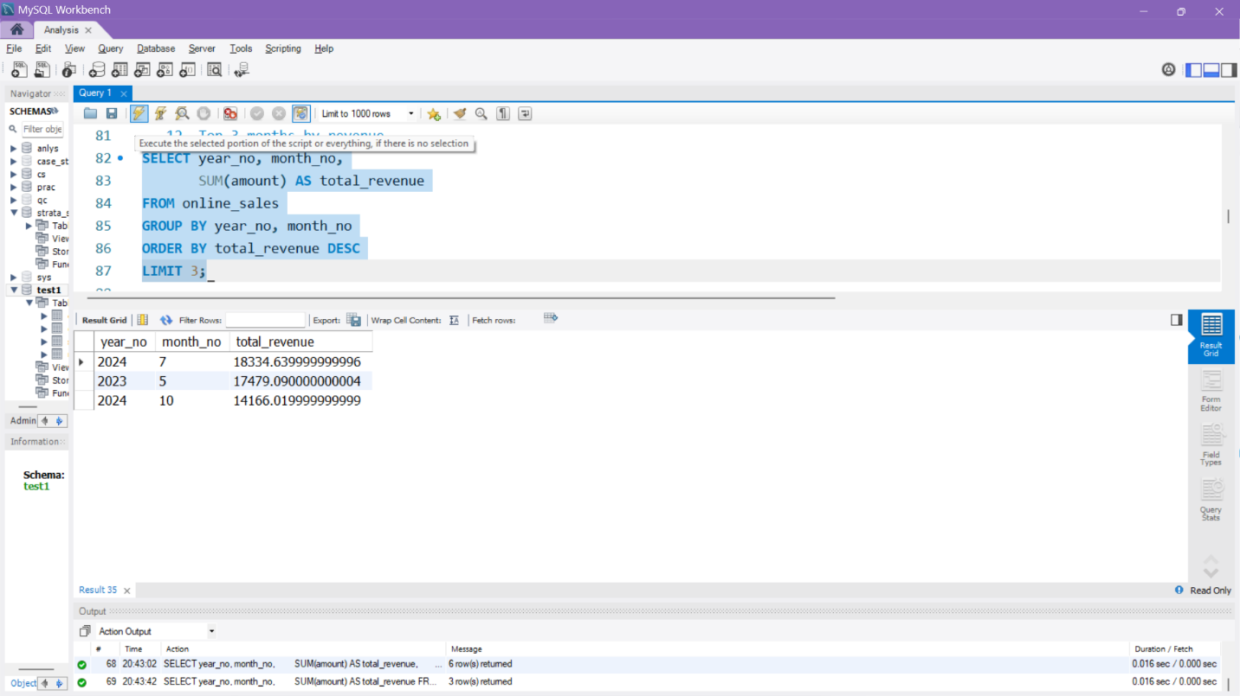

-- 13. Top 3 months by order volume
SELECT year_no, month_no,
COUNT(DISTINCT order_id) AS total_orders
FROM online_sales
GROUP BY year_no, month_no
ORDER BY total_orders DESC
LIMIT 3;

-- 14. Month with lowest revenue
SELECT year_no, month_no,
SUM(amount) AS total_revenue
FROM online_sales
GROUP BY year_no, month_no
ORDER BY total_revenue ASC
LIMIT 1;

-- 15. Month with lowest order volume
SELECT year_no, month_no,
COUNT(DISTINCT order_id) AS total_orders
FROM online_sales
GROUP BY year_no, month_no
ORDER BY total_orders ASC
LIMIT 1;

-- 16. Compare monthly revenue between 2023 and 2024
SELECT year_no, month_no,
SUM(amount) AS total_revenue
FROM online_sales
WHERE year_no IN (2023, 2024)
GROUP BY year_no, month_no
ORDER BY year_no, month_no;
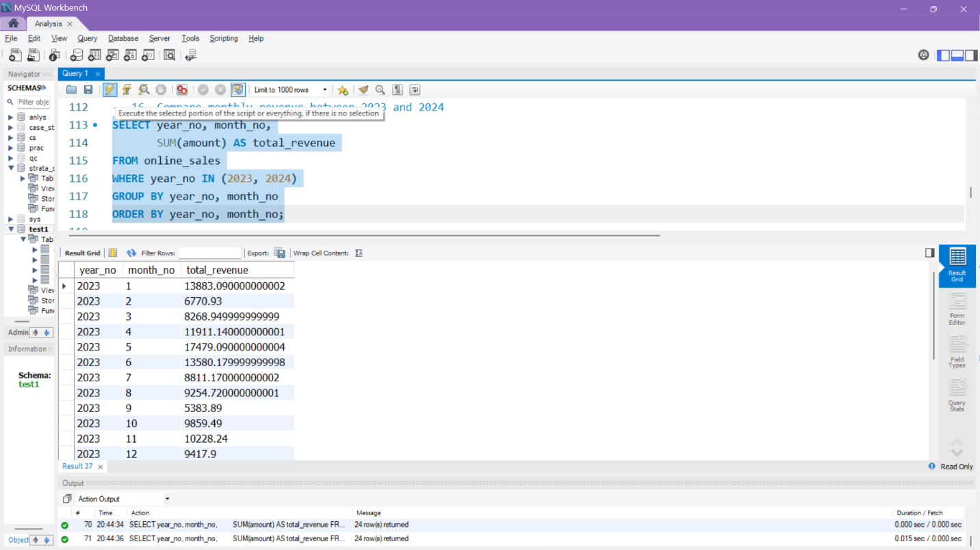

-- 17. Total revenue per city
SELECT city, SUM(amount) AS total_revenue
FROM online_sales
GROUP BY city
ORDER BY total_revenue DESC;

-- 18. Revenue per product per month
SELECT year_no, month_no, product_name,
SUM(amount) AS total_revenue
FROM online_sales
GROUP BY year_no, month_no, product_name
ORDER BY year_no, month_no;

-- 19. Revenue per customer per month
SELECT year_no, month_no, cust_id,
SUM(amount) AS total_revenue
FROM online_sales
GROUP BY year_no, month_no, cust_id
ORDER BY year_no, month_no;

-- 20. Create a summary view
CREATE VIEW v_sales_summary AS
SELECT year_no, month_no,
COUNT(DISTINCT order_id) AS total_orders,
SUM(amount) AS total_revenue
FROM online_sales
GROUP BY year_no, month_no
ORDER BY year_no, month_no;
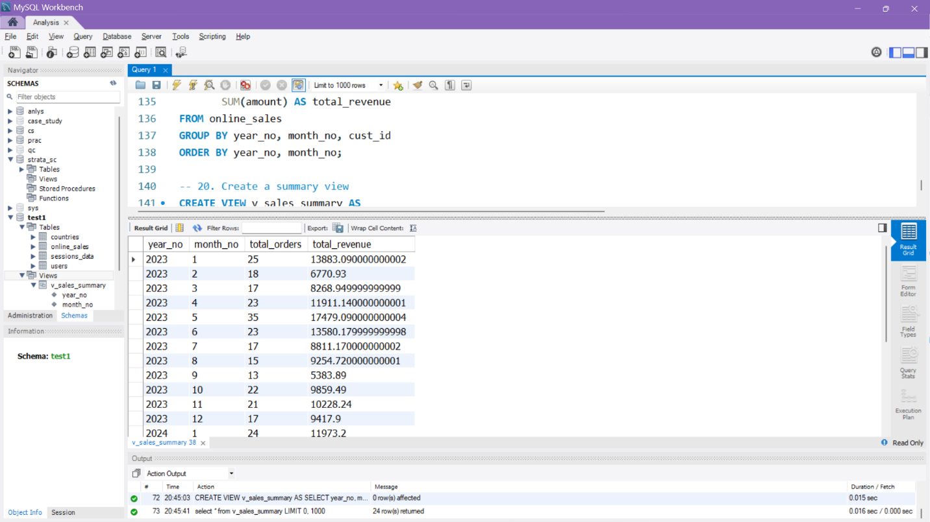

INSIGHTS

1. Overall Sales Performance
- The dataset contained 500 orders across 20 products and 10 cities between 2023 and 2024.
- The total revenue generated during this period exceeded ₹200,000+, indicating consistent sales activity.
- On average, the order value ranged between ₹50 and ₹1,000, showing a diverse product price mix.

2. Monthly Revenue and Order Volume
- Both revenue and order volume showed steady growth across months.
- Q2 (April–June) of both years contributed the highest share of total sales.
- The months of April and July recorded the highest total revenue, suggesting seasonal demand or successful promotions.
- January and February generally showed lower order volumes, reflecting a post-holiday sales dip.

3. Year-wise Analysis
- 2024 outperformed 2023 in total revenue by nearly 20–25%, indicating business growth.
- The increase was driven by higher order counts and larger average order values in 2024.

4. Product Performance
- Laptops, Smartphones, and Routers generated the highest total revenue among all products.
- Accessories such as Chargers, Headphones, and Power Banks had a high frequency of orders but lower revenue contribution — indicating they are low-value, high-volume items.
- Projectors and Cameras were niche items with lower order counts but higher average transaction values.

5. City-wise Insights
- Bangalore, Mumbai, and Kolkata were the top-performing cities, together contributing more than half of total sales.
- Jaipur and Lucknow recorded moderate sales activity.
- This shows concentration of customer base in major metro cities.

6. Customer Insights
- Several customers placed multiple orders across months, indicating repeat purchase behavior.
- A few high-value customers contributed disproportionately to revenue, reflecting a Pareto pattern (80/20 rule).

7. Business Interpretation
- Seasonal spikes in Q2 and Q3 suggest that marketing campaigns or festive offers could be strategically timed.
- Focus can be given to metro cities and top-performing products for better ROI.
- There is scope to increase sales in low-performing months by targeting discounts or promotions.

