SQL*Pizza-Project*(15 Questions)
PIZZA.DB = pizza_eva
1= Total Revenue
select Round(SUM(total_price),2) as Total_revenue
from pizza_eva
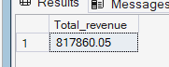

2- --AVG_Order_price
--select Round(Sum(total_price) / COUNT(distinct order_id),4) as Avg_Order_Value
from pizza_eva
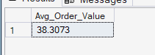

3-Total_pizza_sold
select sum(quantity) as Total_Pizza_Sold
from pizza_eva
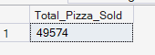

4-Total_Orders
select COUNT(distinct order_id) as Total_orders
from pizza_eva
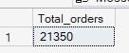

5-Avg_pizza_order
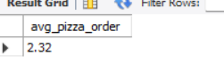
select round(sum(quantity) / count(distinct order_id),2) as avg_pizza_order
from pizza_eva

6-pizza_category
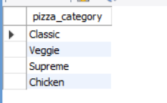
select distinct pizza_category
from pizza_eva

7-Total_chicken_pizza(--top seller chicken pizza)
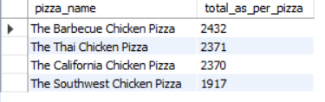

select distinct pizza_name, sum(quantity) as total_as_per_pizza
from pizza_eva
where pizza_name Like '%CHICKEN%'
group by pizza_name
order by total_as_per_pizza desc
limit 4
##top seller chicken pizza

1
8-Pineapple_pizza_eva(top 3 order_id)
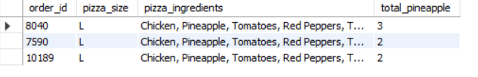
Syntax-----------
use pizza_db;
select order_id,pizza_size,pizza_ingredients,sum(quantity) as total_pineapple
from pizza_eva
where pizza_ingredients like "%pineapple%"
and pizza_name like '%thai%'
and pizza_size = 'L'
group by order_id,pizza_size,pizza_ingredients
order by total_pineapple desc
limit 3

9- Daily Trend
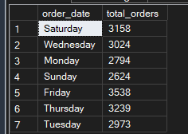
use Pizza_db;
select DATENAME(dw, order_date) as order_date , COUNT(distinct order_id) as total_orders
from pizza_eva
group by DATENAME(dw, order_date

10- Percentage(Pct) of sales syntax
Without month wise
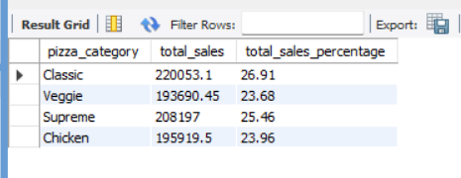
USE pizza_db
SELECT
pizza_category, round(sum(total_price),3) as total_sales,
round(SUM(total_price) * 100.0 / (SELECT SUM(total_price) FROM pizza_eva),2 ) AS total_sales_percentage
FROM pizza_eva
Where month(order_date) = 1 (we used one bcz we needed for jan only (same wit2,3,4 month name))
GROUP BY pizza_category;
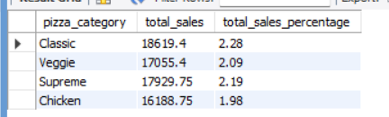with month wise quey 10
11- As per pizza size and day months wise (of 1,2 month only)
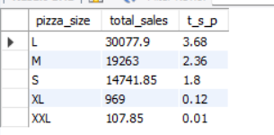
SELECT
pizza_size, round(sum(total_price),3) as total_sales,
round(SUM(total_price) * 100.0 / (SELECT SUM(total_price) FROM pizza_eva),2 ) AS t_s_p
FROM pizza_eva
where order_date like '%-02-%' or '%-01-%'
GROUP BY pizza_size
order by t_s_p desc

12=total pizza sold
select pizza_category, sum(quantity) as total_pizza_sold
from pizza_eva
group by pizza_category
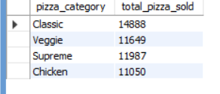

13= top 5 pizza sold
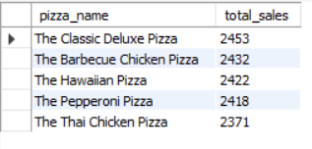
select pizza_name, sum(quantity) as total_sales
from pizza_eva
group by pizza_name
order by sum(quantity) desc
limit 5

14- Bottom 5 pizza
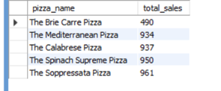
USE pizza_db;
select pizza_name, sum(quantity) as total_sales
from pizza_eva
group by pizza_name
order by sum(quantity)
limit 5

/

