**INTRODUCTION :-**

**Companies employees what they call computer operators who store and handle the database which stores all necessary information concerning the company. What is much needed is a proper interface which may enable us to handle such systems efficiently.**

**This project entitled “Hospital Management System” has been developed with an aim to help one such organization – a school to easily manage and handle the data concerning it.**

**There are mainly three types of actions performed by this project:-**

* **Retrive :-There are dedicated tables made for serving the purpose of viewing the details of Doctors, Patients and staff existing in a school database at a particular time.**
* **Insert :- Data such as names, phone numbers and Address etc. can be inserted, Updated and deleted in case of staff, Doctors, Patients.**
* **Update :- We can simply update Name with the help of phone numbers.**
* **Delete :- We can simply delete the data regarding Doctors, Patients and staff.**

**Hardware&Software Requirements**

***Minimum Requirements***

***Processor: Intel Atom or Greater***

***Main Memory: 1 GB***

***Video Adaptor: 4 MB SVGA***

***Hard Disk: 20 GB***

***Network Card: Ethernet or Any other***

***Software Requirements***

***Platform: Windows NT/XP/7***

***Client Side Validation: Java/Netbeans***

***Server Side Validation: MySQL Server***

***Database Connectivity: JDBC/ODBC***

***RDBMS: MySQL 5.1***

**SQL-JAVA CONNECTOR :-**

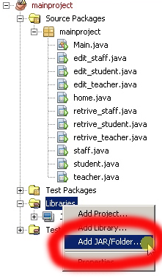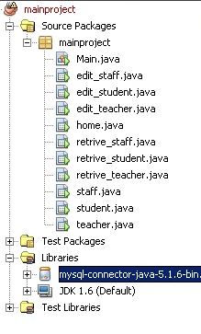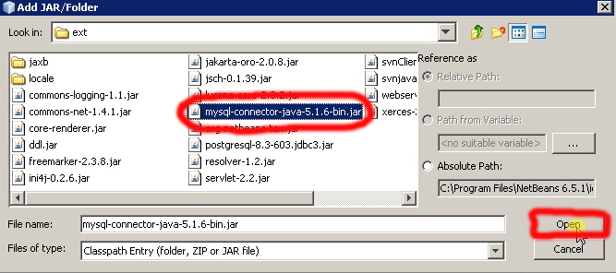

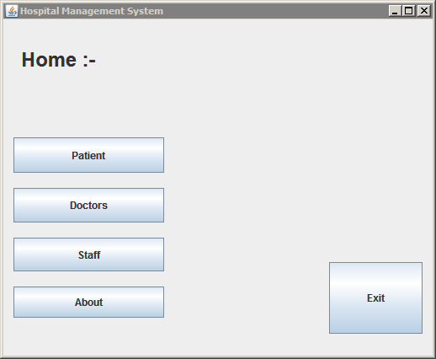Home Screen:-

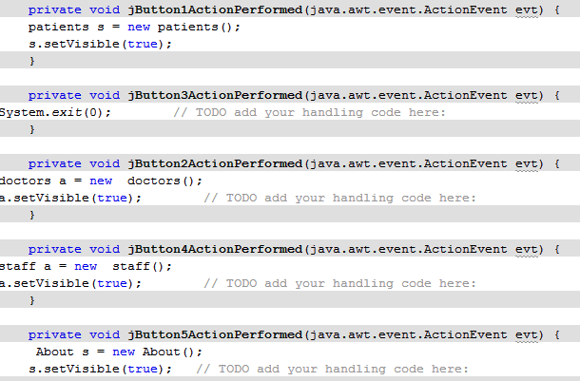Codes:-

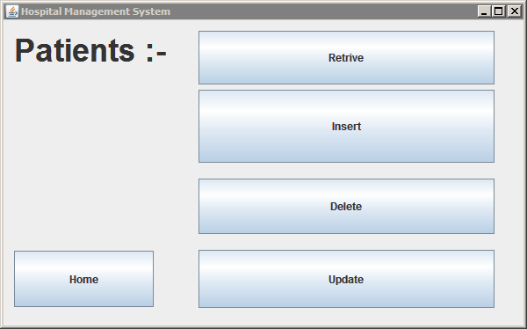Patients

Codes

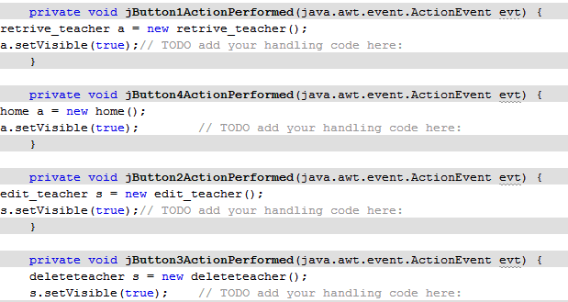

Staff

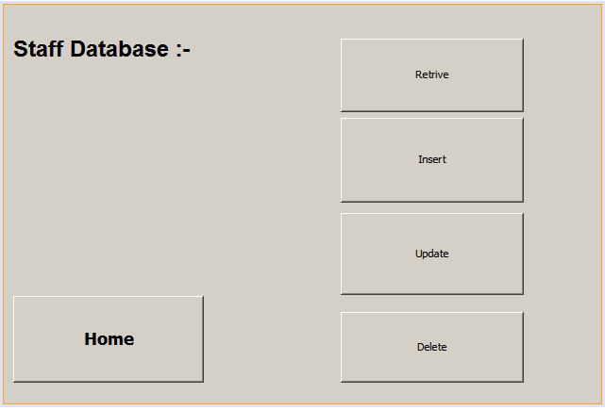

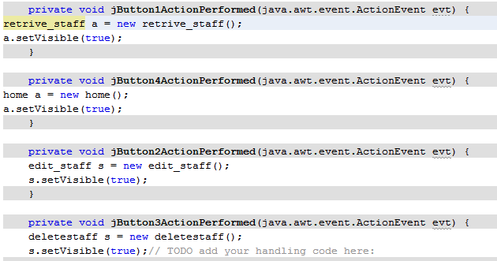Codes

Doctors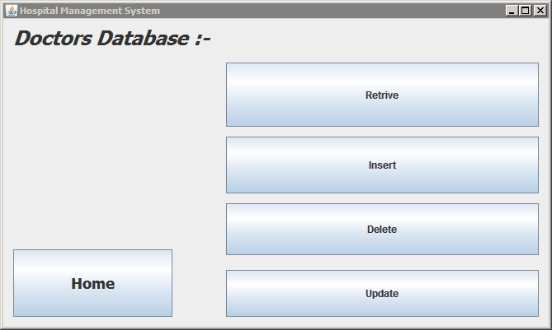

Codes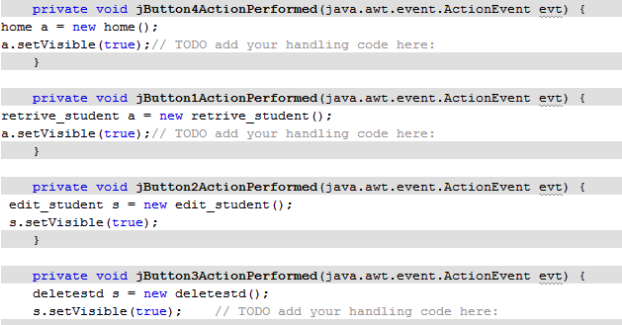

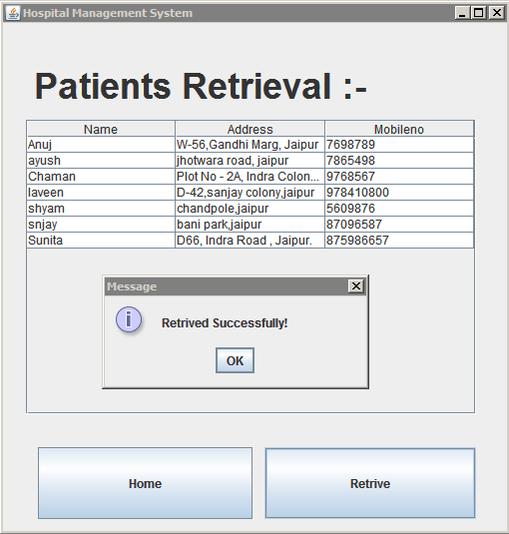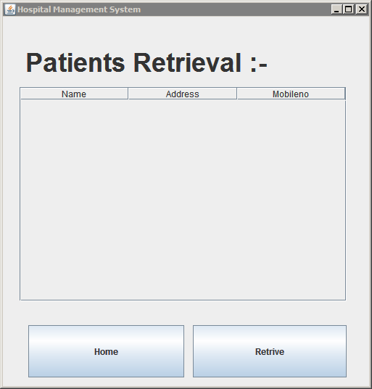Patients Retrival :-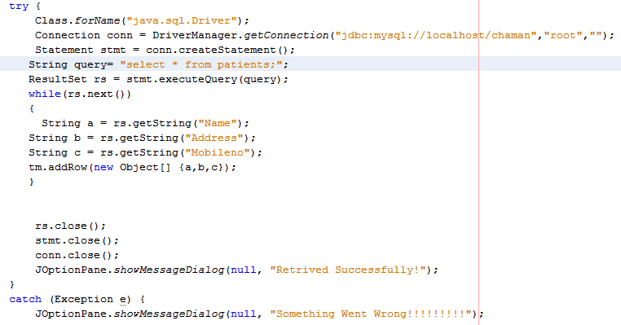

**C**

**O**

**D**

**E**

**S**

**C**

**O**

**D**

**E**

**S**

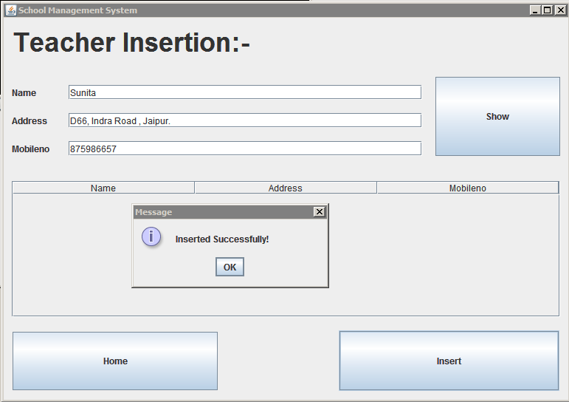Teacher Insertion 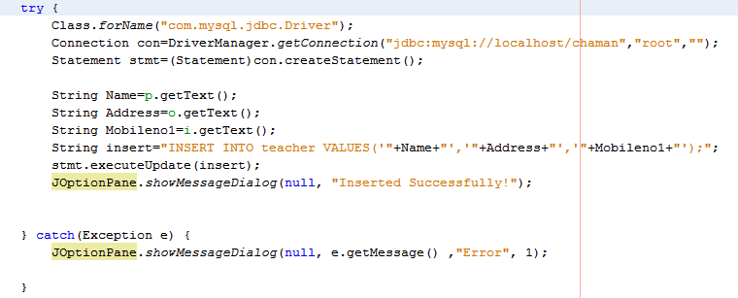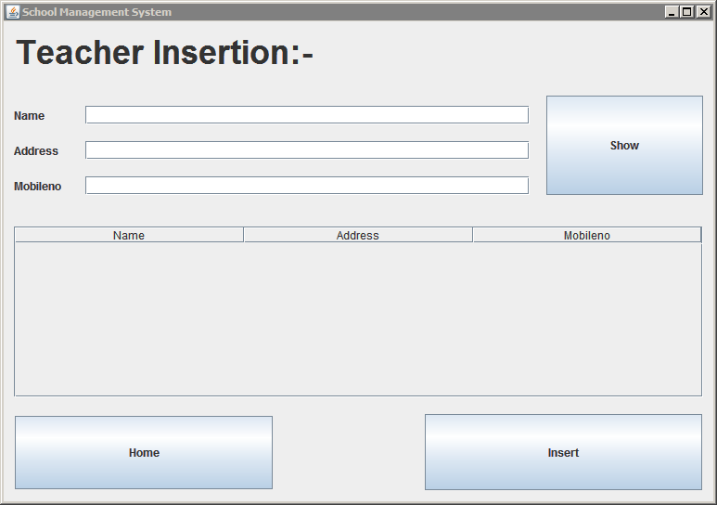

**C**

**O**

**D**

**E**

**S**

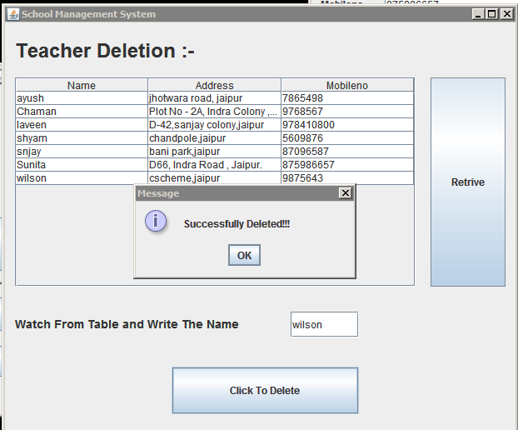Teacher Deletetion

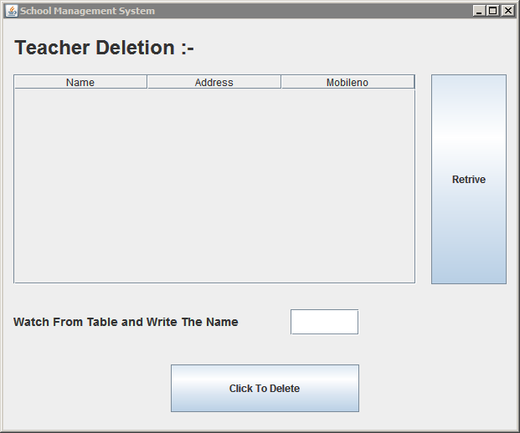



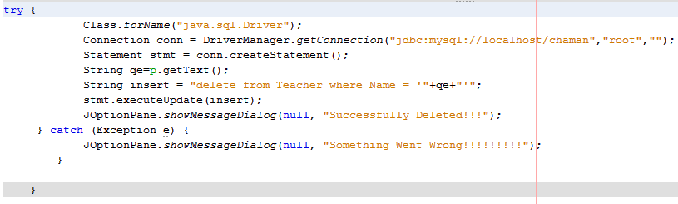

**C**

**O**

**D**

**E**

**S**

Teacher Updation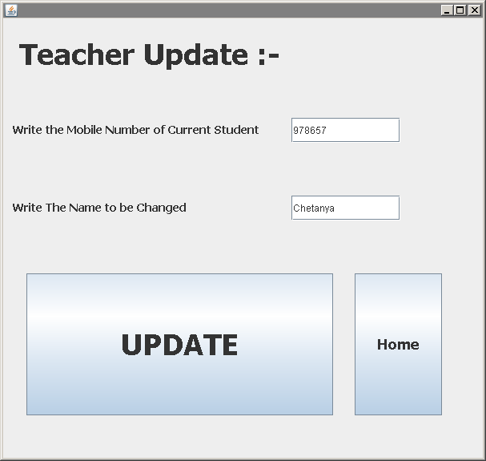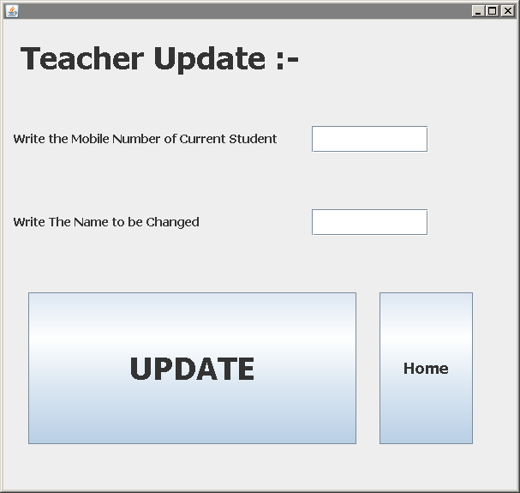

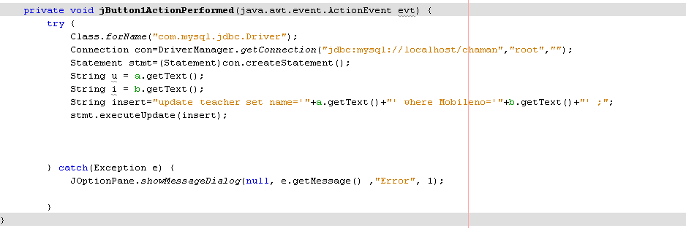

**C**

**O**

**D**

**E**

**S**

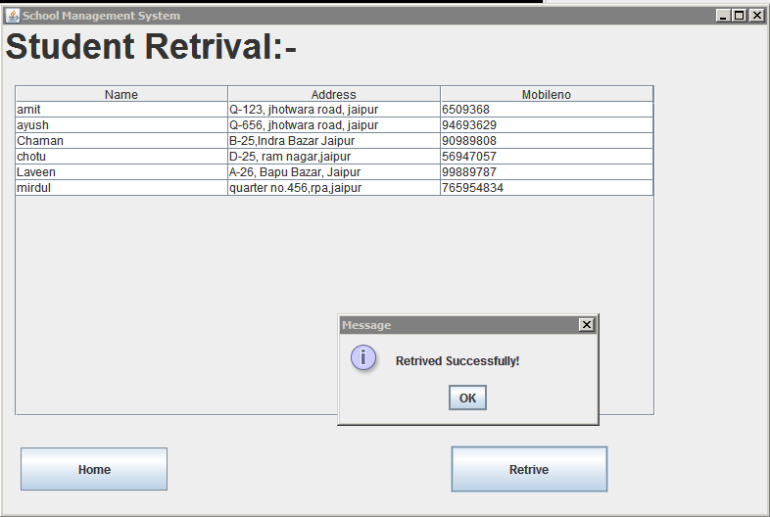Student Retrival

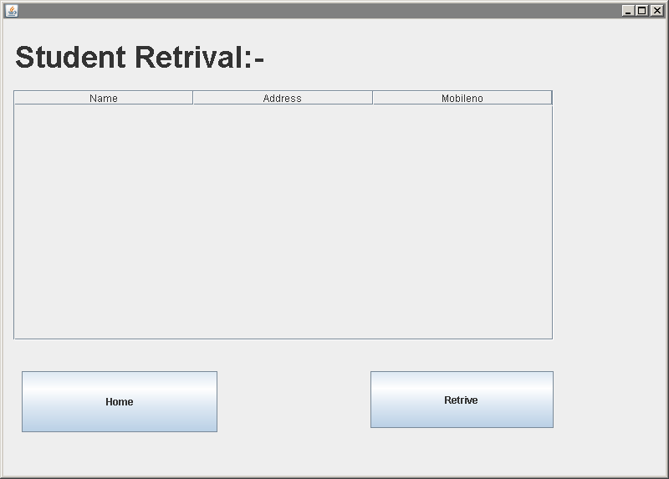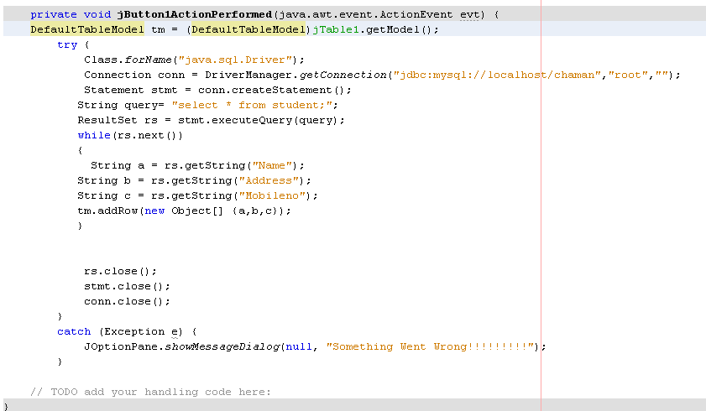

**C**

**O**

**D**

**E**

**S**

Student Update

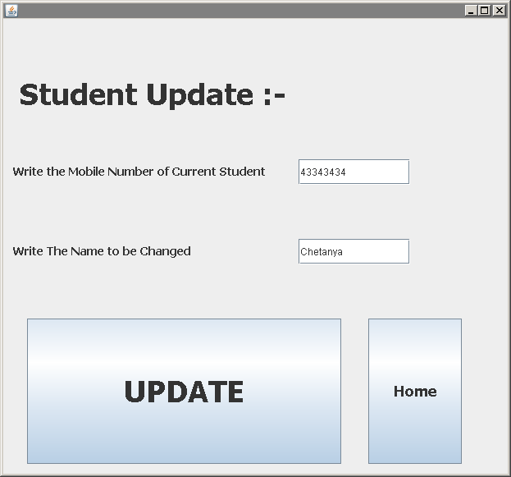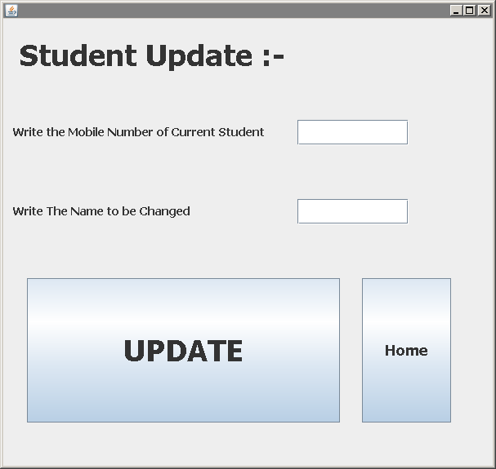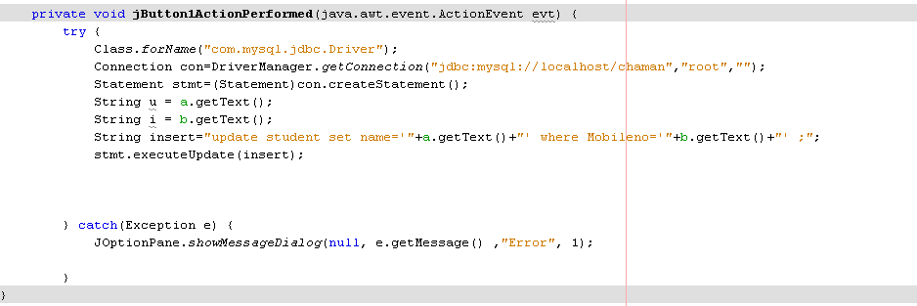

**C**

**O**

**D**

**E**

**S**

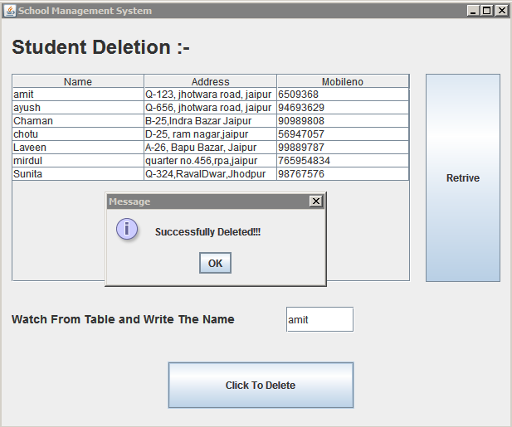Student Deletion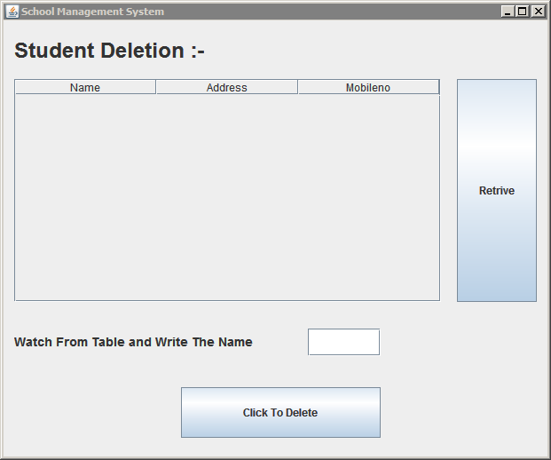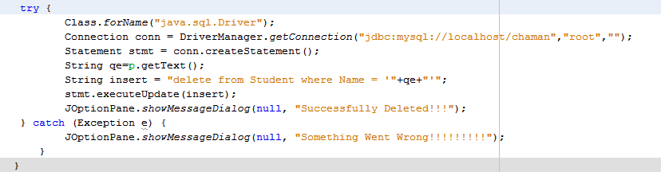

**C**

**O**

**D**

**E**

**S**

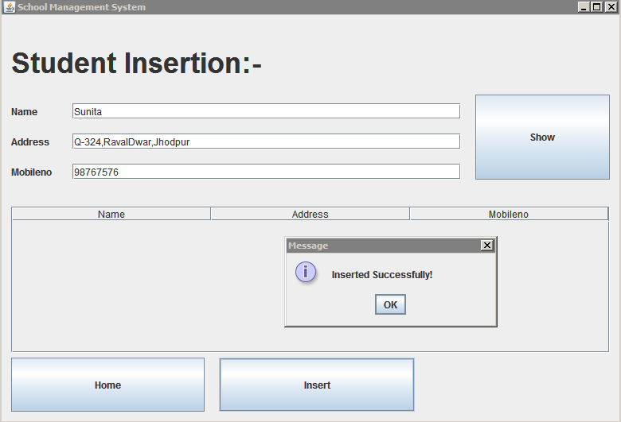Student Insertion

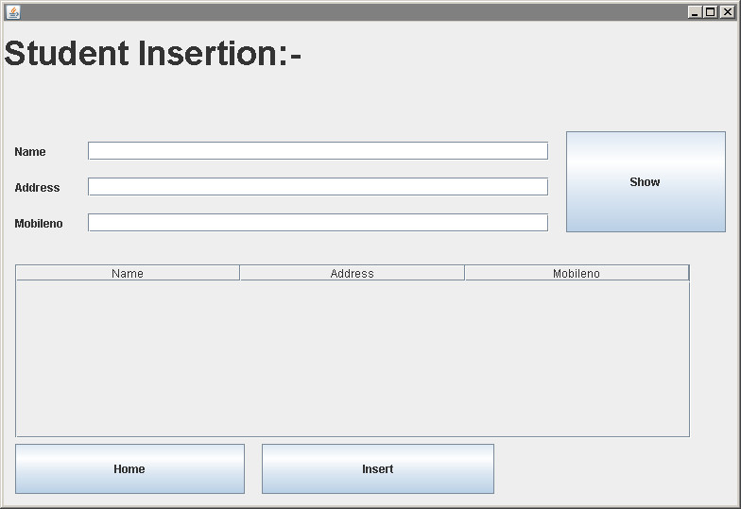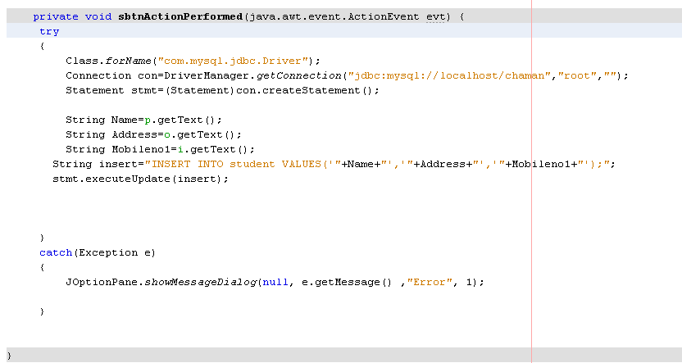

**C**

**O**

**D**

**E**

**S**

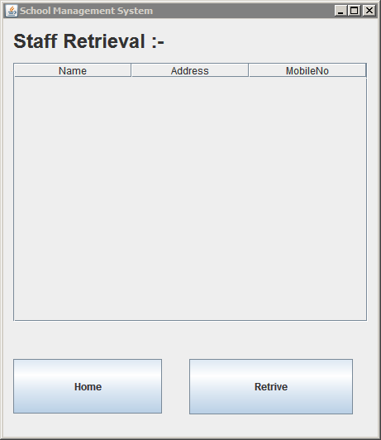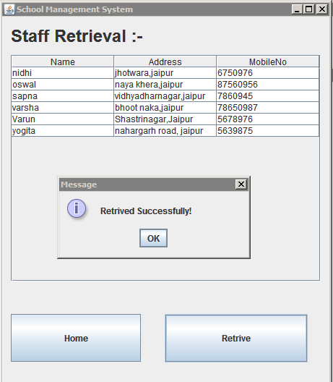Staff Retrival

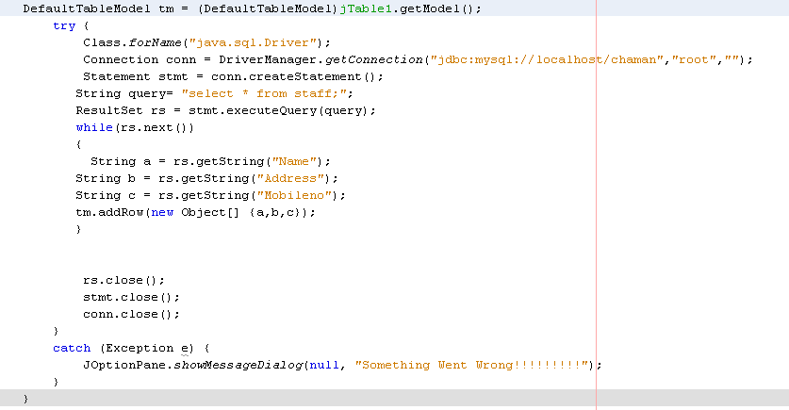

**C**

**O**

**D**

**E**

**S**

Staff Updation

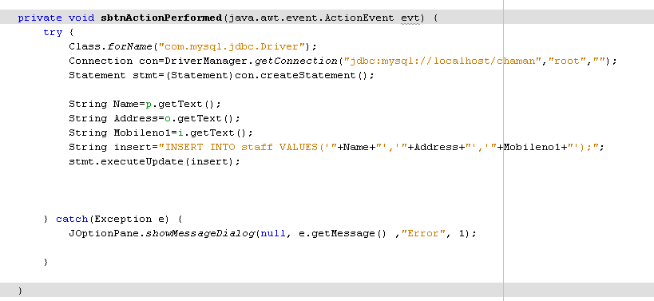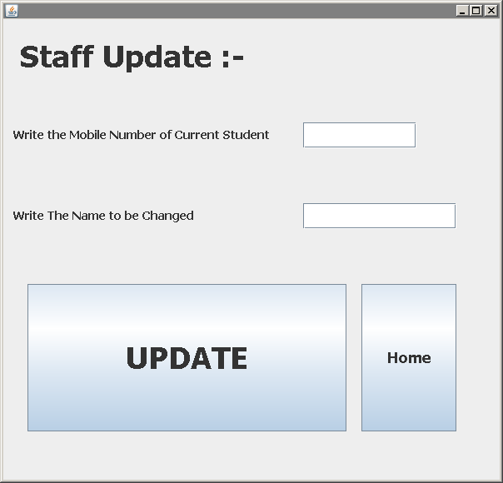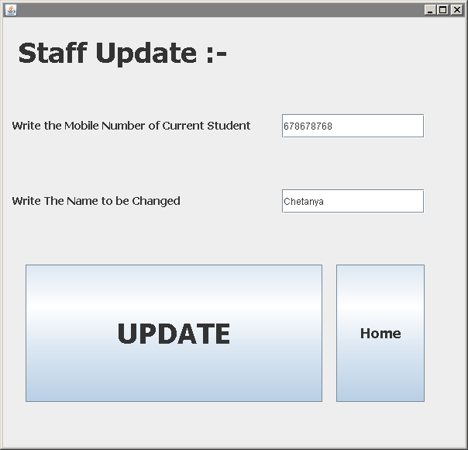

**C**

**O**

**D**

**E**

**S**

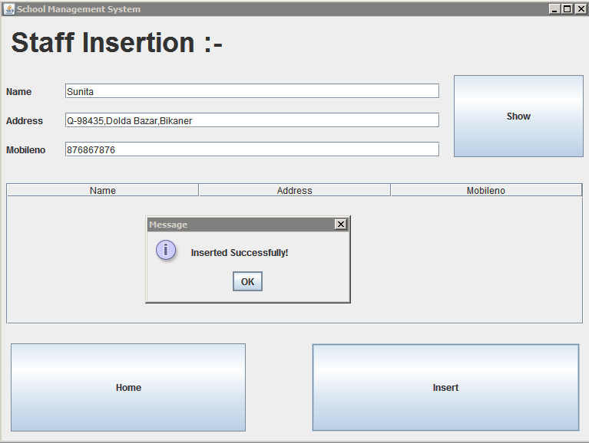Staff Insertion 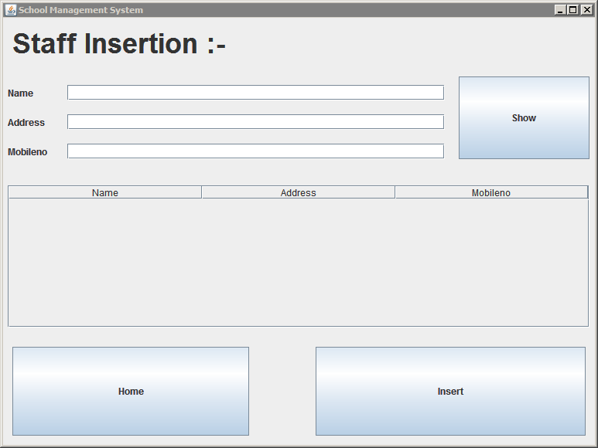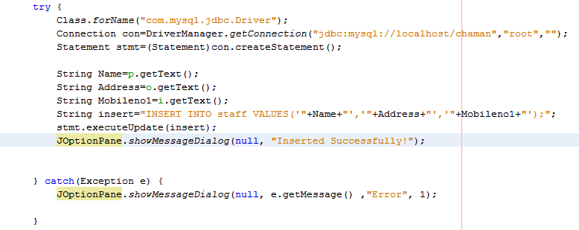

**C**

**O**

**D**

**E**

**S**

Staff Deletion

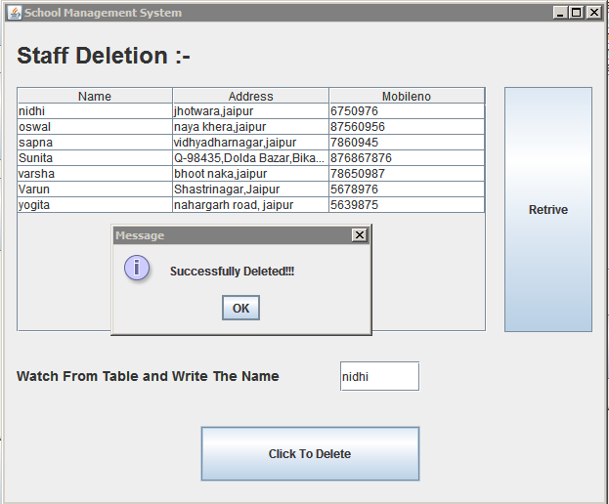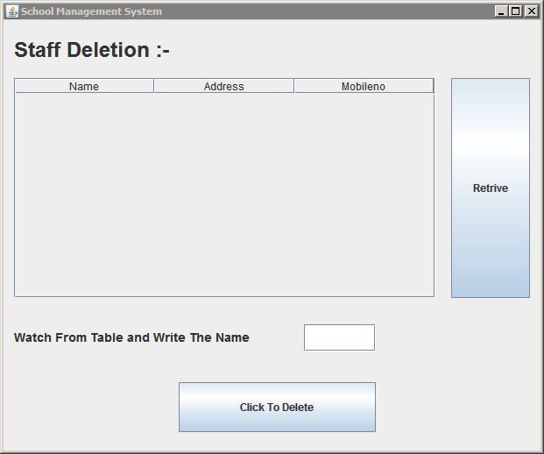

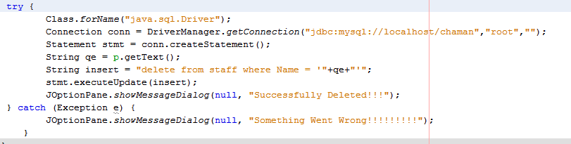

**C**

**O**

**D**

**E**

**S**

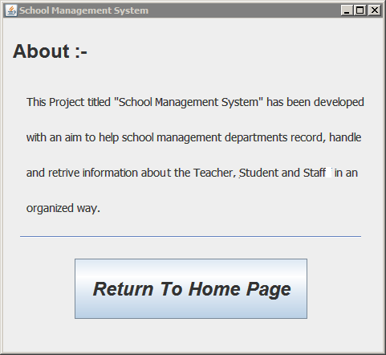About

Codes

C:\Documents and Settings\Administrator\Desktop\ip\about codes.png

**Advantages**

**This project has got a number of advantages. Following are some of the advantages:**

**Using this project, one can easily Insert, Update, Retrive and delete the same about teachers, student and staff of a school.**

* **The interface between the user and the project has been designed to let the user proceed with Insert, Update, Retrive and delete of data easily.**
* **Managing data has been made easy.**
* **Efforts have been made to keep navigation as easy as possible.**
* **For the sake of simplicity and convenience, if in future it is decided to launch this project as an open source, available-to-all project, one will be able to amend the setup without much trouble to modify the project according to one’s need.**
* **The user gets an extra edge due the inter-relatedness of the three tables through the project.**

**Conclusion :-**

**This was an effort to develop a simple School Management System which may be useful to a hospital management to insert, store, handle and retrieve information about teacher, student and staff. We hope you will like it.**

**Following are some possible enhancements which may be incorporated in this project in future:-**

1. **An encryption system may be added to keep data encrypted as an option to add security to the project.**
2. **We will try to advance some current features also in the project.**
3. **More facilities and features can be added into the project for its efficient use to be availed on the Internet.**