**INTRODUCTION :-**

**Companies employees what they call computer operators who store and handle the database which stores all necessary information concerning the company. What is much needed is a proper interface which may enable us to handle such systems efficiently.**

**This project entitled “LIBRARY MANAGEMENT SYSTEM” has been developed with an aim to help one such organization – a library to easily manage and handle the data concerning it.**

**There are mainly three types of actions performed by this project:-**

* **Retrive :-There are dedicated tables made for serving the purpose of viewing the details of books existing in a library database at a particular time.**
* **Insert :- Data such as names, code numbers and authors etc. can be inserted easily.**
* **Update :- We can simply update anything whether it is codeno., name or author.**
* **Delete :- We can simply delete the data regarding our books.**

**INDEX**

* Acknowledgement
* Certificate
* Screenshots/output
* Coding
* Bibliography

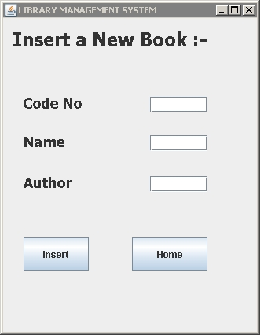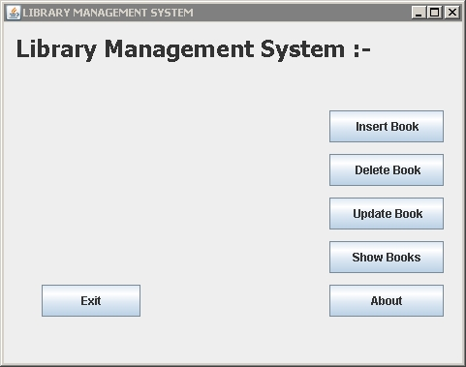

**INSERT:-**

**Home:-**

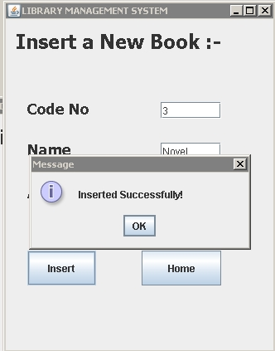

**Insert:-**

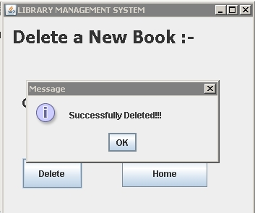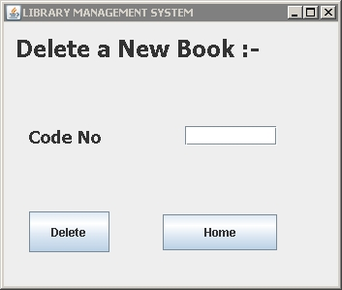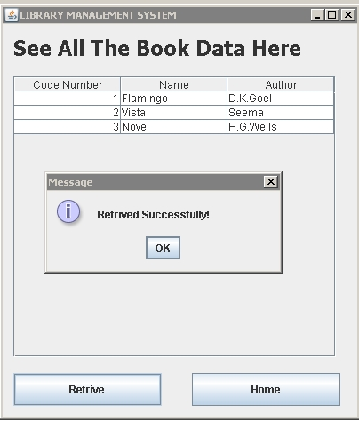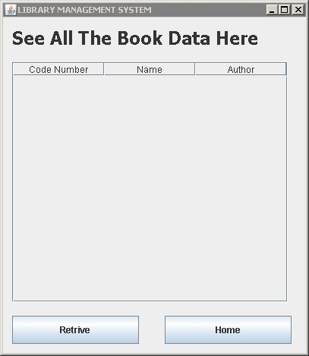

**Retrieve:-**

**Retrieve:-**

**Delete:-**

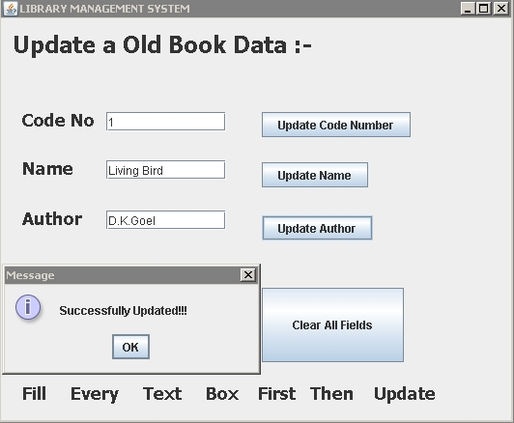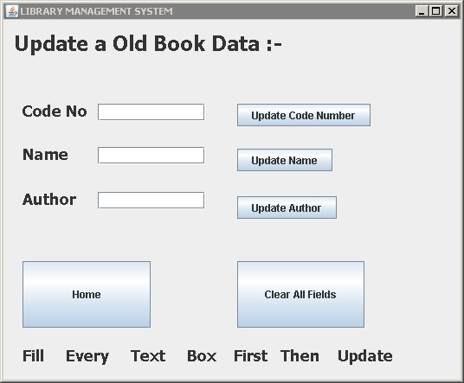

**Update:-**



**Update:-**

**Codes:-**

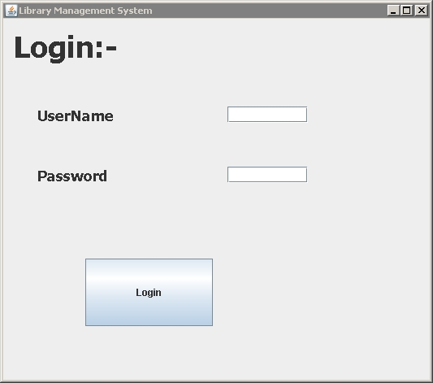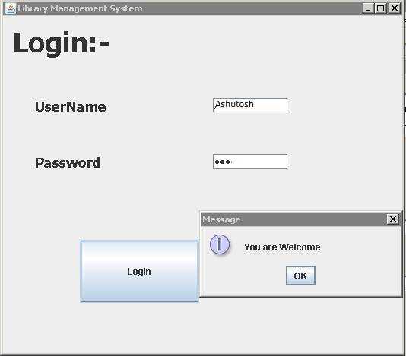

**Login:-**

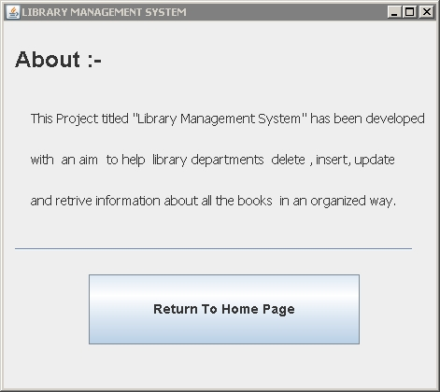

**About:-**

**CODES**

**Home:-**

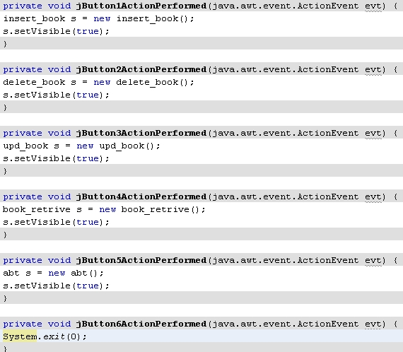

**Retrieve:-**

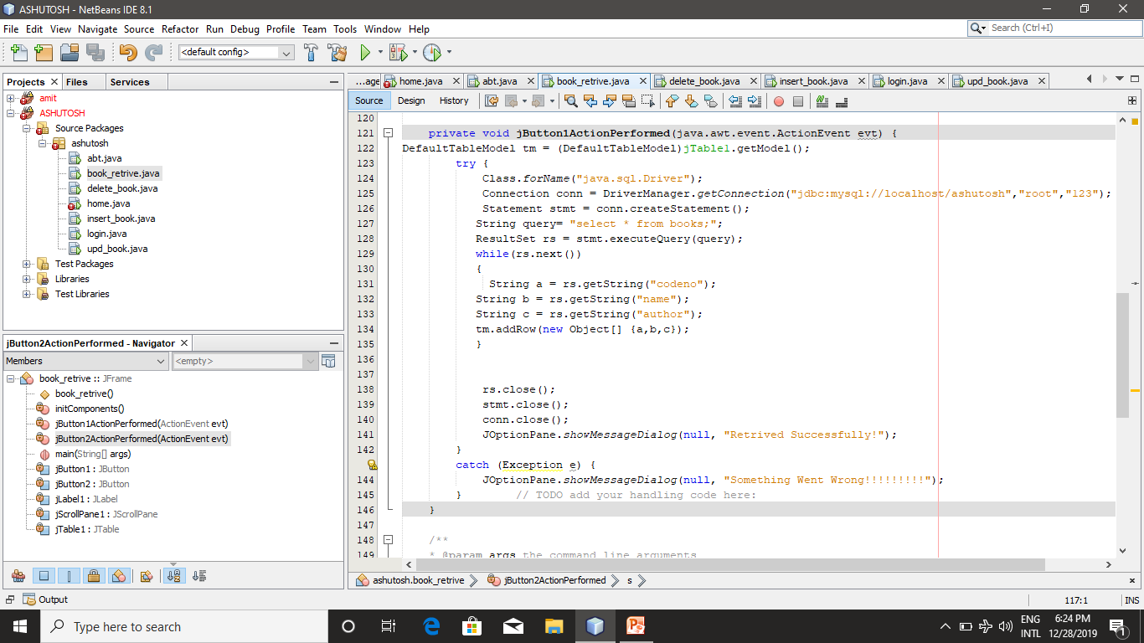

**Delete:-**

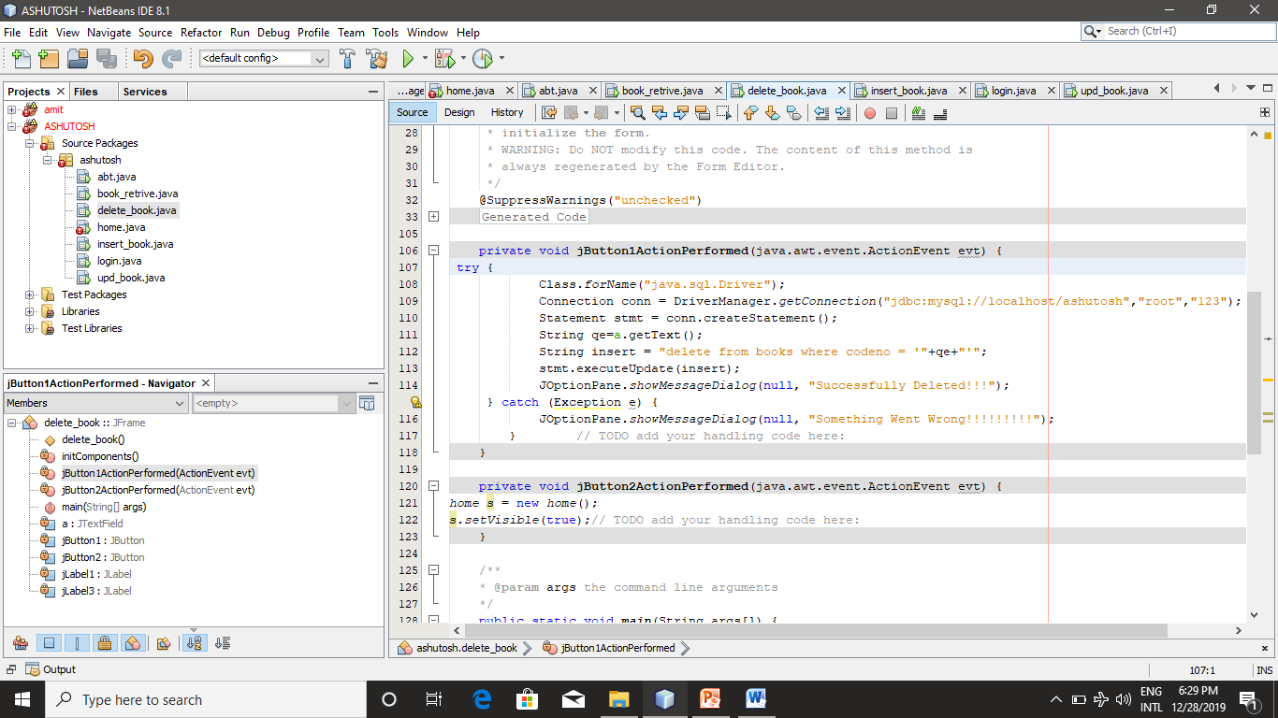

**Update:-**

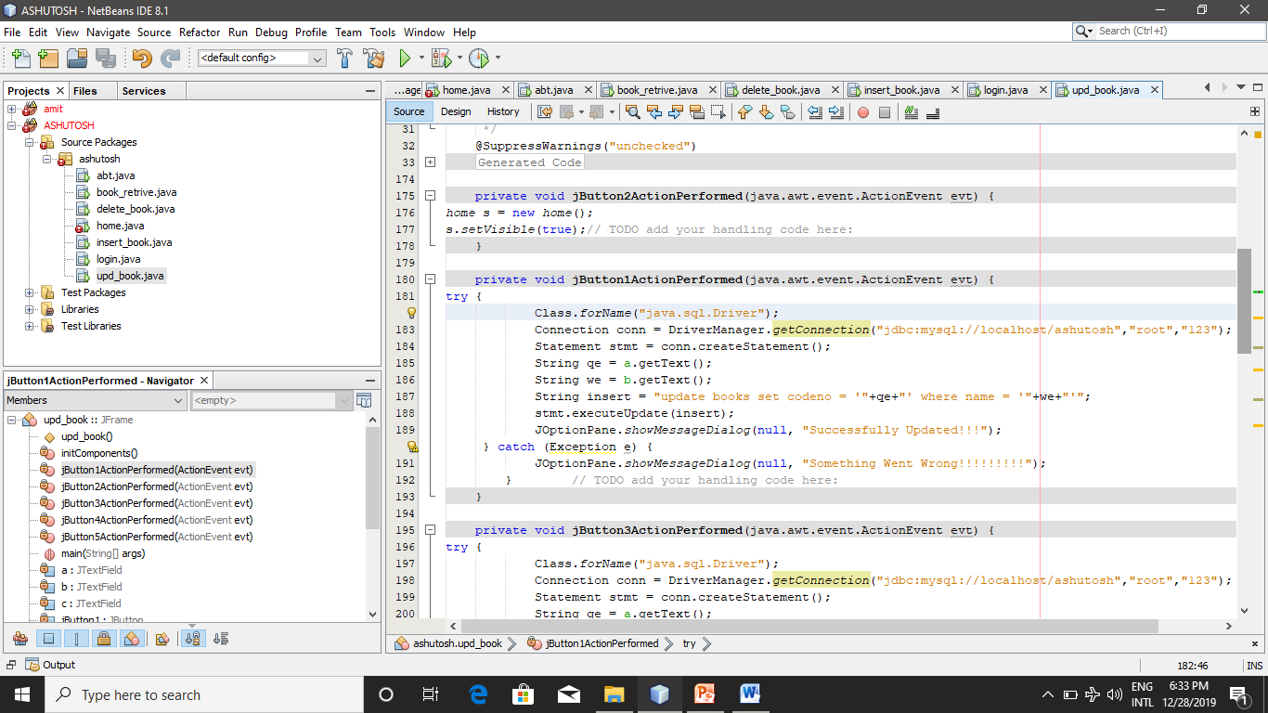

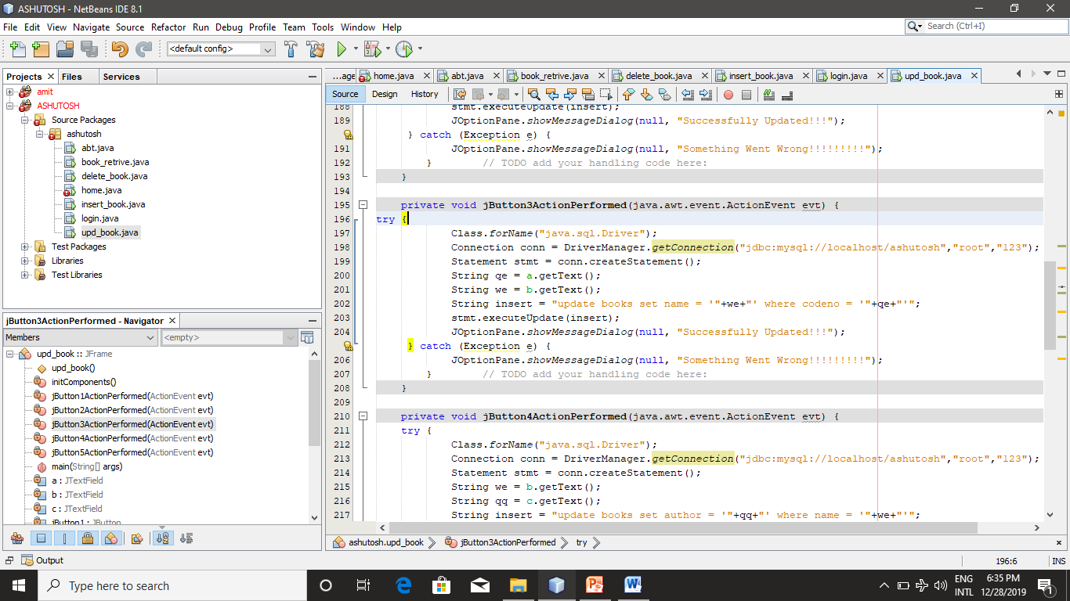

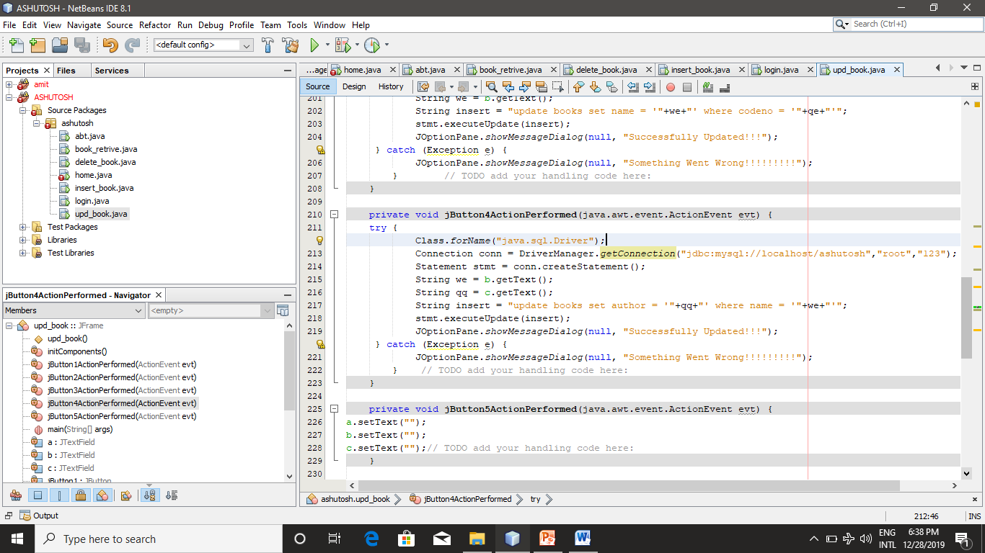

**Login:-**

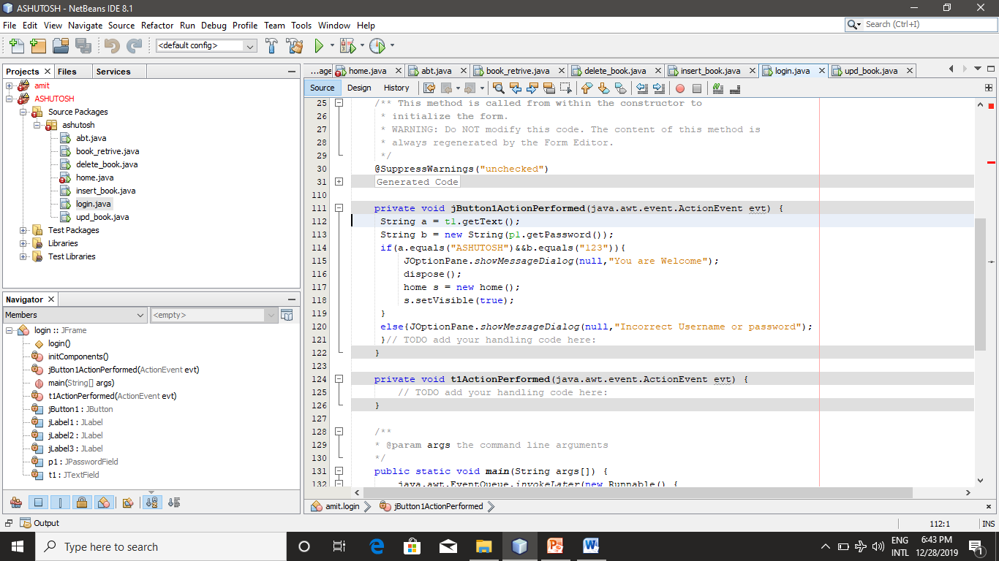

**INSERT:-**

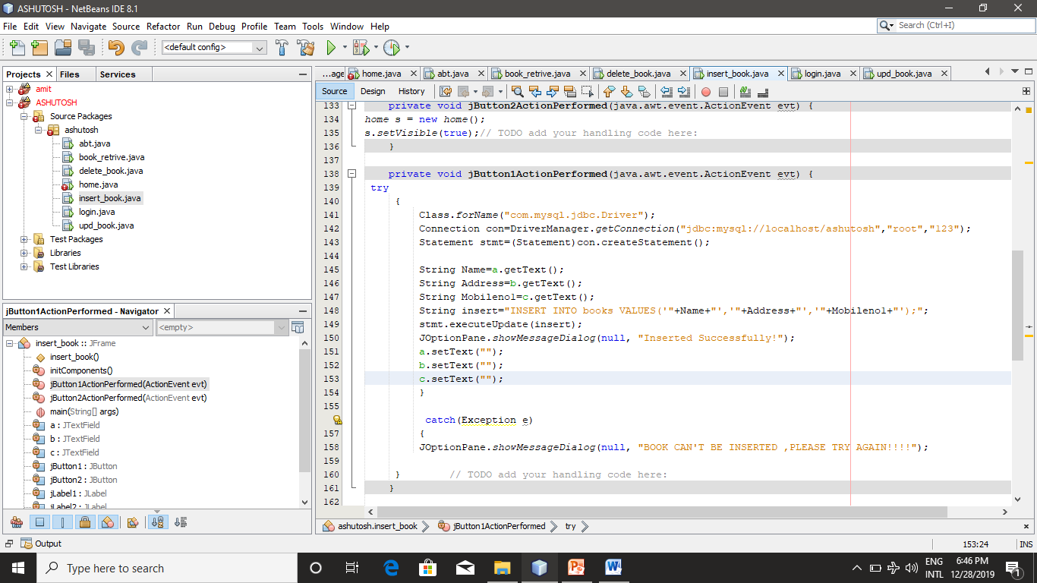

**About:-**

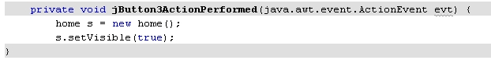

**Bibliography**

1. **Sumit Arora**
2. **Class notes**
3. **CBSE text books**