user1: ashutosh.dev.gitlab

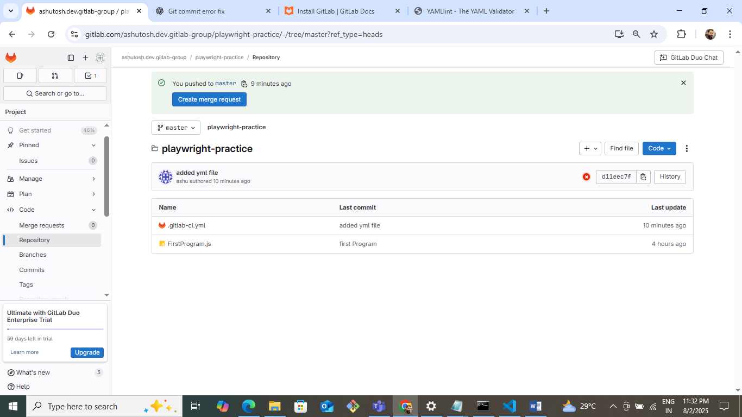

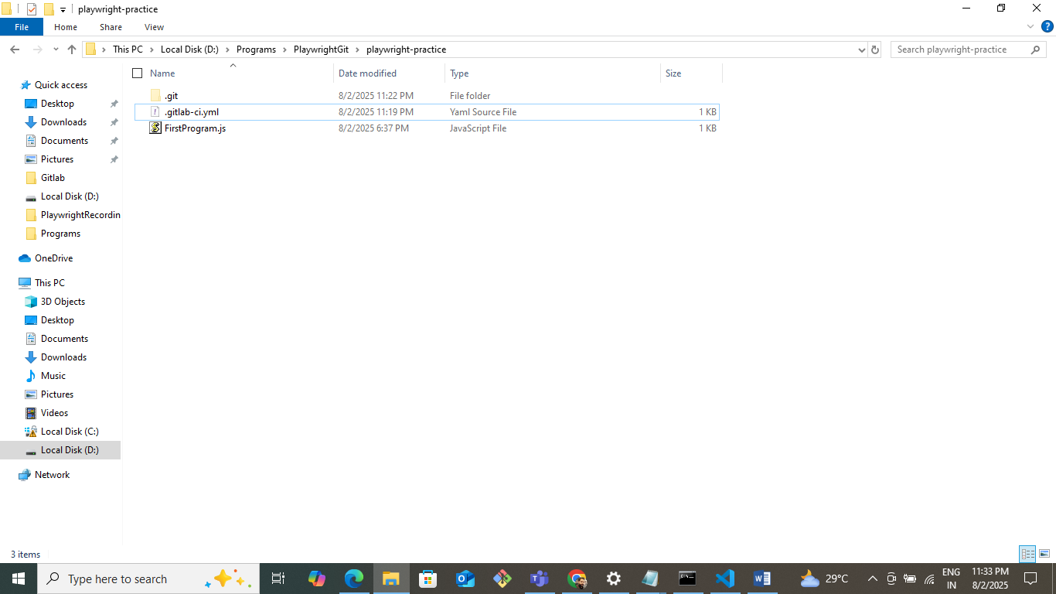

user2: ashutosh.reviewer.gitlab

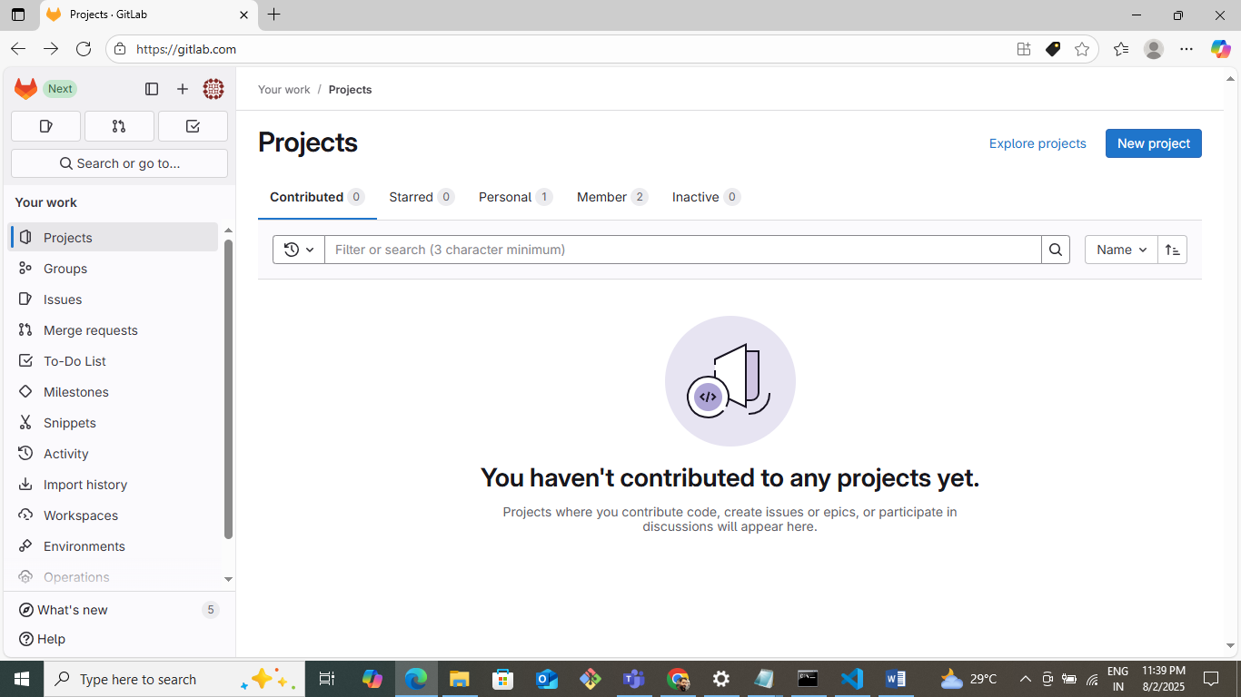

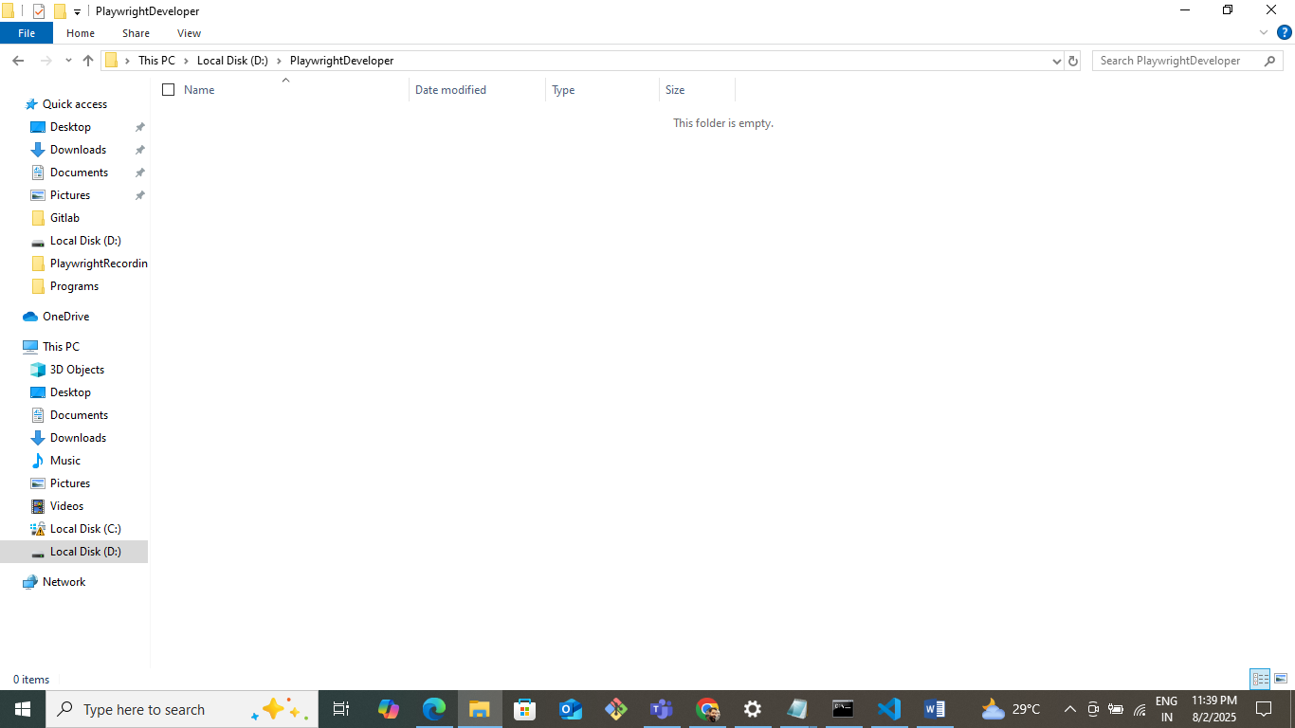

Requirement here is: I have 2 git users as above. For one user I have created a project as can seen above. I have it’s local repository also. I just want to have the same project for my user2 as well on its designated folder. Also if user2 wants to add any file. How he will do it so that it would reflect to user1 in gitlab.