

Foundations of Programming

Assignment No. : 06
Name -Ashutosh Kumar Dewangan
PRN – 1262252582 (DIV 11)

PROBLEM STATEMENT:Write a C function to compute the factorial of a number with and without recursion.

OBJECTIVE:

To demonstrate two different approaches for calculating the factorial of a number: iterative (non-recursive) and recursive, showcasing the versatility of problem-solving methods in programming.

THEORY:
- Explain the difference between the iterative and recursive approaches to calculating the factorial of a number.
- What is the base case in the recursive function for computing factorials, and why is it necessary?
- How does the program handle invalid input, such as negative numbers, and why is this important?
PLATFORM: Linux

INPUT:

CODE- with Recursion
#include<stdio.h>

int main() {
int n, i;
int fact = 1;

printf("Enter number: ");
scanf("%d", &n);

if(n < 0) {
printf("Invalid number");
} else {
for(i = 1; i <= n; i++) {
fact = fact * i;
}
printf("Factorial = %d", fact);
}

return 0;
}
Code -without Recursion
#include <stdio.h>
int factorial(int n) {
int fact = 1;
for(int i = 1; i <= n; i++) {
fact = fact * i;
}
return fact;
}

int main() {
int num;
printf("Enter a number: ");
scanf("%d", &num);

printf("Factorial = %d", factorial(num));
return 0;
}
OUTPUT:
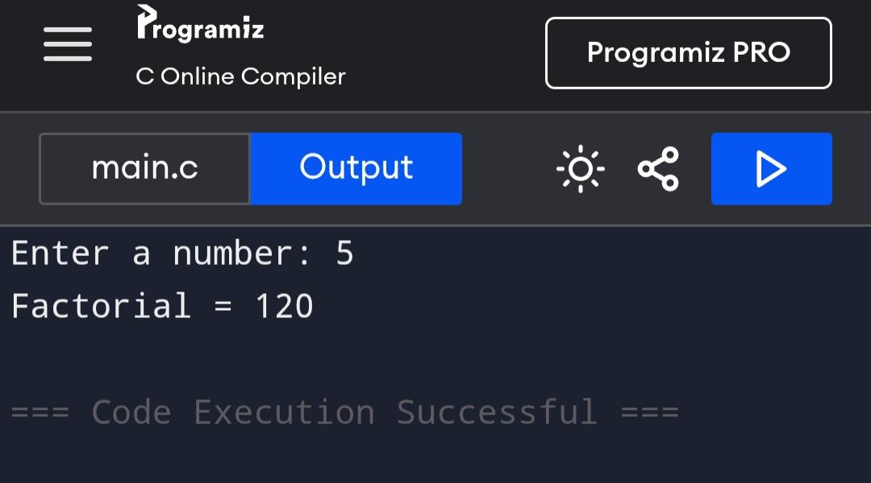
CONCLUSION: Thus, we have successfully executed factorial of a number with and without recursion.

FAQs:
1. What is the purpose of calculating factorial in programming?
2. What is the difference between recursive and non-recursive (iterative) methods?

