**Test on UI**

Q.1 Make three Web Pages. Home.html, Red.html, Blue.html, create two links on the Home.html. When clicked on one link , Red.html should be opened with red coloured background. When clicked on second link, Blue.html should be opened with blue coloured background.

Q.2 Create a Form Registration.html in tabular form and do the following :-

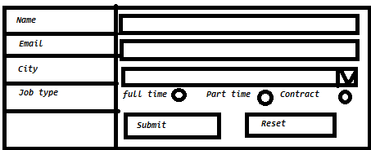

a) Take name in a Text box and Email in second text box.

b) Create a Combo Box which has 3 city names.

c) Create 3 radio buttons on which Full-time, Part-time and Contract should

be displayed along with radio buttons.

d) Create two Buttons Register and Reset, When clicked on Register Button

a new Html Page as NewUser.html should be opened which shows the

message as 'Registration Successful'.

Q.3 Create an external styleSheet as styles.css and one HTML file. Do the following and effects on HTML file should be reflected on elements :

a) Write code in Css file to change the background color of text box as blue.

b) Write code in same Css to change the heading h1 color as Brown.

c) Write code in Css file to change the background color of body to yellow.

d) Write a Program to make a bordered button.

Q.4 Create an ordered List in a Html page which shows the list of fruits. Each

item in the list should be of different color . Also make each item as a

hyperlink.

Q.5 Create a Simple form which has two text boxes for UserName and Password . Password should be of maximum 6 length characters. The Font color of User name should be Red. Background color of input text boxes should be cyan. Create a Login button and a Clear button.

Q.6 Create an external JavaScript file which shows a message "Hello" on the page. This file should be included in HTML page. Display message.