**Test on UI**

Q.1 Write a Javascript Program to take two numbers in two textboxes and create

a button. If the first number is greater than the second number then do

Addition and display addition in Alert box. If the first number is less than

the second number then display the multiplication in the alert box. to Add

numbers and multiply numbers , make separate methods of JavaScript.

Q.2 Write a JavaScript Program to take a number in a text box and create two

buttons on the page. When clicked on Button1 , Factorial of the number

should be displayed in alert box and Square of the number should be

displayed on the div tag of the same web page.

Q.3 Create a web Page as follows:

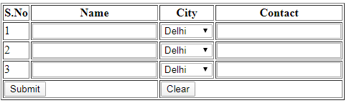

a) In text boxes Apply focus() and blur() events of JQuery.

b) Use Colspan property of table to display Submit & Clear button as

above table.

Q.4 Create an Angular Program in which take an input Text box which take a

number and prints the Square of the entered number in the h1 tag on the

web Page. Use functional Expression to return the square of the number

in the controller.

Q.5 Create a JQuery Program where create a select box and a button on the

Web Page. Select box has 3 colors : Red, Green and Blue. Background

color of the body should be changed according to the selected value when

we click on the button.