/*Problem Staement: Implement DDA and Bresenham line drawing algorithm to draw (2 week, 4 hrs)

i) Simple line

ii) Dotted line

iii) Dashed line

iv) Solid line

using mouse interface. Divide the screen in four quadrants with center as (0, 0). The line shouldwork for

all the slopes +ve, -ve, >1,<1

*/

#include<iostream>

#include<GL/glut.h>

using namespace std;

int Algo,type;

void Init()

{

glClearColor(0,0,0,0);

glColor3f(0,1,0);

gluOrtho2D(0,640,0,480);

glClear(GL_COLOR_BUFFER_BIT);

}

int sign(float a){

if(a==0){

return 0;

}

if(a>0){

return 1;

}

return -1;

}

void B_Line(int x_1,int y_1,int x_2,int y_2,int t){

float dy, dx, m , P;

dy = y_2 - y_1;

dx = x_2 - x_1;

m = dy/dx;

P = 2*dy - dx;

int x = x_1, y = y_1;

cout<<"\n x1 = "<<x<<" y1 = "<<y;

if(m<1){

int cnt=1;

for(int i=0; i<=dx;i++){

if(t == 1){

glBegin(GL_POINTS);

glVertex2i(x,y);

glEnd();

}if(t == 2){

if(i%2==0){

glBegin(GL_POINTS);

glVertex2i(x,y);

glEnd();

}

}

if(t == 3){

if(cnt <= 10){

glBegin(GL_POINTS);

glVertex2i(x,y);

glEnd();

}

cnt++;

if(cnt == 15){

cnt =1;

}

}

if(P<0){

x = x +1;

y =y;

P = P + 2*dy;

}

else{

x= x+1;

y = y+1;

P = P + 2*dy - 2*dx;

}

}

}

else{

int cnt = 1;

for(int i=0;i<=dy;i++){

if(t == 1){

glBegin(GL_POINTS);

glVertex2i(x,y);

glEnd();

}

if(t == 2){

if(i%2==0){

glBegin(GL_POINTS);

glVertex2i(x,y);

glEnd();

}

}

if(t == 3){

if(cnt <= 10){

glBegin(GL_POINTS);

glVertex2i(x,y);

glEnd();

}

cnt++;

if(cnt == 15){

cnt =1;

}

}

if(P<0){

x = x;

y =y+1;

P = P + 2*dx;

}

else{

x= x+1;

y = y+1;

P = P + 2*dx - 2*dy;

}

}

}

cout<<"\n xlast = "<<x<<" ylast = "<<y;

glFlush();

}

void DDA_LINE(int x_1,int y_1,int x_2,int y_2, int t){

float dx,dy,length;

dx = x_2-x_1;

dy = y_2-y_1;

if(abs(dx) >= abs(dy)){

length = abs(dx);

}

else{

length = abs(dy);

}

float xin, yin;

xin = dx/length;

yin = dy/length;

float x,y;

x = x_1 + 0.5 * sign(xin);

y = y_1 + 0.5 * sign(yin);

int i=0;

int cnt =1;

while(i<=length){

if(t == 1){

glBegin(GL_POINTS);

glVertex2i(x,y);

glEnd();

}

if(t == 2){

if(i%2==0){

glBegin(GL_POINTS);

glVertex2i(x,y);

glEnd();

}

}

if(t == 3){

if(cnt <= 10){

glBegin(GL_POINTS);

glVertex2i(x,y);

glEnd();

}

cnt++;

if(cnt == 15){

cnt =1;

}

}

x = x + xin;

y = y + yin;

i++ ;

}

glFlush();

}

void display()

{

DDA_LINE(0,240,640,240,1);

B_Line(320,0,320,640,1);

glFlush();

}

void mymouse(int b,int s, int x, int y)

{

static int x_s,y_s,x_e,y_e,pt=0;

if(b==GLUT_LEFT_BUTTON && s==GLUT_DOWN)

{

if(pt==0)

{

x_s =x;

y_s =480 - y;

pt++;

glBegin(GL_POINTS);

glVertex2i(x_s,y_s);

glEnd();

}

else

{

x_e=x;

y_e=480-y;

cout<<"\n x_1_click "<<x_s<<" y_1_click "<<y_s;

cout<<"\n x_2_click "<<x_e<<" y_2_click "<<y_e<<"\n";

glBegin(GL_POINTS);

glVertex2i(x_e,y_e);

glEnd();

if(Algo == 1){

DDA_LINE(x_s,y_s,x_e,y_e,type);

}

if(Algo == 2){

B_Line(x_s,y_s,x_e,y_e,type);

}

}

}

else if(b==GLUT_RIGHT_BUTTON && s==GLUT_DOWN)

{

pt=0;

}

glFlush();

}

int main(int argc ,char **argv)

{

cout<<"\n Select the Algorithm \n 1. DDA \n 2. Bresenham's \n";

cin>>Algo;

cout<<"Select the Line Type \n 1. Simple Line \n 2. Dotted Line\n 3. Dashed Line \n";

cin>>type;

if((Algo == 1 || Algo == 2 )&&(type==1 || type==2 || type==3)){

}

else{

cout<<"\n Option enter are wrong \n";

return 0;

}

glutInit(&argc,argv);

glutInitDisplayMode(GLUT_SINGLE|GLUT_RGB);

glutInitWindowPosition(100,100);

glutInitWindowSize(640,480);

glutCreateWindow("DDA &Bresenham's Line");

Init();

glutDisplayFunc(display);

glutMouseFunc(mymouse);

glutMainLoop();

return 0;

}

//OUTPUT

1. DDA

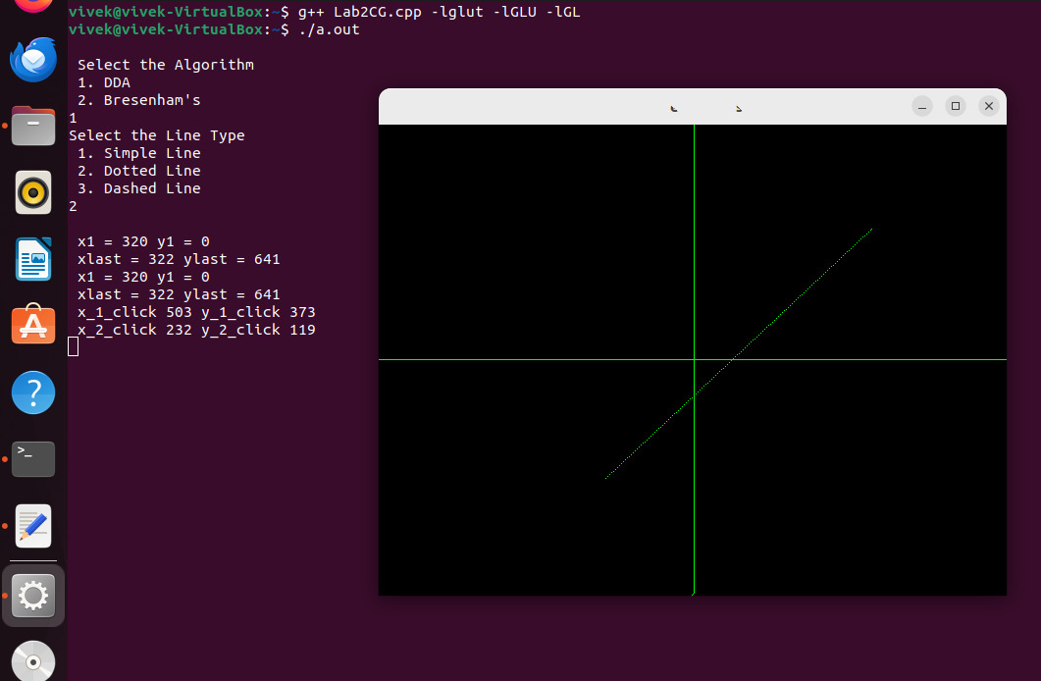

1. Bresenham

