**Trident Hotels**

**Project Overview**

Trident Hotels is a leading hotel chain in India which operates across all metropolitan cities. Trident club rooms are designed for discerning business travellers. Plethora of services and amenities are provided. We invite you at Trident Hotels for your upcoming trip. The hotel already operating online with all locations having a single site resulting in higher traffic and difficulty in management

Trident Hotels has decided to make a standalone web portal for Hyderabad location. This document specifies the list of requirements that are needed for the initial phase of the web launch.

**Scope of project:**

**In Scope**

Following are the key features that needs to be implemented for User/Guest and Admin:

**Admin**

1. CRUD Guests

2. CRUD Users

3. CRUD Services

4. Change Admin Password

5. Login

(NOTE: CRUD- Create Retrieve Update Delete)

**Customer/Guest**

1. CRUD Guest

2. CRUD User

3. Change Password

4. View Services

**DB SCHEMA:**

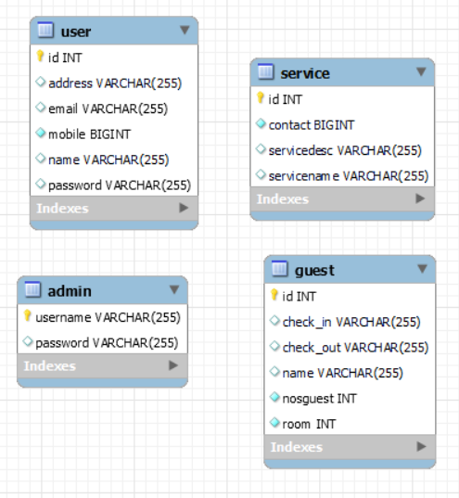

**USE CASES:**

There will be **two types of users** whom will be using this application:

1. Admin

2. Customer/Guest

**Key Responsibilities:**

* Admin – Responsible for managing the guest booked and User registered on Trident hotels
* Customer – Update booked guest and there registration details.

**ADMIN SCOPE:**

**Admin View Menu Items**

1. Admin should login with credentials.
2. Admin home page has guests, users and services list. Application fetches the guests, users and services list from the database.

***List of menu items shown to the admin with following details about each menu item:***

1. Guest (Id, Name, check-in date, check-out date, No. of rooms, No. of guest)
2. User (Id, Name, Phone Number, email, address)
3. Services (Id, Service Name, Service Description, Contact)
4. Change Password
5. Logout

**Note:** Continue for all the features – **ex:** admin add/ admin update/ admin delete.

**CUSTOMER SCOPE:**

**Customer/Guest View Menu Items**

1. User/Guest should login with credentials
2. User/Guest shoud register.
3. Guest/User home page has guest, user and services list. Application fetches the guest, user and services list from the database.

***List of menu items shown to the Guest/User with following details about each menu item:***

1. Guest (Id, Name, check-in date, check-out date, No. of rooms, No. of guest)
2. User (Id, Name, Phone Number, email, address)
3. Services (Id, Service Name, Service Description
4. Change Password
5. Logout

**FUTURE SCOPE :**

Trident hotels website currently created for hotel reservation operation. The hotel aims to bring all operation comprising restaurant management, Employee management on this standalone website**.**

**GIT REPOSITORY: https://gitlab.com/ashutoshh09/test**