Market Research Report
AI-Based Gym Companion Apps & Services
  - Prepared for a product concept combining adaptive diet planning, workout programming, logging, and vision-model-based rep counting.
Date: 21 March 2026
Executive takeaways
• The demand side is real: global health & fitness app downloads reached 3.6 billion in 2024, while mobile exercise apps rank #2 in ACSM’s 2025 fitness trends survey.
• The most attractive wedge is not “general wellness AI”; it is a gym-specific workflow that reduces logging friction, adapts plans weekly, and turns the phone camera into a coach and tracker.
• The category is crowded in planning and content, but still fragmented across workout programming, nutrition, accountability, and computer-vision execution.
• Recent winners show two viable models: software-first subscription apps (Freeletics, Fitbod, Zing, Ladder) and gym-stack/platform plays (EGYM). Failures suggest avoiding hardware dependency unless unit economics are exceptional.
• Your concept is strongest when positioned as an AI gym companion for strength and body-composition goals, not as a generic chatbot trainer.

1. Scope and category definition
For this report, “AI-based gym companion apps and services” refers to mobile-first products that combine some or all of the following: personalized workout planning, exercise logging, technique or movement analysis, rep/set counting, progress analytics, and nutrition guidance. The focus is on products used by consumers training in a gym or hybrid gym/home environment—not only pure meditation, step counting, or general wellness apps.
This matters because market estimates vary widely depending on how analysts define the category. Broad fitness-app reports include running, yoga, and trackers; AI personal trainer reports include rehabilitation and smart equipment; connected-fitness reports include hardware and content subscriptions. The right way to interpret the market is therefore as an overlapping stack, not one single clean market.

2. Industry financials and market sizing
The industry is large enough to support venture-scale companies, but it should be framed as overlapping markets. Broad fitness apps were estimated at $12.12B in 2025 and projected to reach $33.58B by 2033. Grand View also reports that exercise & weight-loss apps accounted for 53.69% of the fitness-app segment in 2025, iOS led with 51.99%, smartphones with 66.70%, and North America held 39.82% of revenue. Separately, the AI personal trainer market was estimated at $16.93B in 2025 and projected to reach $65.70B by 2033, with software accounting for 66.8% of revenue, smartphones 46.5%, and North America 32.7%.
These two estimates overlap heavily, but together they confirm the same directional thesis: buyers are moving toward software-first, smartphone-first, subscription-based, personalized fitness experiences. Supporting this, Sensor Tower reported that global Health & Fitness app downloads hit 3.6B in 2024, up 6% year over year, after category softness in 2022–2023.
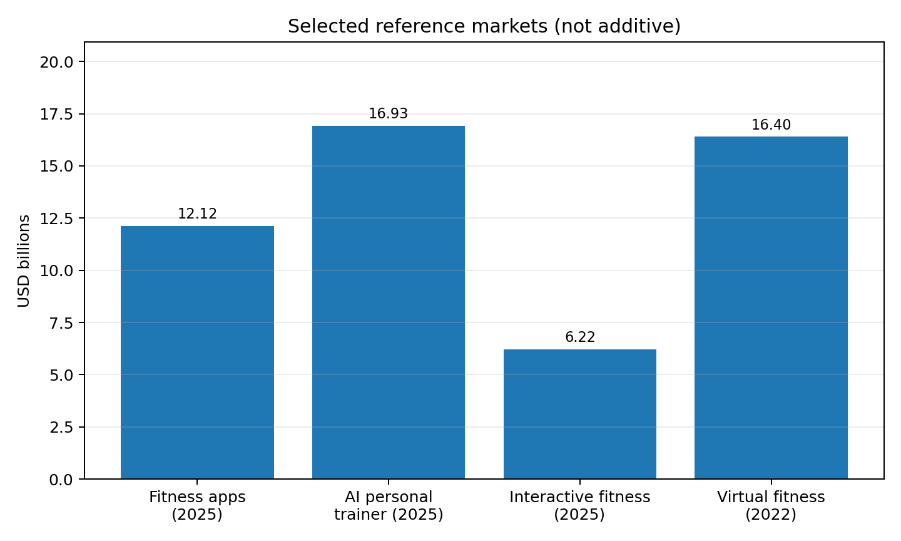
Figure 1. Selected reference markets. Values are from multiple research firms and are not additive.
A useful way to think about your company’s serviceable market is as the intersection of four monetizable behaviors: (1) people willing to pay for fitness planning, (2) people willing to log strength workouts, (3) people seeking body-composition or weight-loss outcomes, and (4) people open to camera-based assistance. That intersection is smaller than the full fitness-app market, but more valuable per user because it supports premium subscriptions, coaching upsells, and potentially B2B2C gym partnerships.

Selected industry financials
Reference market | Latest size | Forecast | Why it matters | Source key
Fitness apps | USD 12.12B (2025) | USD 33.58B by 2033 | Broadest top-down TAM for workout, diet, and tracking apps | S1
AI personal trainer | USD 16.93B (2025) | USD 65.70B by 2033 | Closest market to adaptive AI coaching and personalized plans | S2
Interactive fitness | USD 6.22B (2025) | USD 13.09B by 2034 | Captures coaching + engagement + connected workflow demand | S3
Virtual fitness | USD 16.4B (2022) | USD 106.4B by 2030 | Shows continued demand for remote digital fitness experiences | S4
Mobile demand signal | 3.6B downloads (2024) | +6% YoY | Confirms large top-of-funnel mobile demand | S5

3. Demand signals and market surveys
Consumer data shows both strong demand and an important caveat. Demand is high for wellness, personalization, and mobile delivery. In McKinsey’s 2024 wellness work, 82% of US consumers said wellness is a top or important priority in their everyday lives, and 58% said they are prioritizing wellness more than a year earlier. In the 2025 wave, McKinsey expanded the survey to more than 9,000 consumers across China, Germany, the UK, and the US, finding that younger users—especially Gen Z and millennials—treat wellness as a daily, personalized practice.
Category-specific surveys reinforce the same message. Kantar found that 32% of respondents globally said fitness and exercise apps had the greatest impact on their physical health, ahead of smartwatches (18%) and diet/nutrition apps (12%). ACSM’s 2025 Worldwide Fitness Trends survey placed Wearable Technology at #1 and Mobile Exercise Apps at #2, showing that digital guidance and data-driven training are now central to mainstream fitness behavior. ABC Fitness’ 2025 Wellness Watch reported that nearly half of consumers use AI-powered fitness and wellness apps daily, even though 55% still worry about data and privacy.
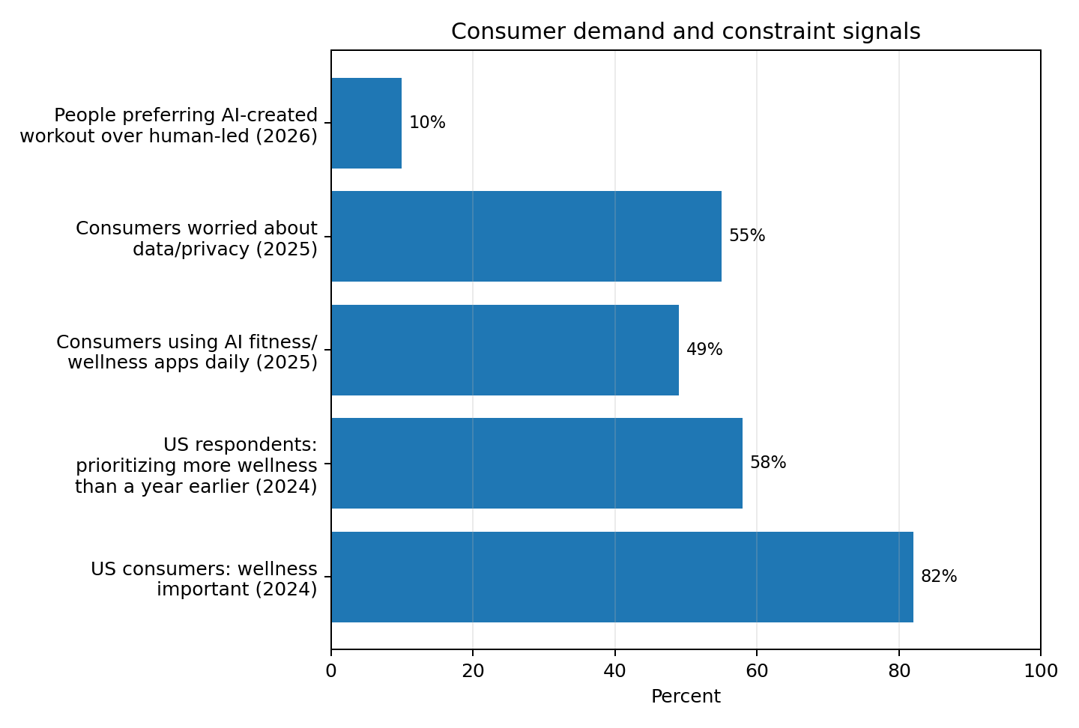
Figure 2. Positive adoption signals coexist with privacy and trust constraints.
The caveat is critical: AI interest does not equal full trust. Les Mills’ 2026 Global Fitness Report found that only 10% of people preferred an AI-created workout over a human-led experience, while a majority leaned toward or strongly preferred human instruction. This suggests the winning product design is probably “AI + reassurance + optional human layer,” not “AI replacing all coaching.”

Survey highlights
Survey / dataset | Key result | Strategic implication | Source key
McKinsey Future of Wellness 2024 | 82% of US consumers view wellness as top/important priority; 58% are prioritizing it more than a year ago | Wellness remains a resilient spend category | S6
McKinsey Future of Wellness 2025 | 9,000+ consumers across China, Germany, UK, US; younger consumers treat wellness as a daily personalized practice | Strong fit for Gen Z / Millennial personalization products | S7
Kantar health & fitness apps study | 32% say fitness/exercise apps have greatest impact on physical health vs 18% smartwatches and 12% diet apps | Workout apps remain the central mobile entry point | S8
ACSM 2025 fitness trends survey | Wearables #1, mobile exercise apps #2 | The mainstream market has normalized tech-led training | S9
ABC Fitness Wellness Watch 2025 | ~49% use AI-powered fitness/wellness apps daily; 55% worry about privacy | Adoption is strong, but privacy UX and trust must be product priorities | S10
Les Mills Global Fitness Report 2026 | Only 10% prefer AI-created workouts over human-led experiences | Pure AI coaching can be a positioning trap; blend guidance with credibility | S11

4. Market segmentation
The space segments more meaningfully by job-to-be-done than by generic demographics. Below is a pragmatic segmentation model for an AI gym companion product.

4.1 Segmentation by user job
Segment | Primary job | Current alternatives | Willingness to pay | Product fit
Beginner transformation seekers | Need a safe plan, accountability, and visible progress | YouTube, generic workout apps, PT starter packages | Medium | High if onboarding is low-friction and progress is obvious
Intermediate gym regulars | Need adaptive programming and easy workout logging | Fitbod, Strong, Hevy, coach-made spreadsheets | High | Very high if rep counting and progression save time
Body recomposition / weight-loss users | Need diet + training + adherence support | Noom, MyFitnessPal, Freeletics Nutrition, Simple | High | High if plans unify calories/macros with strength and activity
Form-sensitive home/hybrid users | Need confidence that movement is done correctly | Tempo, Peloton Guide, YouTube | Medium to high | High if phone-based computer vision works reliably
Gym operators / trainers | Need scalable personalization and retention tools | EGYM, Technogym, trainer CRM systems | B2B budgets | Strong for white-label or member-engagement partnerships
For your concept, the highest-potential entry segment is likely intermediate gym regulars pursuing body recomposition. They have recurring gym behavior, a clear need for progression, and strong frustration with manual logging. They are also more likely than true beginners to appreciate rep counting and adaptive plan changes.

4.2 Segmentation by delivery model
There are currently four dominant delivery models: (1) AI-only software subscriptions; (2) hybrid human + AI coaching; (3) connected-fitness or hardware-assisted systems; and (4) gym-platform or B2B2C systems. AI-only apps scale best and can achieve attractive margins, but often struggle with trust and adherence. Hybrid models improve accountability but raise CAC and gross-margin complexity. Hardware-assisted systems can produce better sensing and form feedback, but they carry inventory and support risk. Gym-platform systems can lower consumer acquisition cost by riding existing memberships, but sales cycles are longer.

4.3 Geographic and platform segmentation
North America is the largest revenue pool in both broad fitness apps and AI personal trainers, while Asia-Pacific is the fastest-growing region in the broad fitness-app market. iOS over-indexes on monetization in broad fitness apps, but Android remains important for top-of-funnel scale and international expansion. In practice, an early-stage startup should design for iPhone quality first if computer vision accuracy is core, while preserving a roadmap to Android for volume.

5. Competitive landscape
The competitive set is broad, but no single mainstream product fully owns the combination of adaptive workout planning, integrated diet workflow, gym-specific tracking, and phone-camera rep counting. That gap is the most important strategic opening.
Company / app | Core offer | Workout plan | Nutrition / diet | Tracking / logging | Vision / form feedback | Observed gap vs your concept
Freeletics | AI coach for home/gym workouts; separate nutrition app | Strong | Moderate (separate app) | Moderate | Limited public emphasis | Not one unified gym logging + CV system
Fitbod | Adaptive strength programming for gym/home | Strong | Weak | Strong manual logging | No major CV layer evident | Great at programming; weaker on diet and computer vision
Zing Coach | AI fitness companion with body scan, goals, and CV form tracking | Strong | Moderate | Moderate | Strong | Closest direct analog; challenge is differentiation and execution quality
Future | Premium human coach + app | Strong (human-led) | Emerging broader health direction | Moderate | No clear CV focus | Excellent accountability, but expensive and less scalable
Caliber | Science-based coaching, strength + nutrition targets | Strong | Moderate | Strong | Human video review, not automatic CV | Hybrid model creates premium price point
Tempo | Home gym + AI-guided strength with form feedback | Strong | Weak | Strong | Strong (hardware-assisted) | Hardware-dependent and home-centric, not mobile-first gym use
EGYM Genius | AI plans for gyms and members | Strong in gym network | Limited consumer-facing nutrition story | Strong in gym ecosystem | Machine-based more than smartphone CV | More B2B gym infrastructure than direct consumer companion
Competitive white space: an app that behaves like “Fitbod + MyFitnessPal-lite + Zing-style computer vision,” but optimized for real gym sessions rather than generic workouts, would sit in a comparatively open position.

6. Recent successes in the industry—and what they reveal

6.1 Software-first winners
Ladder’s November 2024 financing is one of the clearest signals that investors still like subscription strength products when engagement is strong. Ladder announced a $15M Series B plus $90M in go-to-market financing. The lesson is that focused programming plus community can still attract major capital even without a heavy hardware story.
Zing Coach’s 2024 $10M Series A demonstrates investor belief in AI-native fitness companions—especially those promising hyper-personalization and computer-vision-led feedback. Freeletics, while older, remains a benchmark for global software scale; the company markets a community of more than 25 million registered users and continues to position itself as an AI coach for busy people.

6.2 Platform and gym-stack winners
EGYM’s September 2024 $200M round at a valuation above $1.2B shows the enduring attractiveness of B2B and B2B2C infrastructure. EGYM later said that combined 2025 net revenue with Playlist exceeded $800M, underscoring the advantage of integrating software, equipment, and member engagement inside existing fitness operators.

6.3 The main shortcomings behind recent winners
Success in this category does not mean the product is complete. Most winners still lean heavily toward only one part of the workflow: planning, content, or accountability. Many do not deeply unify training and nutrition in one loop. Others rely on human coaches to deliver stickiness, which improves retention but weakens software economics. The biggest unresolved issue remains trust: users like personalization, but many still prefer human-led fitness experiences.

7. Category shortcomings and warning signs
There are four repeat failure modes in the market. First, hardware dependency can create fragility. Lululemon said in 2023 that it would discontinue Mirror sales, and later reports noted the end of new Mirror content after spring 2024. Peloton disclosed in its 2025 Form 10-K that it discontinued Guide sales and new Guide memberships in July 2025 while continuing support for existing users. These examples suggest that vision-based coaching is strategically attractive, but packaging it as dedicated hardware is risky unless the hardware itself has exceptional margins or retention.
Second, privacy anxiety is real. If a camera is part of the product, users will immediately ask where video is processed, what is stored, and whether bodies or homes are being recorded. Third, AI planning quality remains uneven. Emerging research is promising but mixed: one 2025 case study found GPT-4 showed an advantage in personalization but no significant difference versus human coaches on effectiveness, safety, or comprehensiveness; another 2025 calisthenics study suggested AI-generated programs were usable but human-made programs still produced superior performance in some areas.
Fourth, adherence remains the core business problem. Planning is easy to generate; sustained execution is what users pay for. Products that do not reduce friction during the actual session—setting up the workout, counting reps, logging sets, and adapting next week’s plan—tend to become content libraries rather than companions.

8. Recent VC and strategic investment activity
Company | Date | Amount | What investors are backing | Source key
Zing Coach | Jun/Jul 2024 | $10M Series A | AI-native hyper-personalized workout plans, motivation, computer vision | S12
Hexis | May 2024 | $2M pre-seed | AI-powered personalized sports nutrition | S13
EGYM | Sep 2024 | $200M | Connected fitness + gym operating system + AI enablement | S14
Ladder | Nov 2024 | $15M Series B + $90M GTM financing | Focused strength app with scalable subscriber economics | S15
Simple Life | Oct 2025 | $35M Series B | AI health coach integrating nutrition, exercise, voice/vision inputs, and gamification | S16
What the investment pattern says: capital is moving toward products that either (a) have high-LTV subscription economics, (b) own a differentiated sensing or data layer, or (c) can distribute through existing gyms, coaches, or health ecosystems. Pure “LLM wrapper” fitness apps are unlikely to remain defensible.

9. Scientific and technical evidence relevant to your concept
The evidence base for AI fitness coaching is improving but still immature. Early 2025 studies suggest AI can generate reasonably personalized plans, yet it does not fully replace human expertise. At the same time, academic work on viewpoint-invariant repetition counting and one-shot skeletal action segmentation indicates that camera-based rep counting and exercise segmentation are technically feasible and improving. In other words: the technology can work, but product quality will depend on robustness under real-world gym conditions—occlusion, poor lighting, crowded backgrounds, variable camera placement, and exercise-specific edge cases.
For product strategy, this means the CV layer should start with a narrow set of high-frequency, visually distinct exercises—such as bodyweight squats, push-ups, curls, lunges, and machine-based movements with stable range-of-motion patterns—before expanding to harder lifts like deadlifts, rows, and crowded free-weight scenarios.

10. Implications for your product idea

Recommended positioning
Position the product as an “AI gym companion for body recomposition and strength progression,” not merely as an AI trainer. The differentiation should be operational: it builds the plan, helps execute the session, counts the work, updates progression, and aligns the diet. This is more concrete and believable than broad claims of replacing a coach.

Best product wedge
The best initial wedge is likely: adaptive gym programming + frictionless workout logging + limited-but-high-quality computer-vision rep counting. Nutrition should be present from day one, but as a simple adaptive diet layer—calorie target, protein target, meal templates, and weekly adjustments—rather than a sprawling recipe universe. Users mainly need coherence and accountability, not infinite content.

Potential moat
Your moat is not the LLM. It is the training loop data. If the product learns from planned workouts, completed reps, deviations, fatigue signals, adherence, and nutrition compliance, it can build a proprietary progression graph per user and per exercise. Over time, that can become a better recommendation engine than generic chat-based coaching.

Monetization
A credible monetization stack is: freemium tracking; premium AI programming and diet adaptation; plus optional higher-tier form feedback, coach review, or gym partnerships. A B2C-first model is simplest to validate, but B2B2C distribution through gyms could become a powerful second act once the workout engine and CV reliability are proven.

Risks to manage early
The three biggest early risks are CV reliability, privacy trust, and overly broad scope. If rep counting fails too often, users will abandon the feature. If privacy messaging is weak, camera adoption will stall. If the app tries to solve every wellness problem at once, it will look undifferentiated against bigger incumbents.

11. Bottom-line conclusion
This market is attractive because the demand trend is real, the smartphone is already the default hardware, and users increasingly expect personalization. It is also difficult because many products have already solved parts of the workflow. The strongest opportunity is not to be another generic AI coach, but to unify planning, execution, and adaptation inside the gym session itself.
A startup that makes strength and body-composition training measurably easier—by removing logging friction, making diet guidance actionable, and turning a phone camera into a trusted assistant—can still carve out meaningful space. The market evidence supports building in this category. The competitive evidence suggests your best shot is focused differentiation, not breadth.

Source key
S1 Grand View Research, Fitness Apps Market, 2025 size and segmentation.
S2 Grand View Research, AI Personal Trainer Market, 2025 size and segmentation.
S3 Precedence Research, Interactive Fitness Market, 2025 size / forecast.
S4 Grand View Research, Virtual Fitness Market, 2022 baseline / 2030 forecast.
S5 Sensor Tower, State of Mobile Health & Fitness Apps 2025.
S6 McKinsey, The trends defining the $1.8T global wellness market in 2024.
S7 McKinsey, The $2T global wellness market gets a millennial and Gen Z glow-up, 2025.
S8 Kantar, willingness to pay for health and fitness apps study.
S9 ACSM Announces Top Fitness Trends for 2025.
S10 ABC Fitness Summer 2025 Wellness Watch report summary / press coverage.
S11 Les Mills 2026 Global Fitness Report summary.
S12 Zing Coach funding coverage and official product pages.
S13 Sports Business Journal, Hexis AI nutrition app raises $2M pre-seed.
S14 TechCrunch, EGYM raises $200M at $1.2B+ valuation.
S15 Business Wire, Ladder secures over $100M in funding.
S16 Simple Life funding announcement and TechCrunch coverage.
S17 Freeletics official site / Google Play listing.
S18 Fitbod official site.
S19 Zing Coach official site.
S20 Future official site / app-store listing.
S21 Caliber official site / app-store listing.
S22 Tempo official site / support documentation.
S23 Peloton support and 2025 Form 10-K on Guide discontinuation.
S24 lululemon corporate release and BusinessWire trade-in release on Mirror discontinuation.
S25 Academic/PMC studies on AI fitness coaching, rep counting, and adherence.

