System Design

The purpose of this Smart Emission Surveillance System Design Document is to provide a description for how the monitoring of the exhaust gases from vehicles could be done in an efficient way. This system is created to ensure that the design meets the requirements of the users. The System Design gives a brief idea about software design, hardware design, activity diagram and detailed design of the entire process.

Hardware:

* Arduino Uno - a microcontroller board based on the ATmega328 (datasheet) which has 14 digital input/output pins (of which can be used as PWM outputs), analog inputs, A 16MHz crystal oscillator, a USB connection, a power jack, an ICSP header, and a reset button.
* Gas sensors - useful for gas leakage detection (In home and industry). The Grove-Gas Sensor (MQ2) module is detecting LPG, CH4, CO, Alcohol, smoke or Propane.
* MQ-7 gas sensor - composed of micro AL2O3 ceramic tube, Tin Dioxide (SnO2) sensitive layer, measuring electrode and heater.
* MQ-135 gas sensor – carbon dioxide gas detector.
* Light Emitting Diodes for indication purpose.
* Jumper wires, Bread board and Resistors.
* GSM module - Global System for Mobile Communication uses as variety of TDMA and is the three-digital wireless technology such as TDMA, CDMA. It digitizes and compresses data and operates at either 900MHz or 1800MHz frequency band.

Software:

* The open-source **Arduino Software** (**IDE**) is used to write code and upload it to the Arduino board. It runs on Windows, Mac OS X, and Linux. The environment is written in Java and based on Processing and other open-source software.
* Automated Notification module – The information is sent to the vehicle owner using GSM and it is programmed in such a way that all the details regarding the levels of the emitted gases will be available to the end user.
* Android Studio is used for presenting the details to the owner.

Activity Diagram:

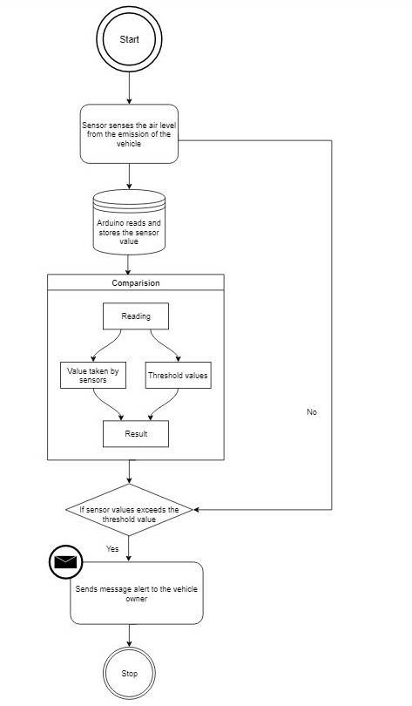

Smart Emission Surveillance System can be divided into different modules as mentioned below:

* Data Collection:

Data Collection module is placed in car. The three sensors MQ-2, MQ-7, MQ-135 which senses the hydro carbon gas, carbon monoxide and carbon dioxide respectively are placed near the vehicle exhaust. These sensors give emission values in analog signal in the form of volts. This analog signal can be digitised using an inbuilt ADC in a microcontroller. The digital values obtained can be served as input to next module and processed for further testing.

* Data Testing:

This module uses the standard emission values such as BS- IV. The module includes the testing of the gases from the exhaust. The values collected from the previous module are compared with the local standard values. Depending on the test results and levels of the each of the gases detected by the sensors, decision will be taken on further processing of the results. These tested values are used by the data transmission module.

* Data Transmission:

In Data transmission we process the data from the previous step. If the amount of pollutants is higher than the threshold level then the led will glow automatically, which is controlled by Arduino. The data, i.e., the emission rates will be continuously sent to vehicles’ owner using the GSM Module which can be linked to owner’s phone for monitoring the emissions from vehicles. It can smell out the vehicle exhaust in real-time. The measured data is shared to vehicle proprietor via text messages.