Mini Project Report On

PERSONAL LIBRARY MANAGEMENT SYSTEM



SUBMITTED BY

Mr. Ashutosh Mishra Regd.No:17B91A05P4

DEPARTMENT OF COMPUTER SCIENCE AND ENGINEERING

S.R.K.R. ENGINEERING COLLEGE CHINA AMIRAM,BHIMAVARAM

(2017-2021)

# ABSTRACT

The project titled Personal Library Management System is personal library software for the purpose of monitoring and controlling the transactions in one’s own library.

Personal Library Management System allows the user to store the book details . This project on the personal library management system gives us the complete information about the library and the daily transactions done in a Library. We need to maintain the record of books and retrieve the details of books available in the library which mainly focuses on basic operations in a library like adding new member, new books, movies and music, and update new information, searching books and members and facility to borrow and return books.

In this project we have developed a new approach in the library system which is able to transfer the facilities like login user, registration of new user, adding/removing of books, music or moviesin the library, searching, issuing and returning of thebooks.

The user will find it easy in the automated system rather than using the manual writing system. The system contains a database where all the information will be stored safely.

|  |  |  |
| --- | --- | --- |
| S.NO. | DESCRIPTION | PAGE.NO. |
| 1. | DATA REQUIREMENTS | 1 |
| 2. | ER DIAGRAM | 2 |
| 3. | ER DIAGRAM TO RELATIONS | 3 |
| 4. | NORMALIZATION | 4 |
| 5. | CREATION OF TABLES | 5 |
| 6. | SCREENSHOTS OF THE FRONT END | 6-8 |
| 7. | PHP DATABASECONNECTION | 9-10 |
| 8. | QUERIES |  |

TABLE OF CONTENTS

## 1

## DATA REQUIREMENTS

ENTITIES

1BooksDetails

1. Music Details

3 Movie Details

4 User Details

ATTRIBUTES

Books Details

1. Isbn Number
2. Title
3. Author
4. Category
5. Publisher
6. Status

Music Details

1. Music Code
2. Music Name
3. Genre
4. Language

Movie Details

1. Movie Number
2. Movie Name
3. Language
4. Category

User Details

1. UserId
2. UserName
3. Contact Number
4. Address

# ER DIAGRAM2

Isbn

Title

Author

Category

Status

Publisher

Books Details

borrowed by

Upload

User Details Stores

Contact

|  |  |
| --- | --- |
| UserId  MusicName  Code | |
|  | MusicDetails |
|  |

Address

Lead Actor

UserName

Language

### Movie Details

Category

Code

Movie name

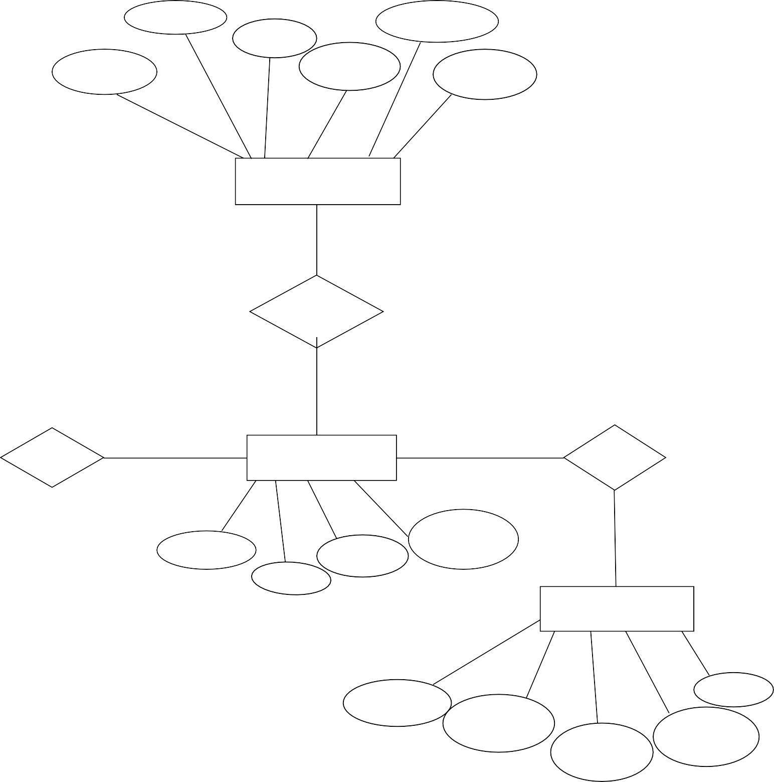

Genre Type Musician

3

**ER DIAGRAM TO RELATIONS**

**Book Details**

|  |  |  |  |  |  |  |
| --- | --- | --- | --- | --- | --- | --- |
| Isbn | Title | Author | Category | Status | Publisher | User ID |

**User Details**

|  |  |  |  |
| --- | --- | --- | --- |
| User ID | Contact | Address | User Name |

**Music Details**

|  |  |  |  |  |  |
| --- | --- | --- | --- | --- | --- |
| Code | Music Name | Genre | Type | Musician | User ID |

**Movie Details**

|  |  |  |  |  |  |
| --- | --- | --- | --- | --- | --- |
| M Code | Movie Name | Category | Language | Lead Actor | User ID |

**Normalisation**4

1NF

Books:

Attribute ‘Author’ can have multiple values i.e, author and co.author. So the ‘bookdetails’ table may not be in 1NF. But, we can restrict the field into ‘atomic value field’ , and convert it into 1NF.

2NF

Since all the tables have single attribute as key, there cannot be any partial dependency . Thus, all the tables are in 2NF.

3NF

MovieDetails:

Here, there is a transitive dependency.

Moviecode Moviename Star Language Category

Star->Language

This is a transitive dependency.

Thus, the ‘MovieDetails’ table ,in this form, is not in 3NF.

We decompose the table:

Moviecode Moviename Star Category

Star Language

BCNF(Boyce Codd Normal Form)

In no table, there is a dependency of the form ‘non-key -> part of the key’. Also, all the tables are formerly in 3NF.Thus, due to the absence of such dependency, all the tables are in BCNF.

5

CREATION OF TABLES

Create table BooksDetails(isbn number(10),title varchar2(10),author varchar2(10),category varchar2(10),status varchar2(10),publisher varchar2(10),primarykey(isbn);

Create table UserDetails(Userid number(10),Username varchar2(10),Contact number(10),Address varchar2(20),primarykey(Userid));

Create table MovieDetails(MovieCode number(10),MovieName varchar2(10),Category varchar2(10),UserId number(10),Actor varchar2(10),primarykey(MovieCode),foriegnkey(UserId)references UserDetails);

Create table MusicDetails(MusicCode number(10),Name varchar2(10),UserId number(10),Genre varchar2(10),Musician varchar2(10), primarykey(MovieCode),foriegnkey(UserId)references UserDetails);

Screen Shots Of The Front End 6

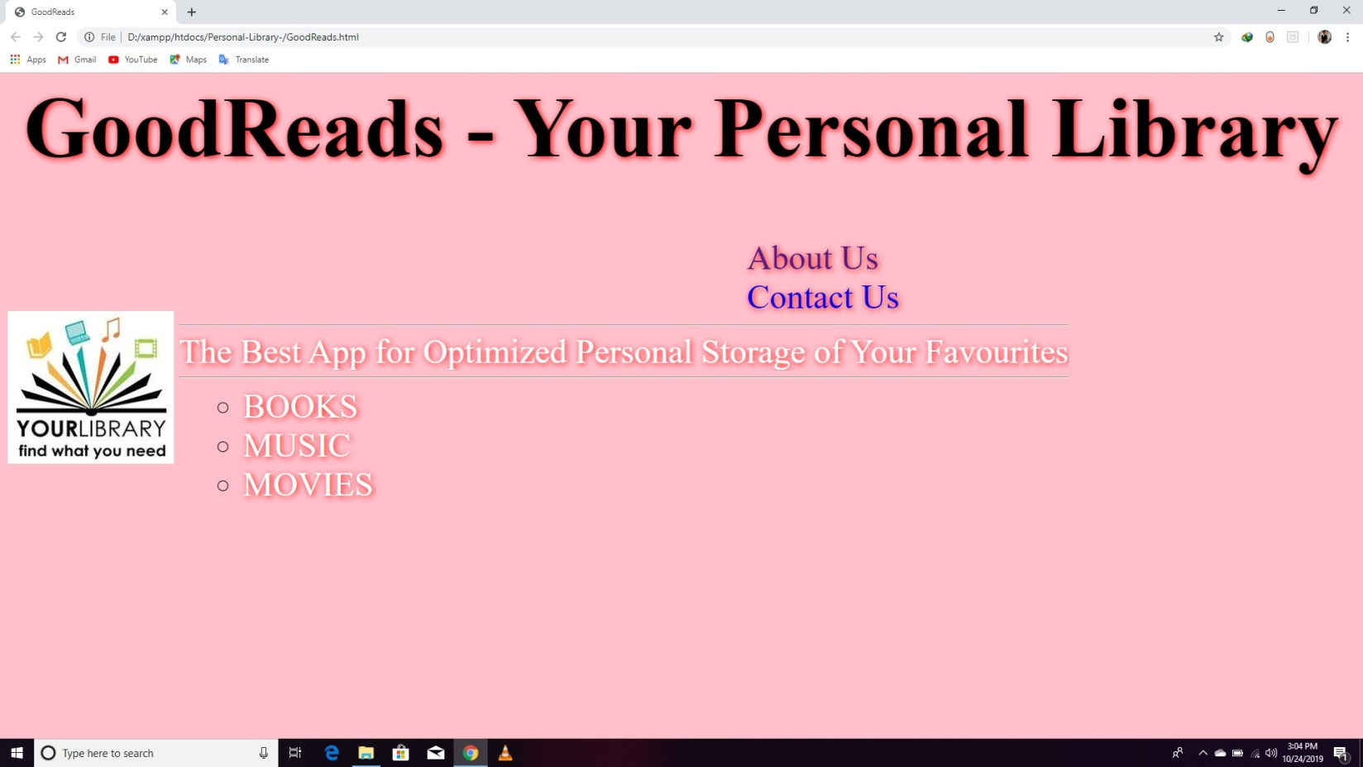

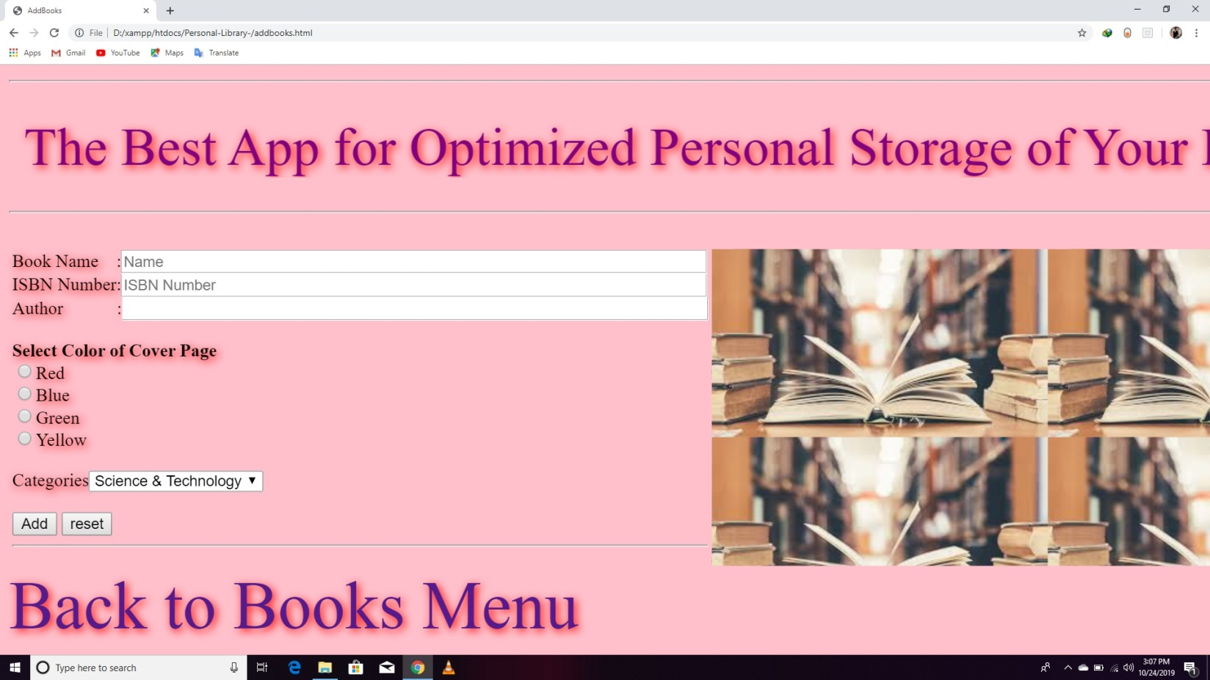

7

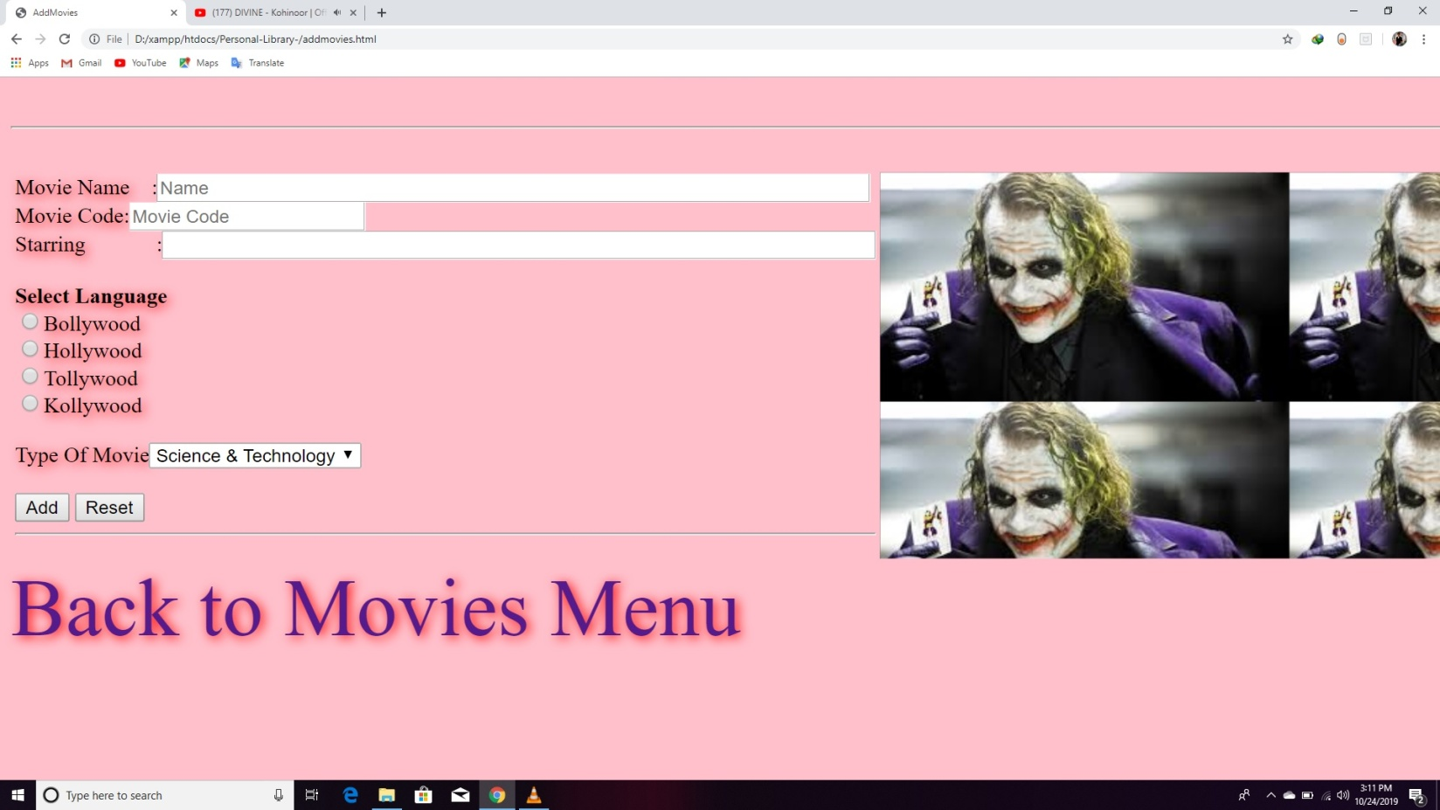

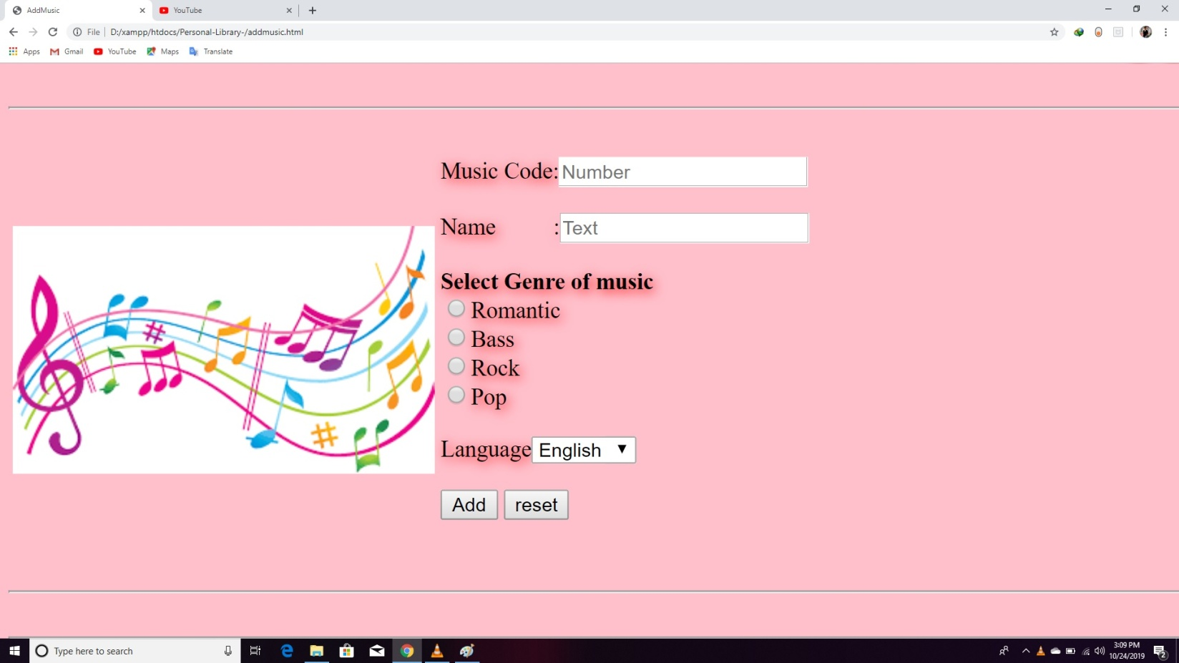

8

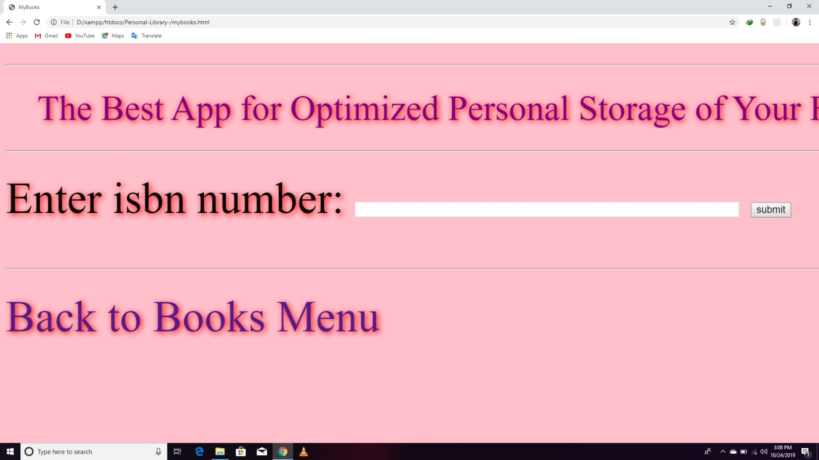

PHP Database Connectivity 9

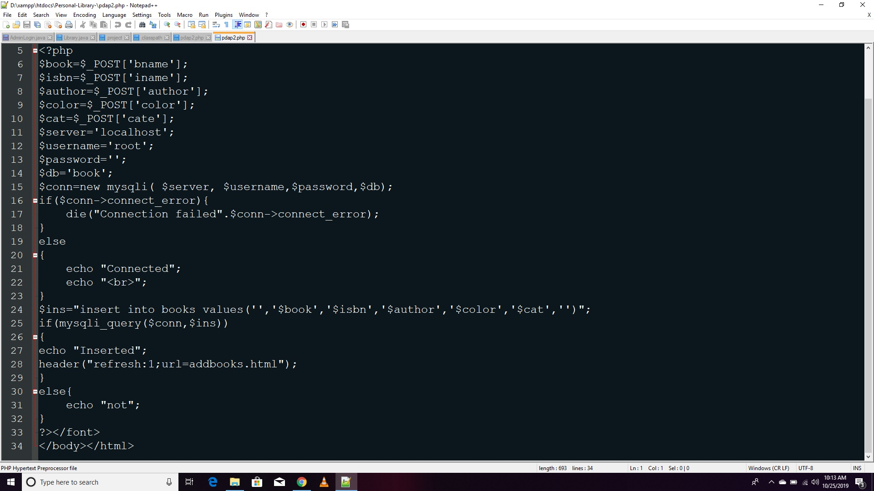

10

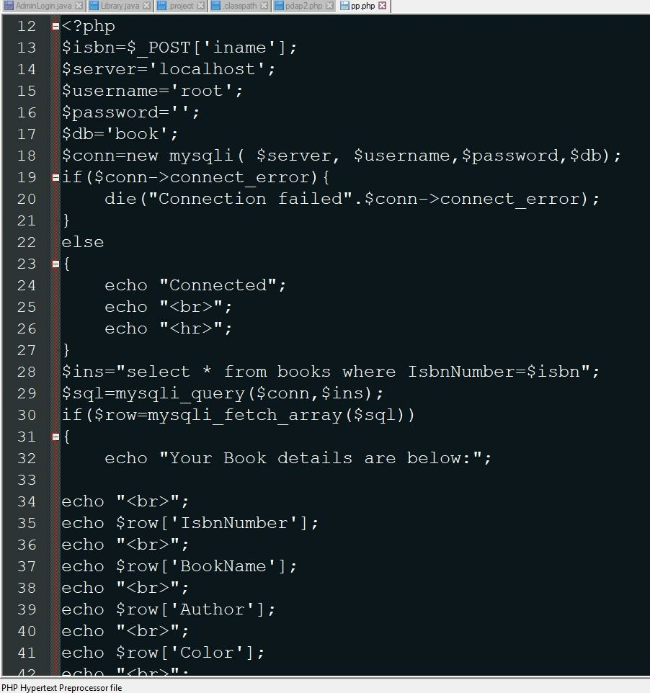

**11**

**Insertion of Values**

"insert intobooks values(' ','$book','$author','$color','$cat',' ')";

"insert into books values('The Jungle Book','RudyardKipling','Gray','Fiction')";

"insert into books values('The Lord of the Rings','J.R.R.Tolkien','Black','Fiction')";

"insert into books values('Becoming','MichelleObama','Green','Biography')";

"insert into books values('The Da Vinci Code','DanBrown','Brown','Thriller')";

"insert into books values('Bully','PenelopeDouglas','Romance')";

"insert into movies values(' ','$moviename','$star','$language','$cat',' ')";

"insert into movies values('The Shawshank Redemption','TimRobbins','English','Drama')";

"insert into movies values('Baahubali','Prabhas','Telugu','Action')";

"insert into movies values('Thor','ChrisHemsworth','English','Science Fiction')";

"insert into movies values('Kabaddi','DayahangRai','Nepali','Romance')";

"insert into movies values('Hush','KateSiegel','English','Horror')";

"insert into music values(' ','$musicname','$genre','$musician',' ')";

"insert into music values('Let it be','Pop','The Beatles')";

"insert into music values('Let it go','Folk','Idina Menzel')";

"insert into music values('Stitches','Pop','Shawn Mendes')";

"insert into music values('I like it','Rap','Cardi B')";

"insert into music values('Fire','Pop','The Chainsmokers')";

DEPARTMENT OF COMPUTER SCIENCE ENGINEERING

S.R.K.R ENGINEERING COLLEGE BHIMAVARAM



CERTIFICATE

1. This is to certify that it is a bonafide work on “Personal Library Management System” has been submitted mini-project by Ashutosh Mishra (17B91A05P4) in **Database Management System** Labs during the academic year 2019-2020.

**In-Charges:**

**Mr. Ch. Raminaidu Assistant Professor CSE Department**

**S.R.K.R Engineering College**