**E-TENDERING**

**ORGANISATION :** Tripura Institute of Technology

## PROBLEM STATMENT (DB126) : In order to simplify the process of e-tendering and to make the system cost effective and user friendly, the EVC (electronic verification code) system are required to be performed through Aadhaar based OTP, instead of existing Digital Signature Certificate. Design efficient solutions that enable use of Aadhar OTP and DigiLocker for sharing the documents for eTendering.

**TEAM NAME :** Cookie Army

**TEAM MEMBERS:**

1)SHAIK FAYAZUDDIN (Team Leader)

2)TULASI DEVI

3)ASHUTOSH MISHRA

4)TEJA KRISHNA

5)SHAIK HANIFA

6)SAI SUMANTH

**COLLEGE CODE** :1-4263427227

**ABSTRACT**

Electronic Tendering is the method of carrying out the traditional tendering process in an electronic form, using the internet. The tendering process is a key business process that helps businesses find a suitable contractor. In the building and construction of industries, clients invite tenderers to submit an estimate of prices, detailing the costs associated with completing a building. In this way, the client can base their decision on the result of the tenders to select the most suitable contractor. The tenderers need to collect the tender's booklet, price it, and bring it back to the client's office before the deadline. In this project, we present a design and implementation of an e-tendering system by using Web services for the automation of such tendering processes and replacing existing system which contains digital signature certificate for tender purpose with Aadhar based one time password(otp) and sharing documents through digilocker.

**INTRODUCTION**

* 1. **Purpose of Project**

This document contains a description for **“E-TENDERING”** enhancement. This document will contain the functional requirements of the project andhow the Aadhar based OTP verification will simplify the process, achieving all the objectives, along with its simplification.

**Scope:** This Document depicts the Software development life cycle (SDLC) and describes the complete requirement of the system.

**2.3 STUDY OF THE SYSTEM**

Initially,

The GUI’S at the top level have been categorized as

1. Administrative user interface
2. The operational or generic user interface

The administrative user interface concentrates on the consistent information that is practically, part of the organizational activities and which needs proper authentication for the data collection. The interfaces help the administrations with all the transactional states like Data insertion, Data deletion and Data updating along with the extensive data search capabilities.

The operational or generic user interface helps the users upon the system in transactions through the existing data and required services. The operational user interface also helps the ordinary users in managing their own information helps the ordinary users in managing their own information in a customized manner as per the assisted flexibilities

**Modules**

The project is mainly divided into 4 modules:

**1). Administrator**

This administrator will maintain all the master information like Items Information, suppliers’ information, Employee information.

**2). Employee**

He is going to prepare the indent for the required product to the purchase department, and also he checks indent status.

**3). Purchase Department**

Displaying indent information from different departments. Preparation of tenders for the indents, Invitation to the supplier for the tender  
  **4). Bidder**

Supplier is going to bid the amount for tender with in the stipulated time, and will know the final status of the tender once it is closed.

**2.4 System Requirement Specifications**

**Hardware Requirements:**

* PIV 2.8 GHz Processor and Above
* RAM 512MB and Above
* HDD 40 GB Hard Disk Space and Above

**Software Requirements:**

* WINDOWS OS (XP / 2000 / 200 Server / 2003 Server)
* Enclipse Enterprise Edition
* Bootstrap
* My SQL Server

**PAGES**

**INDEX.JSP:**

**<!-- Cookie Army -->**

<%@ page import = "java.sql.*" %>

<%@ page language="java" contentType="text/html; charset=ISO-8859-1"

pageEncoding="ISO-8859-1"%>

<!DOCTYPE html>

<html>

<head>

<title>Etender</title>

<link rel="stylesheet" href="css/global.css">

<link rel="stylesheet" href="https://stackpath.bootstrapcdn.com/bootstrap/4.4.1/css/bootstrap.min.css" integrity="sha384-Vkoo8x4CGsO3+Hhxv8T/Q5PaXtkKtu6ug5TOeNV6gBiFeWPGFN9MuhOf23Q9Ifjh" crossorigin="anonymous">

<script src="https://code.jquery.com/jquery-3.4.1.slim.min.js" integrity="sha384-J6qa4849blE2+poT4WnyKhv5vZF5SrPo0iEjwBvKU7imGFAV0wwj1yYfoRSJoZ+n" crossorigin="anonymous"></script>

<script src="https://cdn.jsdelivr.net/npm/popper.js@1.16.0/dist/umd/popper.min.js" integrity="sha384-Q6E9RHvbIyZFJoft+2mJbHaEWldlvI9IOYy5n3zV9zzTtmI3UksdQRVvoxMfooAo" crossorigin="anonymous"></script>

<script src="https://stackpath.bootstrapcdn.com/bootstrap/4.4.1/js/bootstrap.min.js" integrity="sha384-wfSDF2E50Y2D1uUdj0O3uMBJnjuUD4Ih7YwaYd1iqfktj0Uod8GCExl3Og8ifwB6" crossorigin="anonymous"></script>

<script src="https://www.google.com/recaptcha/api.js" async defer></script>

<script src="js/cities.js"></script>

<script type="text/javascript" src="js/preferential.js"></script>

<script type="text/javascript" src="js/bidderTypeLoc.js"></script>

<script type="text/javascript">

var onloadCallback = function() {

grecaptcha.render('html_element', {

'sitekey' : '6Lenzu0UAAAAANwru86INC1KaBKQ-llAVyRItx-s'

});

};

</script>

<style>

body{

background-color: beige;

}

</style>

</head>

<body>

<div class="navbar">

<div class="flex item-12"><img class="logo" src="images/satya3.png" alt="goi-logo" class="left-img"></div>

<div class="flex item-13"><img class="logo" src="images/topbanb.png" alt="goi-logo" class="img-ban" style="width: 144%;"></div>

<div class="flex item-14"><img class="logo1" src="images/satya3.png" alt="goi-logo" class="right-img"></div>

</div>

<div class="datass">

<div class="flex datas1" id="date1"></div>

<div class="flex datas2"><marquee>eTendering System - Government of India

</marquee></div>

</div>

<div class="menu">

&nbsp;&nbsp;&nbsp;&nbsp;&nbsp;&nbsp;&nbsp;&nbsp;&nbsp;&nbsp;&nbsp;&nbsp;&nbsp;&nbsp;&nbsp;&nbsp;&nbsp;&nbsp;&nbsp;&nbsp;&nbsp;&nbsp;&nbsp;

&nbsp;&nbsp;&nbsp;&nbsp;&nbsp;&nbsp;&nbsp;&nbsp;&nbsp;&nbsp;&nbsp;&nbsp;&nbsp;&nbsp;&nbsp;&nbsp;&nbsp;&nbsp;&nbsp;&nbsp;&nbsp;&nbsp;&nbsp;

&nbsp;&nbsp;&nbsp;&nbsp;&nbsp;&nbsp;&nbsp;&nbsp;&nbsp;&nbsp;&nbsp;&nbsp;&nbsp;&nbsp;&nbsp;&nbsp;&nbsp;&nbsp;&nbsp;&nbsp;&nbsp;&nbsp;&nbsp;

&nbsp;&nbsp;&nbsp;&nbsp;&nbsp;&nbsp;&nbsp;&nbsp;&nbsp;&nbsp;&nbsp;&nbsp;&nbsp;&nbsp;&nbsp;&nbsp;&nbsp;&nbsp;&nbsp;&nbsp;&nbsp;&nbsp;&nbsp;

&nbsp;&nbsp;&nbsp;&nbsp;&nbsp;&nbsp;&nbsp;&nbsp;&nbsp;&nbsp;&nbsp;&nbsp;&nbsp;&nbsp;&nbsp;&nbsp;&nbsp;&nbsp;&nbsp;&nbsp;&nbsp;&nbsp;&nbsp;

&nbsp;&nbsp;&nbsp;&nbsp;&nbsp;&nbsp;&nbsp;&nbsp;&nbsp;&nbsp;&nbsp;&nbsp;&nbsp;&nbsp;&nbsp;&nbsp;&nbsp;&nbsp;&nbsp;&nbsp;&nbsp;&nbsp;&nbsp;

<span id="If">

<span id="For">

<span>

<a id="link1" name="link1" title="Search" class="Menu" href="/eprocure/app?page=FrontEndAdvancedSearch&amp;service=page" target="_self">Search</a>

</span>

<span class="divider1" id="Insert_2">|</span>

</span><span id="For_0">

<span>

<a id="link1" name="link1" title="Active Tenders" class="Menu" href="/eprocure/app?page=FrontEndLatestActiveTenders&amp;service=page" target="_self">Active Tenders</a>

</span>

<span class="divider1" id="Insert_2_0">|</span>

</span><span id="For_1">

<span>

<a id="link1" name="link1" title="Tenders by Closing Date" class="Menu" href="/eprocure/app?page=FrontEndListTendersbyDate&amp;service=page" target="_self">Tenders by Closing Date</a>

</span>

<span class="divider1" id="Insert_2_1">|</span>

</span><span id="For_2">

<span>

<a id="link1" name="link1" title="Corrigendum" class="Menu" href="/eprocure/app?page=FrontEndLatestActiveCorrigendums&amp;service=page" target="_self">Corrigendum</a>

</span>

</span>

</span>

</div>

<div class="main-body">

<!--Aside starts from here-->

<div class="flex aside">

<input type="button" class="links" value="Home" onclick="window.location.href = 'index.jsp';"></button><br>

<input type="button" class="links" value="Nodal Officer Login" onclick="window.location.href = 'mislogin.jsp';"></button><br>

<input type="button" class="links" value="Tender By Location" onclick="window.location.href = 'tenderByLocation.jsp';"></button><br>

<input type="button" class="links" value="Tender By Organisation" onclick="window.location.href = 'tenderByOrg.jsp';"></button><br>

<input type="button" class="links" value="Tender By Classification" onclick="window.location.href = 'tenderByClass.jsp';"></button><br>

<input type="button" class="links" value="Tenders in Archive" onclick="window.location.href = 'tendersInArchive.jsp';"></button><br>

<input type="button" class="links" value="Announcements" onclick="window.location.href = 'announcement.jsp';"></button><br>

<input type="button" class="links" value="Cancelled/Retendered" onclick="window.location.href = 'cancelled.jsp';"></button><br>

</div>

<% session.removeAttribute("username"); %>

<!--Main starts from here-->

<div class="flex main">

<div class="card text-center">

<div class="card-header">

<h4>Latest Tender</h4>

</div>

<div class="home-container">

<div class="flex item-1"> Tender Title</div>

<div class="flex item-2"> Reference No</div>

<div class="flex item-3"> Closing Date</div>

<div class="flex item-4"> Bid Opening Date</div>

</div>

<div class="card-body">

<marquee direction="up" onmouseover="this.stop() ;" onmouseout="this.start() ;"> <p class="card-text">

<%

Class.forName("com.mysql.jdbc.Driver");

Connection con = DriverManager.getConnection("jdbc:mysql://localhost:3307/etendering","root","tulasidevi@11");

Statement st = con.createStatement();

ResultSet rs;

rs = st.executeQuery("select * from tenderdetails ");

while(rs.next())

{

out.print

(

"<div class='home-container-1'>"+

"<div class='flex item-1'>"+rs.getString(1)+"</div>"+

"<div class='flex item-2'>"+rs.getString(2)+"</div>"+

"<div class='flex item-3'>"+rs.getString(3)+"</div>"+

"<div class='flex item-4'>"+rs.getString(4)+"</div>"+

"</div>"

);

}

con.close();

%>

</p></marquee>

</div>

</div><br>

<div class="card text-center">

<div class="card-header" >

<h4>Latest Corrigendums</h4>

</div>

<div class="home-container">

<div class="flex item-1"> Tender Title</div>

<div class="flex item-2"> Reference No</div>

<div class="flex item-3"> Closing Date</div>

<div class="flex item-4"> Bid Opening Date</div>

</div>

<div class="card-body">

<marquee direction="up" onmouseover="this.stop() ;" onmouseout="this.start() ;"> <p class="card-text">

<%

Class.forName("com.mysql.jdbc.Driver");

Connection con1 = DriverManager.getConnection("jdbc:mysql://localhost:3307/etendering","root","tulasidevi@11");

Statement st1 = con1.createStatement();

ResultSet rs1;

rs1 = st1.executeQuery("select * from tenderdetails where classification=\"work\"");

while(rs1.next())

{

out.print

(

"<div class='home-container-1'>"+

"<div class='flex item-1'>"+rs1.getString(1)+"</div>"+

"<div class='flex item-2'>"+rs1.getString(2)+"</div>"+

"<div class='flex item-3'>"+rs1.getString(3)+"</div>"+

"<div class='flex item-4'>"+rs1.getString(4)+"</div>"+

"</div>"

);

}

con1.close();

%>

</p></marquee>

</div>

</div>

</div>

<!--Login starts from here-->

<div class="flex login">

<form class="login-form" method="POST" action="bidPortal.jsp">

<div class="card-header"><h2>Login</h2></div>

<div class="form-group">

<label for="exampleInputEmail1">Email address</label>

<input type="email" class="form-control" name="bid" id="exampleInputEmail1" aria-describedby="emailHelp">

<!-- <small id="emailHelp" class="form-text text-muted">We'll never share your email with anyone else.</small> -->

</div>

<div class="form-group">

<label for="exampleInputPassword1">Password</label>

<input type="password" class="form-control" name="bpass" id="exampleInputPassword1">

</div>

<div class="g-recaptcha" data-sitekey="6Lenzu0UAAAAANwru86INC1KaBKQ-llAVyRItx-s"></div><br>

&nbsp; &nbsp; <a href="bidderForgetPass.jsp">Forget Password</a><br><br>&nbsp; &nbsp;

<a href="bidderReg.jsp">New User? Register Here!</a><br><br>&nbsp; &nbsp;

<a href="onlineBidderEnrollment.jsp">Online Bidder Enrollment</a><br><br>&nbsp; &nbsp;

<button type="submit" class="btn btn-primary">Login</button>

<br><br>

</form>

</div>

</div>

<footer class="footer-box">

<div class="container">

<span class="text-muted">Contents owned and maintained by concerned Departments in coordination with Finance Department and Information Technology Department, Government of India.</span>

</div>

</footer>

<script>

var today = new Date();

var dd = String(today.getDate()).padStart(2, '0');

var mm = String(today.getMonth() + 1).padStart(2, '0'); //January is 0!

var yyyy = today.getFullYear();

today = mm + '/' + dd + '/' + yyyy;

document.getElementById("date1").innerHTML=today;

</script>

</body>

</html>

**Bidder Reg:**

<!-- Cookie Army -->

<%@ page import = "java.sql.*" %>

<%@ page language="java" contentType="text/html; charset=ISO-8859-1"

pageEncoding="ISO-8859-1"%>

<!DOCTYPE html>

<html>

<head>

<title>Etender</title>

<link rel="stylesheet" href="https://stackpath.bootstrapcdn.com/bootstrap/4.4.1/css/bootstrap.min.css" integrity="sha384-Vkoo8x4CGsO3+Hhxv8T/Q5PaXtkKtu6ug5TOeNV6gBiFeWPGFN9MuhOf23Q9Ifjh" crossorigin="anonymous">

<script src="https://code.jquery.com/jquery-3.4.1.slim.min.js" integrity="sha384-J6qa4849blE2+poT4WnyKhv5vZF5SrPo0iEjwBvKU7imGFAV0wwj1yYfoRSJoZ+n" crossorigin="anonymous"></script>

<script src="https://cdn.jsdelivr.net/npm/popper.js@1.16.0/dist/umd/popper.min.js" integrity="sha384-Q6E9RHvbIyZFJoft+2mJbHaEWldlvI9IOYy5n3zV9zzTtmI3UksdQRVvoxMfooAo" crossorigin="anonymous"></script>

<script src="https://stackpath.bootstrapcdn.com/bootstrap/4.4.1/js/bootstrap.min.js" integrity="sha384-wfSDF2E50Y2D1uUdj0O3uMBJnjuUD4Ih7YwaYd1iqfktj0Uod8GCExl3Og8ifwB6" crossorigin="anonymous"></script>

<script src="https://www.google.com/recaptcha/api.js" async defer></script>

<script src="js/cities.js"></script>

<script type="text/javascript" src="js/preferential.js"></script>

<script type="text/javascript" src="js/bidderTypeLoc.js"></script>

<script type="text/javascript">

var onloadCallback = function() {

grecaptcha.render('html_element', {

'sitekey' : '6Lenzu0UAAAAANwru86INC1KaBKQ-llAVyRItx-s'

});

};

</script>

</script>

<link rel="stylesheet" href="css/global.css">

</head>

<body>

<div class="navbar">

<div class="flex item-12"><img class="logo" src="images/satya3.png" alt="goi-logo" class="left-img"></div>

<div class="flex item-13"><img class="logo" src="images/topbanb.png" alt="goi-logo" class="img-ban" style="width: 144%;"></div>

<div class="flex item-14"><img class="logo1" src="images/satya3.png" alt="goi-logo" class="right-img"></div>

</div>

<div class="datass">

<div class="flex datas1" id="date1"></div>

<div class="flex datas2"><marquee>eTendering System - Government of India

</marquee></div>

</div>

<div class="menu">

&nbsp;&nbsp;&nbsp;&nbsp;&nbsp;&nbsp;&nbsp;&nbsp;&nbsp;&nbsp;&nbsp;&nbsp;&nbsp;&nbsp;&nbsp;&nbsp;&nbsp;&nbsp;&nbsp;&nbsp;&nbsp;&nbsp;&nbsp;

&nbsp;&nbsp;&nbsp;&nbsp;&nbsp;&nbsp;&nbsp;&nbsp;&nbsp;&nbsp;&nbsp;&nbsp;&nbsp;&nbsp;&nbsp;&nbsp;&nbsp;&nbsp;&nbsp;&nbsp;&nbsp;&nbsp;&nbsp;

&nbsp;&nbsp;&nbsp;&nbsp;&nbsp;&nbsp;&nbsp;&nbsp;&nbsp;&nbsp;&nbsp;&nbsp;&nbsp;&nbsp;&nbsp;&nbsp;&nbsp;&nbsp;&nbsp;&nbsp;&nbsp;&nbsp;&nbsp;

&nbsp;&nbsp;&nbsp;&nbsp;&nbsp;&nbsp;&nbsp;&nbsp;&nbsp;&nbsp;&nbsp;&nbsp;&nbsp;&nbsp;&nbsp;&nbsp;&nbsp;&nbsp;&nbsp;&nbsp;&nbsp;&nbsp;&nbsp;

&nbsp;&nbsp;&nbsp;&nbsp;&nbsp;&nbsp;&nbsp;&nbsp;&nbsp;&nbsp;&nbsp;&nbsp;&nbsp;&nbsp;&nbsp;&nbsp;&nbsp;&nbsp;&nbsp;&nbsp;&nbsp;&nbsp;&nbsp;

&nbsp;&nbsp;&nbsp;&nbsp;&nbsp;&nbsp;&nbsp;&nbsp;&nbsp;&nbsp;&nbsp;&nbsp;&nbsp;&nbsp;&nbsp;&nbsp;&nbsp;&nbsp;&nbsp;&nbsp;&nbsp;&nbsp;&nbsp;

<span id="If">

<span id="For">

<span>

<a id="link1" name="link1" title="Search" class="Menu" href="/eprocure/app?page=FrontEndAdvancedSearch&amp;service=page" target="_self">Search</a>

</span>

<span class="divider1" id="Insert_2">|</span>

</span><span id="For_0">

<span>

<a id="link1" name="link1" title="Active Tenders" class="Menu" href="/eprocure/app?page=FrontEndLatestActiveTenders&amp;service=page" target="_self">Active Tenders</a>

</span>

<span class="divider1" id="Insert_2_0">|</span>

</span><span id="For_1">

<span>

<a id="link1" name="link1" title="Tenders by Closing Date" class="Menu" href="/eprocure/app?page=FrontEndListTendersbyDate&amp;service=page" target="_self">Tenders by Closing Date</a>

</span>

<span class="divider1" id="Insert_2_1">|</span>

</span><span id="For_2">

<span>

<a id="link1" name="link1" title="Corrigendum" class="Menu" href="/eprocure/app?page=FrontEndLatestActiveCorrigendums&amp;service=page" target="_self">Corrigendum</a>

</span>

</span>

</span>

</div>

<div class="main-body">

<!--Aside starts from here-->

<div class="flex aside" style="margin-left: 50px;">

<input type="button" class="links" value="Home" onclick="window.location.href = 'index.jsp';"></button><br>

<input type="button" class="links" value="Nodal Officer Login" onclick="window.location.href = 'mislogin.jsp';"></button><br>

<input type="button" class="links" value="Tender By Location" onclick="window.location.href = 'tenderByLocation.jsp';"></button><br>

<input type="button" class="links" value="Tender By Organisation" onclick="window.location.href = 'tenderByOrg.jsp';"></button><br>

<input type="button" class="links" value="Tender By Classification" onclick="window.location.href = 'tenderByClass.jsp';"></button><br>

<input type="button" class="links" value="Tenders in Archive" onclick="window.location.href = 'tendersInArchive.jsp';"></button><br>

<input type="button" class="links" value="Announcements" onclick="window.location.href = 'announcement.jsp';"></button><br>

<input type="button" class="links" value="Cancelled/Retendered" onclick="window.location.href = 'cancelled.jsp';"></button><br>

</div>

<!--Main starts from here-->

<div class="flex main">

<div class="jumbotron"><br>

<h1 class="display-4" id="header" align="center">Bidder Registration</h1>

<div align="right"><a class="btn btn-light btn-lg" href="index.jsp" role="button">Back</a></div>

<br>

<hr class="my-4">

<h3 class="display-6" id="header" align="left">Personal Information</h3><br>

<form method="post" action="bidderReg2.jsp">

<div class="container">

<div class="row">

<div class="col-sm">

<div class="form-group">

<label for="exampleInputName1">First Name*</label>

<input type="text" class="form-control" name="bname" pattern="[a-zA-Z]{1,}" title="enter valid name" id="exampleInputName1" aria-describedby="nameHelp" placeholder="Enter your full name" required>

<!-- <small id="emailHelp" class="form-text text-muted">We'll never share your email with anyone else.</small> -->

</div>

<div class="form-group">

<label for="exampleInputName1">Last Name*</label>

<input type="text" class="form-control" name="blname" pattern="[a-zA-Z]{1,}" title="enter valid name" id="exampleInputName1" aria-describedby="nameHelp" placeholder="Enter your full name" required>

<!-- <small id="emailHelp" class="form-text text-muted">We'll never share your email with anyone else.</small> -->

</div>

</div>

<div class="col-sm">

<div class="form-group">

<label for="exampleInputReg1">Aadhar number*</label>

<input type="text" class="form-control" name="badharno" pattern="[0-9]{12}" title="enter valid 12-digit aadhar no." id="exampleInputReg1" aria-describedby="regHelp" placeholder="Enter your Aadhar number" required>

<!-- <small id="emailHelp" class="form-text text-muted">We'll never share your email with anyone else.</small> -->

</div>

</div>

</div>

</div>

<div class="container">

<div class="row">

<div class="col-sm">

<div class="form-group">

<label for="exampleInputPoy1">Phone ISD Code*</label>

<input type="number" pattern="[1-9]{2}" class="form-control" name="bisdcode" id="exampleInputPoy1" aria-describedby="poyHelp" placeholder="Phone ISD Code" required>

<!-- <small id="emailHelp" class="form-text text-muted">We'll never share your contact number with anyone else.</small> -->

</div>

</div>

<div class="col-sm">

<div class="form-group">

<label for="exampleInputPoy1">Phone Number*</label>

<div class="form-row">

<input type="text" class="form-control" pattern="[0-9]{10}" title="enter 10-digit valid number" name="bphno" id="exampleInputPoy1" aria-describedby="poyHelp" placeholder="Phone Number" required>

<small id="emailHelp" class="form-text text-muted">We'll never share your contact number with anyone else.</small>

</div>

</div>

</div>

</div>

</div>

<div class="container">

<div class="row">

<div class="col-sm">

<div class="form-group">

<label for="exampleInputmail1">Email Id*</label>

<input type="email" class="form-control" name="bemail" title="enter valid email" id="exampleInputDes1" pattern="[a-z0-9._%+-]+@[a-z0-9.-]+\.[a-z]{2,}$" aria-describedby="phoneHelp" placeholder="Eg : johndoe@gmail.com" required>

<!-- <small id="emailHelp" class="form-text text-muted">We'll never share your email with anyone else.</small> -->

</div>

</div>

<div class="col-sm">

<div class="form-group">

<label for="exampleInputName1">PAN Card Number*</label>

<input type="text" class="form-control" name="bpanno" id="exampleInputName1" aria-describedby="nameHelp" pattern="[A-Z]{5}[0-9]{4}[A-Z]{1}" title="enter valid PAN number" placeholder="Permanent Account Number" required>

<!-- <small id="emailHelp" class="form-text text-muted">We'll never share your email with anyone else.</small> -->

</div>

</div>

</div>

</div>

<hr class="my-4">

<h3 class="display-6" id="header" align="left">Address</h3><br>

<div class="container">

<div class="row">

<div class="col-sm">

<div class="form-group">

<label for="exampleInputPoy1">State*</label>

<select onchange="print_city('state', this.selectedIndex);" id="sts" name ="bstate" class="form-control" ></select><br>

<label for="exampleInputPoy1">City*</label>

<select id ="state" name="bdist" class="form-control" ></select>

<script language="javascript">print_state("sts");</script>

</div>

</div>

</div>

</div>

<div class="container">

<div class="row">

<div class="col-sm">

<div class="form-group">

<label for="exampleInputPoy1">Pin Code*</label>

<input type="number" class="form-control" pattern="[0-9]{6}" title="enter 6-digit valid pincode" name="bpincode" id="exampleInputPoy1" aria-describedby="poyHelp" placeholder="Pin Code" required>

<!-- <small id="emailHelp" class="form-text text-muted">We'll never share your contact number with anyone else.</small> -->

</div>

</div>

<div class="col-sm">

<div class="form-group">

<label for="exampleInputPoy1">District*</label>

<input type="text" class="form-control" name="bdist" id="exampleInputPoy1" aria-describedby="poyHelp" placeholder="District" required>

<!-- <small id="emailHelp" class="form-text text-muted">We'll never share your contact number with anyone else.</small> -->

</div>

</div>

</div>

</div>

<hr class="my-4">

<h3 class="display-6" id="header" align="left">Login Details</h3><br>

<div class="container">

<div class="form-group">

<label for="exampleInputlink1">Login ID*</label>

<input type="text" class="form-control" id="exampleInputlink1" name="bid" aria-describedby="linkHelp" placeholder="Choose a Login ID">

<!-- <small id="emailHelp" class="form-text text-muted">We'll never share your email with anyone else.</small> -->

</div>

</div>

<div class="container">

<div class="row">

<div class="col-sm">

<div class="form-group">

<label for="exampleInputPasswrd1">Password*</label>

<input type="password" class="form-control" name="bpass" pattern="^(?=.*[0-9]+.*)(?=.*[a-zA-Z]+.*)[0-9a-zA-Z]{6,8}$" title=""Must contain at least one number and one uppercase and lowercase letter, and at least 6 ,atmost 8 characters" id="exampleInputPasswrd1" placeholder="Eg:Abcd123" required>

</div>

</div>

<div class="col-sm">

<div class="form-group">

<label for="exampleInputCPasswrd1">Confirm Password*</label>

<input type="password" class="form-control" name="bcpass" id="exampleInputCPasswrd1" placeholder="Enter your confirm password" required>

</div>

</div>

</div>

</div>

<br>

<div class="text-center">

<button type="submit" class="btn btn-primary">Register as a bidder</button>

</div>

</form>

</div>

</div>

<!--Login starts from here-->

<footer class="footer-box">

<div class="container">

<span class="text-muted">Contents owned and maintained by concerned Departments in coordination with Finance Department and Information Technology Department, Government of India.</span>

</div>

</footer>

<script>

var today = new Date();

var dd = String(today.getDate()).padStart(2, '0');

var mm = String(today.getMonth() + 1).padStart(2, '0'); //January is 0!

var yyyy = today.getFullYear();

today = mm + '/' + dd + '/' + yyyy;

document.getElementById("date1").innerHTML=today;

</script>

</body>

</html>

<!-- Cookie Army -->

<%@ page import = "java.sql.*" %>

<%@ page language="java" contentType="text/html; charset=ISO-8859-1"

pageEncoding="ISO-8859-1"%>

<!DOCTYPE html>

<html>

<head>

<title>Etender</title>

<link rel="stylesheet" href="https://stackpath.bootstrapcdn.com/bootstrap/4.4.1/css/bootstrap.min.css" integrity="sha384-Vkoo8x4CGsO3+Hhxv8T/Q5PaXtkKtu6ug5TOeNV6gBiFeWPGFN9MuhOf23Q9Ifjh" crossorigin="anonymous">

<script src="https://code.jquery.com/jquery-3.4.1.slim.min.js" integrity="sha384-J6qa4849blE2+poT4WnyKhv5vZF5SrPo0iEjwBvKU7imGFAV0wwj1yYfoRSJoZ+n" crossorigin="anonymous"></script>

<script src="https://cdn.jsdelivr.net/npm/popper.js@1.16.0/dist/umd/popper.min.js" integrity="sha384-Q6E9RHvbIyZFJoft+2mJbHaEWldlvI9IOYy5n3zV9zzTtmI3UksdQRVvoxMfooAo" crossorigin="anonymous"></script>

<script src="https://stackpath.bootstrapcdn.com/bootstrap/4.4.1/js/bootstrap.min.js" integrity="sha384-wfSDF2E50Y2D1uUdj0O3uMBJnjuUD4Ih7YwaYd1iqfktj0Uod8GCExl3Og8ifwB6" crossorigin="anonymous"></script>

<script src="https://www.google.com/recaptcha/api.js" async defer></script>

<script src="js/cities.js"></script>

<script type="text/javascript" src="js/preferential.js"></script>

<script type="text/javascript" src="js/bidderTypeLoc.js"></script>

<script type="text/javascript">

var onloadCallback = function() {

grecaptcha.render('html_element', {

'sitekey' : '6Lenzu0UAAAAANwru86INC1KaBKQ-llAVyRItx-s'

});

};

</script>

</script>

<link rel="stylesheet" href="css/global.css">

</head>

<body>

<div class="navbar">

<div class="flex item-12"><img class="logo" src="images/satya3.png" alt="goi-logo" class="left-img"></div>

<div class="flex item-13"><img class="logo" src="images/topbanb.png" alt="goi-logo" class="img-ban" style="width: 144%;"></div>

<div class="flex item-14"><img class="logo1" src="images/satya3.png" alt="goi-logo" class="right-img"></div>

</div>

<div class="datass">

<div class="flex datas1" id="date1"></div>

<div class="flex datas2"><marquee>eTendering System - Government of India

</marquee></div>

</div>

<div class="menu">

&nbsp;&nbsp;&nbsp;&nbsp;&nbsp;&nbsp;&nbsp;&nbsp;&nbsp;&nbsp;&nbsp;&nbsp;&nbsp;&nbsp;&nbsp;&nbsp;&nbsp;&nbsp;&nbsp;&nbsp;&nbsp;&nbsp;&nbsp;

&nbsp;&nbsp;&nbsp;&nbsp;&nbsp;&nbsp;&nbsp;&nbsp;&nbsp;&nbsp;&nbsp;&nbsp;&nbsp;&nbsp;&nbsp;&nbsp;&nbsp;&nbsp;&nbsp;&nbsp;&nbsp;&nbsp;&nbsp;

&nbsp;&nbsp;&nbsp;&nbsp;&nbsp;&nbsp;&nbsp;&nbsp;&nbsp;&nbsp;&nbsp;&nbsp;&nbsp;&nbsp;&nbsp;&nbsp;&nbsp;&nbsp;&nbsp;&nbsp;&nbsp;&nbsp;&nbsp;

&nbsp;&nbsp;&nbsp;&nbsp;&nbsp;&nbsp;&nbsp;&nbsp;&nbsp;&nbsp;&nbsp;&nbsp;&nbsp;&nbsp;&nbsp;&nbsp;&nbsp;&nbsp;&nbsp;&nbsp;&nbsp;&nbsp;&nbsp;

&nbsp;&nbsp;&nbsp;&nbsp;&nbsp;&nbsp;&nbsp;&nbsp;&nbsp;&nbsp;&nbsp;&nbsp;&nbsp;&nbsp;&nbsp;&nbsp;&nbsp;&nbsp;&nbsp;&nbsp;&nbsp;&nbsp;&nbsp;

&nbsp;&nbsp;&nbsp;&nbsp;&nbsp;&nbsp;&nbsp;&nbsp;&nbsp;&nbsp;&nbsp;&nbsp;&nbsp;&nbsp;&nbsp;&nbsp;&nbsp;&nbsp;&nbsp;&nbsp;&nbsp;&nbsp;&nbsp;

<span id="If">

<span id="For">

<span>

<a id="link1" name="link1" title="Search" class="Menu" href="/eprocure/app?page=FrontEndAdvancedSearch&amp;service=page" target="_self">Search</a>

</span>

<span class="divider1" id="Insert_2">|</span>

</span><span id="For_0">

<span>

<a id="link1" name="link1" title="Active Tenders" class="Menu" href="/eprocure/app?page=FrontEndLatestActiveTenders&amp;service=page" target="_self">Active Tenders</a>

</span>

<span class="divider1" id="Insert_2_0">|</span>

</span><span id="For_1">

<span>

<a id="link1" name="link1" title="Tenders by Closing Date" class="Menu" href="/eprocure/app?page=FrontEndListTendersbyDate&amp;service=page" target="_self">Tenders by Closing Date</a>

</span>

<span class="divider1" id="Insert_2_1">|</span>

</span><span id="For_2">

<span>

<a id="link1" name="link1" title="Corrigendum" class="Menu" href="/eprocure/app?page=FrontEndLatestActiveCorrigendums&amp;service=page" target="_self">Corrigendum</a>

</span>

</span>

</span>

</div>

<div class="main-body">

<!--Aside starts from here-->

<div class="flex aside" style="margin-left: 50px;">

<input type="button" class="links" value="Home" onclick="window.location.href = 'index.jsp';"></button><br>

<input type="button" class="links" value="Nodal Officer Login" onclick="window.location.href = 'mislogin.jsp';"></button><br>

<input type="button" class="links" value="Tender By Location" onclick="window.location.href = 'tenderByLocation.jsp';"></button><br>

<input type="button" class="links" value="Tender By Organisation" onclick="window.location.href = 'tenderByOrg.jsp';"></button><br>

<input type="button" class="links" value="Tender By Classification" onclick="window.location.href = 'tenderByClass.jsp';"></button><br>

<input type="button" class="links" value="Tenders in Archive" onclick="window.location.href = 'tendersInArchive.jsp';"></button><br>

<input type="button" class="links" value="Announcements" onclick="window.location.href = 'announcement.jsp';"></button><br>

<input type="button" class="links" value="Cancelled/Retendered" onclick="window.location.href = 'cancelled.jsp';"></button><br>

</div>

<!--Main starts from here-->

<div class="flex main">

<div class="jumbotron"><br>

<h1 class="display-4" id="header" align="center">Bidder Registration</h1>

<div align="right"><a class="btn btn-light btn-lg" href="index.jsp" role="button">Back</a></div>

<br>

<hr class="my-4">

<h3 class="display-6" id="header" align="left">Personal Information</h3><br>

<form method="post" action="bidderReg2.jsp">

<div class="container">

<div class="row">

<div class="col-sm">

<div class="form-group">

<label for="exampleInputName1">First Name*</label>

<input type="text" class="form-control" name="bname" pattern="[a-zA-Z]{1,}" title="enter valid name" id="exampleInputName1" aria-describedby="nameHelp" placeholder="Enter your full name" required>

<!-- <small id="emailHelp" class="form-text text-muted">We'll never share your email with anyone else.</small> -->

</div>

<div class="form-group">

<label for="exampleInputName1">Last Name*</label>

<input type="text" class="form-control" name="blname" pattern="[a-zA-Z]{1,}" title="enter valid name" id="exampleInputName1" aria-describedby="nameHelp" placeholder="Enter your full name" required>

<!-- <small id="emailHelp" class="form-text text-muted">We'll never share your email with anyone else.</small> -->

</div>

</div>

<div class="col-sm">

<div class="form-group">

<label for="exampleInputReg1">Aadhar number*</label>

<input type="text" class="form-control" name="badharno" pattern="[0-9]{12}" title="enter valid 12-digit aadhar no." id="exampleInputReg1" aria-describedby="regHelp" placeholder="Enter your Aadhar number" required>

<!-- <small id="emailHelp" class="form-text text-muted">We'll never share your email with anyone else.</small> -->

</div>

</div>

</div>

</div>

<div class="container">

<div class="row">

<div class="col-sm">

<div class="form-group">

<label for="exampleInputPoy1">Phone ISD Code*</label>

<input type="number" pattern="[1-9]{2}" class="form-control" name="bisdcode" id="exampleInputPoy1" aria-describedby="poyHelp" placeholder="Phone ISD Code" required>

<!-- <small id="emailHelp" class="form-text text-muted">We'll never share your contact number with anyone else.</small> -->

</div>

</div>

<div class="col-sm">

<div class="form-group">

<label for="exampleInputPoy1">Phone Number*</label>

<div class="form-row">

<input type="text" class="form-control" pattern="[0-9]{10}" title="enter 10-digit valid number" name="bphno" id="exampleInputPoy1" aria-describedby="poyHelp" placeholder="Phone Number" required>

<small id="emailHelp" class="form-text text-muted">We'll never share your contact number with anyone else.</small>

</div>

</div>

</div>

</div>

</div>

<div class="container">

<div class="row">

<div class="col-sm">

<div class="form-group">

<label for="exampleInputmail1">Email Id*</label>

<input type="email" class="form-control" name="bemail" title="enter valid email" id="exampleInputDes1" pattern="[a-z0-9._%+-]+@[a-z0-9.-]+\.[a-z]{2,}$" aria-describedby="phoneHelp" placeholder="Eg : johndoe@gmail.com" required>

<!-- <small id="emailHelp" class="form-text text-muted">We'll never share your email with anyone else.</small> -->

</div>

</div>

<div class="col-sm">

<div class="form-group">

<label for="exampleInputName1">PAN Card Number*</label>

<input type="text" class="form-control" name="bpanno" id="exampleInputName1" aria-describedby="nameHelp" pattern="[A-Z]{5}[0-9]{4}[A-Z]{1}" title="enter valid PAN number" placeholder="Permanent Account Number" required>

<!-- <small id="emailHelp" class="form-text text-muted">We'll never share your email with anyone else.</small> -->

</div>

</div>

</div>

</div>

<hr class="my-4">

<h3 class="display-6" id="header" align="left">Address</h3><br>

<div class="container">

<div class="row">

<div class="col-sm">

<div class="form-group">

<label for="exampleInputPoy1">State*</label>

<select onchange="print_city('state', this.selectedIndex);" id="sts" name ="bstate" class="form-control" ></select><br>

<label for="exampleInputPoy1">City*</label>

<select id ="state" name="bdist" class="form-control" ></select>

<script language="javascript">print_state("sts");</script>

</div>

</div>

</div>

</div>

<div class="container">

<div class="row">

<div class="col-sm">

<div class="form-group">

<label for="exampleInputPoy1">Pin Code*</label>

<input type="number" class="form-control" pattern="[0-9]{6}" title="enter 6-digit valid pincode" name="bpincode" id="exampleInputPoy1" aria-describedby="poyHelp" placeholder="Pin Code" required>

<!-- <small id="emailHelp" class="form-text text-muted">We'll never share your contact number with anyone else.</small> -->

</div>

</div>

<div class="col-sm">

<div class="form-group">

<label for="exampleInputPoy1">District*</label>

<input type="text" class="form-control" name="bdist" id="exampleInputPoy1" aria-describedby="poyHelp" placeholder="District" required>

<!-- <small id="emailHelp" class="form-text text-muted">We'll never share your contact number with anyone else.</small> -->

</div>

</div>

</div>

</div>

<hr class="my-4">

<h3 class="display-6" id="header" align="left">Login Details</h3><br>

<div class="container">

<div class="form-group">

<label for="exampleInputlink1">Login ID*</label>

<input type="text" class="form-control" id="exampleInputlink1" name="bid" aria-describedby="linkHelp" placeholder="Choose a Login ID">

<!-- <small id="emailHelp" class="form-text text-muted">We'll never share your email with anyone else.</small> -->

</div>

</div>

<div class="container">

<div class="row">

<div class="col-sm">

<div class="form-group">

<label for="exampleInputPasswrd1">Password*</label>

<input type="password" class="form-control" name="bpass" pattern="^(?=.*[0-9]+.*)(?=.*[a-zA-Z]+.*)[0-9a-zA-Z]{6,8}$" title=""Must contain at least one number and one uppercase and lowercase letter, and at least 6 ,atmost 8 characters" id="exampleInputPasswrd1" placeholder="Eg:Abcd123" required>

</div>

</div>

<div class="col-sm">

<div class="form-group">

<label for="exampleInputCPasswrd1">Confirm Password*</label>

<input type="password" class="form-control" name="bcpass" id="exampleInputCPasswrd1" placeholder="Enter your confirm password" required>

</div>

</div>

</div>

</div>

<br>

<div class="text-center">

<button type="submit" class="btn btn-primary">Register as a bidder</button>

</div>

</form>

</div>

</div>

<!--Login starts from here-->

<footer class="footer-box">

<div class="container">

<span class="text-muted">Contents owned and maintained by concerned Departments in coordination with Finance Department and Information Technology Department, Government of India.</span>

</div>

</footer>

<script>

var today = new Date();

var dd = String(today.getDate()).padStart(2, '0');

var mm = String(today.getMonth() + 1).padStart(2, '0'); //January is 0!

var yyyy = today.getFullYear();

today = mm + '/' + dd + '/' + yyyy;

document.getElementById("date1").innerHTML=today;

</script>

</body>

</html>

**EMPREG:**

<!-- Cookie Army -->

<%@ page import = "java.sql.*" %>

<%@ page language="java" contentType="text/html; charset=ISO-8859-1"

pageEncoding="ISO-8859-1"%>

<!DOCTYPE html>

<html>

<head>

<title>Etender</title>

<link rel="stylesheet" href="https://stackpath.bootstrapcdn.com/bootstrap/4.4.1/css/bootstrap.min.css" integrity="sha384-Vkoo8x4CGsO3+Hhxv8T/Q5PaXtkKtu6ug5TOeNV6gBiFeWPGFN9MuhOf23Q9Ifjh" crossorigin="anonymous">

<script src="https://code.jquery.com/jquery-3.4.1.slim.min.js" integrity="sha384-J6qa4849blE2+poT4WnyKhv5vZF5SrPo0iEjwBvKU7imGFAV0wwj1yYfoRSJoZ+n" crossorigin="anonymous"></script>

<script src="https://cdn.jsdelivr.net/npm/popper.js@1.16.0/dist/umd/popper.min.js" integrity="sha384-Q6E9RHvbIyZFJoft+2mJbHaEWldlvI9IOYy5n3zV9zzTtmI3UksdQRVvoxMfooAo" crossorigin="anonymous"></script>

<script src="https://stackpath.bootstrapcdn.com/bootstrap/4.4.1/js/bootstrap.min.js" integrity="sha384-wfSDF2E50Y2D1uUdj0O3uMBJnjuUD4Ih7YwaYd1iqfktj0Uod8GCExl3Og8ifwB6" crossorigin="anonymous"></script>

<script src="https://www.google.com/recaptcha/api.js" async defer></script>

<script src="js/cities.js"></script>

<script type="text/javascript" src="js/preferential.js"></script>

<script type="text/javascript" src="js/bidderTypeLoc.js"></script>

<script type="text/javascript">

var onloadCallback = function() {

grecaptcha.render('html_element', {

'sitekey' : '6Lenzu0UAAAAANwru86INC1KaBKQ-llAVyRItx-s'

});

};

</script>

<link rel="stylesheet" href="css/global.css">

</head>

<body>

<div class="navbar">

<div class="flex item-12"><img class="logo" src="images/satya3.png" alt="goi-logo" class="left-img"></div>

<div class="flex item-13"><img class="logo" src="images/topbanb.png" alt="goi-logo" class="img-ban" style="width: 144%;"></div>

<div class="flex item-14"><img class="logo1" src="images/satya3.png" alt="goi-logo" class="right-img"></div>

</div>

<div class="datass">

<div class="flex datas1" id="date1"></div>

<div class="flex datas2"><marquee>eTendering System - Government of India

</marquee></div>

</div>

<div class="menu">

&nbsp;&nbsp;&nbsp;&nbsp;&nbsp;&nbsp;&nbsp;&nbsp;&nbsp;&nbsp;&nbsp;&nbsp;&nbsp;&nbsp;&nbsp;&nbsp;&nbsp;&nbsp;&nbsp;&nbsp;&nbsp;&nbsp;&nbsp;

&nbsp;&nbsp;&nbsp;&nbsp;&nbsp;&nbsp;&nbsp;&nbsp;&nbsp;&nbsp;&nbsp;&nbsp;&nbsp;&nbsp;&nbsp;&nbsp;&nbsp;&nbsp;&nbsp;&nbsp;&nbsp;&nbsp;&nbsp;

&nbsp;&nbsp;&nbsp;&nbsp;&nbsp;&nbsp;&nbsp;&nbsp;&nbsp;&nbsp;&nbsp;&nbsp;&nbsp;&nbsp;&nbsp;&nbsp;&nbsp;&nbsp;&nbsp;&nbsp;&nbsp;&nbsp;&nbsp;

&nbsp;&nbsp;&nbsp;&nbsp;&nbsp;&nbsp;&nbsp;&nbsp;&nbsp;&nbsp;&nbsp;&nbsp;&nbsp;&nbsp;&nbsp;&nbsp;&nbsp;&nbsp;&nbsp;&nbsp;&nbsp;&nbsp;&nbsp;

&nbsp;&nbsp;&nbsp;&nbsp;&nbsp;&nbsp;&nbsp;&nbsp;&nbsp;&nbsp;&nbsp;&nbsp;&nbsp;&nbsp;&nbsp;&nbsp;&nbsp;&nbsp;&nbsp;&nbsp;&nbsp;&nbsp;&nbsp;

&nbsp;&nbsp;&nbsp;&nbsp;&nbsp;&nbsp;&nbsp;&nbsp;&nbsp;&nbsp;&nbsp;&nbsp;&nbsp;&nbsp;&nbsp;&nbsp;&nbsp;&nbsp;&nbsp;&nbsp;&nbsp;&nbsp;&nbsp;

<span id="If">

<span id="For">

<span>

<a id="link1" name="link1" title="Search" class="Menu" href="/eprocure/app?page=FrontEndAdvancedSearch&amp;service=page" target="_self">Search</a>

</span>

<span class="divider1" id="Insert_2">|</span>

</span><span id="For_0">

<span>

<a id="link1" name="link1" title="Active Tenders" class="Menu" href="/eprocure/app?page=FrontEndLatestActiveTenders&amp;service=page" target="_self">Active Tenders</a>

</span>

<span class="divider1" id="Insert_2_0">|</span>

</span><span id="For_1">

<span>

<a id="link1" name="link1" title="Tenders by Closing Date" class="Menu" href="/eprocure/app?page=FrontEndListTendersbyDate&amp;service=page" target="_self">Tenders by Closing Date</a>

</span>

<span class="divider1" id="Insert_2_1">|</span>

</span><span id="For_2">

<span>

<a id="link1" name="link1" title="Corrigendum" class="Menu" href="/eprocure/app?page=FrontEndLatestActiveCorrigendums&amp;service=page" target="_self">Corrigendum</a>

</span>

</span>

</span>

</div>

<div class="main-body">

<!--Aside starts from here-->

<div class="flex aside" style="margin-left: 50px;">

<input type="button" class="links" value="Home" onclick="window.location.href = 'index.jsp';"></button><br>

<input type="button" class="links" value="Nodal Officer Login" onclick="window.location.href = 'mislogin.jsp';"></button><br>

<input type="button" class="links" value="Tender By Location" onclick="window.location.href = 'tenderByLocation.jsp';"></button><br>

<input type="button" class="links" value="Tender By Organisation" onclick="window.location.href = 'tenderByOrg.jsp';"></button><br>

<input type="button" class="links" value="Tender By Classification" onclick="window.location.href = 'tenderByClass.jsp';"></button><br>

<input type="button" class="links" value="Tenders in Archive" onclick="window.location.href = 'tendersInArchive.jsp';"></button><br>

<input type="button" class="links" value="Announcements" onclick="window.location.href = 'announcement.jsp';"></button><br>

<input type="button" class="links" value="Cancelled/Retendered" onclick="window.location.href = 'cancelled.jsp';"></button><br>

</div>

<!--Main starts from here-->

<div class="flex main">

<div class="jumbotron">

<h1 class="display-4" id="header" align="center">Nodal Officer Registration</h1>

<div align="right"><a class="btn btn-light btn-lg" href="mislogin.jsp" role="button">Back</a></div>

<br>

<hr class="my-4">

<h3 class="display-6" id="header" align="left">Personal Information</h3><br>

<form method="post" action="empReg2.jsp">

<div class="container">

<div class="row">

<div class="col-sm">

<div class="form-group">

<label for="exampleInputName1">First Name*</label>

<input type="text" class="form-control" name="ename" pattern="[a-zA-Z]{3,}" id="exampleInputName1" aria-describedby="nameHelp" placeholder="Enter your full name" required>

<!-- <small id="emailHelp" class="form-text text-muted">We'll never share your email with anyone else.</small> -->

</div>

</div>

<div class="col-sm">

<div class="form-group">

<label for="exampleInputName1">Last Name*</label>

<input type="text" class="form-control" name="lname" id="exampleInputName1" pattern="[a-zA-Z]{3,}" aria-describedby="nameHelp" placeholder="Enter your full name" required>

<!-- <small id="emailHelp" class="form-text text-muted">We'll never share your email with anyone else.</small> -->

</div>

</div>

<div class="col-sm">

<div class="form-group">

<label for="exampleInputReg1">Aadhar number*</label>

<input type="text" class="form-control" name="eadharno" title="enter valid 12-digit aadhar number" pattern="[0-9]{12}" id="exampleInputReg1" aria-describedby="regHelp" placeholder="Enter your Aadhar number" required>

<!-- <small id="emailHelp" class="form-text text-muted">We'll never share your email with anyone else.</small> -->

</div>

</div>

</div>

</div>

<div class="container">

<div class="row">

<div class="col-sm">

<div class="form-group">

<label for="exampleInputPoy1">Office Landline Number*</label>

<input type="text" class="form-control" name="elandlineno" pattern="[0-9]{11}" title="enter valid landline number" id="exampleInputPoy1" aria-describedby="poyHelp" placeholder="Office Landline Number" required>

<!-- <small id="emailHelp" class="form-text text-muted">We'll never share your contact number with anyone else.</small> -->

</div>

</div>

<div class="col-sm">

<div class="form-group">

<label for="exampleInputPoy1">Cell Number*</label>

<input type="text" class="form-control" name="ephno" pattern="[1-9]{1}[0-9]{9}" title="enter valid 10-digit number" id="exampleInputPoy1" aria-describedby="poyHelp" placeholder="Phone Number" required>

<small id="emailHelp" class="form-text text-muted">We'll never share your personal contact number with anyone else.</small>

</div>

</div>

</div>

</div>

<div class="container">

<div class="row">

<div class="col-sm">

<div class="form-group">

<label for="exampleInputDes1">Email Id*</label>

<input type="email" class="form-control" name="eemail" title="Enter valid email id" id="exampleInputDes1" pattern="[a-z0-9._%+-]+@[a-z0-9.-]+\.[a-z]{2,}$" aria-describedby="phoneHelp" placeholder="Eg : johndoe@gmail.com" required>

<!-- <small id="emailHelp" class="form-text text-muted">We'll never share your email with anyone else.</small> -->

</div>

</div>

<div class="col-sm">

<div class="form-group">

<label for="exampleInputContact1">Govt ID Number*</label>

<input type="text" class="form-control" name="egid" pattern="[0-9]{5,10}" title="enter valid govt-id" id="exampleInputDes1" aria-describedby="phoneHelp" placeholder="Government Official ID Number" required>

<!-- <small id="emailHelp" class="form-text text-muted">We'll never share your mobile number with anyone else.</small> -->

</div>

</div>

</div>

</div>

<div class="container">

<div class="row">

<div class="col-sm">

<div class="form-group">

<label for="exampleInputName1">Department*</label>

<input type="text" class="form-control" name="edept" pattern="[a-zA-Z]{2,}" id="exampleInputName1" aria-describedby="nameHelp" placeholder="Department Name" required>

<!-- <small id="emailHelp" class="form-text text-muted">We'll never share your email with anyone else.</small> -->

</div>

</div>

<div class="col-sm">

<div class="form-group">

<label for="exampleFormControlFile1">Submit Your Signature ( .jpg or .png format) *</label>

<input type="file" class="form-control-file" accept="image/*"id="exampleFormControlFile1">

</div>

</div>

</div>

</div>

<hr class="my-4">

<h3 class="display-6" id="header" align="left">Address</h3><br>

<div class="container">

<div class="row">

<div class="col-sm">

<div class="form-group">

<label for="exampleInputPoy1">State*</label>

<select onchange="print_city('state', this.selectedIndex);" id="sts" name ="empstate" class="form-control" ></select><br>

<label for="exampleInputPoy1">City*</label>

<select id ="state" name="empdist" class="form-control" ></select>

<script language="javascript">print_state("sts");</script>

</div>

</div>

</div>

</div>

<div class="container">

<div class="row">

<div class="col-sm">

<div class="form-group">

<label for="exampleInputPoy1">Pin Code*</label>

<input type="number" class="form-control" name="epincode" pattern="^[1-9]{1}[0-9]{2}\\s{0, 1}[0-9]{3}$" title="enter valid pincode" id="exampleInputPoy1" aria-describedby="poyHelp" placeholder="Pin Code" required>

<!-- <small id="emailHelp" class="form-text text-muted">We'll never share your contact number with anyone else.</small> -->

</div>

</div>

<div class="col-sm">

<div class="form-group">

<label for="exampleInputPoy1">Division*</label>

<input type="text" class="form-control" name="edivision" id="exampleInputPoy1" pattern="[a-zA-Z]{2,}" aria-describedby="poyHelp" placeholder="Division" required>

<!-- <small id="emailHelp" class="form-text text-muted">We'll never share your contact number with anyone else.</small> -->

</div>

</div>

</div>

</div>

<hr class="my-4">

<h3 class="display-6" id="header" align="left">Login Details</h3><br>

<div class="container">

<div class="form-group">

<label for="exampleInputlink1">Login ID*</label>

<input type="text" class="form-control" id="exampleInputlink1" pattern="^(?=[a-zA-Z0-9._]{8,20}$)(?!.*[_.]{2})[^_.].*[^_.]$" title="Do not include special symbols other than dot,underscore" name="eid" aria-describedby="linkHelp" placeholder="Choose a Login ID">

<!-- <small id="emailHelp" class="form-text text-muted">We'll never share your email with anyone else.</small> -->

</div>

</div>

<div class="container">

<div class="row">

<div class="col-sm">

<div class="form-group">

<label for="exampleInputPasswrd1">Password*</label>

<input type="password" pattern="^(?=.*[0-9]+.*)(?=.*[a-zA-Z]+.*)[0-9a-zA-Z]{6,8}$" class="form-control" title="Must contain at least one number and one uppercase and lowercase letter, and at least 6 ,atmost 8 characters" name="epass" id="exampleInputPasswrd1" placeholder="Eg:Abcd123S" required>

</div>

</div>

<div class="col-sm">

<div class="form-group">

<label for="exampleInputCPasswrd1">Confirm Password*</label>

<input type="password" class="form-control" name="ecpass" id="exampleInputCPasswrd1" placeholder="Enter your confirm password" required>

</div>

</div>

</div>

</div>

<br>

<div class="text-center">

<button type="submit" class="btn btn-primary">Register as a Nodal Officer</button>

</div>

</form>

</div>

</div>

<!--Login starts from here-->

</div>

<footer class="footer-box">

<div class="container">

<span class="text-muted">Contents owned and maintained by concerned Departments in coordination with Finance Department and Information Technology Department, Government of India.</span>

</div>

</footer>

<script>

var today = new Date();

var dd = String(today.getDate()).padStart(2, '0');

var mm = String(today.getMonth() + 1).padStart(2, '0'); //January is 0!

var yyyy = today.getFullYear();

today = mm + '/' + dd + '/' + yyyy;

document.getElementById("date1").innerHTML=today;

</script>

</body>

</html>

**OnlineBidderEnrollment.Jsp:**

<!-- Cookie Army -->

<%@ page import = "java.sql.*" %>

<%@ page language="java" contentType="text/html; charset=ISO-8859-1"

pageEncoding="ISO-8859-1"%>

<!DOCTYPE html>

<html>

<head>

<title>Etender</title>

<link rel="stylesheet" href="css/global.css">

<link rel="stylesheet" href="https://stackpath.bootstrapcdn.com/bootstrap/4.4.1/css/bootstrap.min.css" integrity="sha384-Vkoo8x4CGsO3+Hhxv8T/Q5PaXtkKtu6ug5TOeNV6gBiFeWPGFN9MuhOf23Q9Ifjh" crossorigin="anonymous">

<script src="https://code.jquery.com/jquery-3.4.1.slim.min.js" integrity="sha384-J6qa4849blE2+poT4WnyKhv5vZF5SrPo0iEjwBvKU7imGFAV0wwj1yYfoRSJoZ+n" crossorigin="anonymous"></script>

<script src="https://cdn.jsdelivr.net/npm/popper.js@1.16.0/dist/umd/popper.min.js" integrity="sha384-Q6E9RHvbIyZFJoft+2mJbHaEWldlvI9IOYy5n3zV9zzTtmI3UksdQRVvoxMfooAo" crossorigin="anonymous"></script>

<script src="https://stackpath.bootstrapcdn.com/bootstrap/4.4.1/js/bootstrap.min.js" integrity="sha384-wfSDF2E50Y2D1uUdj0O3uMBJnjuUD4Ih7YwaYd1iqfktj0Uod8GCExl3Og8ifwB6" crossorigin="anonymous"></script>

<script src="https://www.google.com/recaptcha/api.js" async defer></script>

<script src="js/cities.js"></script>

<script type="text/javascript" src="js/preferential.js"></script>

<script type="text/javascript" src="js/bidderTypeLoc.js"></script>

<script type="text/javascript">

var onloadCallback = function() {

grecaptcha.render('html_element', {

'sitekey' : '6Lenzu0UAAAAANwru86INC1KaBKQ-llAVyRItx-s'

});

};

</script>

<style>

body{

background-color: beige;

}

</style>

</head>

<body>

<div class="navbar">

<div class="flex item-12"><img class="logo" src="images/satya3.png" alt="goi-logo" class="left-img"></div>

<div class="flex item-13"><img class="logo" src="images/topbanb.png" alt="goi-logo" class="img-ban" style="width: 144%;"></div>

<div class="flex item-14"><img class="logo1" src="images/satya3.png" alt="goi-logo" class="right-img"></div>

</div>

<div class="datass">

<div class="flex datas1" id="date1"></div>

<div class="flex datas2"><marquee>eTendering System - Government of India

</marquee></div>

</div>

<div class="menu">

&nbsp;&nbsp;&nbsp;&nbsp;&nbsp;&nbsp;&nbsp;&nbsp;&nbsp;&nbsp;&nbsp;&nbsp;&nbsp;&nbsp;&nbsp;&nbsp;&nbsp;&nbsp;&nbsp;&nbsp;&nbsp;&nbsp;&nbsp;

&nbsp;&nbsp;&nbsp;&nbsp;&nbsp;&nbsp;&nbsp;&nbsp;&nbsp;&nbsp;&nbsp;&nbsp;&nbsp;&nbsp;&nbsp;&nbsp;&nbsp;&nbsp;&nbsp;&nbsp;&nbsp;&nbsp;&nbsp;

&nbsp;&nbsp;&nbsp;&nbsp;&nbsp;&nbsp;&nbsp;&nbsp;&nbsp;&nbsp;&nbsp;&nbsp;&nbsp;&nbsp;&nbsp;&nbsp;&nbsp;&nbsp;&nbsp;&nbsp;&nbsp;&nbsp;&nbsp;

&nbsp;&nbsp;&nbsp;&nbsp;&nbsp;&nbsp;&nbsp;&nbsp;&nbsp;&nbsp;&nbsp;&nbsp;&nbsp;&nbsp;&nbsp;&nbsp;&nbsp;&nbsp;&nbsp;&nbsp;&nbsp;&nbsp;&nbsp;

&nbsp;&nbsp;&nbsp;&nbsp;&nbsp;&nbsp;&nbsp;&nbsp;&nbsp;&nbsp;&nbsp;&nbsp;&nbsp;&nbsp;&nbsp;&nbsp;&nbsp;&nbsp;&nbsp;&nbsp;&nbsp;&nbsp;&nbsp;

&nbsp;&nbsp;&nbsp;&nbsp;&nbsp;&nbsp;&nbsp;&nbsp;&nbsp;&nbsp;&nbsp;&nbsp;&nbsp;&nbsp;&nbsp;&nbsp;&nbsp;&nbsp;&nbsp;&nbsp;&nbsp;&nbsp;&nbsp;

<span id="If">

<span id="For">

<span>

<a id="link1" name="link1" title="Search" class="Menu" href="/eprocure/app?page=FrontEndAdvancedSearch&amp;service=page" target="_self">Search</a>

</span>

<span class="divider1" id="Insert_2">|</span>

</span><span id="For_0">

<span>

<a id="link1" name="link1" title="Active Tenders" class="Menu" href="/eprocure/app?page=FrontEndLatestActiveTenders&amp;service=page" target="_self">Active Tenders</a>

</span>

<span class="divider1" id="Insert_2_0">|</span>

</span><span id="For_1">

<span>

<a id="link1" name="link1" title="Tenders by Closing Date" class="Menu" href="/eprocure/app?page=FrontEndListTendersbyDate&amp;service=page" target="_self">Tenders by Closing Date</a>

</span>

<span class="divider1" id="Insert_2_1">|</span>

</span><span id="For_2">

<span>

<a id="link1" name="link1" title="Corrigendum" class="Menu" href="/eprocure/app?page=FrontEndLatestActiveCorrigendums&amp;service=page" target="_self">Corrigendum</a>

</span>

<span class="divider1" id="Insert_2_2">|</span>

</span><span id="For_3">

<span>

<a id="link1" name="link1" title="Results of Tenders" class="Menu" href="/eprocure/app?page=ResultOfTenders&amp;service=page" target="_self">Bid Awards</a>

</span>

<span class="divider1" id="Insert_2_3">|</span>

</span><span id="For_4">

<span id="If_0_4">

<a id="link1" name="link1" title="CPPP Home" class="Menu" href="http://eprocure.gov.in/cppp/" target="_self">CPPP Home</a>

</span>

</span>

</span>

</div>

<div class="main-body">

<!--Aside starts from here-->

<div class="flex aside" style="margin-left: 50px;">

<input type="button" class="links" value="Home" onclick="window.location.href = 'index.jsp';"></button><br>

<input type="button" class="links" value="Nodal Officer Login" onclick="window.location.href = 'mislogin.jsp';"></button><br>

<input type="button" class="links" value="Tender By Location" onclick="window.location.href = 'tenderByLocation.jsp';"></button><br>

<input type="button" class="links" value="Tender By Organisation" onclick="window.location.href = 'tenderByOrg.jsp';"></button><br>

<input type="button" class="links" value="Tender By Classification" onclick="window.location.href = 'tenderByClass.jsp';"></button><br>

<input type="button" class="links" value="Tenders in Archive" onclick="window.location.href = 'tendersInArchive.jsp';"></button><br>

<input type="button" class="links" value="Announcements" onclick="window.location.href = 'announcement.jsp';"></button><br>

<input type="button" class="links" value="Cancelled/Retendered" onclick="window.location.href = 'cancelled.jsp';"></button><br>

</div>

<!--Main starts from here-->

<div class="flex main">

<div class="jumbotron">

<h1 class="display-4" id="header" align="center">Online Bidder Enrollment</h1>

<div align="right"><a class="btn btn-light btn-lg" href="index.jsp" role="button">Back</a></div>

<br>

<hr class="my-4">

<form method="post" action="onlineBidderEnrollment2.jsp" id="CorporateTendererForm" autocomplete="off">

<div class="jumbotron">

<div class="container">

<div class="row">

<div class="col-sm">

<div class="form-group">

<label for="exampleInputName1">Login ID*</label>

<input type="text" class="form-control" name="bid" id="exampleInputName1" aria-describedby="nameHelp" placeholder="Enter your Login ID" required>

<small id="emailHelp" class="form-text text-muted">Enter Login Id

(Care may be taken to enter valid e-mail ID. This information will be kept confidential. The login ID cannot be modified once registered.)</small>

</div>

</div>

<div class="col-sm">

<div class="form-group">

<label for="exampleInputReg1">Correspondence email*</label>

<input type="text" class="form-control" name="cemail" id="exampleInputReg1" aria-describedby="regHelp" placeholder="Correspondence email" required>

<small id="emailHelp" class="form-text text-muted">(Correspondence Email ID can be same as your Login ID.)</small>

</div>

</div>

</div>

</div>

<div class="container">

<div class="row">

<div class="col-sm">

<div class="form-group">

<label for="exampleInputReg1">Aadhar Number*</label>

<input type="text" class="form-control" name="aadhar" id="exampleInputReg1" aria-describedby="regHelp" placeholder="Enter your aadhar number" required>

<!-- <small id="emailHelp" class="form-text text-muted">We'll never share your email with anyone else.</small> -->

</div>

</div>

</div>

</div>

</div>

<div class="jumbotron">

<h3 class="display-6" id="header" align="left">Company Details</h3><br>

<hr class="my-4">

<div class="container">

<div class="row">

<div class="col-sm">

<div class="form-group">

<label for="exampleInputName1">Company Name*</label>

<input type="text" class="form-control" name="cname" id="exampleInputName1" aria-describedby="nameHelp" placeholder="Enter the company name" required>

<!-- <small id="emailHelp" class="form-text text-muted">We'll never share your email with anyone else.</small> -->

</div>

</div>

<div class="col-sm">

<div class="form-group">

<label for="exampleInputReg1">Registration number*</label>

<input type="text" class="form-control" name="regno" id="exampleInputReg1" aria-describedby="regHelp" placeholder="Enter the registration number" required>

<!-- <small id="emailHelp" class="form-text text-muted">We'll never share your email with anyone else.</small> -->

</div>

</div>

</div>

</div>

<div class="container">

<div class="form-group">

<label for="exampleInputClg1">Preferential Bidder : </label>&nbsp;&nbsp;&nbsp;&nbsp;&nbsp;&nbsp;

<input type="checkbox" class="form-check-input" name="privilegeYes" id="privilegeYes" onclick="javascript: setMultiCurrencyCheckBox(this, 1);">

<!-- <small id="emailHelp" class="form-text text-muted">We'll never share your email with anyone else.</small> -->

</div>

</div>

<div id="multiCu">

<div class="container">

<div class="form-group">

<label for="exampleInputClg1">Preferential Category*</label>

<select class="form-control" name="pcate" id="exampleFormControlSelect2">

<option value="msme">MSME</option>

<option value="mii">Make in India</option>

</select>

<small id="emailHelp" class="form-text text-muted">If you have selected MSME or Startup Company in Preference Category, visit MSME or Startup India icon under My Accounts--> Privileges menu and complete registration process.</small>

</div>

</div>

</div>

<div class="container">

<div class="row">

<div class="col-sm">

<div class="form-group">

<label for="exampleInputName1">Establishment Year*</label>

<select class="form-control" name="estdyear" id="exampleFormControlSelect2">

<option value="0">2020</option>

<option value="1">2019</option>

<option value="2">2018</option>

<option value="3">2017</option>

<option value="4">2016</option>

<option value="5">2015</option>

<option value="6">2014</option>

<option value="7">2013</option>

<option value="8">2012</option>

<option value="9">2011</option>

<option value="10">2010</option>

<option value="11">2009</option>

<option value="12">2008</option>

<option value="13">2007</option>

<option value="14">2006</option>

<option value="15">2005</option>

<option value="16">2004</option>

<option value="17">2003</option>

<option value="18">2002</option>

<option value="19">2001</option>

<option value="20">2000</option>

<option value="21">1999</option>

<option value="22">1998</option>

<option value="23">1997</option>

<option value="24">1996</option>

<option value="25">1995</option>

<option value="26">1994</option>

<option value="27">1993</option>

<option value="28">1992</option>

<option value="29">1991</option>

<option value="30">1990</option>

<option value="31">1989</option>

<option value="32">1988</option>

<option value="33">1987</option>

<option value="34">1986</option>

<option value="35">1985</option>

<option value="36">1984</option>

<option value="37">1983</option>

<option value="38">1982</option>

<option value="39">1981</option>

<option value="40">1980</option>

<option value="41">1979</option>

<option value="42">1978</option>

<option value="43">1977</option>

<option value="44">1976</option>

<option value="45">1975</option>

<option value="46">1974</option>

<option value="47">1973</option>

<option value="48">1972</option>

<option value="49">1971</option>

<option value="50">1970</option>

<option value="51">1969</option>

<option value="52">1968</option>

<option value="53">1967</option>

<option value="54">1966</option>

<option value="55">1965</option>

<option value="56">1964</option>

<option value="57">1963</option>

<option value="58">1962</option>

<option value="59">1961</option>

<option value="60">1960</option>

<option value="61">1959</option>

<option value="62">1958</option>

<option value="63">1957</option>

<option value="64">1956</option>

<option value="65">1955</option>

<option value="66">1954</option>

<option value="67">1953</option>

<option value="68">1952</option>

<option value="69">1951</option>

<option value="70">1950</option>

<option value="71">1949</option>

<option value="72">1948</option>

<option value="73">1947</option>

<option value="74">1946</option>

<option value="75">1945</option>

<option value="76">1944</option>

<option value="77">1943</option>

<option value="78">1942</option>

<option value="79">1941</option>

<option value="80">1940</option>

<option value="81">1939</option>

<option value="82">1938</option>

<option value="83">1937</option>

<option value="84">1936</option>

<option value="85">1935</option>

<option value="86">1934</option>

<option value="87">1933</option>

<option value="88">1932</option>

<option value="89">1931</option>

<option value="90">1930</option>

<option value="91">1929</option>

<option value="92">1928</option>

<option value="93">1927</option>

<option value="94">1926</option>

<option value="95">1925</option>

<option value="96">1924</option>

<option value="97">1923</option>

<option value="98">1922</option>

<option value="99">1921</option>

<option value="100">1920</option>

<option value="101">1919</option>

<option value="102">1918</option>

<option value="103">1917</option>

<option value="104">1916</option>

<option value="105">1915</option>

<option value="106">1914</option>

<option value="107">1913</option>

<option value="108">1912</option>

<option value="109">1911</option>

<option value="110">1910</option>

<option value="111">1909</option>

<option value="112">1908</option>

<option value="113">1907</option>

<option value="114">1906</option>

<option value="115">1905</option>

<option value="116">1904</option>

<option value="117">1903</option>

<option value="118">1902</option>

<option value="119">1901</option>

<option value="120">1900</option>

<option value="121">1899</option>

<option value="122">1898</option>

<option value="123">1897</option>

<option value="124">1896</option>

<option value="125">1895</option>

<option value="126">1894</option>

<option value="127">1893</option>

<option value="128">1892</option>

<option value="129">1891</option>

<option value="130">1890</option>

<option value="131">1889</option>

<option value="132">1888</option>

<option value="133">1887</option>

<option value="134">1886</option>

<option value="135">1885</option>

<option value="136">1884</option>

<option value="137">1883</option>

<option value="138">1882</option>

<option value="139">1881</option>

<option value="140">1880</option>

<option value="141">1879</option>

<option value="142">1878</option>

<option value="143">1877</option>

<option value="144">1876</option>

<option value="145">1875</option>

<option value="146">1874</option>

<option value="147">1873</option>

<option value="148">1872</option>

<option value="149">1871</option>

<option value="150">1870</option>

<option value="151">1869</option>

<option value="152">1868</option>

<option value="153">1867</option>

<option value="154">1866</option>

<option value="155">1865</option>

<option value="156">1864</option>

<option value="157">1863</option>

<option value="158">1862</option>

<option value="159">1861</option>

<option value="160">1860</option>

<option value="161">1859</option>

<option value="162">1858</option>

<option value="163">1857</option>

<option value="164">1856</option>

<option value="165">1855</option>

<option value="166">1854</option>

<option value="167">1853</option>

<option value="168">1852</option>

<option value="169">1851</option>

<option value="170">1850</option>

</select>

<!-- <small id="emailHelp" class="form-text text-muted">We'll never share your email with anyone else.</small> -->

</div>

</div>

<div class="col-sm">

<div class="form-group">

<label for="exampleInputReg1">Nature of Business*</label>

<input type="text" class="form-control" name="compnature" id="exampleInputReg1" aria-describedby="regHelp" placeholder="Enter the nature of your Business" required>

<!-- <small id="emailHelp" class="form-text text-muted">We'll never share your email with anyone else.</small> -->

</div>

</div>

</div>

</div>

<div class="container">

<div class="row">

<div class="col-sm">

<div class="form-group">

<label for="exampleInputName1">Legal Status*</label>

<select class="form-control" name="legalstatus" id="exampleFormControlSelect2">

<option value="1">Limited Company</option>

<option value="2">Undertaking</option>

<option value="3">Jointventure</option>

<option value="4">Partnership</option>

<option value="5">Others</option>

</select>

<!-- <small id="emailHelp" class="form-text text-muted">We'll never share your email with anyone else.</small> -->

</div>

</div>

<div class="col-sm">

<div class="form-group">

<label for="exampleInputReg1">Company Category*</label>

<select class="form-control" name="comcat" id="exampleFormControlSelect2">

<option value="1">Micro Unit as per MSME</option>

<option value="2">Small Unit as per MSME</option>

<option value="3">Medium Unit as per MSME</option>

<option value="4">Ancillary Unit</option>

<option value="5">Project Affected Person of this Company</option>

<option value="6">SSI</option>

<option value="7">Others</option>

</select>

<!-- <small id="emailHelp" class="form-text text-muted">We'll never share your email with anyone else.</small> -->

</div>

</div>

</div>

</div>

<div class="container">

<div class="form-group">

<label for="exampleInputClg1">Name of Partners / Directors</label>

<input type="text" class="form-control" name="nameOfPartners" id="exampleInputClg1" aria-describedby="colHelp">

<!-- <small id="emailHelp" class="form-text text-muted">We'll never share your email with anyone else.</small> -->

</div>

</div>

<hr class="my-4">

<h4>Bidder Type*</h4><br>

<div class="container">

<div class="row">

<div class="col-sm">

<div class="form-group">

<label for="exampleInputName1">Indian</label>&nbsp;&nbsp;&nbsp;&nbsp;&nbsp;&nbsp;&nbsp;

<input type="radio" name="bidderType" id="bidderTypeIndian" checked="checked" value="0" onclick="tapestry.byId('bidderType').onChange(0);" onChange="indianForeignBidderEnable();" class="form-check-input" />

</div>

</div>

<div class="col-sm">

<div class="form-group">

<label for="exampleInputReg1">Foreign</label>&nbsp;&nbsp;&nbsp;&nbsp;&nbsp;&nbsp;&nbsp;

<input type="radio" name="bidderType" id="bidderTypeForeign" value="1" onclick="tapestry.byId('bidderType').onChange(1);" onChange="indianForeignBidderEnable();" class="form-check-input" />

</div>

</div>

</div>

</div>

<div id="IndianBidderDetails" >

<div class="container">

<div class="row">

<div class="col-sm">

<div class="form-group">

<label for="exampleInputPoy1">State*</label>

<select onchange="print_city('state', this.selectedIndex);" id="sts" name ="cstate" class="form-control" ></select><br>

<label for="exampleInputPoy1">District*</label>

<select id ="state" name="cdist" class="form-control" ></select>

<script language="javascript">print_state("sts");</script>

</div>

</div>

</div>

</div>

<div class="container">

<div class="row">

<div class="col-sm">

<div class="form-group">

<label for="exampleInputPoy1">Pin Code*</label>

<input type="number" class="form-control" name="cpincode" id="exampleInputPoy1" aria-describedby="poyHelp" placeholder="Pin Code" >

<!-- <small id="emailHelp" class="form-text text-muted">We'll never share your contact number with anyone else.</small> -->

</div>

</div>

<div class="col-sm">

<div class="form-group">

<label for="exampleInputPoy1">City*</label>

<input type="text" class="form-control" name="ccity" id="exampleInputPoy1" aria-describedby="poyHelp" placeholder="District" >

<!-- <small id="emailHelp" class="form-text text-muted">We'll never share your contact number with anyone else.</small> -->

</div>

</div>

</div>

</div>

</div>

<div id="ForeignBidderDetails">

<div class="container">

<div class="row">

<div class="col-sm">

<div class="form-group">

<label for="exampleInputPoy1">Country*</label>

<select class="form-control" name="ccountry" id="exampleFormControlSelect2">

<option value="1">Afghanistan</option>

<option value="2">Albania</option>

<option value="3">Algeria</option>

<option value="4">Andorra</option>

<option value="5">Angola</option>

<option value="6">Antarctica</option>

<option value="7">Argentina</option>

<option value="8">Armenia</option>

<option value="9">Aruba</option>

<option value="10">Australia</option>

<option value="11">Austria</option>

<option value="12">Azerbaijan</option>

<option value="13">Bahrain</option>

<option value="14">Bangladesh</option>

<option value="15">Belarus</option>

<option value="16">Belgium</option>

<option value="17">Belize</option>

<option value="18">Benin</option>

<option value="19">Bhutan</option>

<option value="20">Bolivia</option>

<option value="21">Bosnia and Herzegovina</option>

<option value="22">Botswana</option>

<option value="23">Brazil</option>

<option value="24">British lndian Ocean Territory</option>

<option value="25">Brunei Darussalam</option>

<option value="26">Bulgaria</option>

<option value="27">Burkina Faso</option>

<option value="28">Burundi</option>

<option value="29">Cambodia</option>

<option value="30">Cameroon</option>

<option value="31">Canada</option>

<option value="32">Cape Verde</option>

<option value="33">Central African Republic</option>

<option value="34">Chad</option>

<option value="35">Chile</option>

<option value="36">China</option>

<option value="37">Christmas Island</option>

<option value="38">Cocos (Keeling) Islands</option>

<option value="39">Colombia</option>

<option value="40">Comoros</option>

<option value="41">Congo</option>

<option value="42">Cook Islands</option>

<option value="43">Costa Rica</option>

<option value="44">Croatia (Hrvatska)</option>

<option value="45">Cuba</option>

<option value="46">Cyprus</option>

<option value="47">Czech Republic</option>

<option value="48">Denmark</option>

<option value="49">Djibouti</option>

<option value="50">East Timor</option>

<option value="51">Ecuador</option>

<option value="52">Egypt</option>

<option value="53">El Salvador</option>

<option value="54">Equatorial Guinea</option>

<option value="55">Eritrea</option>

<option value="56">Estonia</option>

<option value="57">Ethiopia</option>

<option value="58">Falkland Islands (Malvinas)</option>

<option value="59">Faroe Islands</option>

<option value="60">Fiji</option>

<option value="61">Finland</option>

<option value="62">France</option>

<option value="63">French Guiana</option>

<option value="64">French Polynesia</option>

<option value="65">Gabon</option>

<option value="66">Gambia</option>

<option value="67">Georgia</option>

<option value="68">Germany</option>

<option value="69">Ghana</option>

<option value="70">Gibraltar</option>

<option value="71">Greece</option>

<option value="72">Greenland</option>

<option value="73">Guadeloupe</option>

<option value="74">Guatemala</option>

<option value="75">Guinea</option>

<option value="76">Guinea-Bissau</option>

<option value="77">Guyana</option>

<option value="78">Haiti</option>

<option value="79">Honduras</option>

<option value="80">Hong Kong</option>

<option value="81">Hungary</option>

<option value="82">Iceland</option>

<option value="83">India</option>

<option value="84">Indonesia</option>

<option value="85">Iran (Islamic Republic of)</option>

<option value="86">Iraq</option>

<option value="87">Ireland</option>

<option value="88">Israel</option>

<option value="89">Italy</option>

<option value="90">Ivory Coast</option>

<option value="91">Japan</option>

<option value="92">Jordan</option>

<option value="93">Kazakhstan</option>

<option value="94">Kenya</option>

<option value="95">Kiribati</option>

<option value="96">Korea Republic of</option>

<option value="97">Kosovo</option>

<option value="98">Kuwait</option>

<option value="99">Kyrgyzstan</option>

<option value="100">Latvia</option>

<option value="101">Lebanon</option>

<option value="102">Lesotho</option>

<option value="103">Liberia</option>

<option value="104">Libyan Arab Jamahiriya</option>

<option value="105">Liechtenstein</option>

<option value="106">Lithuania</option>

<option value="107">Luxembourg</option>

<option value="108">Macau</option>

<option value="109">Macedonia</option>

<option value="110">Madagascar</option>

<option value="111">Malawi</option>

<option value="112">Malaysia</option>

<option value="113">Maldives</option>

<option value="114">Mali</option>

<option value="115">Malta</option>

<option value="116">Marshall Islands</option>

<option value="117">Martinique</option>

<option value="118">Mauritania</option>

<option value="119">Mauritius</option>

<option value="120">Mayotte</option>

<option value="121">Mexico</option>

<option value="122">Monaco</option>

<option value="123">Mongolia</option>

<option value="124">Montenegro</option>

<option value="125">Morocco</option>

<option value="126">Mozambique</option>

<option value="127">Myanmar</option>

<option value="128">Namibia</option>

<option value="129">Nauru</option>

<option value="130">Nepal</option>

<option value="131">Netherlands</option>

<option value="132">Netherlands Antilles</option>

<option value="133">New Caledonia</option>

<option value="134">New Zealand</option>

<option value="135">Nicaragua</option>

<option value="136">Niger</option>

<option value="137">Nigeria</option>

<option value="138">Niue</option>

<option value="139">Norway</option>

<option value="140">Oman</option>

<option value="141">Pakistan</option>

<option value="142">Palau</option>

<option value="143">Panama</option>

<option value="144">Papua New Guinea</option>

<option value="145">Paraguay</option>

<option value="146">Peru</option>

<option value="147">Philippines</option>

<option value="148">Pitcairn</option>

<option value="149">Poland</option>

<option value="150">Portugal</option>

<option value="151">Qatar</option>

<option value="152">Reunion</option>

<option value="153">Romania</option>

<option value="154">Russian Federation</option>

<option value="155">Rwanda</option>

<option value="156">Saint Helena</option>

<option value="157">Saint Pierre and Miquelon</option>

<option value="158">Samoa</option>

<option value="159">San Marino</option>

<option value="160">Sao Tome and Principe</option>

<option value="161">Saudi Arabia</option>

<option value="162">Senegal</option>

<option value="163">Serbia</option>

<option value="164">Seychelles</option>

<option value="165">Sierra Leone</option>

<option value="166">Singapore</option>

<option value="167">Slovakia</option>

<option value="168">Slovenia</option>

<option value="169">Solomon Islands</option>

<option value="170">Somalia</option>

<option value="171">South Africa</option>

<option value="172">Spain</option>

<option value="173">Sri Lanka</option>

<option value="174">Sudan</option>

<option value="175">Suriname</option>

<option value="176">Svalbard</option>

<option value="177">Swaziland</option>

<option value="178">Sweden</option>

<option value="179">Switzerland</option>

<option value="180">Syria</option>

<option value="181">Taiwan</option>

<option value="182">Tajikistan</option>

<option value="183">Tanzania</option>

<option value="184">Thailand</option>

<option value="185">Togo</option>

<option value="186">Tokelau</option>

<option value="187">Tonga</option>

<option value="188">Tunisia</option>

<option value="189">Turkey</option>

<option value="190">Turkmenistan</option>

<option value="191">Tuvalu</option>

<option value="192">Uganda</option>

<option value="193">Ukraine</option>

<option value="194">United Arab Emirates</option>

<option value="195">United Kingdom</option>

<option value="196">United States</option>

<option value="197">Uruguay</option>

<option value="198">Uzbekistan</option>

<option value="199">Vanuatu</option>

<option value="200">Venezuela</option>

<option value="201">Vietnam</option>

<option value="202">Wallis and Futuna</option>

<option value="203">Western Sahara</option>

<option value="204">Yemen</option>

<option value="205">Zambia</option>

<option value="206">Zimbabwe</option>

</select>

<!-- <small id="emailHelp" class="form-text text-muted">We'll never share your contact number with anyone else.</small> -->

</div>

</div>

<div class="col-sm">

<div class="form-group">

<label for="exampleInputPoy1">State / City*</label>

<input type="text" class="form-control" name="cscity" id="exampleInputPoy1" aria-describedby="poyHelp" placeholder="Enter the City or State" >

<!-- <small id="emailHelp" class="form-text text-muted">We'll never share your contact number with anyone else.</small> -->

</div>

</div>

</div>

</div>

<div class="container">

<div class="form-group">

<label for="exampleInputClg1">Postal Code*</label>

<input type="number" class="form-control" name="cpostalcode" id="exampleInputClg1" aria-describedby="colHelp" placeholder="Enter your postal code" >

<!-- <small id="emailHelp" class="form-text text-muted">We'll never share your email with anyone else.</small> -->

</div>

</div>

</div>

<div id="IndianBidderDetailsPan" >

<div class="container">

<div class="form-group">

<label for="exampleInputClg1">PAN / TAN Number*</label>

<input type="text" class="form-control" name="cpanno" id="exampleInputClg1" aria-describedby="colHelp" placeholder="PAN/TAN number must have 10 characters. For eg: AESTG2458A" >

<small id="emailHelp" class="form-text text-muted">For Bidders who do not have PAN/TAN number may enter TEMPZ9999Z as the PAN/TAN number.</small>

</div>

</div>

</div>

</div>

<div class="jumbotron">

<h3 class="display-6" id="header" align="left">Company Details</h3>

<small id="emailHelp" class="form-text text-muted">Enter Company's Contact Person Details</small>

<hr class="my-4">

<div class="container">

<div class="row">

<div class="col-sm">

<div class="form-group">

<label for="exampleInputPoy1">Title*</label>

<select class="form-control" name="ccountry" id="exampleFormControlSelect2">

<option value="1">Mrs</option>

<option value="2">Mr</option>

<option value="3">Ms</option>

<option value="4">Dr</option>

<option value="5">Sri</option>

</select>

</div>

</div>

<div class="col-sm">

<div class="form-group">

<label for="exampleInputPoy1">Contact Name*</label>

<input type="text" class="form-control" name="ccname" id="exampleInputPoy1" aria-describedby="poyHelp" placeholder="Enter Contact Name" required>

<!-- <small id="emailHelp" class="form-text text-muted">We'll never share your contact number with anyone else.</small> -->

</div>

</div>

</div>

</div>

<div class="container">

<div class="row">

<div class="col-sm">

<div class="form-group">

<label for="exampleInputContact1">Date of Birth*</label>

<input type="text" class="form-control" name="ccdob" id="exampleInputDes1" aria-describedby="phoneHelp" placeholder="Format - DD/MM//YYYY" required>

<!-- <small id="emailHelp" class="form-text text-muted">We'll never share your contact number with anyone else.</small> -->

</div>

</div>

<div class="col-sm">

<div class="form-group">

<label for="exampleInputPoy1">Designation*</label>

<input type="text" class="form-control" name="disignation" id="exampleInputPoy1" aria-describedby="poyHelp" placeholder="Enter the contact person's designation" required>

<!-- <small id="emailHelp" class="form-text text-muted">We'll never share your contact number with anyone else.</small> -->

</div>

</div>

</div>

</div>

<div class="container">

<div class="row">

<div class="col-sm">

<div class="form-group">

<label for="exampleInputName1">Mobile Number ISD Code*</label>

<select class="form-control" name="ccisdcode" id="exampleFormControlSelect2">

<option value="0">-Select-</option>

<option value="1">ABW (297)</option>

<option value="2">AFG (93)</option>

<option value="3">AGO (244)</option>

<option value="4">ALB (355)</option>

<option value="5">AND (376)</option>

<option value="6">ANT (599)</option>

<option value="7">ARE (971)</option>

<option value="8">ARG (54)</option>

<option value="9">ARM (374)</option>

<option value="10">ATA (672)</option>

<option value="11">AUS (61)</option>

<option value="12">AUT (43)</option>

<option value="13">AZE (994)</option>

<option value="14">BDI (257)</option>

<option value="15">BEL (32)</option>

<option value="16">BEN (229)</option>

<option value="17">BFA (226)</option>

<option value="18">BGD (880)</option>

<option value="19">BGR (359)</option>

<option value="20">BHR (973)</option>

<option value="21">BIH (387)</option>

<option value="22">BLR (375)</option>

<option value="23">BLZ (501)</option>

<option value="24">BOL (591)</option>

<option value="25">BRA (55)</option>

<option value="26">BRN (673)</option>

<option value="27">BTN (975)</option>

<option value="28">BWA (267)</option>

<option value="29">CAF (236)</option>

<option value="30">CAN (1)</option>

<option value="31">CCK (672)</option>

<option value="32">CHE (41)</option>

<option value="33">CHL (56)</option>

<option value="34">CHN (86)</option>

<option value="35">CIV (225)</option>

<option value="36">CMR (237)</option>

<option value="37">COG (242)</option>

<option value="38">COK (682)</option>

<option value="39">COL (57)</option>

<option value="40">COM (269)</option>

<option value="41">CPV (238)</option>

<option value="42">CRI (506)</option>

<option value="43">CUB (53)</option>

<option value="44">CXR (61)</option>

<option value="45">CYP (357)</option>

<option value="46">CZE (420)</option>

<option value="47">DEU (49)</option>

<option value="48">DJI (253)</option>

<option value="49">DNK (45)</option>

<option value="50">DZA (213)</option>

<option value="51">ECU (593)</option>

<option value="52">EGY (20)</option>

<option value="53">ERI (291)</option>

<option value="54">ESH (212)</option>

<option value="55">ESP (34)</option>

<option value="56">EST (372)</option>

<option value="57">ETH (251)</option>

<option value="58">FIN (358)</option>

<option value="59">FJI (679)</option>

<option value="60">FLK (500)</option>

<option value="61">FRA (33)</option>

<option value="62">FRO (298)</option>

<option value="63">GAB (241)</option>

<option value="64">GBR (44)</option>

<option value="65">GEO (995)</option>

<option value="66">GHA (233)</option>

<option value="67">GIB (350)</option>

<option value="68">GIN (224)</option>

<option value="69">GLP (590)</option>

<option value="70">GMB (220)</option>

<option value="71">GNB (245)</option>

<option value="72">GNQ (240)</option>

<option value="73">GRC (30)</option>

<option value="74">GRL (299)</option>

<option value="75">GTM (502)</option>

<option value="76">GUF (594)</option>

<option value="77">GUY (592)</option>

<option value="78">HKG (852)</option>

<option value="79">HND (504)</option>

<option value="80">HRV (385)</option>

<option value="81">HTI (509)</option>

<option value="82">HUN (36)</option>

<option value="83">IDN (62)</option>

<option value="84">IND (91)</option>

<option value="85">IOT (246)</option>

<option value="86">IRL (353)</option>

<option value="87">IRN (98)</option>

<option value="88">IRQ (964)</option>

<option value="89">ISL (354)</option>

<option value="90">ISR (972)</option>

<option value="91">ITA (39)</option>

<option value="92">JOR (962)</option>

<option value="93">JPN (81)</option>

<option value="94">KAZ (7)</option>

<option value="95">KEN (254)</option>

<option value="96">KGZ (996)</option>

<option value="97">KHM (855)</option>

<option value="98">KIR (686)</option>

<option value="99">KOR (82)</option>

<option value="100">KWT (965)</option>

<option value="101">LBN (961)</option>

<option value="102">LBR (231)</option>

<option value="103">LBY (218)</option>

<option value="104">LIE (423)</option>

<option value="105">LKA (94)</option>

<option value="106">LSO (266)</option>

<option value="107">LTU (370)</option>

<option value="108">LUX (352)</option>

<option value="109">LVA (371)</option>

<option value="110">MAC (853)</option>

<option value="111">MAR (212)</option>

<option value="112">MCO (377)</option>

<option value="113">MDG (261)</option>

<option value="114">MDV (960)</option>

<option value="115">MEX (52)</option>

<option value="116">MHL (692)</option>

<option value="117">MKD (389)</option>

<option value="118">MLI (223)</option>

<option value="119">MLT (356)</option>

<option value="120">MMR (95)</option>

<option value="121">MNE (382)</option>

<option value="122">MNG (976)</option>

<option value="123">MOZ (258)</option>

<option value="124">MRT (222)</option>

<option value="125">MTQ (596)</option>

<option value="126">MUS (230)</option>

<option value="127">MWI (265)</option>

<option value="128">MYS (60)</option>

<option value="129">MYT (269)</option>

<option value="130">NAM (264)</option>

<option value="131">NCL (687)</option>

<option value="132">NER (227)</option>

<option value="133">NGA (234)</option>

<option value="134">NIC (505)</option>

<option value="135">NIU (683)</option>

<option value="136">NLD (31)</option>

<option value="137">NOR (47)</option>

<option value="138">NPL (977)</option>

<option value="139">NRU (674)</option>

<option value="140">NZL (64)</option>

<option value="141">OMN (968)</option>

<option value="142">PAK (92)</option>

<option value="143">PAN (507)</option>

<option value="144">PCN (64)</option>

<option value="145">PER (51)</option>

<option value="146">PHL (63)</option>

<option value="147">PLW (680)</option>

<option value="148">PNG (675)</option>

<option value="149">POL (48)</option>

<option value="150">PRT (351)</option>

<option value="151">PRY (595)</option>

<option value="152">PYF (689)</option>

<option value="153">QAT (974)</option>

<option value="154">REU (262)</option>

<option value="155">ROM (40)</option>

<option value="156">RUS (70)</option>

<option value="157">RWA (250)</option>

<option value="158">SAU (966)</option>

<option value="159">SDN (249)</option>

<option value="160">SEN (221)</option>

<option value="161">SGP (65)</option>

<option value="162">SHN (290)</option>

<option value="163">SJM (47)</option>

<option value="164">SLB (677)</option>

<option value="165">SLE (232)</option>

<option value="166">SLV (503)</option>

<option value="167">SMR (378)</option>

<option value="168">SOM (252)</option>

<option value="169">SPM (508)</option>

<option value="170">SRB (381)</option>

<option value="171">STP (239)</option>

<option value="172">SUR (597)</option>

<option value="173">SVK (421)</option>

<option value="174">SVN (386)</option>

<option value="175">SWE (46)</option>

<option value="176">SWZ (268)</option>

<option value="177">SYC (248)</option>

<option value="178">SYR (963)</option>

<option value="179">TCD (235)</option>

<option value="180">TGO (228)</option>

<option value="181">THA (66)</option>

<option value="182">TJK (992)</option>

<option value="183">TKL (690)</option>

<option value="184">TKM (993)</option>

<option value="185">TLS (670)</option>

<option value="186">TON (676)</option>

<option value="187">TUN (216)</option>

<option value="188">TUR (90)</option>

<option value="189">TUV (688)</option>

<option value="190">TWN (886)</option>

<option value="191">TZA (255)</option>

<option value="192">UGA (256)</option>

<option value="193">UKR (380)</option>

<option value="194">URY (598)</option>

<option value="195">USA (1)</option>

<option value="196">UZB (998)</option>

<option value="197">VEN (58)</option>

<option value="198">VNM (84)</option>

<option value="199">VUT (678)</option>

<option value="200">WLF (681)</option>

<option value="201">WSM (684)</option>

<option value="202">XKX (383)</option>

<option value="203">YEM (967)</option>

<option value="204">ZAF (27)</option>

<option value="205">ZMB (260)</option>

<option value="206">ZWE (263)</option>

</select>

<!-- <small id="emailHelp" class="form-text text-muted">We'll never share your email with anyone else.</small> -->

</div>

</div>

<div class="col-sm">

<div class="form-group">

<label for="exampleInputReg1">Mobile number*</label>

<input type="text" class="form-control" name="ccphno" id="exampleInputReg1" aria-describedby="regHelp" placeholder="Enter your phone number" required>

<!-- <small id="emailHelp" class="form-text text-muted">We'll never share your email with anyone else.</small> -->

</div>

</div>

</div>

<div class="container">

</div>

</div>

</div>

<center><div class="g-recaptcha" data-sitekey="6Lenzu0UAAAAANwru86INC1KaBKQ-llAVyRItx-s"></div><center><br>

<div class="text-center">

<button type="submit" class="btn btn-primary">Submit</button>

</div>

</form>

</div>

</div>

</div>

<!--Login starts from here-->

</div>

<footer class="footer-box">

<div class="container">

<span class="text-muted">Contents owned and maintained by concerned Departments in coordination with Finance Department and Information Technology Department, Government of India.</span>

</div>

</footer>

<script>

var today = new Date();

var dd = String(today.getDate()).padStart(2, '0');

var mm = String(today.getMonth() + 1).padStart(2, '0'); //January is 0!

var yyyy = today.getFullYear();

today = mm + '/' + dd + '/' + yyyy;

document.getElementById("date1").innerHTML=today;

</script>

</body>

</html>

**ViewBidder.jsp:**

<!-- Cookie Army -->

<%@ page import = "java.sql.*" %>

<%@ page language="java" contentType="text/html; charset=ISO-8859-1"

pageEncoding="ISO-8859-1"%>

<!DOCTYPE html>

<html>

<head>

<title>Etender</title>

<link rel="stylesheet" href="https://stackpath.bootstrapcdn.com/bootstrap/4.4.1/css/bootstrap.min.css" integrity="sha384-Vkoo8x4CGsO3+Hhxv8T/Q5PaXtkKtu6ug5TOeNV6gBiFeWPGFN9MuhOf23Q9Ifjh" crossorigin="anonymous">

<script src="https://code.jquery.com/jquery-3.4.1.slim.min.js" integrity="sha384-J6qa4849blE2+poT4WnyKhv5vZF5SrPo0iEjwBvKU7imGFAV0wwj1yYfoRSJoZ+n" crossorigin="anonymous"></script>

<script src="https://cdn.jsdelivr.net/npm/popper.js@1.16.0/dist/umd/popper.min.js" integrity="sha384-Q6E9RHvbIyZFJoft+2mJbHaEWldlvI9IOYy5n3zV9zzTtmI3UksdQRVvoxMfooAo" crossorigin="anonymous"></script>

<script src="https://stackpath.bootstrapcdn.com/bootstrap/4.4.1/js/bootstrap.min.js" integrity="sha384-wfSDF2E50Y2D1uUdj0O3uMBJnjuUD4Ih7YwaYd1iqfktj0Uod8GCExl3Og8ifwB6" crossorigin="anonymous"></script>

<script src="https://www.google.com/recaptcha/api.js" async defer></script>

<script src="js/cities.js"></script>

<script type="text/javascript" src="js/preferential.js"></script>

<script type="text/javascript" src="js/bidderTypeLoc.js"></script>

<script type="text/javascript">

var onloadCallback = function() {

grecaptcha.render('html_element', {

'sitekey' : '6Lenzu0UAAAAANwru86INC1KaBKQ-llAVyRItx-s'

});

};

</script>

<style>

.item-1

{

flex: 1;

}

.item-2

{

flex: 1;

}

.item-3

{

flex: 1;

}

.item-4

{

flex: 1;

}

.item-5

{

flex: 1;

}

</style>

<link rel="stylesheet" href="css/global1.css">

</head>

<body>

<div class="navbar">

<div class="flex item-12"><img class="logo" src="images/satya3.png" alt="goi-logo" class="left-img"></div>

<div class="flex item-13"><img class="logo" src="images/topbanb.png" alt="goi-logo" class="img-ban" style="width: 144%;"></div>

<div class="flex item-14"><img class="logo1" src="images/satya3.png" alt="goi-logo" class="right-img"></div>

</div>

<div class="datass">

<div class="flex datas1" id="date1"></div>

<div class="flex datas2"><marquee>eTendering System - Government of India

</marquee></div>

</div>

<div class="menu">

&nbsp;&nbsp;&nbsp;&nbsp;&nbsp;&nbsp;&nbsp;&nbsp;&nbsp;&nbsp;&nbsp;&nbsp;&nbsp;&nbsp;&nbsp;&nbsp;&nbsp;&nbsp;&nbsp;&nbsp;&nbsp;&nbsp;&nbsp;

&nbsp;&nbsp;&nbsp;&nbsp;&nbsp;&nbsp;&nbsp;&nbsp;&nbsp;&nbsp;&nbsp;&nbsp;&nbsp;&nbsp;&nbsp;&nbsp;&nbsp;&nbsp;&nbsp;&nbsp;&nbsp;&nbsp;&nbsp;

&nbsp;&nbsp;&nbsp;&nbsp;&nbsp;&nbsp;&nbsp;&nbsp;&nbsp;&nbsp;&nbsp;&nbsp;&nbsp;&nbsp;&nbsp;&nbsp;&nbsp;&nbsp;&nbsp;&nbsp;&nbsp;&nbsp;&nbsp;

&nbsp;&nbsp;&nbsp;&nbsp;&nbsp;&nbsp;&nbsp;&nbsp;&nbsp;&nbsp;&nbsp;&nbsp;&nbsp;&nbsp;&nbsp;&nbsp;&nbsp;&nbsp;&nbsp;&nbsp;&nbsp;&nbsp;&nbsp;

&nbsp;&nbsp;&nbsp;&nbsp;&nbsp;&nbsp;&nbsp;&nbsp;&nbsp;&nbsp;&nbsp;&nbsp;&nbsp;&nbsp;&nbsp;&nbsp;&nbsp;&nbsp;&nbsp;&nbsp;&nbsp;&nbsp;&nbsp;

&nbsp;&nbsp;&nbsp;&nbsp;&nbsp;&nbsp;&nbsp;&nbsp;&nbsp;&nbsp;&nbsp;&nbsp;&nbsp;&nbsp;&nbsp;&nbsp;&nbsp;&nbsp;&nbsp;&nbsp;&nbsp;&nbsp;&nbsp;

<span id="If">

<span id="For">

<span>

<a id="link1" name="link1" title="Search" class="Menu" href="/eprocure/app?page=FrontEndAdvancedSearch&amp;service=page" target="_self">Search</a>

</span>

<span class="divider1" id="Insert_2">|</span>

</span><span id="For_0">

<span>

<a id="link1" name="link1" title="Active Tenders" class="Menu" href="/eprocure/app?page=FrontEndLatestActiveTenders&amp;service=page" target="_self">Active Tenders</a>

</span>

<span class="divider1" id="Insert_2_0">|</span>

</span><span id="For_1">

<span>

<a id="link1" name="link1" title="Tenders by Closing Date" class="Menu" href="/eprocure/app?page=FrontEndListTendersbyDate&amp;service=page" target="_self">Tenders by Closing Date</a>

</span>

<span class="divider1" id="Insert_2_1">|</span>

</span><span id="For_2">

<span>

<a id="link1" name="link1" title="Corrigendum" class="Menu" href="/eprocure/app?page=FrontEndLatestActiveCorrigendums&amp;service=page" target="_self">Corrigendum</a>

</span>

<span class="divider1" id="Insert_2_2">|</span>

</span><span id="For_3">

<span>

<a id="link1" name="link1" title="Results of Tenders" class="Menu" href="/eprocure/app?page=ResultOfTenders&amp;service=page" target="_self">Bid Awards</a>

</span>

<span class="divider1" id="Insert_2_3">|</span>

</span><span id="For_4">

<span id="If_0_4">

<a id="link1" name="link1" title="CPPP Home" class="Menu" href="http://eprocure.gov.in/cppp/" target="_self">CPPP Home</a>

</span>

</span>

</span>

</div>

<!--Aside starts from here-->

<!--Main starts from here-->

<div class="jumbotron" style="width: 50%; margin-left: 450px;">

<div class="text-center">

<h1 class="display-4">Your Tenders</h1>

</div>

<div align="right"><a class="btn btn-light btn-lg" href="empPortal.jsp" role="button">Back</a></div>

<hr class="my-4">

<div class="card">

<div class="card-header">

List View

</div>

<div class="home-container">

<div class="flex item-1"> Tender Title</div>

<div class="flex item-2"> Amount he Bids</div>

<div class="flex item-3"> Company Reference Number</div>

<div class="flex item-4"> Establishment Year</div>

<div class="flex item-5"> Bidder-ID</div>

</div>

<div class="card-body">

<p class="card-text">

<%

Class.forName("com.mysql.jdbc.Driver");

Connection con = DriverManager.getConnection("jdbc:mysql://localhost:3307/sih","root","tulasidevi@11");

Statement st = con.createStatement();

ResultSet rs;

rs = st.executeQuery("select * from tenderdetails where empId='SESSIONVARIABLE EMPID'");

while(rs.next())

{

out.print

(

"<div class='home-container-1'>"+

"<div class='flex item-1'><a href='viewTenderdetail.jsp'>"+rs.getString(1)+"</a></div>"+

"<div class='flex item-2'>"+rs.getString(2)+"</div>"+

"<div class='flex item-3'>"+rs.getString(3)+"</div>"+

"<div class='flex item-4'>"+rs.getString(4)+"</div>"+

"<div class='flex item-5'>"+rs.getString(5)+"</div>"+

"</div>"

);

}

%>

</p>

</div>

<div class="card">

<div class="card-header">

Uploaded Documents

</div>

<div class="card-body">

<p class="card-text">

<%

Class.forName("com.mysql.jdbc.Driver");

Connection con = DriverManager.getConnection("jdbc:mysql://localhost:3307/sih","root","tulasidevi@11");

Statement st = con.createStatement();

ResultSet rs;

rs = st.executeQuery("select * from tenderdetails where empId='SESSIONVARIABLE EMPID'");

while(rs.next())

{

out.print

(

"<div class='home-container-1'>"+

"<div class='flex item-1'>"+rs.getString(1)+"</div>"+

"</div>"

);

}

%>

</p>

</div>

</div>

<a class="btn btn-dark btn-lg" href="selectBidder.jsp" role="button">Select This Bidder</a>

</div>

<!--Login starts from here-->

<footer class="footer-box">

<div class="container">

<span class="text-muted">Contents owned and maintained by concerned Departments in coordination with Finance Department and Information Technology Department, Government of India.</span>

</div>

</footer>

<script>

var today = new Date();

var dd = String(today.getDate()).padStart(2, '0');

var mm = String(today.getMonth() + 1).padStart(2, '0'); //January is 0!

var yyyy = today.getFullYear();

today = mm + '/' + dd + '/' + yyyy;

document.getElementById("date1").innerHTML=today;

</script>

</body>

</html>

VIEW TENDER.JSP:

<!-- Cookie Army -->

<%@ page import = "java.sql.*" %>

<%@ page language="java" contentType="text/html; charset=ISO-8859-1"

pageEncoding="ISO-8859-1"%>

<!DOCTYPE html>

<html>

<head>

<title>Etender</title>

<link rel="stylesheet" href="https://stackpath.bootstrapcdn.com/bootstrap/4.4.1/css/bootstrap.min.css" integrity="sha384-Vkoo8x4CGsO3+Hhxv8T/Q5PaXtkKtu6ug5TOeNV6gBiFeWPGFN9MuhOf23Q9Ifjh" crossorigin="anonymous">

<script src="https://code.jquery.com/jquery-3.4.1.slim.min.js" integrity="sha384-J6qa4849blE2+poT4WnyKhv5vZF5SrPo0iEjwBvKU7imGFAV0wwj1yYfoRSJoZ+n" crossorigin="anonymous"></script>

<script src="https://cdn.jsdelivr.net/npm/popper.js@1.16.0/dist/umd/popper.min.js" integrity="sha384-Q6E9RHvbIyZFJoft+2mJbHaEWldlvI9IOYy5n3zV9zzTtmI3UksdQRVvoxMfooAo" crossorigin="anonymous"></script>

<script src="https://stackpath.bootstrapcdn.com/bootstrap/4.4.1/js/bootstrap.min.js" integrity="sha384-wfSDF2E50Y2D1uUdj0O3uMBJnjuUD4Ih7YwaYd1iqfktj0Uod8GCExl3Og8ifwB6" crossorigin="anonymous"></script>

<script src="https://www.google.com/recaptcha/api.js" async defer></script>

<script src="js/cities.js"></script>

<script type="text/javascript" src="js/preferential.js"></script>

<script type="text/javascript" src="js/bidderTypeLoc.js"></script>

<script type="text/javascript">

var onloadCallback = function() {

grecaptcha.render('html_element', {

'sitekey' : '6Lenzu0UAAAAANwru86INC1KaBKQ-llAVyRItx-s'

});

};

</script>

<link rel="stylesheet" href="css/global.css">

</head>

<body>

<div class="navbar">

<div class="flex item-12"><img class="logo" src="images/satya3.png" alt="goi-logo" class="left-img"></div>

<div class="flex item-13"><img class="logo" src="images/topbanb.png" alt="goi-logo" class="img-ban" style="width: 144%;"></div>

<div class="flex item-14"><img class="logo1" src="images/satya3.png" alt="goi-logo" class="right-img"></div>

</div>

<div class="datass">

<div class="flex datas1" id="date1"></div>

<div class="flex datas2"><marquee>eTendering System - Government of India

</marquee></div>

</div>

<div class="menu">

&nbsp;&nbsp;&nbsp;&nbsp;&nbsp;&nbsp;&nbsp;&nbsp;&nbsp;&nbsp;&nbsp;&nbsp;&nbsp;&nbsp;&nbsp;&nbsp;&nbsp;&nbsp;&nbsp;&nbsp;&nbsp;&nbsp;&nbsp;

&nbsp;&nbsp;&nbsp;&nbsp;&nbsp;&nbsp;&nbsp;&nbsp;&nbsp;&nbsp;&nbsp;&nbsp;&nbsp;&nbsp;&nbsp;&nbsp;&nbsp;&nbsp;&nbsp;&nbsp;&nbsp;&nbsp;&nbsp;

&nbsp;&nbsp;&nbsp;&nbsp;&nbsp;&nbsp;&nbsp;&nbsp;&nbsp;&nbsp;&nbsp;&nbsp;&nbsp;&nbsp;&nbsp;&nbsp;&nbsp;&nbsp;&nbsp;&nbsp;&nbsp;&nbsp;&nbsp;

&nbsp;&nbsp;&nbsp;&nbsp;&nbsp;&nbsp;&nbsp;&nbsp;&nbsp;&nbsp;&nbsp;&nbsp;&nbsp;&nbsp;&nbsp;&nbsp;&nbsp;&nbsp;&nbsp;&nbsp;&nbsp;&nbsp;&nbsp;

&nbsp;&nbsp;&nbsp;&nbsp;&nbsp;&nbsp;&nbsp;&nbsp;&nbsp;&nbsp;&nbsp;&nbsp;&nbsp;&nbsp;&nbsp;&nbsp;&nbsp;&nbsp;&nbsp;&nbsp;&nbsp;&nbsp;&nbsp;

&nbsp;&nbsp;&nbsp;&nbsp;&nbsp;&nbsp;&nbsp;&nbsp;&nbsp;&nbsp;&nbsp;&nbsp;&nbsp;&nbsp;&nbsp;&nbsp;&nbsp;&nbsp;&nbsp;&nbsp;&nbsp;&nbsp;&nbsp;

<span id="If">

<span id="For">

<span>

<a id="link1" name="link1" title="Search" class="Menu" href="/eprocure/app?page=FrontEndAdvancedSearch&amp;service=page" target="_self">Search</a>

</span>

<span class="divider1" id="Insert_2">|</span>

</span><span id="For_0">

<span>

<a id="link1" name="link1" title="Active Tenders" class="Menu" href="/eprocure/app?page=FrontEndLatestActiveTenders&amp;service=page" target="_self">Active Tenders</a>

</span>

<span class="divider1" id="Insert_2_0">|</span>

</span><span id="For_1">

<span>

<a id="link1" name="link1" title="Tenders by Closing Date" class="Menu" href="/eprocure/app?page=FrontEndListTendersbyDate&amp;service=page" target="_self">Tenders by Closing Date</a>

</span>

<span class="divider1" id="Insert_2_1">|</span>

</span><span id="For_2">

<span>

<a id="link1" name="link1" title="Corrigendum" class="Menu" href="/eprocure/app?page=FrontEndLatestActiveCorrigendums&amp;service=page" target="_self">Corrigendum</a>

</span>

<span class="divider1" id="Insert_2_2">|</span>

</span><span id="For_3">

<span>

<a id="link1" name="link1" title="Results of Tenders" class="Menu" href="/eprocure/app?page=ResultOfTenders&amp;service=page" target="_self">Bid Awards</a>

</span>

<span class="divider1" id="Insert_2_3">|</span>

</span><span id="For_4">

<span id="If_0_4">

<a id="link1" name="link1" title="CPPP Home" class="Menu" href="http://eprocure.gov.in/cppp/" target="_self">CPPP Home</a>

</span>

</span>

</span>

</div>

<!--Aside starts from here-->

<!--Main starts from here-->

<div class="jumbotron" style="width: 50%; margin-left: 450px;">

<div class="text-center">

<h1 class="display-4">Your Tenders</h1>

</div>

<div align="right"><a class="btn btn-light btn-lg" href="empPortal.jsp" role="button">Back</a></div>

<hr class="my-4">

<div class="card">

<div class="card-header">

List View

</div>

<div class="home-container">

<div class="flex item-1"> Tender Title</div>

<div class="flex item-2"> Reference No</div>

<div class="flex item-3"> Closing Date</div>

<div class="flex item-4"> Bid Opening Date</div>

</div>

<div class="card-body">

<p class="card-text">

<%

Class.forName("com.mysql.jdbc.Driver");

Connection con = DriverManager.getConnection("jdbc:mysql://localhost:3307/etendering","root","tulasidevi@11");

Statement st = con.createStatement();

ResultSet rs;

rs = st.executeQuery("select * from tenderdetails where empid='"+session.getAttribute("eusername")+"'");

while(rs.next())

{

%>

<div class='home-container-1'>

<div class='flex item-1'><a href='viewTenderdetail.jsp?id=<%=rs.getString(2)%>'><%= rs.getString(1)%></a></div>

<div class='flex item-2'><%=rs.getString(2)%></div>

<div class='flex item-3'><%= rs.getString(3)%></div>

<div class='flex item-4'><%= rs.getString(4)%></div>

</div>

<%

/* out.print

(

"<div class='home-container-1'>"+

"<div class='flex item-1'><a href='viewTenderdetail.jsp'>"+rs.getString(1)+"</a></div>"+

"<div class='flex item-2'>"+rs.getString(2)+"</div>"+

"<div class='flex item-3'>"+rs.getString(3)+"</div>"+

"<div class='flex item-4'>"+rs.getString(4)+"</div>"+

"</div>"

);

*/

}

%>

</p>

</div>

</div>

<!--Login starts from here-->

<footer class="footer-box" >

<div class="container" >

<span class="text-muted">Contents owned and maintained by concerned Departments in coordination with Finance Department and Information Technology Department, Government of India.</span>

</div>

</footer>

<script>

var today = new Date();

var dd = String(today.getDate()).padStart(2, '0');

var mm = String(today.getMonth() + 1).padStart(2, '0'); //January is 0!

var yyyy = today.getFullYear();

today = mm + '/' + dd + '/' + yyyy;

document.getElementById("date1").innerHTML=today;

</script>

</body>

</html>

ALGORITHMS

AES:

import java.io.File;

import java.io.FileInputStream;

import java.io.FileNotFoundException;

import java.io.FileOutputStream;

import java.io.IOException;

import java.io.InputStream;

import java.security.Key;

import java.security.NoSuchAlgorithmException;

import javax.crypto.Cipher;

import javax.crypto.KeyGenerator;

public class ImageEncDec {

public static byte[] getFile() {

File f;

f = new File("C:/Users/vasam/123.png");

InputStream is = null;

try {

is = new FileInputStream(f);

} catch (FileNotFoundException e2) {

// TODO Auto-generated catch block

e2.printStackTrace();

}

byte[] content = null;

try {

content = new byte[is.available()];

} catch (IOException e1) {

// TODO Auto-generated catch block

e1.printStackTrace();

}

try {

is.read(content);

} catch (IOException e) {

// TODO Auto-generated catch block

e.printStackTrace();

}

return content;

}

public static byte[] encryptPdfFile(Key key, byte[] content) {

Cipher cipher;

byte[] encrypted = null;

try {

cipher = Cipher.getInstance("AES/ECB/PKCS5Padding");

cipher.init(Cipher.ENCRYPT_MODE, key);

encrypted = cipher.doFinal(content);

} catch (Exception e) {

e.printStackTrace();

}

return encrypted;

}

public static byte[] decryptPdfFile(Key key, byte[] textCryp) {

Cipher cipher;

byte[] decrypted = null;

try {

cipher = Cipher.getInstance("AES/ECB/PKCS5Padding");

cipher.init(Cipher.DECRYPT_MODE, key);

decrypted = cipher.doFinal(textCryp);

} catch (Exception e) {

e.printStackTrace();

}

return decrypted;

}

public static void saveFile(byte[] bytes) throws IOException {

FileOutputStream fos = new FileOutputStream("C:/Users/vasam/789.png");

fos.write(bytes);

fos.close();

}

public static void main(String args[])

throws NoSuchAlgorithmException, InstantiationException, IllegalAccessException, IOException {

KeyGenerator keyGenerator = KeyGenerator.getInstance("AES");

keyGenerator.init(128);

Key key = keyGenerator.generateKey();

System.out.println(key);

byte[] content = getFile();

System.out.println(content);

byte[] encrypted = encryptPdfFile(key, content);

System.out.println(encrypted);

byte[] decrypted = decryptPdfFile(key, encrypted);

System.out.println(decrypted);

saveFile(decrypted);

System.out.println("Done");

}

}

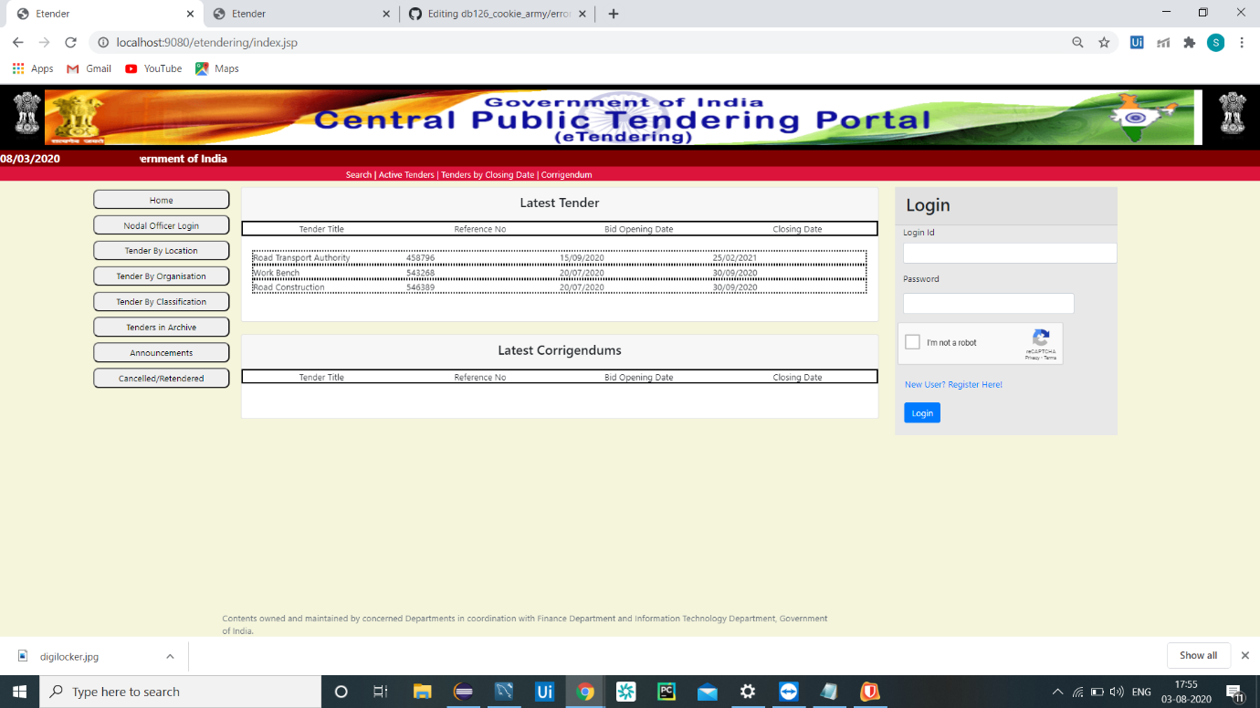

Fig.1.1:home page

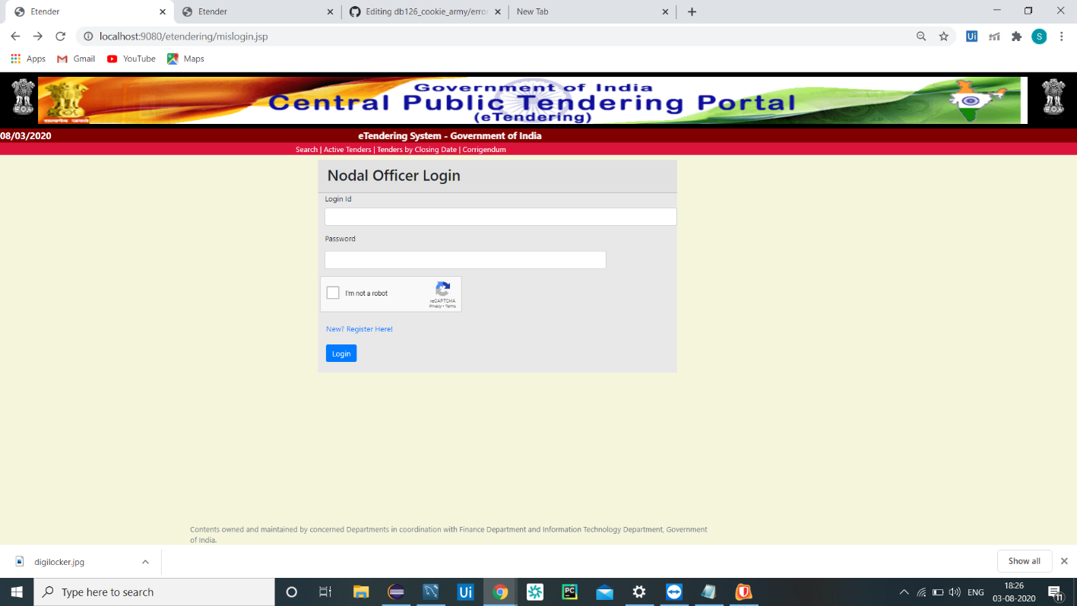

Fig.1.2:Nodal officer Login page

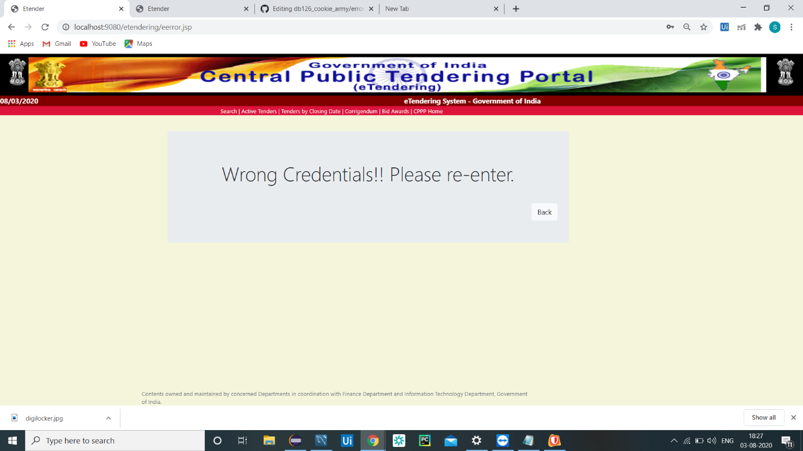

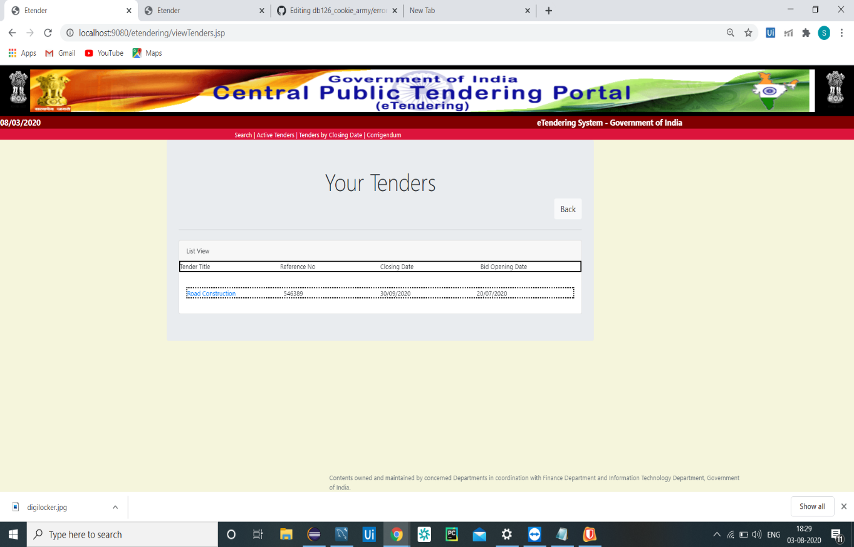

Fig.1.3:View Tender page

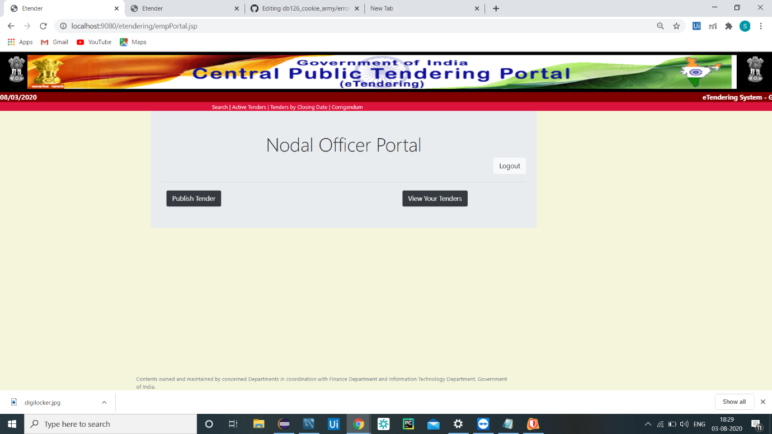

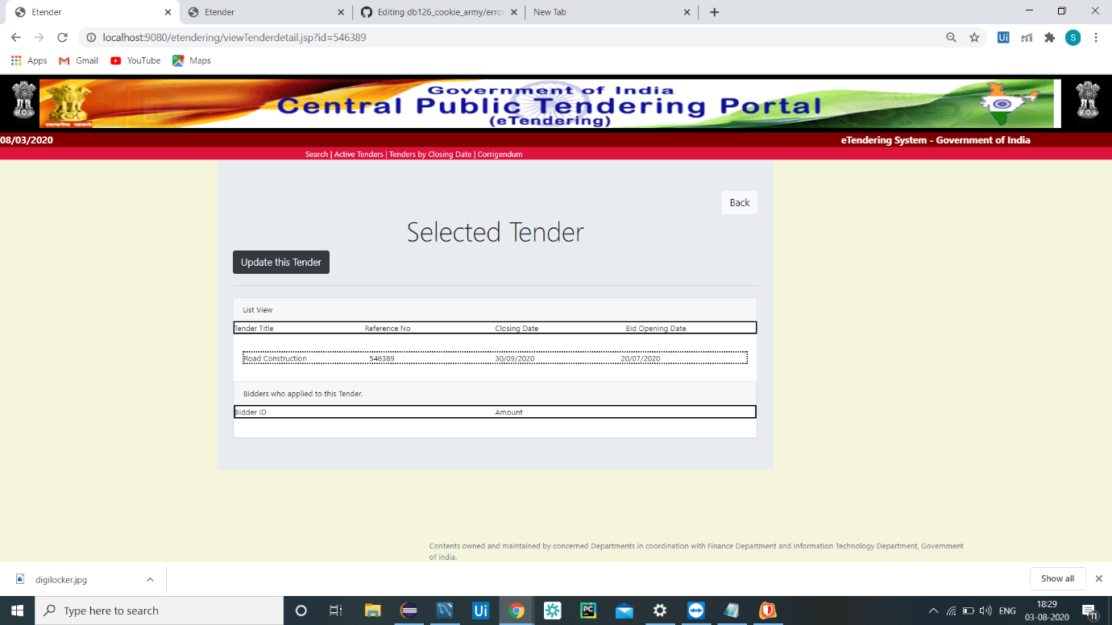

Fig.1.4:Update Tender page

## 

## 

Fig.1.5:Wrong Credentails

Fig.1.6:Response Tender Page

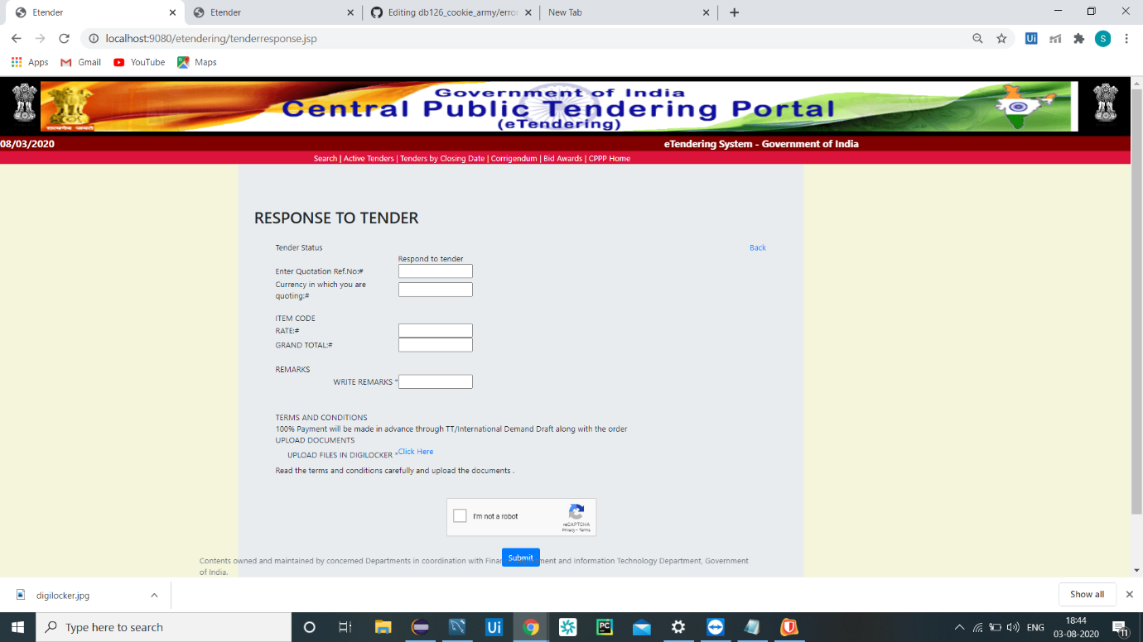

Fig.1.7:Digilocker Login page

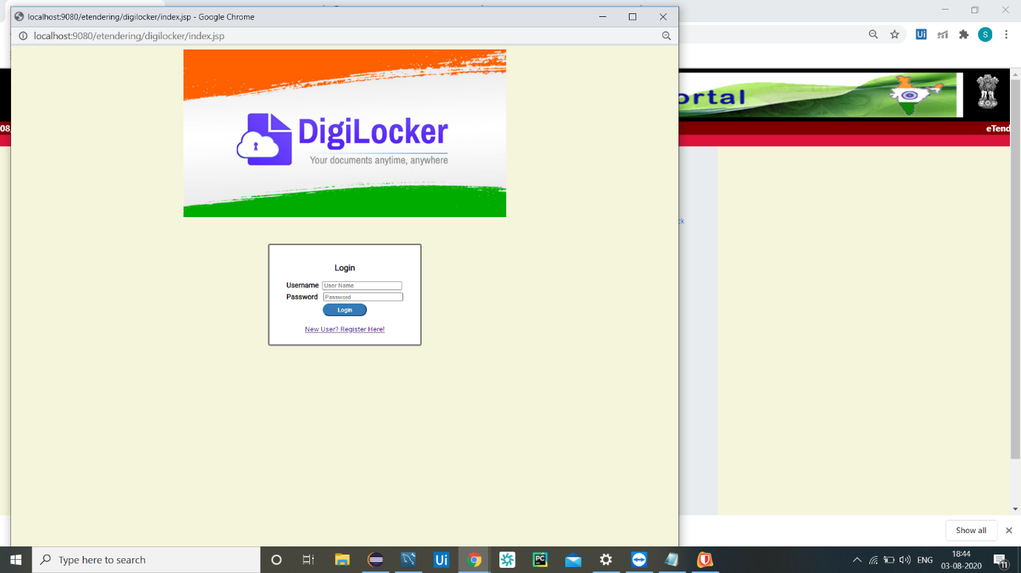

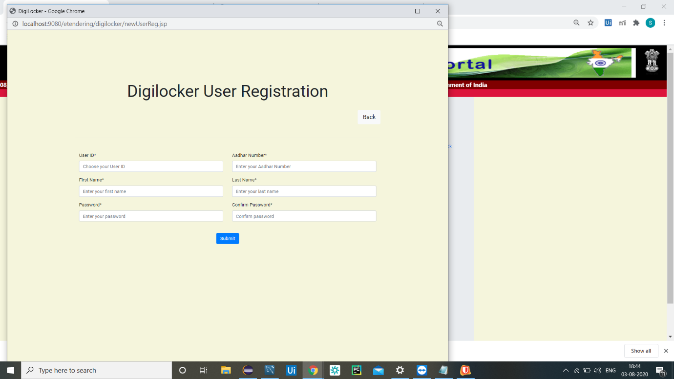

Fig.1.8:DigiLocker Registration page

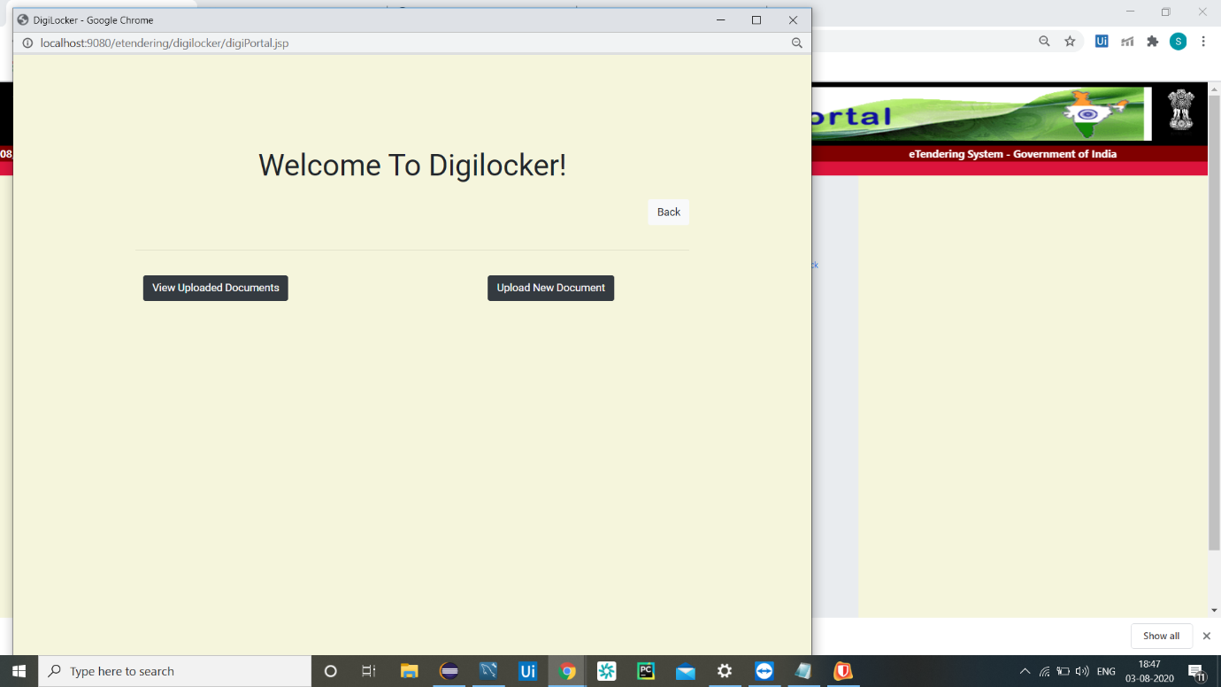

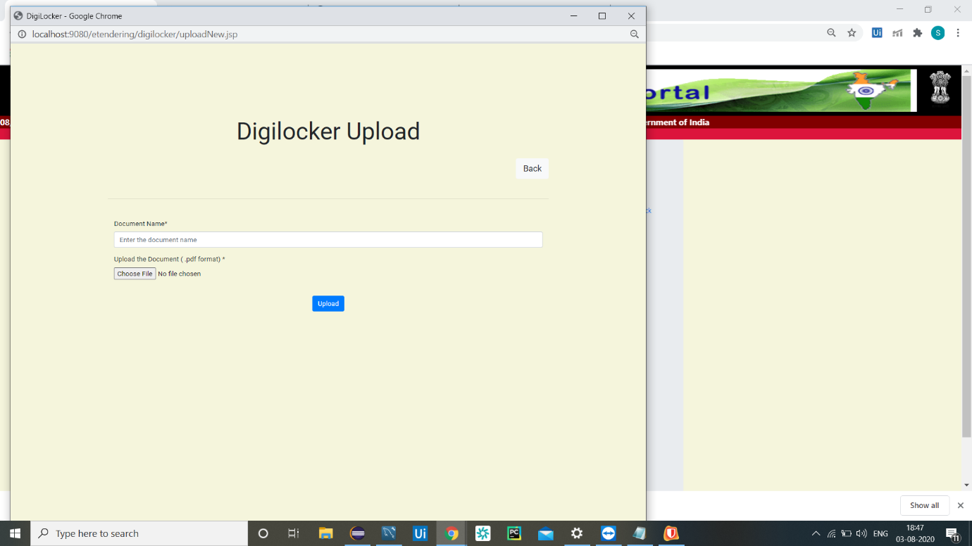

Fig.1.9:Upload page

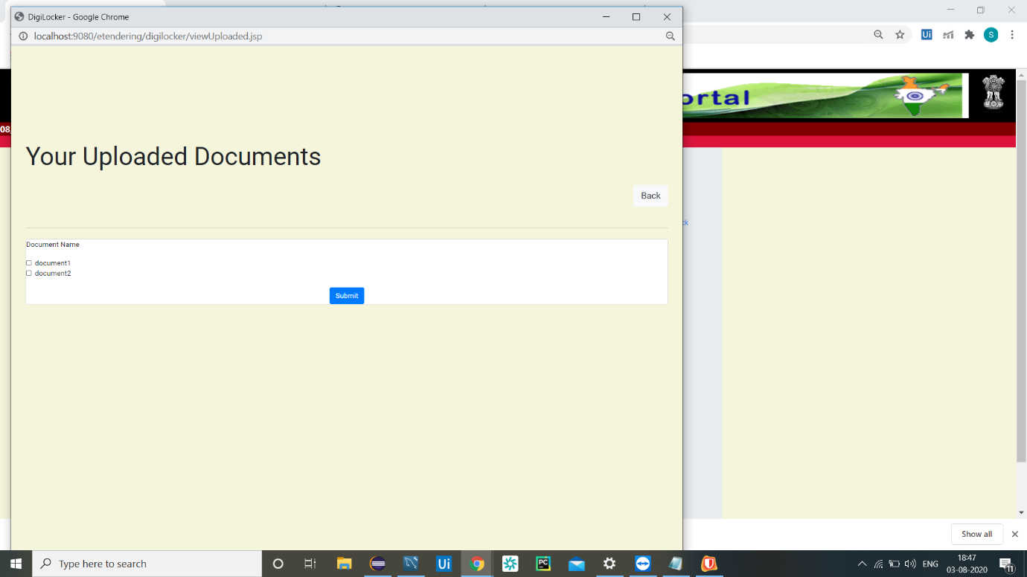

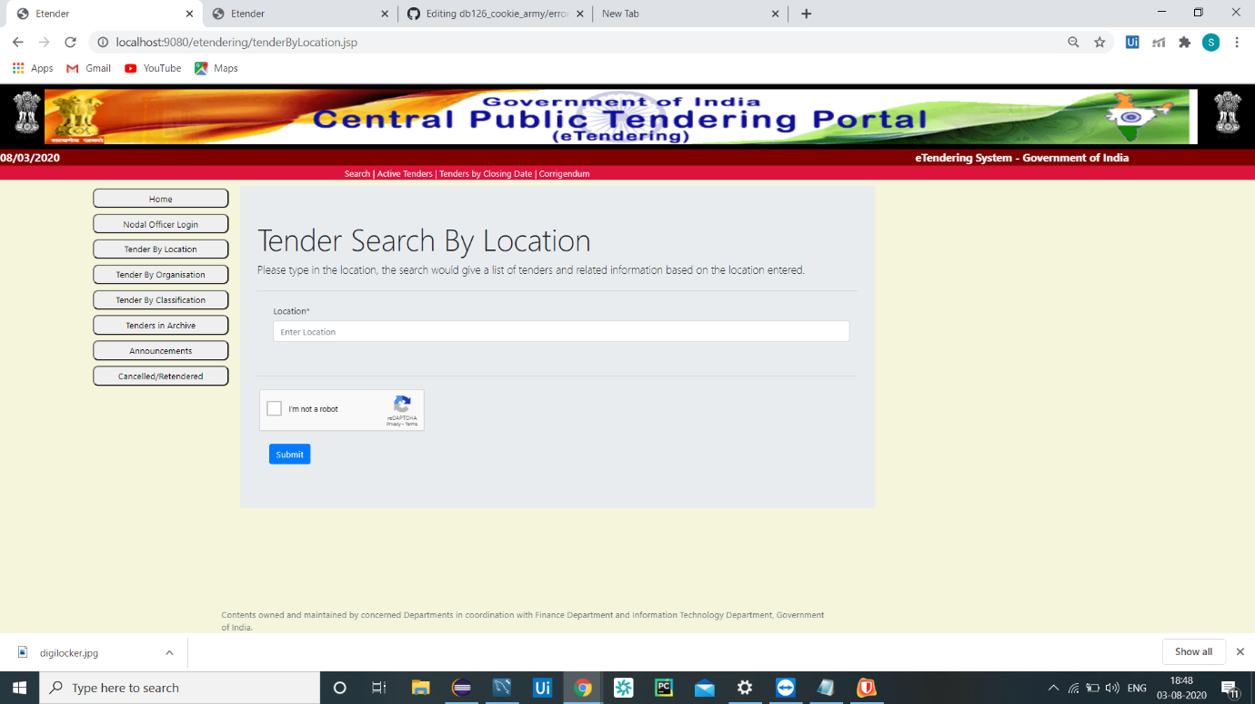

Fig.2.0:Tender Search By Location page

