**Tutorial for Order Shipping**

The GUI was built to serve two purposes for Amazon orders. Currently, for every order, we have to go into the order to get the shipping address individually. If done together through Amazon, there are lots of unwanted text which are not required for shipping as shown in the figure below. This increase cost by unnecessary printing (not to mention, it is not environmentally friendly). Black boxes are used to cover the confidential information.

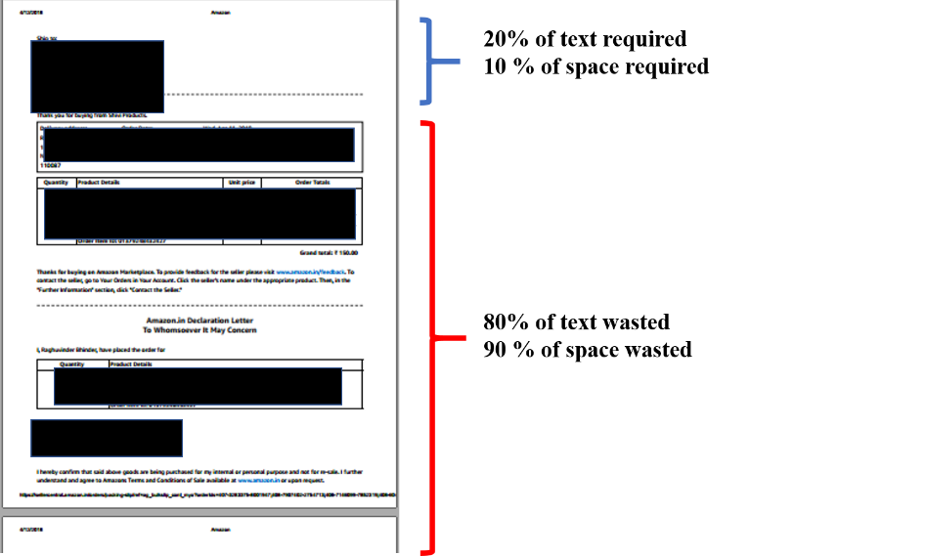

Second was that keeping a track of tracking ID with Indian Postal services is a pain. As they do not give a receipt, we have to maintain the record of tracking id individually that increases the time spent in shipping (which could be spent on increasing the business). Thus, GUI also, creates a list of Order IDs, against which the tracking id can be written and be kept on records for our purpose. The final look of the document generated form the GUI is shown in the figure below. It clubs just the shipping address and also types in seller (our) address so that in 1 page, 6 orders can be printed.

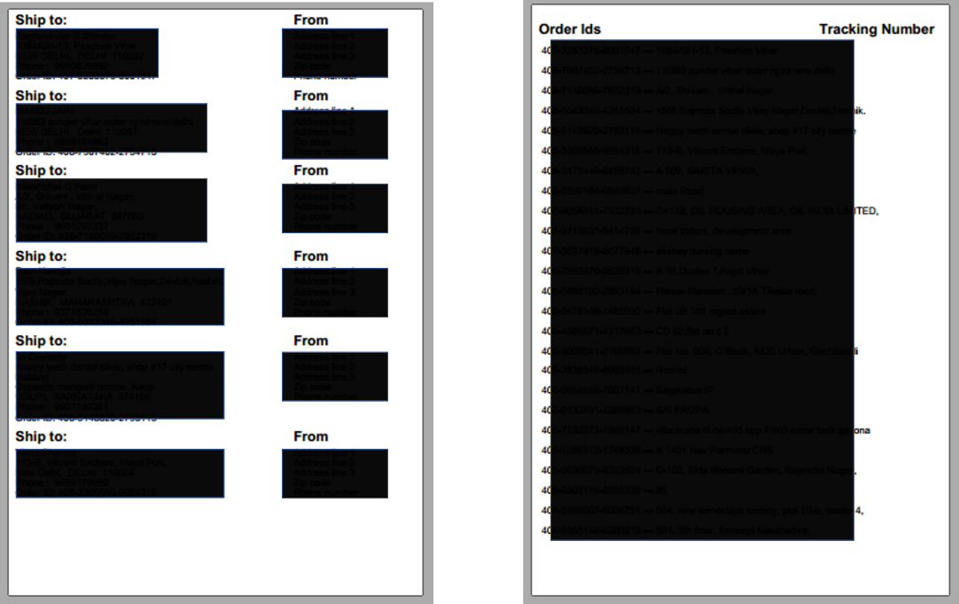

The steps are described below:

1. Download the dist.zip file from the github repository and unzip it anywhere on the computer)

<https://github.com/ashutoshnayakIE/amazon_gui>

1. Install JDK version 1.8.0_101 from the following link  
   <http://www.oracle.com/technetwork/java/javase/downloads/jdk8-downloads-2133151.html>  
   Select the version: jdk-8u161-windows-x64.exe
2. Go to seller central in the Amazon. Click on the Unshipped Orders:  
   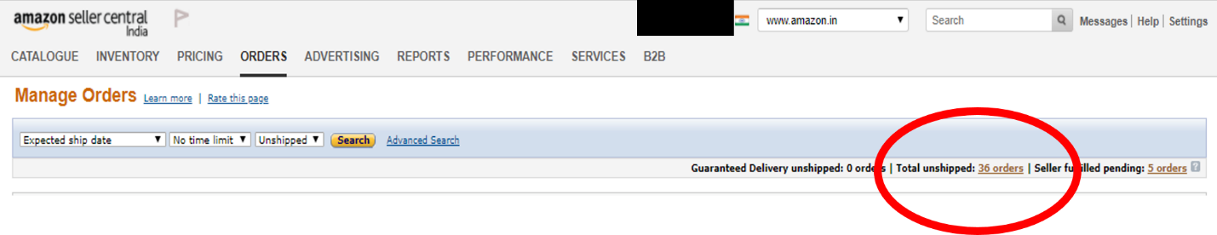
3. Go to the bottom left of page and select the option such that it covers all the orders (Example, for 36 orders, I selected “Show 50 results per page”) and click the go button next to it.  
     
   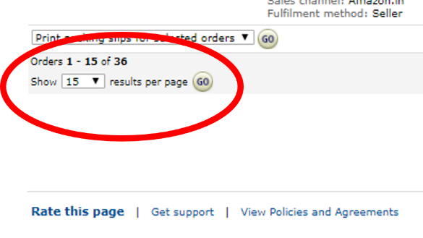
4. After that, go to the top of the page and click on the “Orders” box that selects all the orders.  
     
   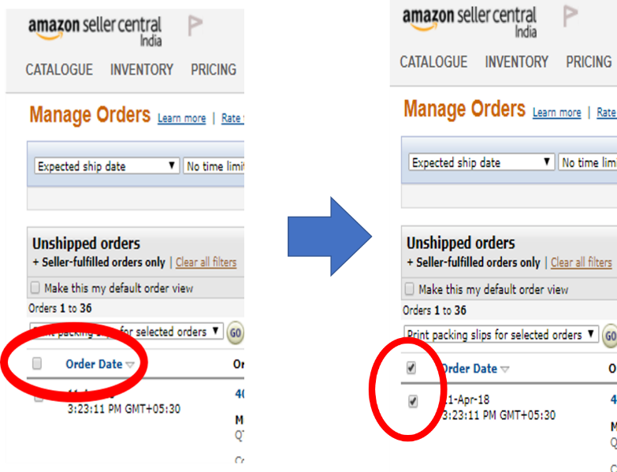
5. Select the “print packing slips for the selected orders” option from the option above and click on “go” to the right of it. Save the file which is downloaded in the pdf format (it is generally downloaded in pdf format but if it is downloaded in html, save as .pdf file)  
   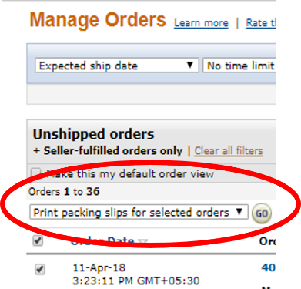
6. Go the folder where you unzipped the dist.zip zar file. Now click on the “Orders.jar” file and the GUI opens that looks as shown below. Follow the steps as mentioned to the left side in the sequence.
7. Select the file you have downloaded in Step 6.
8. Wait till the “Success/Fail” text changes to “Success” and also changes color to green.
9. After that, write down the filename you want to save the output in. Examples like “Amazon_order_3_12_18”.
10. Enter your address if you want it to be printed. Click on the button and go to the folder. You will see a text file named “address”. Do not change the name of the file. Save your address in the file (line by line as shown in the file when you open it). Keep the address such that the lines are not too long (otherwise it does not come out pretty in the output). For the same reason, please limit the address to 5 lines. If you have already saved your address, do not need to edit the file every time you run it. After editing the file, save the file. AGAIN, do not change the name of the file. The button will turn green after completion.
11. Click on the “Save” button and select the folder you want to save the file in.
12. Open the file and check if the orders are listed on the file.