PROJECT REPORT

Name : Ashutosh kumar pandey
Registration Id : 25bai11361
TASK 1 :
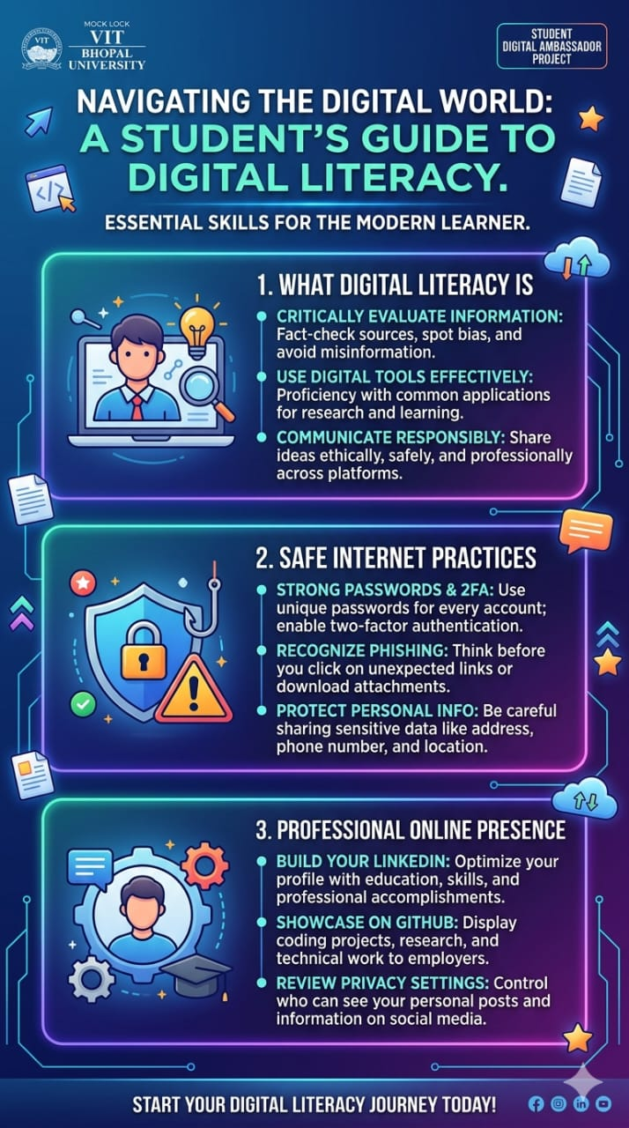

For this infographic titled "Navigating the Digital World: A Student’s Guide to Digital Literacy," I utilized Canva, leveraging its robust library of vector illustrations and neon-gradient templates to create a high-energy, modern aesthetic. The choice of a dark background paired with vibrant cyan and purple borders was intentional, aiming to mimic a digital interface that feels familiar to a tech-savvy student audience.
The design is structured into three distinct pillars of digital fluency:
- Defining Digital Literacy: Focusing on critical evaluation and ethical communication.
- Safe Internet Practices: Highlighting essential security measures like 2FA and phishing awareness.
- Professional Online Presence: Encouraging students to leverage platforms like LinkedIn and GitHub for career growth.
One of the most interesting aspects of the process was maintaining a balance between visual hierarchy and information density. I found it challenging to condense complex cybersecurity and professional branding concepts into punchy, three-point lists without losing depth. Integrating custom icons—like the shield for security and the gear for profile optimization—was a rewarding exercise in visual storytelling, ensuring the graphic remains engaging and scannable at a glance while still serving as a comprehensive educational resource.

TASK 2 :

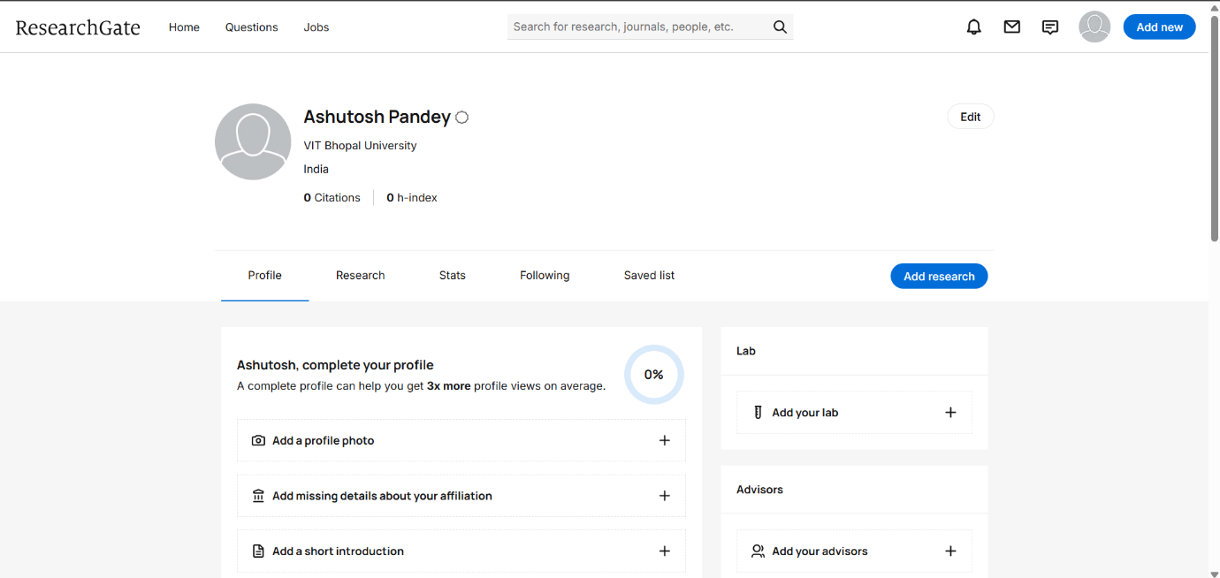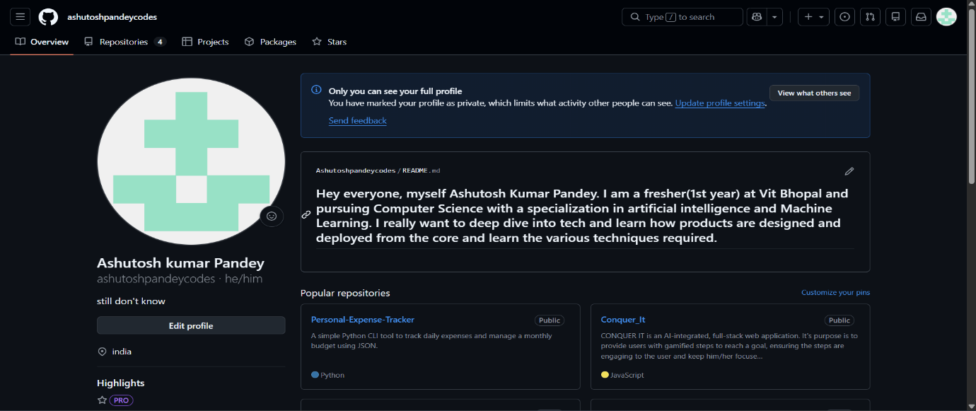
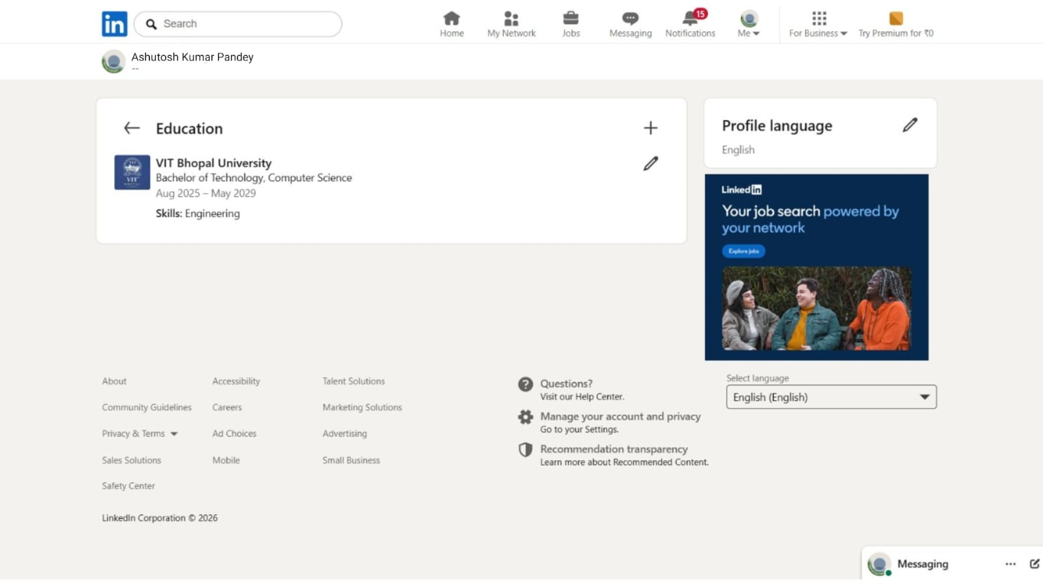

For my digital portfolio, I established a presence on GitHub, LinkedIn, and Kaggle.
GitHub is a foundational platform for version control and collaborative software development. Over the next four years, I plan to use it to host my web development projects, document my journey through complex software engineering concepts like system design and cloud computing, and actively contribute to open-source repositories.
LinkedIn serves as a professional networking hub where I can build my industry brand. I have updated my education details and intend to use the platform to connect with tech professionals, share insights from my learning journey, and ultimately secure internships and full-time roles in the tech industry.
Finally, Kaggle is the premier community for data science and machine learning. I will utilize Kaggle to practice working with diverse datasets, participate in predictive modeling competitions, and review notebooks from experienced data scientists to sharpen my AI and ML skills.
By actively maintaining these three profiles, I aim to transition from a student learning fundamental concepts to a capable software engineer with a proven, visible track record.

TASK – 3 :

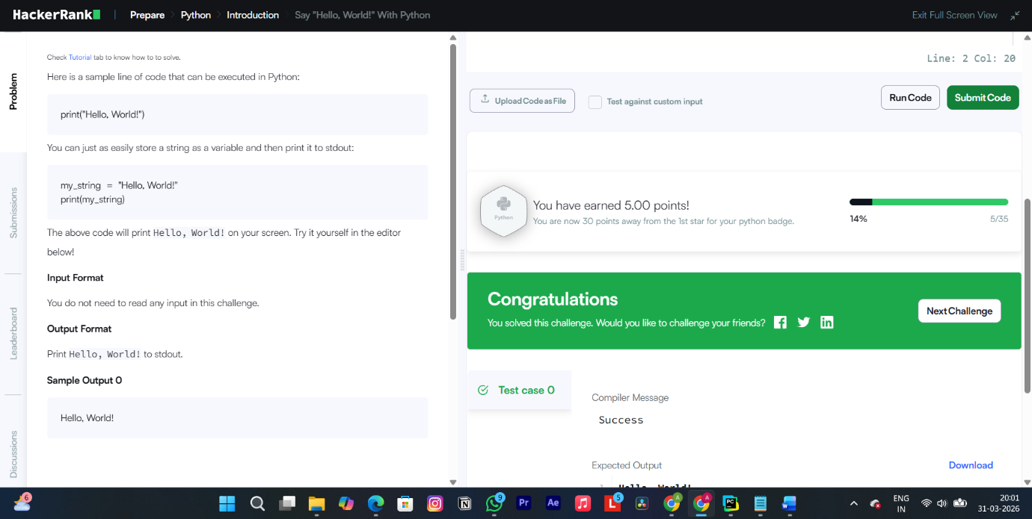
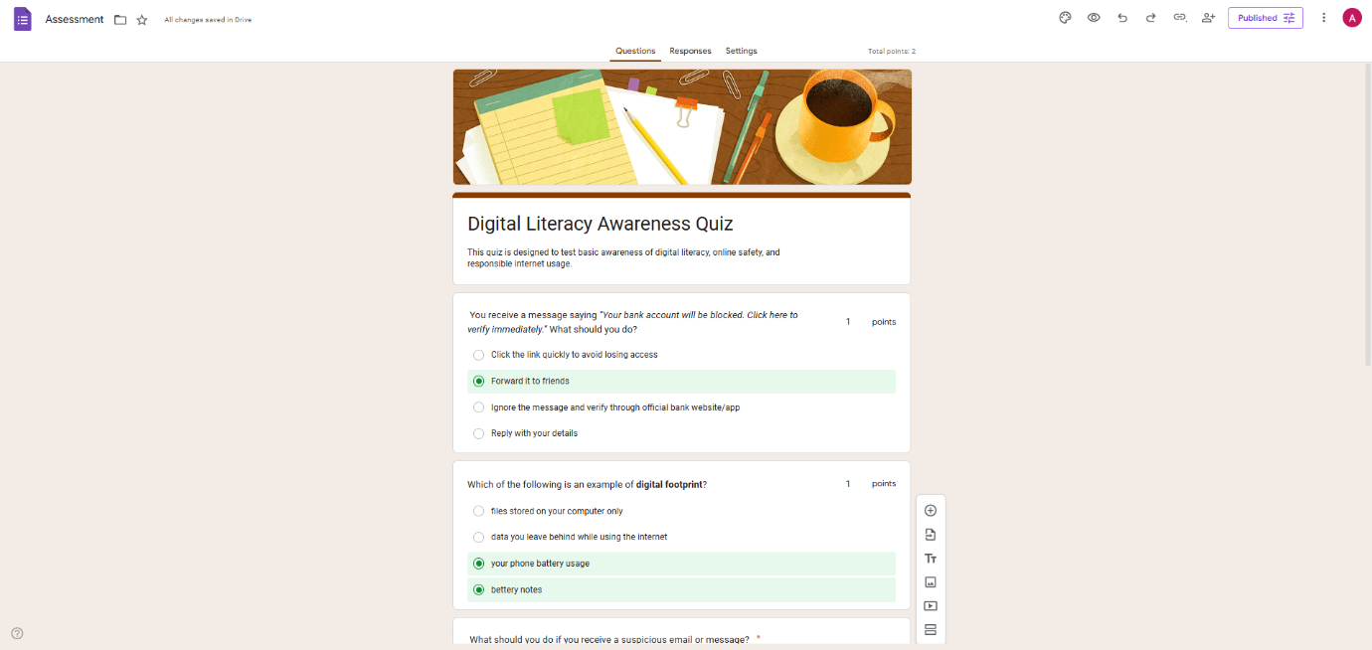

For Part A, I selected HackerRank to reinforce my programming fundamentals, specifically completing the "Say Hello, World! With Python" challenge. As I delve deeper into software engineering concepts like system design and cloud computing, maintaining a strong, practical grip on core languages is essential. Platforms like HackerRank provide the hands-on coding practice required to tackle complex algorithms and build robust applications.
For Part B, I utilized Google Forms to create a "Digital Literacy Awareness Quiz." This five-question survey included a mix of multiple-choice and short-answer formats to test basic digital safety.
Academically, these tools are highly synergistic. HackerRank sharpens my technical problem-solving skills, which are critical for my coursework and upcoming projects in AI and machine learning. Meanwhile, Google Workspace tools like Forms and Sheets streamline data collection and cloud collaboration. Whether I am gathering peer feedback for a university group project or organizing structured datasets to train predictive models, mastering these applications ensures I can manage information efficiently and work seamlessly alongside my batchmates.

TASK – 4 :
A prime example of poor digital communication causing a tangible problem very often occurs within modern collaborative academic environments. In a highly relatable hypothetical scenario, a student working on a final group assignment became deeply frustrated when a teammate pushed faulty code that broke the shared project repository. Instead of addressing the issue constructively, the student lashed out in the team’s public Discord channel—which also included their professor. They sent a harsh, sarcastic message mocking the teammate's programming skills and demanding they "stay away from the backend."
The consequences of this digital misstep were immediate and destructive. The public humiliation severely demotivated the targeted teammate, causing them to withdraw from the project entirely. Furthermore, it created a toxic, hostile environment for the rest of the group, immediately halting their productivity. The professor also took note of the unprofessional behavior, which ultimately impacted the offending student’s peer evaluation score and damaged their academic reputation.
What could have been done differently? First, the frustrated student should have stepped away from the keyboard to manage their emotional response before typing or sending anything out. Second, they should have utilized the appropriate channel for technical feedback—conducting an objective code review on GitHub, pointing out the specific bugs without resorting to personal attacks. If a direct conversation was necessary, scheduling a quick video call or sending a polite, private direct message offering to pair-program and troubleshoot the issue together would have resolved the technical problem while preserving the professional working relationship and demonstrating true leadership.

TASK – 5 :

As the digital landscape rapidly evolves, transitioning from a passive consumer of technology to a responsible, proactive learner requires a deliberate approach to online presence, continuous skill development, and cybersecurity. This report synthesizes my journey through establishing a professional footprint, enhancing collaborative abilities, and understanding critical digital threats.
The foundation of my digital portfolio began with strategically selecting platforms that align with my long-term software engineering goals. I established a presence on GitHub to host my development projects and document my progress in areas like cloud computing and system design. To build my industry brand, I optimized my LinkedIn profile to connect with tech professionals and share insights from my learning journey, with the ultimate goal of securing future internships. Furthermore, setting up Kaggle provided a dedicated space to practice predictive modeling and analyze diverse datasets. By actively maintaining these profiles, I aim to project a capable, visible track record to future employers and collaborators.
Beyond static profiles, active skill development and seamless teamwork are critical. I utilized HackerRank to reinforce core programming fundamentals through hands-on coding challenges, ensuring my problem-solving skills remain sharp for complex algorithms. Concurrently, I leveraged Google Workspace, specifically Google Forms and Sheets, to design a peer-focused Digital Literacy Awareness Quiz. These cloud-based tools are highly synergistic, streamlining data collection and enabling seamless, real-time collaboration alongside my batchmates for academic group projects.
Effective digital communication is just as vital as technical proficiency. Through researching digital etiquette, the destructive impact of public communication missteps became glaringly apparent. For instance, addressing technical disputes or group frustrations in public group channels can severely damage team morale and individual reputations. This reinforced the necessity of stepping away from the keyboard during emotional moments and utilizing appropriate, private channels for constructive feedback and professional conflict resolution.
Finally, researching modern cybercrime, particularly UPI and online payment fraud, was a significant wake-up call. The psychological sophistication of scammers—who exploit human emotions like urgency and excitement rather than just relying on technical vulnerabilities—surprised me the most. It highlighted that technical literacy does not automatically guarantee digital security awareness. Consequently, I have fundamentally changed my personal security habits, transitioning from reusing password variations to implementing a dedicated password manager to ensure unique, complex credentials for every single account.
Ultimately, this project has equipped me with the holistic skills required to navigate, collaborate, and lead safely in a digital-first world.

