**A Project/Dissertation Report**

**Crypto currency using Power BI**

# On

***Submitted in partial fulfilment of the requirement for the award of the degree of***

## B.TECH - CSE



# Abstract

A Power BI Dashboard is like a canvas that is used to tell a story. It presents the most important data points in various elements within one single page. It is an entry to the reports that are based on the dataset. Well-designed dashboards contain only important points of the data story. If you select or click a particular tile (snapshot of data), it will take you to the main report from where it is taken. Dashboards are good to monitor your business performance, sales performance, or any important parameters at a glance. It offers a bird’s- eye view of your business and helps you create data-backed strategies for future actions. Dashboard in Power BI may come from one or many reports or underlying datasets or many. It represents a consolidated view of important business metrics. This single-page visualization in the Power BI dashboard automatically refreshes when the dataset gets updated, and thus, you can have real-time tracking of the data that matter the most. Power is an online service that search the data, transformation and visualized it, and share the data than create report dashboard and report with other users in the same or different department or even with the general public. Power BI having a free features that help in to visualized the data and functionality, one of the most important features of Power BI is its Quick analysis of feature that already present in advanced analytical algorithms. The above line describes our project by the built in dashboard which is when we drop the data of that is collected from “ Julco ” website , which is full of crypto currency data analysis and then show in dashboard , In power BI there are one important feature that is predict the value crypto currency for upcoming time. We used forecast feature to prediction the value of crypto currency for upcoming time.

# Introduction

In market there are many product to analyses the data like Power BI, from Microsoft tool that use in Business analytics tools that analyses data and share databases that given , etc. form the inputs for Power BI. Datasets are formed the data visualization of that data. there are many type feature and filtering in the dashboard that help in data organized .

Most people know that their data only tell story, yet most organizations still struggle to understand what their data is telling them. Power BI is one of Advancement in data analytics platform, it is efficient, and user-friendly, because it is easy to understand and ever on easily understand the feature. In begin some difficult to know where to start and where not. The contest allows anyone to create a Power BI dashboard to analyses data and showcase the storytelling power of Power BI. Basically a crypto currency is digital currency, there are some coins like Bit coin, Ethereum, lit coin and many more coins are there in these currency. Bit coin is the most important coin for investment options.

The past of Bit coin is very poorly, which has affected the crypto market greatly. The price of crypto in the time since 2016 very big increment , the passion of people started invest more and more in the time of 2016 . The most important and decentralized crypto on October 31, 2008 Satoshi Nakamoto was intro about bit coin, It occupied 39 % of over market . The main aim of this project is to build the dashboard using power BI tool or we take the data from website. Which list over 2175 crypto currencies of various types Since these currencies are primarily based on public opinion, they have aggressive price movements. This makes it very difficult to conduct a proper risk assessment at any time. With crypto currency prices rising by, mining also became a very lucrative business for people. Power BI offers interactive and dynamic features required for creating interactive dashboards. These dashboards, which are simply a collection of visuals, can be built with a deep level of interactivity and are accessible in various formats to consumers. Since they are usually a single page, Power BI dashboards need to be well-designed highlights of an entire story.

**Methods**

1. **Data Sets**

A dataset is the dataset you are importing or linking to . With Power BI, you can connect to and import any datasets and get it all in one place . A dataset can also be a data source for a dataflow.

Datasets are associated with workspaces and one datasets can be a part of multiple workspaces. When you open a workspace, linked datasets appear on the Datasets tab. Each specified datasets is a data source that can be used in one or more reports, and a dataset can contain data from one or more sources

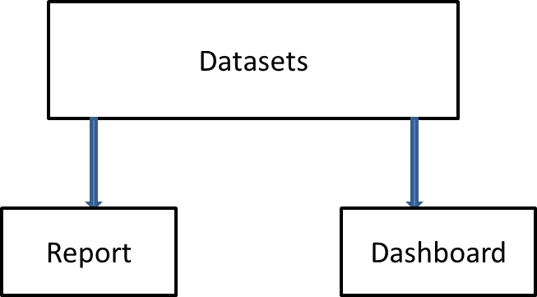

1. **Drag and Drop method**

Drag and Drop is part of Power BI. Writeback is now enabled when a user opens their Power BI workbook in Visual Planner. The Drag and Drop function saves the allocation result back to the source database. Row-level security in Power BI ensures that they can only change data that admin users want users to edit. Users can either adjust the number that the chart represents directly or the relative individual contribution it represents to the total. In most cases, current data is read-only. There are two types of drag and drop visuals: Line and bar charts that users can edit .Power BI has easy drag and drop functionality and the ability to copy all formatting between similar images.

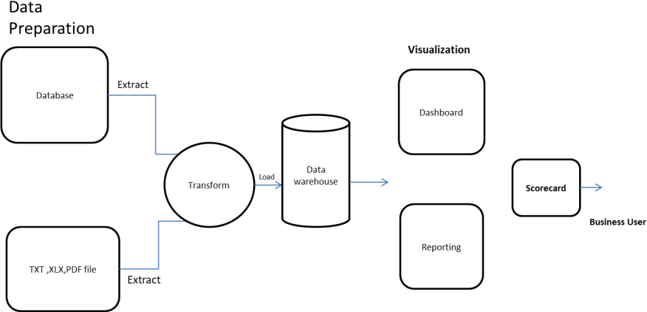

Features of Power BI:

Following are some of the features of Power BI -

1. Power BI Desktop

Power BI Desktop is free software that you can download and install, and it allows you to build reports by accessing data easily. For using Power BI desktop, you do not need advanced report designing, or query skills to build a report.

1. Stream Analytics

Power BI's primary advantage is its support stream analytics. From factory sensors to social media sources, Power BI assists in real-time analytics to make timely decisions.

1. Multiple Data Sources

Support for various data sources is one of the vital features of Power BI. You can access various sources of data such as Excel, CSV, SQL Server, Web files, etc. to create interactive visualizations.

1. Custom Visualization

While dealing with complex data, Power BI's default standard might not be enough in some cases. In that case, you can access the custom library of visualization that meets your needs. Now, to better understand what is Power BI, and how does it helps, let us look at a case study on how Meijer, which is one of the United States' largest supermarket chains, used Power BI to solve its business problems.

# Literature Survey

This trading information dashboard in Power BI helps you understand interesting trading analytics in world. It consists of 4 different pages converting huge tables of data into an interesting and easy-to-understand format. Using this dashboard, you can get all information about all trading developments in the top coins by year 2015-2019. Power BI offers interactive and dynamic features required for creating interactive dashboards. These dashboards, which are simply a collection of visuals, can be built with a deep level of interactivity and are accessible in various formats to consumers. Since they are usually a single page, Power BI dashboards need to be well-designed highlights of an entire story. for example it the beginning of 2016 bitcoin has daily transaction volume is around of $53M that increased to $89M in 2017 and in 2018 it is about $14B .The exchange of cryptocurreny in open source connect client . In real time trades Power BI stream and display them on a dashboard. The exchange of crypto currency we see in this diagram we collect data from Binance and then web socket API then the after some application core data dataset API streaming than we use power BI than we perform some operation in power Bi and decorated visualization of data .power BI crypto trade data pipeline it is very useful where the reliable API source old data is available for all the consumption .Power BI have many type of features in it to crypto data. Data has been fetched from many place. In power bi there are many type of features to represent different of data like pictorial representation we used line charts to indicates the ups data and down in the value of crypto currency. All features in power BI are helping in visualization the data in easy to easy way by use chats, graph, line and many more which have been used to show this decorated the data : 1.line charts 2.cleaning process through power query editor . There are also a most important feature in power BI which is predict the value of crypto currency for upcoming time . we used forecast feature to prediction the value of crypto currency for upcoming time In this diagram for zero line upward we usually draw column segments and categories in legends in top – bottom order and in left – to right order .Due to this sometime feel that their Order can ‘reversed ’. in this diagram we see the data between Seles Amount , Seles Upper and Sales Lower . In this we show the data of year in between that a new formatting pane option to reverse stack of your stacked column and bar , area , ribbon and combo charts. It is necessary to login in power BI and use the desktop feature .In power BI desktop there are many feature are available that make easy decorated the data in this Anna university project power BI desktop to build a excel spreadsheet using in data

## Architecture Diagram of Power BI

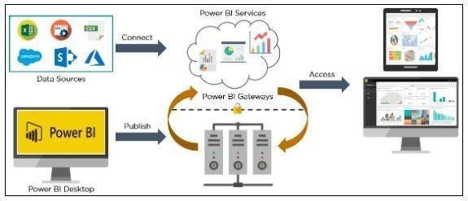

Components of Power BI

1. Power Query

[Power Query i](https://www.simplilearn.com/tutorials/excel-tutorial/power-query-in-excel)s the data transformation and mash up the engine. It enables you to discover, connect, combine, and refine data sources to meet your analysis need. It can be downloaded as an add-in for Excel or can be used as part of the Power BI Desktop.

1. Power Pivot

Power Pivot is a [data modeling t](https://www.simplilearn.com/what-is-data-modeling-article)echnique that lets you create data models, establish relationships, and create calculations. It uses Data Analysis Expression (DAX) language to model simple and complex data.

1. Power View

Power View is a technology that is available in Excel, Sharepoint, SQL Server, and Power BI. It lets you create interactive charts, graphs, maps, and other visuals that bring your data to life. It can connect to data sources and filter data for each data visualization element or the entire report.

1. Power Map

Microsoft's Power Map for Excel and Power BI is a 3-D data visualization tool that lets you map your data and plot more than a million rows of data visually on Bing maps in 3-D format from an Excel table or Data Model in Excel. Power Map works with Bing maps to get the best visualization based on latitude, longitude, or country, state, city, and street address information.

1. Power BI Desktop

Power BI Desktop is a development tool for Power Query, Power Pivot, and Power View. With Power BI Desktop, you have everything under the same solution, and it is easier to develop BI and data analysis experience.

1. Power Q&A

The Q&A feature in Power BI lets you explore your data in your own words. It is the fastest way to get an answer from your data using natural language. An example could be what was the total sales last year? Once you've built your data model and deployed that into the Power BI website, then you can ask questions and get answers quickly.

# Technical Description

Importing Data

The first step in building a Power BI dashboard is to import the dataset that will be used to build the report. You can connect to a variety of data sources, including Excel worksheets, databases, the web, and cloud services. On the homepage of the Power BI service, you can click on the ‘Get Data’ button found at the bottom right of your window. A new ‘Get Data’ window will come up, and we should be able to preview some of the major data sources available for building our dashboard.

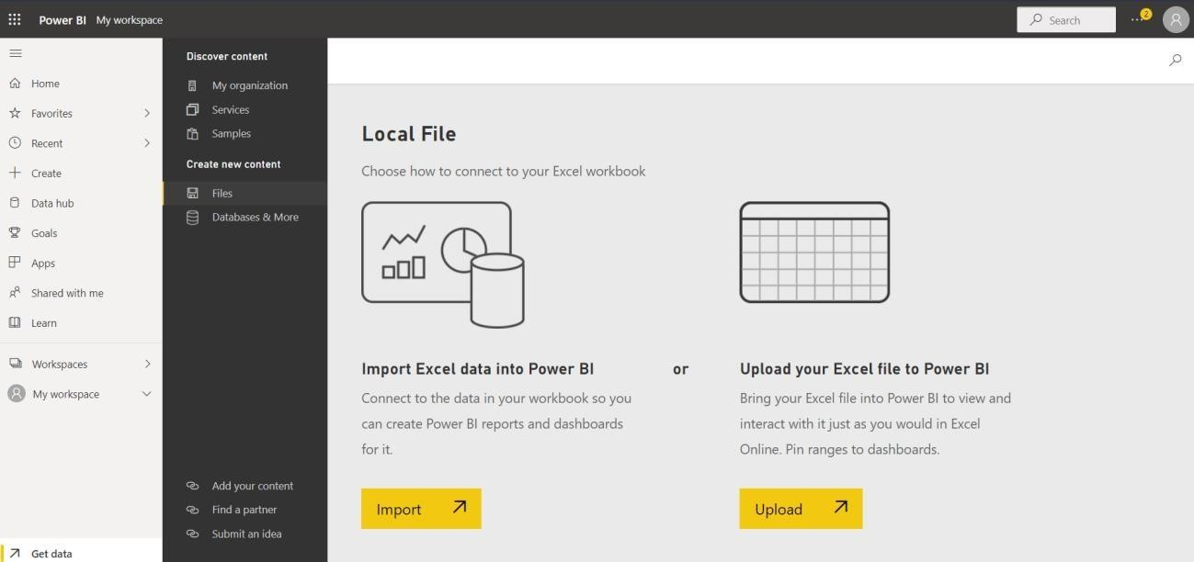

Opening a Report from the Uploaded Data

Notice that from the workspace image, there are two file types of the same name. One is the dataset and the other is the dashboard. Click on the Superstore.xlsx dashboard. On the blank canvas that pops up, click on the dataset name ‘Superstore.xlsx’.

Finally, a Reporting canvas will appear, similar to the view on Power BI Desktop.

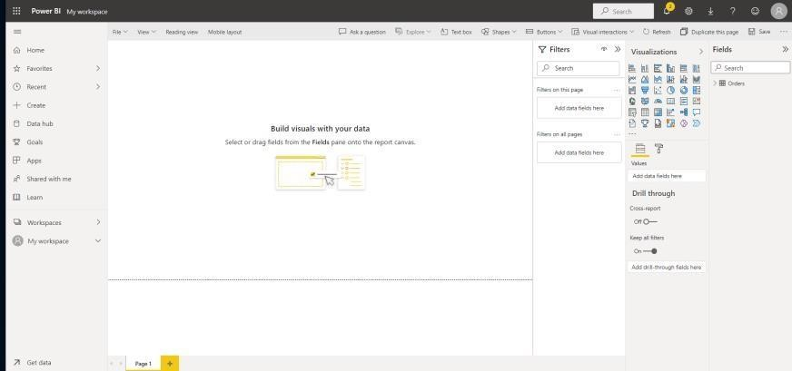

Creating a Tile and ‘Pin to a Dashboard’

Power BI report service, just like the desktop version, includes a variety of page formatting options, including visuals, shapes, and images, that can help your report stand out. One of the most efficient ways to identify and communicate insights is to [use Power BI to create visuals. Y](https://www.datacamp.com/learn/power-bi)ou can begin creating your visuals after you have decided on the data that will form the basis of your report, and designed the layout of this report. However, before you start working on your data visualization, you must first decide what insights you want to garner, and then develop and personalize visualizations to display the data in an engaging and informative manner. You can work on how to visualize these insights after you have identified them in order to bring value to your audience.We will create a simple donut chart that shows the ‘Sales across the Shipmode’.

Drop the Sales in the Values field and Ship Mode to the legend.



Organizing and Updating Tiles

**Positioning of Tiles**

You can move the tile around on your dashboard to a convenient position just by holding a left click on the tile and moving it.

**Tile Size**

You can increase or decrease your tile size by dragging the little arrow at the bottom right of the tile.

**Other Tile Options:**

By clicking on the kebab (...) menu on the tile, more options are shown around ‘Tile settings’.

Pin an Entire Report to a Power BI Dashboard

* We will first need to create more visuals for our Superstore Report. You can download the sample report used [**here**.](https://github.com/simmieyungie/DataCamp-Resources/blob/main/Datacamp%20-%20PBI%20Dashboard%20Tutorial.pbix?raw=true)
* Go back to ‘My workspace’. Open the Superstore report type.
* Click on the Edit button.
* Add some more Power BI Visuals.
* Select the option (...) at the top of the report view.

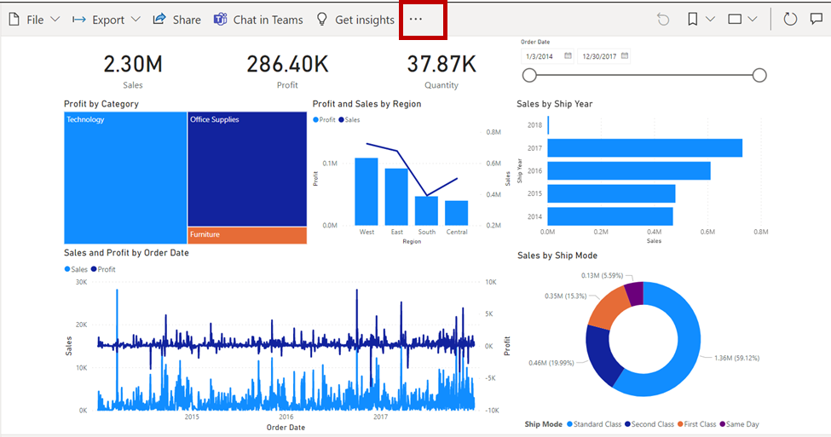

Adding Images, Shapes, and Textboxes: Clicking on the Edit button on the dashboard, choose ‘Add a tile’. You can include images in the form of a company logo, text boxes for title blocks, comments, etc.

Share a Power BI Dashboard: At the top of our dashboard page, we can share the dashboard with other members of our organization.

Collaboration with Comments: When we build dashboards like this, it is important to get feedback and collaborate with either team members or major consumers of this report. The comments option provides a mini forum for conversations around the dashboard elements.

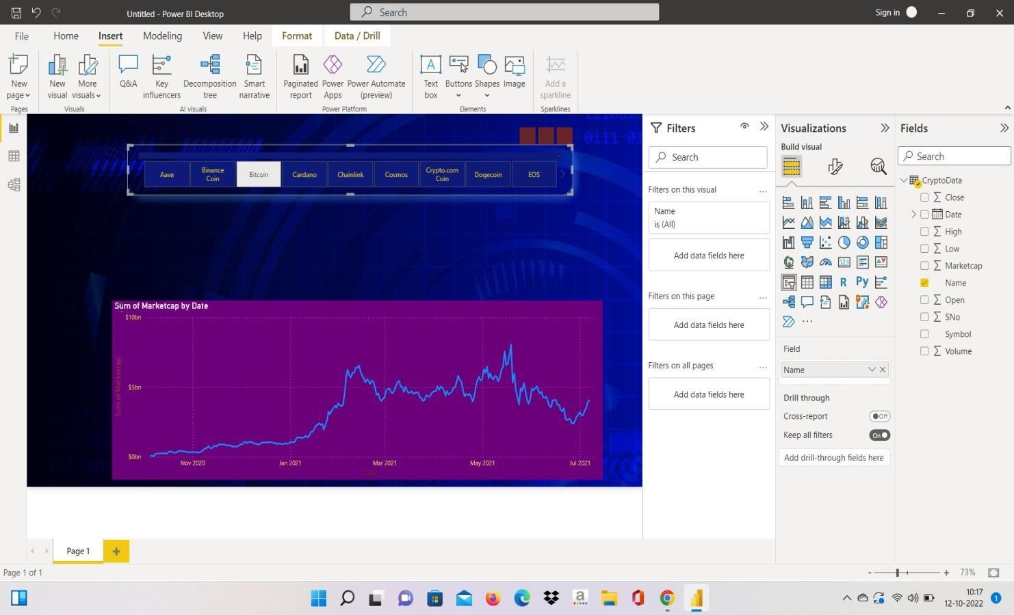

# Result and Discussions

**After completing** the project, we get fully functional Dashboard of crypto currency of showing different graphs.

It is also responsive in both pc and phones.

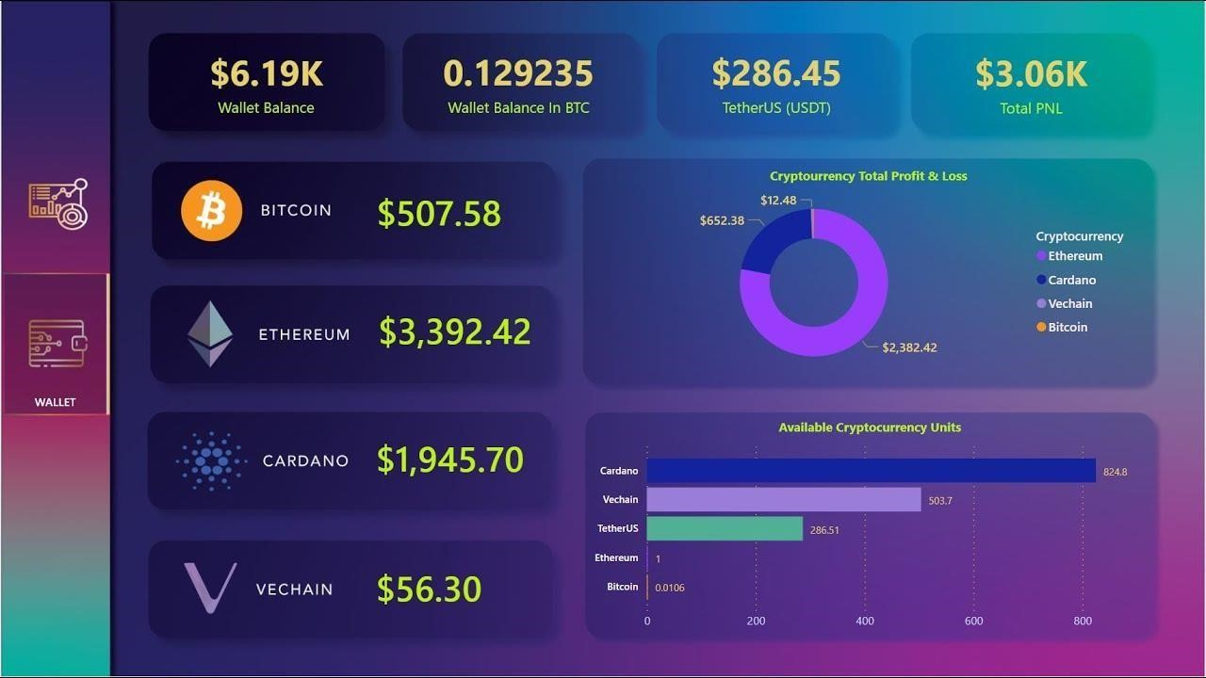

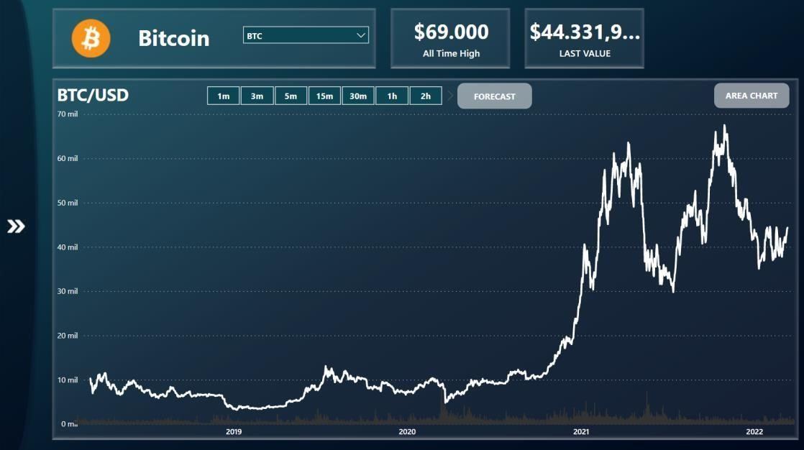

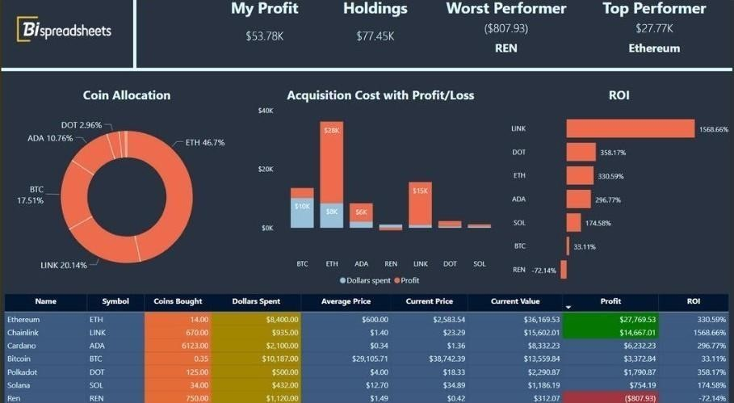

**Conclusion of Power BI:**

Crypto currency Dashboard is easy to Predict the price of the coin.

Overall, predicting price .related fluctuations is difficult when considering related m arket forces. Add to that the fact that prices are more dependent on future prosp ects than historical data.

**Future work of Power BI Dashboard:**

In future work, we will investigate other factors that may affect cryptocurrency m arket prices, and we will focus on the impact that the social media in general a nd tweets in particular can have on the price and trading volume ofTcryptocurren sets by analyzing tweets using the environment. language analysis and emotional a nalysis techniques

## References

* Ter Ji-Xi, Joye, Yashar Salamzadeh, and Ai Ping Teoh. "Behavioral intention to use cryptocurrency in Malaysia: an empirical study." *The Bottom Line* (2021).

* Tok, Mevliit Serkan, Murat Dener, and Mehmet Demirci. "Processing Honeypot Logs with Big Data and Data Visualization via Hadoop-Power BI Integration." *2022 15th International Conference on Information Security and Cryptography (ISCTURKEY)*. IEEE, 2022. • Viriyasitavat, Wattana, Danupol Hoonsopon, and Zhuming Bi. "Augmenting cryptocurrency in smart supply chain." *Journal of Industrial Information Integration* 21 (2021): 100188.

* M. C. ERDOĞAN and M. CANAYAZ, "Crypto-Currency

Sentiment Analyse on Social Media," *2018 International Conference on Artificial Intelligence and Data Processing (IDAP)*,

2018, pp. 1-5, doi: 10.1109/IDAP.2018.862

* King, Sunny. "Primecoin: Cryptocurrency with prime number proof-of-work." *July 7th* 1.6 (2013). Bruzgė, R., & Šapkauskienė,

A. (2022). Network analysis on Bitcoin arbitrage opportunities. *The North American Journal of Economics and Finance*, *59*, 101562.