GymBuddy User Research Analysis
Deliverable 1: Market & User Research | Sample size: 20 Google Form responses
Executive Summary
The research supports GymBuddy's core thesis: beginner and budget gym users need practical in-gym clarity more than advanced fitness optimization. The MVP should help users know what to do today, show how to do it safely, offer alternatives when equipment is busy, and adapt next week's plan from check-in behavior.

1. Research Objective
The goal of this research was to understand the pain points of beginner and budget gym users, especially the moments that cause confusion, skipped exercises, and early drop-off. The findings are intended to guide the GymBuddy MVP scope, onboarding, workout flow, demo support, check-ins, and adaptive weekly planning.

2. Methodology
Field | Details
Method | Google Form survey
Responses | 20
Audience | Current gym users, recently joined users, planning users, and users who stopped going
Research focus | Gym clarity, skipped exercises, equipment constraints, AI trust, desired app features, and consistency barriers

3. Key Metrics
Metric | Result
Total responses | 20
Budget-adjacent users | 14/20 (70%)
0-1 gym days last week | 9/20 (45%)
Lack full in-gym clarity | 5/20 (25%)
Skipped due to uncertainty | 13/20 (65%)
Open to AI plan | 18/20 (90%)
Prototype testers | 15/20 (75%)

4. What Users Struggle With Inside the Gym
The biggest reported pain point is equipment availability, followed closely by uncertainty around correct form. This matters because the GymBuddy flow should not assume the user's first exercise option will always be available or that the user knows how to perform it correctly.
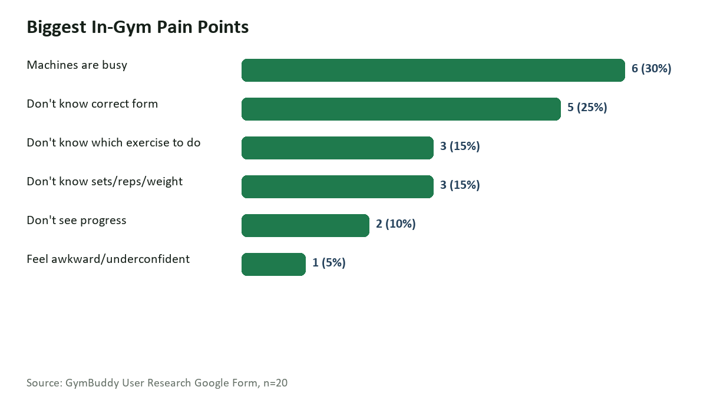
Figure 1. Biggest in-gym pain points from survey responses.
Pain Point | Count | % of Respondents
Machines are busy | 6 | 30%
Don't know correct form | 5 | 25%
Don't know which exercise to do | 3 | 15%
Don't know sets/reps/weight | 3 | 15%
Don't see progress | 2 | 10%
Feel awkward/underconfident | 1 | 5%

5. AI Trust and Safety
Trust in AI is high, but conditional. Most users are willing to trust an AI weekly gym plan when it is simple, supported by demo videos, or includes safety warnings. This means AI should be positioned as a guided planning and adaptation layer, not as an unrestricted trainer replacement.
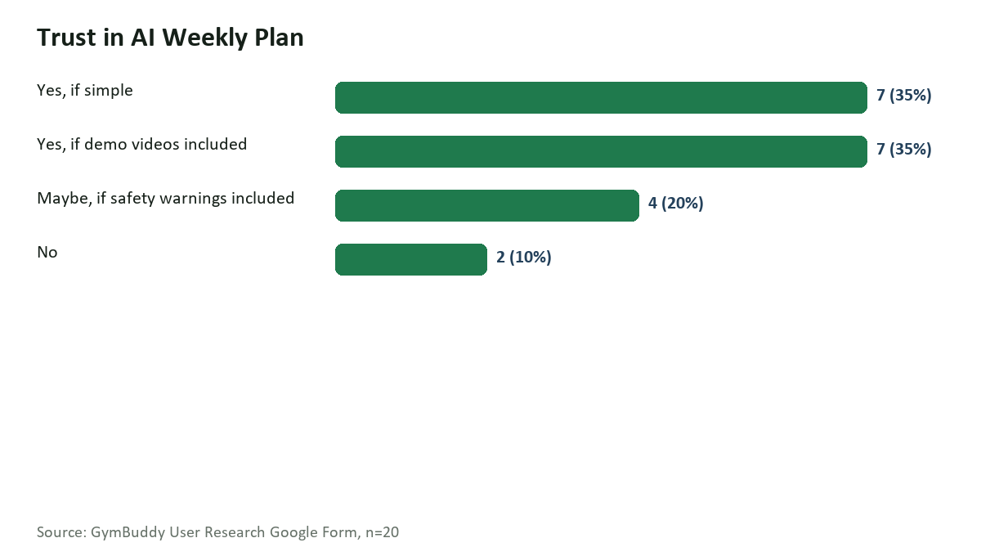
Figure 2. Trust in an AI-generated weekly plan.

6. Desired Product Features
The most requested features are simple daily workouts, sets/reps/weight guidance, demo videos, and progress tracking. This validates the MVP direction: a simple workout checklist with clear instructions and low-friction logging.
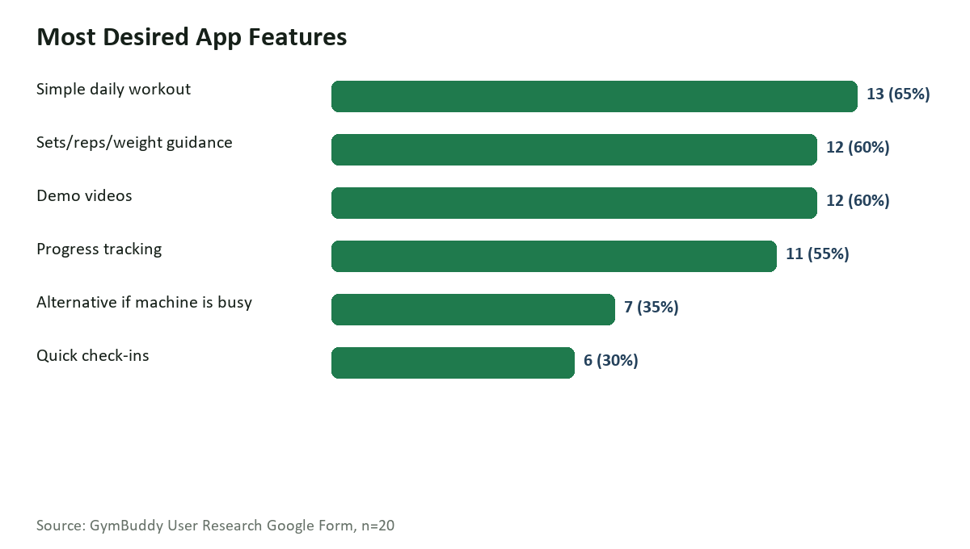
Figure 3. Most desired GymBuddy app features.
Feature | Count | % of Respondents
Simple daily workout | 13 | 65%
Sets/reps/weight guidance | 12 | 60%
Demo videos | 12 | 60%
Progress tracking | 11 | 55%
Alternative if machine is busy | 7 | 35%
Quick check-ins | 6 | 30%

7. Consistency Barriers
Open-ended responses show that consistency is affected by motivation, energy after work, difficulty starting, soreness, and practical friction such as distance or weather. GymBuddy should reduce mental effort before and during the workout.
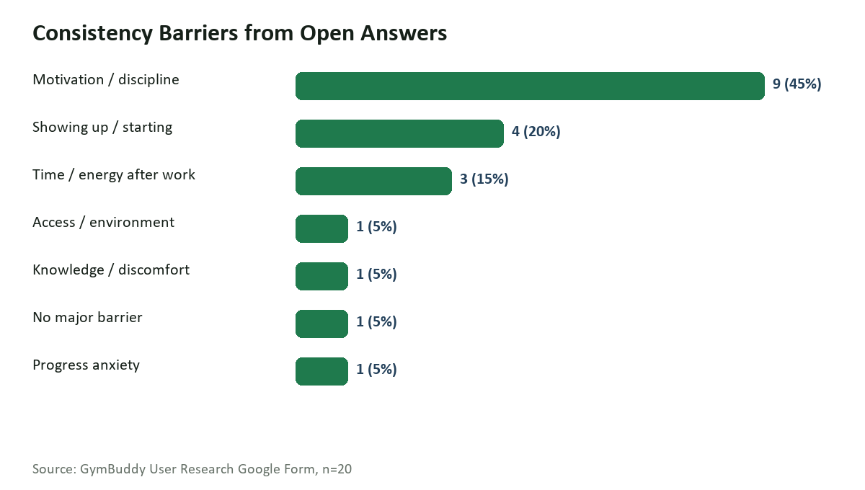
Figure 4. Themes from open-ended consistency-barrier answers.

8. Sharp User Insights
# | Insight | Evidence | Product Decision
1 | The biggest pain is practical gym execution, not motivation alone. | Machines are busy is the top stated gym problem (6/20), followed by form, exercise choice, and sets/reps uncertainty. | Make GymBuddy's primary screen a Today's Workout checklist with exact exercise, sets, reps, weight guidance, and demo help.
2 | Users are open to AI, but only when it feels simple, visual, and safe. | 18/20 respondents are open to an AI weekly plan; 14/20 explicitly trust it if simple or supported by demo videos. | Position AI as a plan generator and weekly adapter, not as an unrestricted trainer chat.
3 | The MVP should focus on substitutes and confidence loops. | 13/20 users have skipped exercises because they did not know how to do them, and equipment availability is the top problem. | Every exercise should include one demo link, one machine-busy alternative, and a low-friction Done/Skipped check-in.

9. Representative User Quotes
"Being consistent with flexible job shifts"
"Reaching the Gym"
"the mental friction of simply starting"
"Lack of energy Especially after work"
"Distance between my place and my gym and the weather."
"Working through the soreness and any fitness related issue."
"When motivation is low"
"Lack of clarity"

10. Implications for GymBuddy MVP
- Prioritize a mobile-first Today's Workout screen over a broad dashboard.
- Show exact exercise, sets, reps, rest timer, and weight logging for each movement.
- Include one short demo link and one equipment-busy alternative for every exercise.
- Keep check-ins under 20 seconds: completed, skipped, pain, energy, confidence.
- Use AI for weekly plan generation and next-week adaptation, with visible safety boundaries.
- Track Week 4 completion as the main success metric, supported by first check-in and confidence change as early indicators.
Recommended MVP Positioning
GymBuddy should be positioned as a first-month gym confidence system for budget gym beginners. It should not try to be a complete fitness app. Its job is to help the user enter the gym, complete the next right workout, check in quickly, and come back next week.

Appendix: Source Summary
Item | Value
Source file | C:\Users\ashut\Downloads\GymBuddy User Research (Responses).xlsx
Analysis date | 2026-06-22
Prepared for | GymBuddy Product Management Launchpad assignment

