GymBuddy Secondary Research Report
Market scope, health-impact evidence, competitive app review scan, and product implications
Prepared for: GymBuddy Product Management Capstone | Date: 22 June 2026
Executive Summary
GymBuddy has a credible opportunity because the fitness market is growing, physical inactivity remains a public-health problem, and existing apps often optimize for content, tracking, or advanced users rather than the first-month budget gym beginner. The evidence suggests that health apps can improve behavior, but impact is not automatic; the product must reduce gym-floor confusion, make completion easy, and adapt weekly based on real check-ins.

1. Research Questions
- Is there a meaningful business opportunity for gym and health apps, especially in India?
- Do gym apps and health apps actually improve health behavior in real life?
- What do popular fitness apps do well, and where do users still feel friction?
- What product gaps should GymBuddy exploit for beginner budget gym users?

2. Market And Business Scope
The business case for GymBuddy sits at the intersection of three trends: growth in global mHealth apps, growth in fitness-specific apps, and the expansion of India's commercial fitness market.
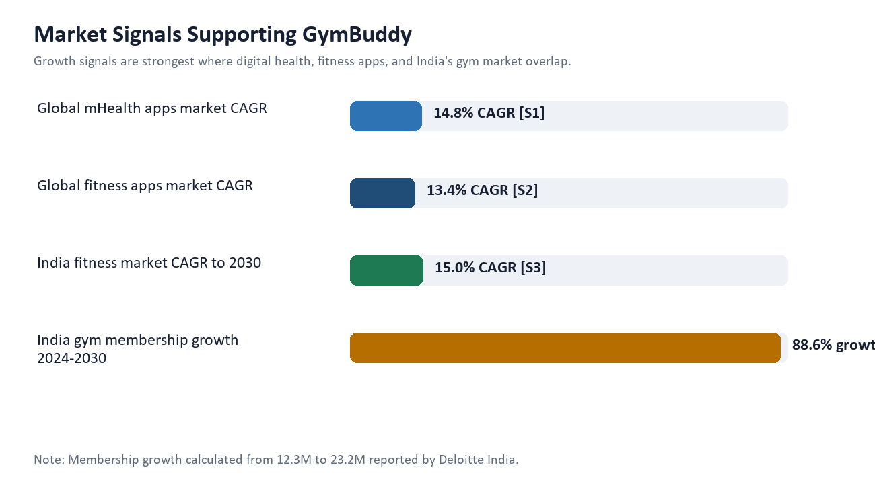
Figure 1. Market signals that support the GymBuddy opportunity. Sources: [S1][S2][S3][S4].
Area | Evidence | Business Meaning | Source
Global mHealth apps | Grand View Research estimates the global mHealth apps market at USD 37.5B in 2024 and projects USD 86.37B by 2030 at 14.8% CAGR. | Health behavior is becoming a software category, not only a clinic or trainer category. | [S1]
Global fitness apps | Grand View Research estimates the global fitness apps market at USD 12.1B in 2025 and projects USD 33.6B by 2033 at 13.4% CAGR. | Fitness app demand is large enough for focused, use-case-specific products. | [S2]
India commercial fitness | HFA/Deloitte report about 46,500 fitness facilities in India and a fitness market expected to grow about 15% CAGR to 2030. | India is not under-supplied by gyms; the gap is guidance after users enter the gym. | [S3]
India gym membership | Deloitte India reports memberships expected to rise from 12.3M in 2024 to 23.2M by 2030, while penetration remains low. | A beginner-first product can ride gym adoption while solving early drop-off. | [S4]

Business Perspective
The strongest wedge is not 'another workout library'. It is a guided first-month retention layer for budget gyms: onboarding, daily workout clarity, demo support, check-ins, and next-week adaptation. This can later become a B2C app, a gym-partner retention tool, or a low-cost AI coaching layer for budget facilities.

3. Do Health Apps Impact Real Life Health?
The evidence is positive but nuanced. Digital tools can improve activity when they create reminders, feedback loops, goals, and self-monitoring. However, simply giving users content is not enough, and the effect can weaken when apps are too generic or require too much effort.
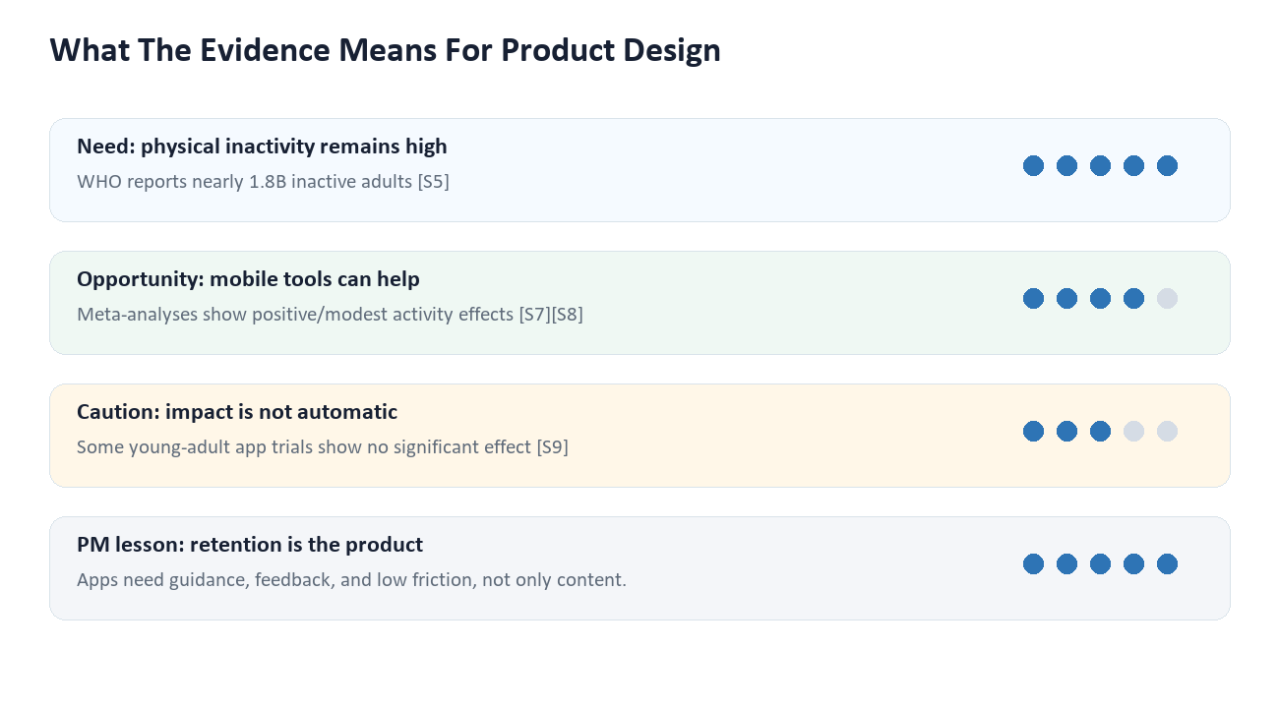
Figure 2. Evidence implications for GymBuddy's product design. Sources: [S5][S6][S7][S8][S9].
Evidence Area | Finding | Implication For GymBuddy | Source
Public-health need | WHO reported that nearly one-third of adults, about 1.8B people, did not meet recommended physical-activity levels in 2022. | There is a real behavior problem, not just a content-discovery problem. | [S5]
Digital-health legitimacy | WHO's digital-health strategy positions digital health as a tool for strengthening health systems when implemented responsibly. | GymBuddy should present AI as supportive guidance with safe boundaries. | [S6]
Positive app evidence | A JMIR systematic review/meta-analysis found modest evidence that smartphone apps can increase physical activity, especially over short periods. | A 4-week beginner journey is a sensible MVP horizon. | [S7]
Tracker/app effectiveness | A BJSM meta-analysis found smartphone apps and activity trackers had positive effects on physical activity in adults. | Self-monitoring and feedback should be core, not optional. | [S8]
Important caution | A 2024 PLOS ONE review of healthy young adults found no significant pooled effect and noted the limited number of studies. | GymBuddy must prove impact through check-ins, completion, and user testing. | [S9]

4. Competitive App Store Review Scan
This scan uses official app store pages, official product pages, and public review snippets visible during the research pass. App ratings and individual reviews change frequently, so the conclusions focus on stable product patterns rather than exact rating values.
App | Positioning | Pros | Cons / Review Signals | Opportunity For GymBuddy | Sources
Nike Training Club | Free workout library; trainer-led strength, conditioning, yoga, pilates, recovery, and programs. | Excellent free content and brand trust. Good for users who want guided classes without paying. | Less focused on the budget-gym floor. Review snippets mention app crashes/navigation issues and metrics visibility complaints. | GymBuddy can be more practical inside a real gym: exact sets, equipment alternatives, and check-ins. | [S10][S11]
cult.fit | India-focused fitness ecosystem across gyms, group classes, home workouts, yoga, dance, and services. | Strong local brand, broad supply network, and high store rating signals. | The app is broad. Review snippets mention feature/device issues, and beginners may still need exercise-level guidance inside a budget gym. | GymBuddy should stay narrower: first-month confidence for people already paying for a budget gym. | [S12][S13]
Healthify | AI diet, health tracking, calorie/nutrition guidance, coaching, and Indian food database positioning. | Strong nutrition and weight-management proposition; India-relevant food context. | More diet/weight-loss oriented than gym execution. Gym beginners still need form, sets, reps, and equipment swaps. | GymBuddy can integrate simple diet tips later, but the core wedge should be workout completion. | [S14][S15]
MyFitnessPal | Calorie, macro, meal, water, and goal tracking. | Very strong nutrition database and habit tracking. Useful for users already motivated to log food. | Food logging can feel heavy; not a gym-floor workout coach. Some reviews complain about ads/paywall or free-feature limits. | GymBuddy should keep logging lightweight and avoid asking beginners to track everything. | [S16][S17]
Fitbod | AI-personalized strength workouts based on goals, equipment, recovery, and progressive overload. | Closest competitor for adaptive strength planning. Strong planning logic and equipment personalization. | Can feel optimized for users who already understand exercises and gym structure; subscription/value concerns may appear in reviews. | GymBuddy should beat it on beginner language, budget-gym assumptions, and first-month coaching. | [S18][S19]
Strong | Workout tracking, history, timer, templates, and gym logbook. | Excellent for lifters who know what they plan to do and want clean logging. | Not a beginner coach. It tracks the workout; it does not solve 'what should I do today and how do I do it?' | GymBuddy should combine plan + demo + logging rather than logging alone. | [S20][S21]
JEFIT | Exercise database, premade plans, muscle breakdowns, workout tracking, and progress tracking. | Large exercise library and plan ecosystem. | Users can feel overwhelmed. Review snippets point to interface and sync/friction complaints. | GymBuddy should avoid library overload and make the next action obvious. | [S22][S23]
Freeletics | AI coaching and workout planning, often bodyweight/home-workout oriented. | Strong coaching identity and structured training. | Review snippets mention schedule rigidity and limited flexibility around moving workouts. | GymBuddy should adapt when users skip, miss days, or equipment is unavailable. | [S24]
Caliber | Strength training plans, coaching, workout history, and progress tracking. | Good consistency/history value for strength users. | Review snippets suggest it may be less useful above beginner plans and can miss exercises/equipment. | GymBuddy should build equipment-aware alternatives from day one. | [S25]
Hevy | Workout logging, exercise videos, graphs, and social motivation. | Strong gym logging and progress visualization. | Social/logging value is stronger than first-month guided coaching. | GymBuddy should make users feel safe and capable before asking them to become serious loggers. | [S26]

5. Competitive Pattern Summary
Pattern | Examples | Meaning
Content-heavy apps | Nike Training Club, JEFIT | They give many workouts/exercises, but beginners can still struggle with what to choose and how to execute in a crowded gym.
Ecosystem apps | cult.fit | They solve access and classes, but may not be optimized for a budget-gym user training alone.
Nutrition-first apps | Healthify, MyFitnessPal | They are useful for health goals but do not directly solve gym-floor confusion.
Tracker-first apps | Strong, Hevy | They work best after a user already has workout knowledge and a stable routine.
AI/adaptive strength apps | Fitbod, Freeletics, Caliber | They validate AI planning, but GymBuddy can differentiate through beginner language, Indian budget-gym assumptions, and low-friction weekly adaptation.

6. Sharp Insights For GymBuddy
The gym is already paid for; confidence is the missing layer.
India's gym market is expanding, but the user's pain starts after entry. A budget gym user does not need another generic fitness feed; they need to know exactly what to do today.

Health apps can work when they change behavior loops, not when they only publish content.
The scientific evidence supports apps that create feedback, self-monitoring, and action prompts. This validates GymBuddy's plan + demo + check-in + adaptation loop.

The best competitor gap is 'first-month gym floor execution'.
Popular apps are strong in libraries, diet, classes, AI planning, or logging. GymBuddy should own beginner execution: alternatives, form links, timer, sets/reps/weight, and adaptive next week.

7. Recommended MVP Direction
For a top-scoring capstone, GymBuddy should be framed as a focused MVP rather than a large fitness platform. The product should prove that beginner budget gym users complete more workouts when the app reduces ambiguity at the exact moment of training.
- Core promise: 'Walk into the gym knowing exactly what to do today.'
- Primary user: Indian budget gym beginner in the first 30 days after joining.
- Primary flow: onboarding -> weekly AI plan -> today's workout -> demo link -> set/reps/weight/timer -> 20-second check-in -> next-week adaptation.
- Main metric: Week 4 completion, measured by users who check in at least once during Week 4.
- Differentiator: simple gym-floor confidence, not advanced analytics.
MVP Area | What To Build | Why It Matters
Onboarding | Ask goal, experience, days/week, height, weight, gender, gym type, equipment confidence, injuries, and preferred workout time. | Collects only what is needed to generate a safe first-week plan.
Today's Workout | Show warm-up, 5-7 exercises, sets/reps, rest timer, weight input, and one demo link per exercise. | Reduces decision fatigue inside the gym.
Equipment Alternative | Every exercise has a basic-gym and equipped-gym option. | Solves crowded or limited gym environments.
Check-In | Completed/skipped, difficulty, pain flag, confidence, and notes. | Creates adaptation data without heavy logging.
Adaptive Week | Next week changes volume, exercise difficulty, cardio time, or recovery based on completion and pain. | Turns AI from a buzzword into a visible product behavior.

8. How To Present This In Your Assignment
- Show that the market is attractive, but avoid claiming market size alone proves product demand.
- Use health-impact research to justify behavior loops: plan, reminder, self-monitoring, feedback, adaptation.
- Use competitor analysis to show a clear wedge: beginner budget-gym execution, not generic workouts.
- Tie every feature to Week 4 completion, because that is the assignment's success metric.
- In user testing, measure whether users understand today's workout in under 60 seconds and complete the check-in in under 20 seconds.

Appendix: References
The source IDs below are used throughout the document. Store ratings and review snippets are volatile; they should be treated as public signals observed during the research scan, not permanent values.
ID | Publisher | Source | Link
S1 | Grand View Research | mHealth Apps Market Size, Share & Trends Analysis Report | Open
S2 | Grand View Research | Fitness Apps Market Size, Share & Trends Analysis Report | Open
S3 | Health & Fitness Association and Deloitte India | India Fitness Market Report 2025 | Open
S4 | Deloitte India | India's fitness market to double by 2030 | Open
S5 | World Health Organization | Nearly 1.8 billion adults at risk of disease from not doing enough physical activity | Open
S6 | World Health Organization | Global Strategy on Digital Health 2020-2025 | Open
S7 | JMIR mHealth and uHealth | Can Smartphone Apps Increase Physical Activity? Systematic Review and Meta-Analysis | Open
S8 | British Journal of Sports Medicine | Effectiveness of physical activity monitors in adults: systematic review and meta-analysis | Open
S9 | PLOS ONE | Effect of smartphone applications on physical activity in healthy young adults | Open
S10 | Apple App Store | Nike Training Club App Store listing | Open
S11 | Nike | Nike Training Club official product page | Open
S12 | Apple App Store India | cult.fit App Store listing | Open
S13 | Google Play | cult.fit Google Play listing | Open
S14 | Google Play | Healthify Google Play listing | Open
S15 | Healthify | Healthify official app page | Open
S16 | Apple App Store | MyFitnessPal App Store listing | Open
S17 | Google Play | MyFitnessPal Google Play listing | Open
S18 | Apple App Store | Fitbod App Store listing | Open
S19 | Google Play | Fitbod Google Play listing | Open
S20 | Strong | Strong official product page | Open
S21 | Apple App Store | Strong App Store listing | Open
S22 | Apple App Store | JEFIT App Store listing | Open
S23 | Google Play | JEFIT Google Play listing | Open
S24 | Google Play | Freeletics Google Play listing | Open
S25 | Google Play | Caliber Google Play listing | Open
S26 | Google Play | Hevy Google Play listing | Open

