Geopolitical Risk Analysis — Critical Minerals in Africa
This report presents a geopolitical risk assessment for three critical mineral supply chains: Gold (Mali), Cobalt (DRC), and Platinum (Zimbabwe). It evaluates geography, state and non-state actors, likelihood of disruption, velocity of change, impact severity, and supply chain exposure across three forward-looking scenarios.

1. Country Risk Profiles

Mali — Gold
Country — Mineral | Mali — Gold
Geography | Landlocked West African nation; mining concentrated in Kayes, Sikasso and Koulikoro regions. Sahel climate with limited transport infrastructure linking mines to Bamako and export ports in Senegal/Côte d'Ivoire.
State & Non-State Actors | Military transitional government (CNSP); Ministry of Mines; SOMILO (state mining entity). Non-state: JNIM & ISGS armed groups; artisanal mining cooperatives; Wagner Group/Africa Corps.
Likelihood of Occurrence | 72%
Velocity | High — political instability can escalate within weeks
Impact | Severe — Mali is Africa's 3rd-largest gold producer
Supply Chain | Barrick Gold, B2Gold, Hummingbird Resources operate major mines. Gold exported via Dakar and Abidjan ports. Disruption affects ~70 tonnes/year of global supply.

DRC — Cobalt
Country — Mineral | DRC — Cobalt
Geography | Central African nation; cobalt mining concentrated in the Copperbelt (Katanga/Haut-Katanga & Lualaba provinces). Tropical climate with poor road networks; exports via Dar es Salaam and Durban corridors.
State & Non-State Actors | Presidency & National Assembly; Gécamines (state mining company); Entreprise Générale du Cobalt (EGC). Non-state: M23, ADF and other armed groups in eastern provinces; Chinese-backed private mining firms; artisanal miners (ASM) — estimated 200k workers.
Likelihood of Occurrence | 78%
Velocity | Very High — conflict zones can shut operations overnight
Impact | Critical — DRC produces ~73% of global cobalt, essential for lithium-ion batteries
Supply Chain | CMOC, Glencore (Mutanda & Kamoto), Chemaf supply global market. China refines >80% of DRC cobalt. EV and electronics industries directly exposed.

Zimbabwe — Platinum
Country — Mineral | Zimbabwe — Platinum
Geography | Southern African nation; platinum group metals (PGMs) mined on the Great Dyke geological formation stretching ~550 km. Semi-arid climate; road and rail links to Beira (Mozambique) and South African ports.
State & Non-State Actors | ZANU-PF government; Ministry of Mines & Mining Development; ZMDC (Zimbabwe Mining Development Corp). Non-state: opposition parties; war veterans associations; South African labour unions influencing cross-border workers.
Likelihood of Occurrence | 58%
Velocity | Moderate — policy shifts typically signalled in advance
Impact | High — Zimbabwe holds the world's 2nd-largest platinum reserves after South Africa
Supply Chain | Zimplats (Impala Platinum), Unki (Anglo American Platinum), Mimosa (Sibanye-Stillwater). PGMs critical for catalytic converters, hydrogen fuel cells and electronics.

2. Overall Likelihood Comparison
The chart below compares the overall likelihood of geopolitical disruption for each country-mineral pair. DRC (Cobalt) carries the highest risk at 78%, driven by armed conflict and extreme dependence of the global cobalt supply chain on a single country. Mali (Gold) follows at 72% due to military governance and Sahel instability. Zimbabwe (Platinum) is assessed at 58%, moderated by relatively more stable institutional frameworks.
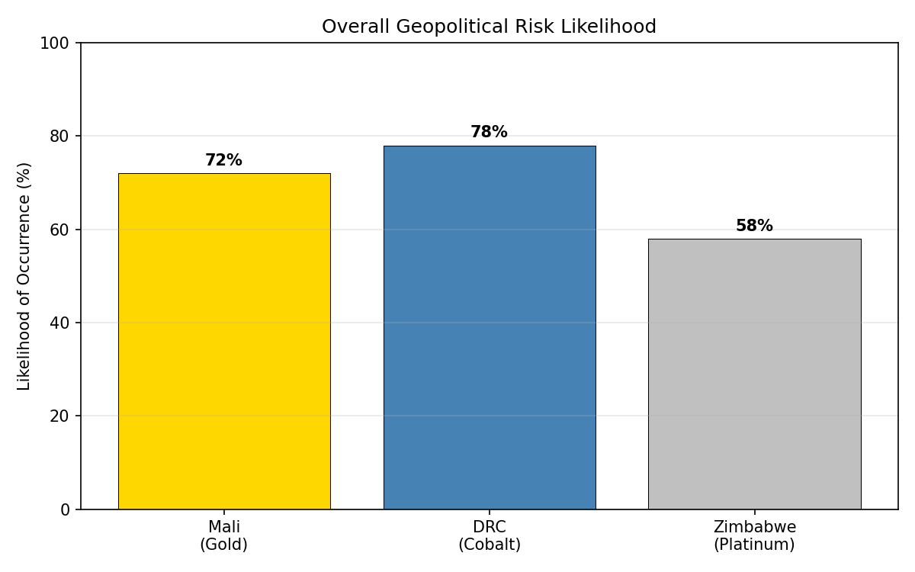

3. Multi-Parameter Risk Comparison
The radar chart compares each country across five normalized risk dimensions: likelihood, velocity of change, impact severity, supply chain exposure, and political instability. DRC dominates in nearly every dimension, underscoring its status as the highest-risk critical mineral jurisdiction.
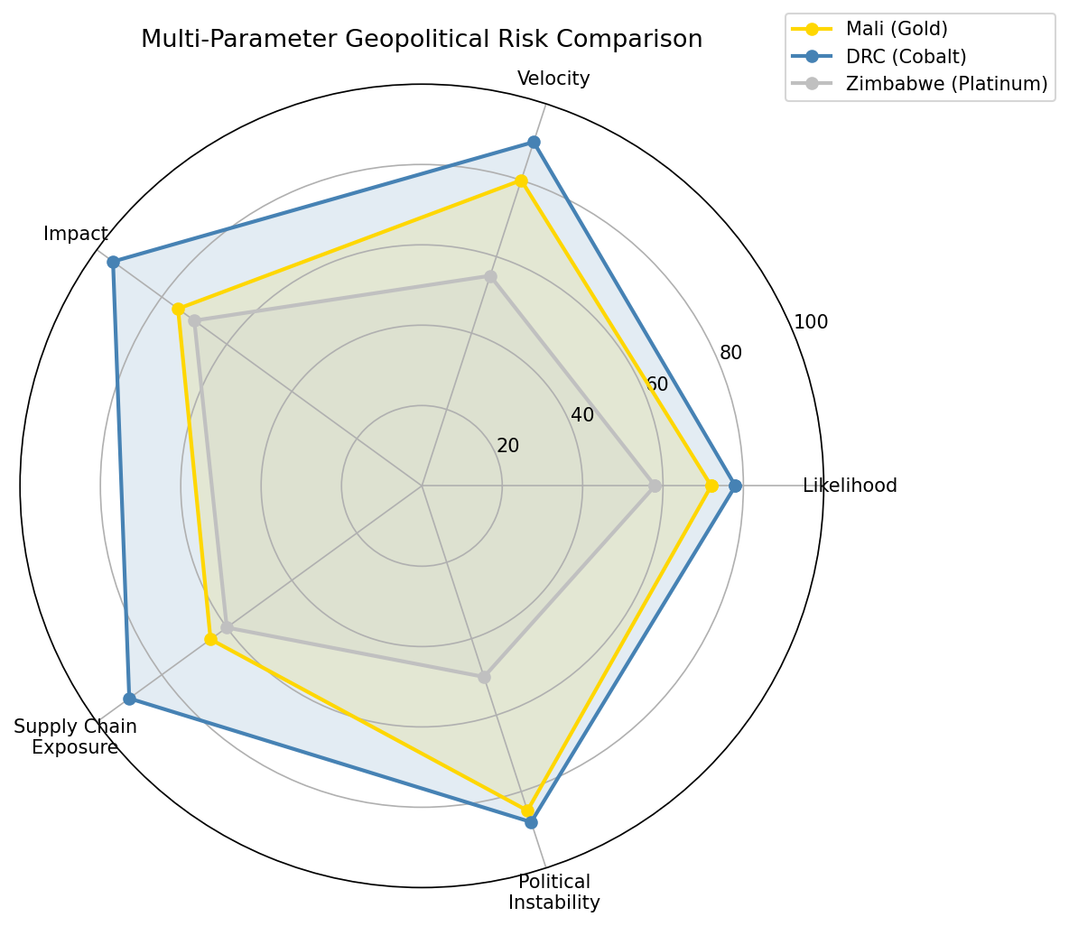

4. Scenario Analysis
Three forward-looking scenarios are evaluated for each country. Likelihood percentages reflect the assessed probability of each scenario materializing within a 3–5 year horizon.

Scenario 1: Government Controls All Mines — No Private Building
Under this scenario, host governments nationalise or assume direct control of all mining operations, barring new private-sector investment. Mali (65%): The military junta has already revised mining codes to increase state ownership stakes; full nationalisation is plausible. DRC (75%): Gécamines and EGC have been empowered to monopolise artisanal cobalt trade; broader nationalisation aligns with political rhetoric. Zimbabwe (50%): Indigenisation laws exist but enforcement is inconsistent; full government takeover faces pushback from international investors.

Scenario 2: Constant Interest Rate & Legislative Changes
Frequent shifts in fiscal policy, royalty rates, and mining legislation create an unstable operating environment. Mali (55%): Post-coup legislative uncertainty, though mining code reform is ongoing. DRC (60%): The 2018 Mining Code revision raised royalties significantly; further changes are anticipated as cobalt strategic importance grows. Zimbabwe (65%): Hyperinflation history, multi-currency regime, and frequent statutory instrument changes make this the highest-scoring country for this scenario.

Scenario 3: International Companies Must Establish Infrastructure
International mining companies are required to build transport, energy, and social infrastructure as a condition of continued operations. Mali (70%): Limited existing infrastructure in the Sahel raises costs; government leverage is increasing. DRC (80%): Massive infrastructure deficit in Katanga; the Lobito Corridor project illustrates the scale of investment required. Zimbabwe (55%): Great Dyke is relatively well-served; South Africa's neighbouring infrastructure provides an alternative.

Scenario Comparison Table
Country | Mineral | Government controls all mines | Interest rate & legislative changes | Infrastructure requirement for intl companies
Mali | Gold | 65% | 55% | 70%
DRC | Cobalt | 75% | 60% | 80%
Zimbabwe | Platinum | 50% | 65% | 55%

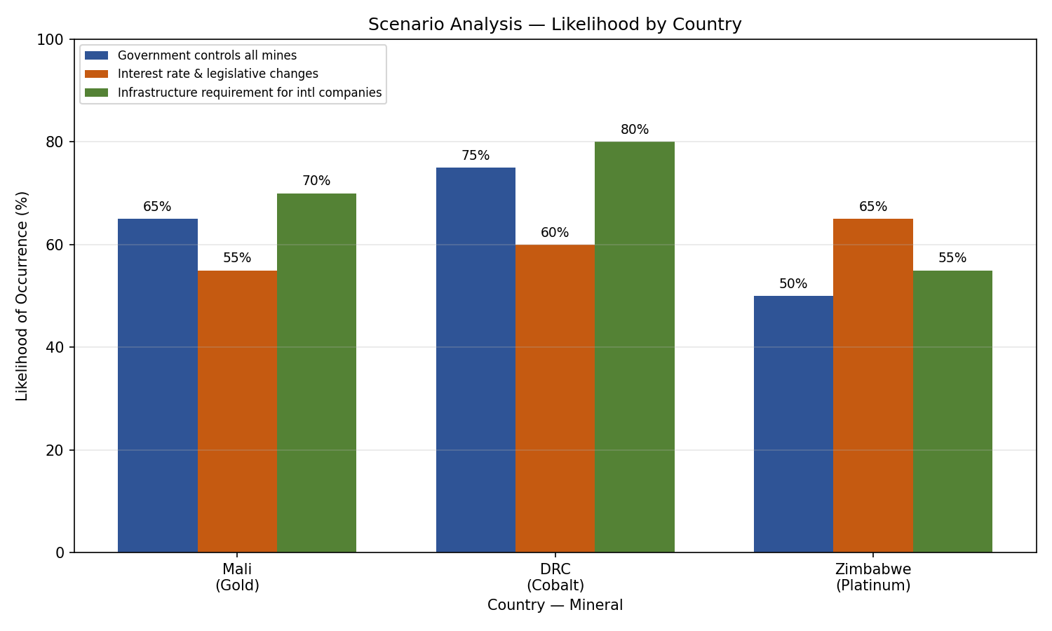

5. Key Takeaways & Recommendations
- DRC (Cobalt) is the highest-risk jurisdiction across all parameters. Diversification of cobalt sourcing (e.g., Indonesia, Australia) and investment in recycling are strategic imperatives.
- Mali (Gold) faces acute near-term risk from military governance and Sahel security deterioration. Companies should stress-test supply chains against a full nationalisation scenario.
- Zimbabwe (Platinum) presents moderate risk; however, legislative volatility warrants close monitoring, especially as hydrogen economy demand for PGMs grows.
- All three countries show elevated risk under the infrastructure mandate scenario. International operators should engage in early-stage public-private partnership negotiations.

