Assignment 1

K-Means and K-medoids

List of user defined functions: -

1-

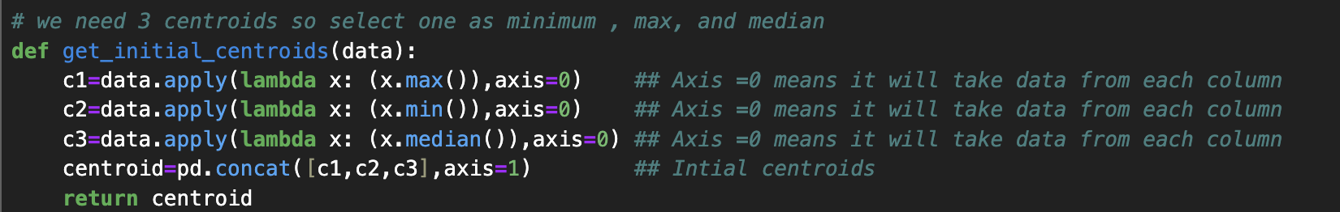

This function initializes 3 centroids which looks like this: -

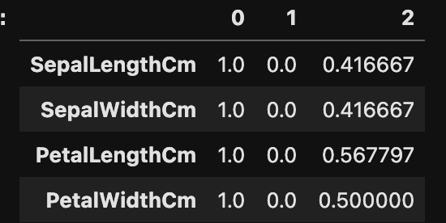

2-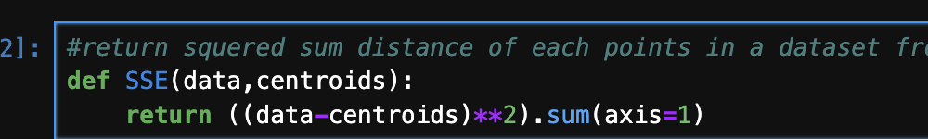

It finds SSE from one given centroid and given pandas data frame

4-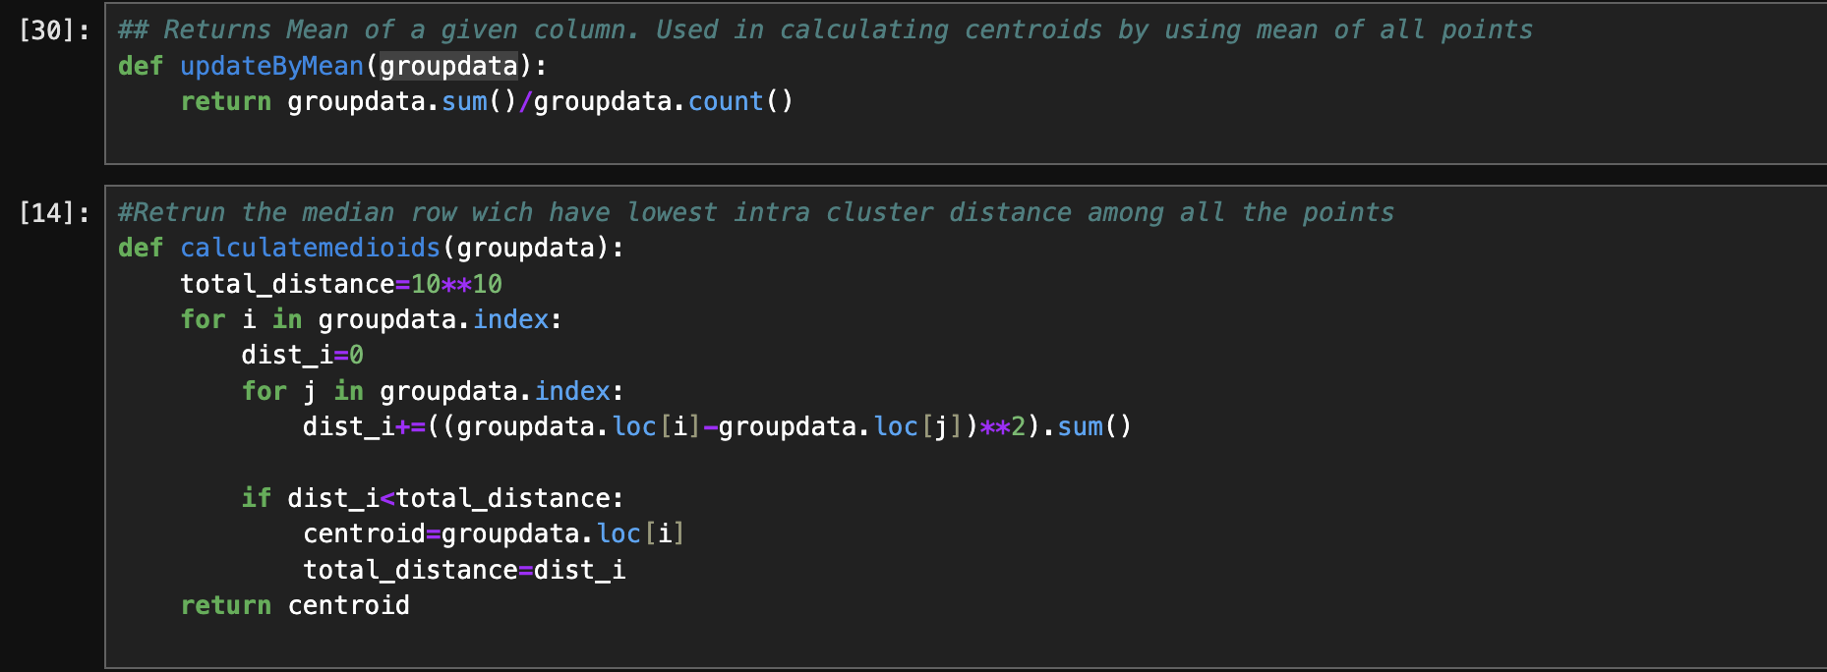

This two-function used to calculate medoids. Given a pandas data frame 1st function calculate mean of each column/feature. And other function returns the median of the data frame given.

It takes data frame of each cluster and returns the new centroids.

5-

This function will return labels as per the given data frame and the 3 centroids.

Here for each centroid, we apply SSE to whole dataset. For each record we will get sse w.r.t to each cluster as shown below:-

Distance dataframe look like this:-

Idxmin will return the index with lowest value (lowest SSE value) along axis =1 ,for each record which will be its cluster (0,1,2)

Returned data frame looks like this:-

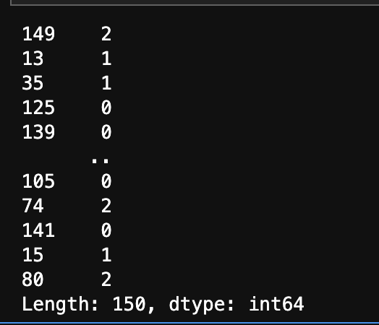

Labeled for each row/record.

6-

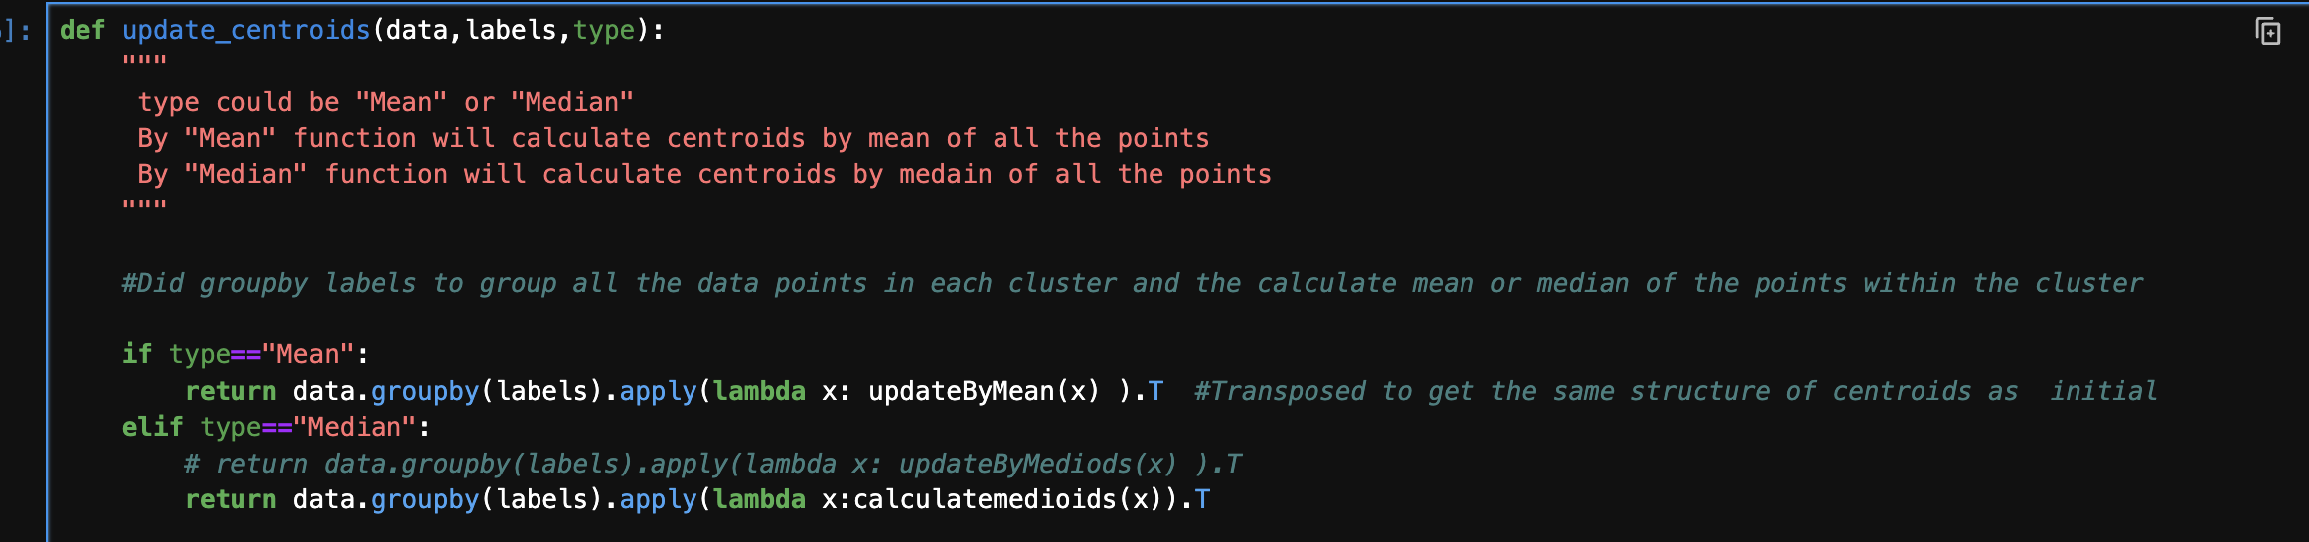

This function used to calculate centroid as per the inputs (mean or median).

I used group by to group data by labels so 3 groups will be created and will be passed one be one to calculatemedioids or updateByMean methods and will get 3 new centroids.

Final transposed it to make it dimension correct

7:-

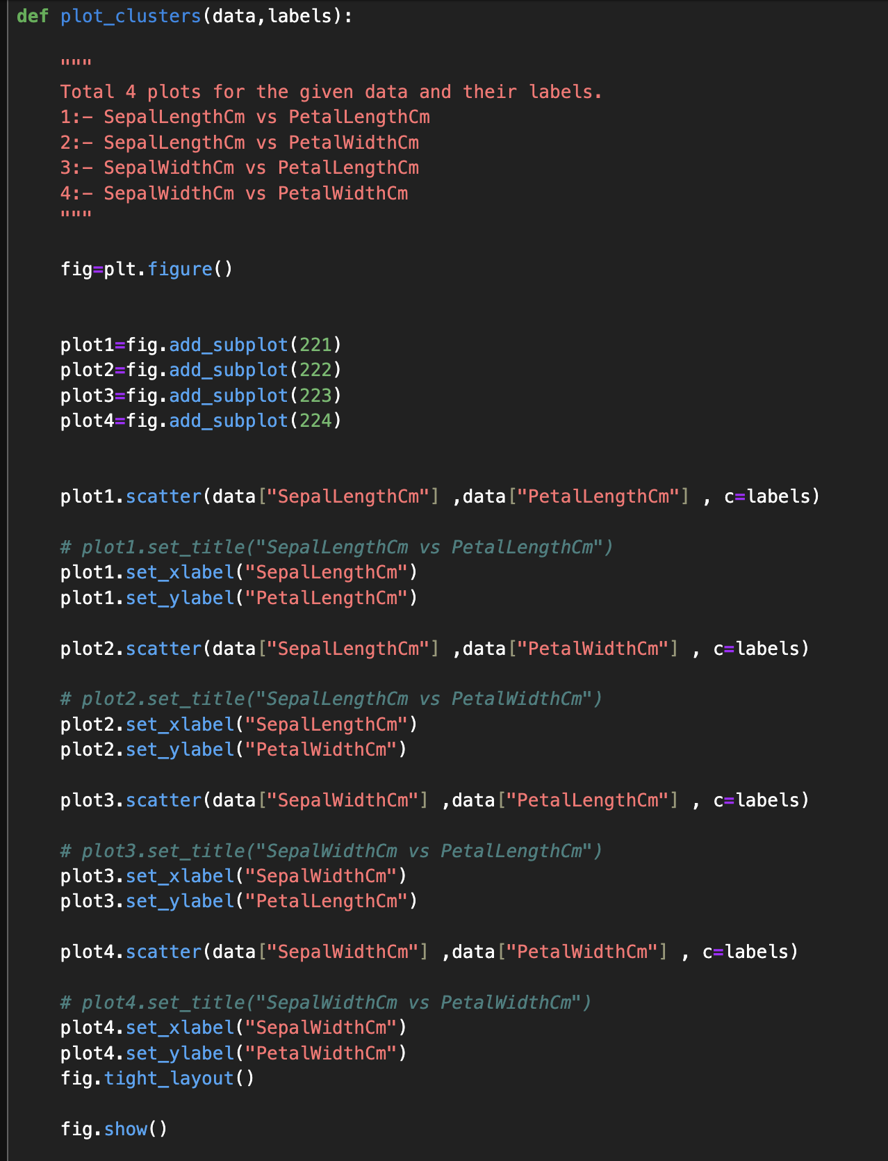

This function is used to plot the graphs. We have 4 features in 2d we can plot 6 types of graphs, but I only plotted 4 graphs in one figure for each iteration.

I will be calling this function in each iteration.

Took color (c) as labels so for each index in dataset it will pick color as per labels

8:-

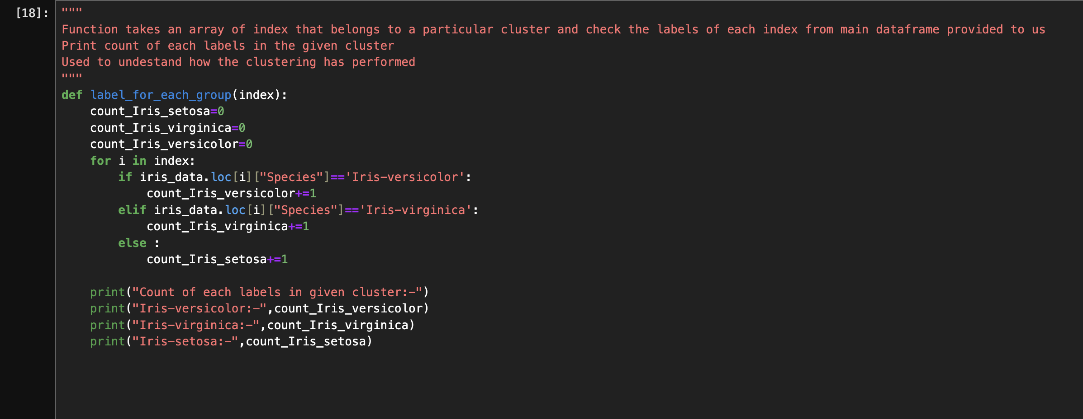

As given data is pre labeled, we want to see how many records are correctly clustered.

This function will take index of records belonging to a particular cluster and print all the labeled count present in that cluster.

9:-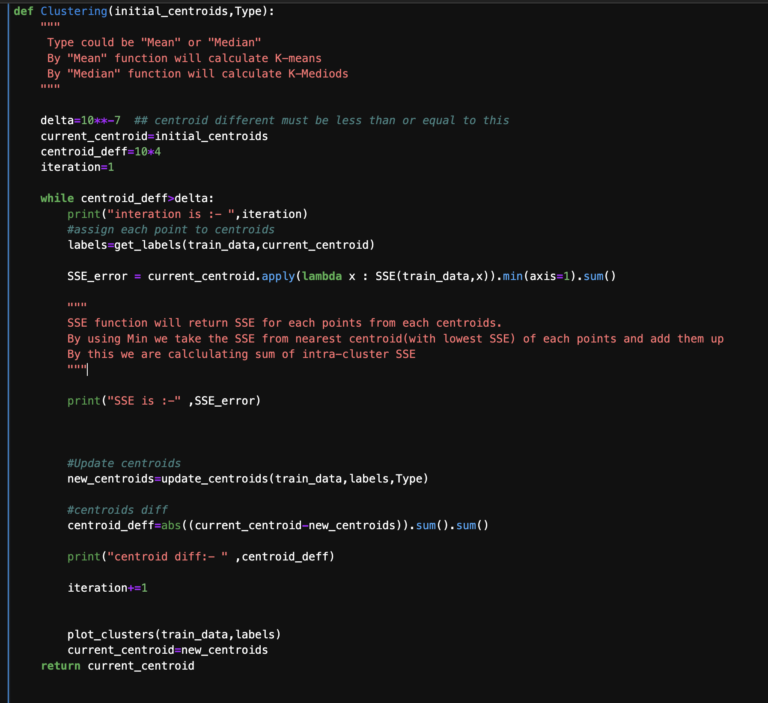

This is main function to evaluate k-means or k-medoids algorithm.

Uses all the helper function defined earlier and returns the final centroids, also prints SSE, plot clustered graph at each iterations.

OUTPUT of the code for K-means: -

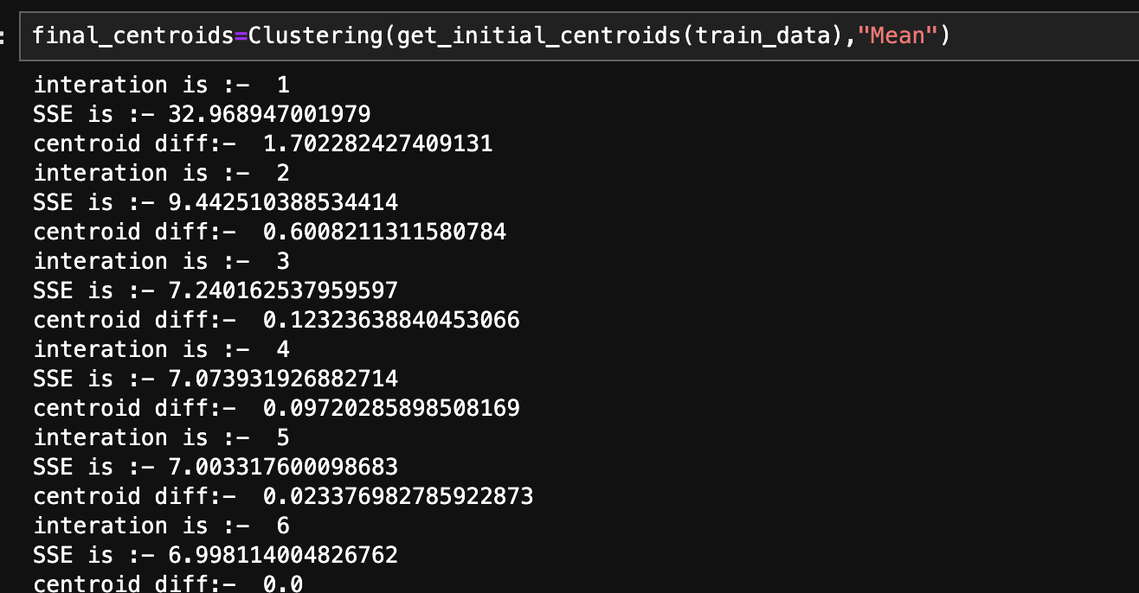

GRAPHS for each iteration: -

1st Iterations

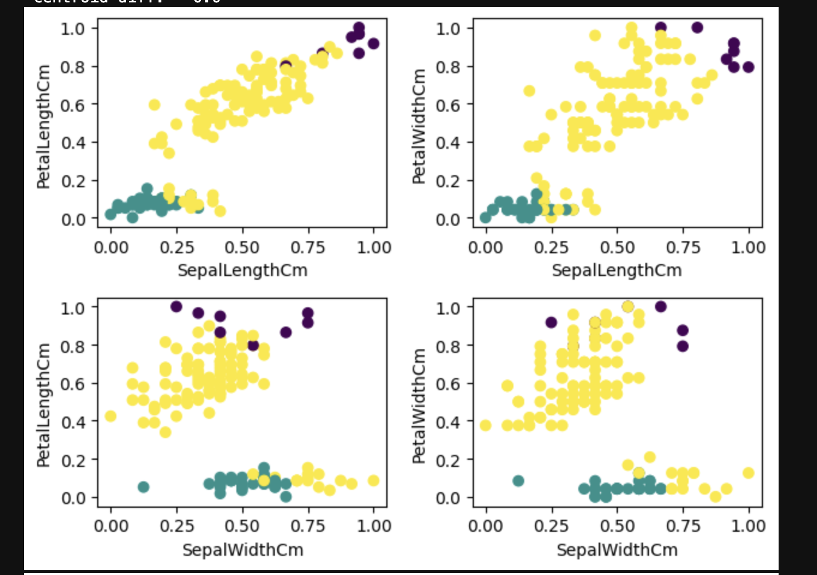

2nd Iteration: -

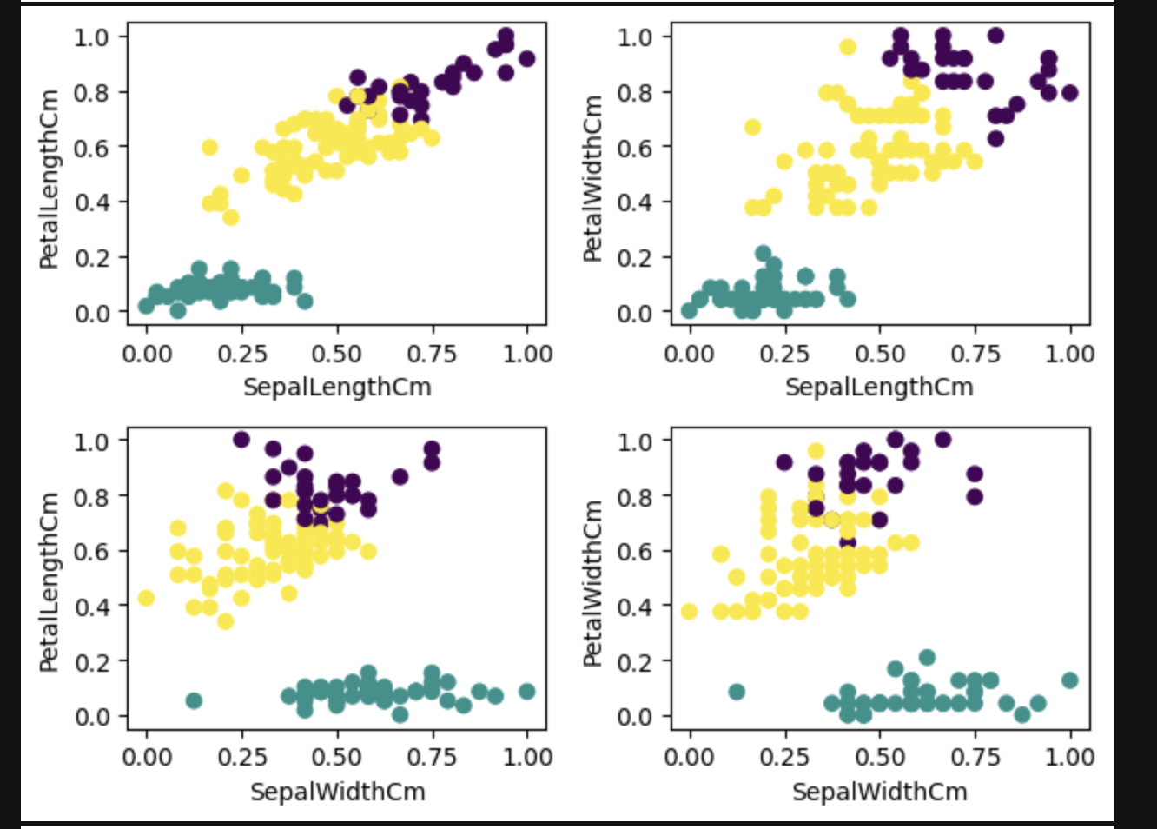

3rd Iteration: -

4th Iteration: -

5th :-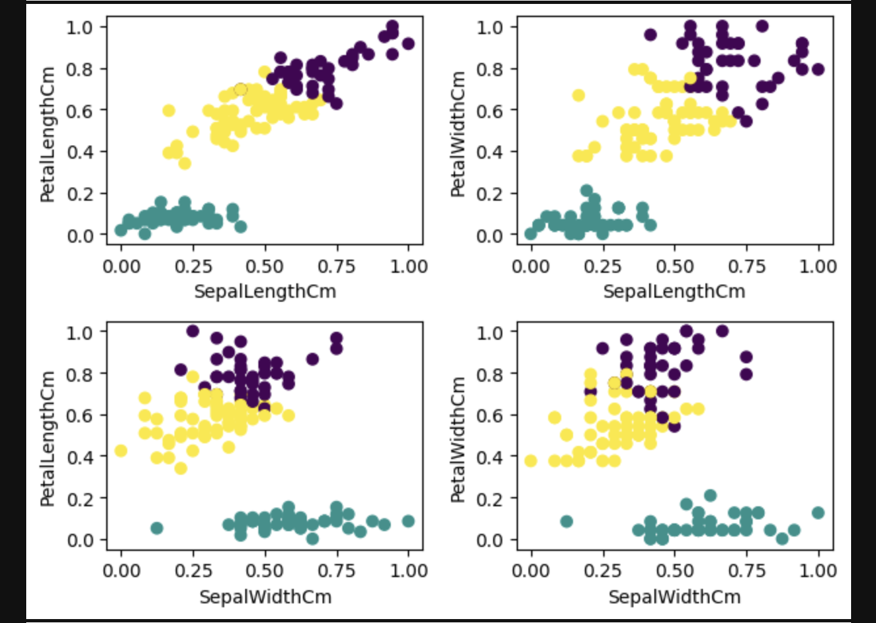

6th :-

OUTPUT of the code for K-medoids: -

