**JRebel**

# JRebel

## Introduction:

* JRebel lets Java developers instantly update code (i.e. add a new feature, fix a bug, etc) and see those changes reflected in their app under development without restarting the application server.
* We can instantly reload changes made to a class structure, making a full app redeploy unnecessary. You just save, refresh and see the changes right away. To achieve this, it does not wrap classloaders around classes, but patches existing classloaders to make classes loaded through them reloadable. JRebel tracks changes that you make in your workspace, and updates them on-the-fly, so you can keep focused on the code and stay in the zone without interruption.
* JRebel makes developers more productive since they can view code changes in real time.
* It works with all java applications.
* JRebel supports various appservers like oracle weblogic, websphere, tomcat, jboss, glassfish etc.
* Developers keep their tempo and focus by eliminating the downtime normally spent waiting for application build and redeploy.

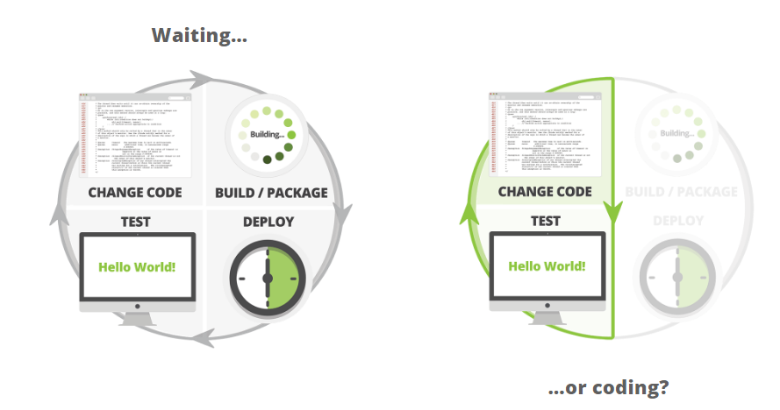

## JRebel Donwload and Installation

Please find the below attachment to understand the installation steps about JRebel.



## Changes in items.xml

If we do any changes (adding attributes, updating attributes, create new item type) in items.xml file, we have to restart the server.

## Changes in Spring Configuration file

**ant build** is required when

* A new bean is configured in spring xml.
* A new attribute is added to the existing bean configuration.
* Any modification to attribute name, datatype, or an attribute is removed.

## Changes in properties file

If we do any changes in local.properties or project.properties, **ant build** is required**.**

## Static variable value changes

For static variables, Jrebel is not working. **ant build** is required.